**Q_01 :**

package Q_01;  
  
import java.util.Scanner;  
  
public class Q1 {  
 public static void main(String[] args) {  
 Scanner scanner = new Scanner(System.*in*);  
  
 System.*out*.println("Enter first number : ");  
 int a = scanner.nextInt();  
 System.*out*.println("Enter second number : ");  
 int b = scanner.nextInt();  
 System.*out*.println("Enter third number : ");  
 int c = scanner.nextInt();  
  
 if (a < b){  
 if (a < c) {  
 System.*out*.println("Minimum Number : " + a);  
 }  
 else {  
 System.*out*.println("Minimum Number : " + c);  
 }  
 }  
 else {  
 if (b < c) {  
 System.*out*.println("Minimum Number : " + b);  
 }  
 else {  
 System.*out*.println("Minimum Number : " + c);  
 }  
 }  
 }  
}

**Output :**

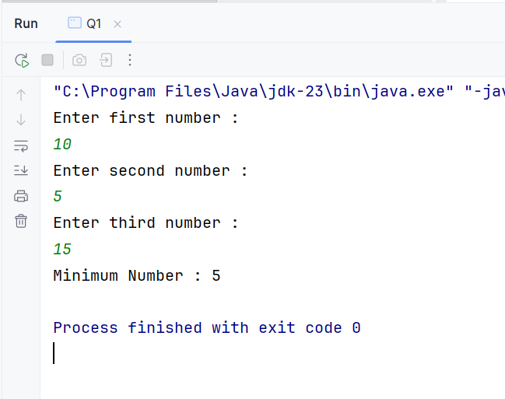

**Q_02 :**

package Q_02;  
  
import java.util.Scanner;  
  
public class Q2 {  
 public static void main(String[] args) {  
 Scanner scanner = new Scanner(System.*in*);  
  
 System.*out*.println("0.Magenta");  
 System.*out*.println("1.Cyan");  
 System.*out*.println("2.Red");  
 System.*out*.println("3.Blue");  
 System.*out*.println("4.Green");  
 System.*out*.println("Select one color from the above list:");  
  
 int selection = scanner.nextInt();  
  
 switch(selection) {  
 case 0:  
 System.*out*.println("You selected Magenta");  
 break;  
 case 1:  
 System.*out*.println("You selected Cyan");  
 break;  
 case 2:  
 System.*out*.println("You selected Red");  
 break;  
 case 3:  
 System.*out*.println("You selected Blue");  
 break;  
 case 4:  
 System.*out*.println("You selected Green");  
 break;  
 default:  
 System.*out*.println("Invalid Selection");  
 }  
 }  
}

**Output :**

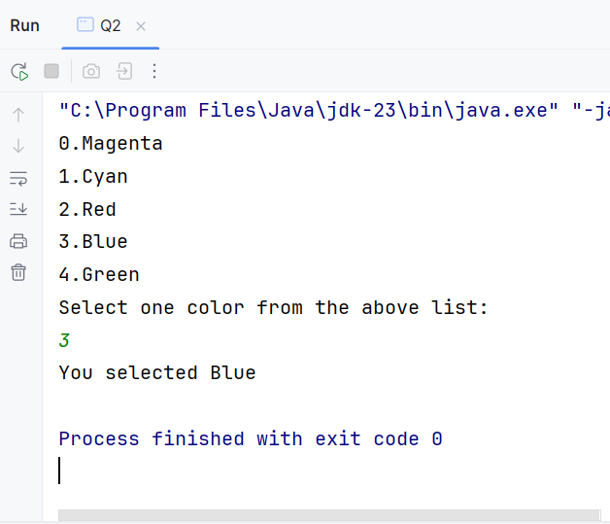

**Q_03:**

package Q_03;  
  
import java.util.Scanner;  
  
public class Q3 {  
 public static void main(String[] args) {  
 Scanner scanner =new Scanner(System.*in*);  
  
 System.*out*.println("Enter power of 10 : ");  
 int power = scanner.nextInt();  
  
 switch (power){  
 case 6:  
 System.*out*.println("Million");  
 break;  
 case 9:  
 System.*out*.println("Billion");  
 break;  
 case 12:  
 System.*out*.println("Trillion");  
 break;  
 case 15:  
 System.*out*.println("Quadrillion");  
 break;  
 case 18:  
 System.*out*.println("Quintillion");  
 break;  
 case 21:  
 System.*out*.println("Sextillion");  
 break;  
 case 30:  
 System.*out*.println("Nonillion");  
 break;  
 case 100:  
 System.*out*.println("Googol");  
 break;  
 default:  
 System.*out*.println("Input value has no corresponding word.");  
 }  
 }  
}

**output :**

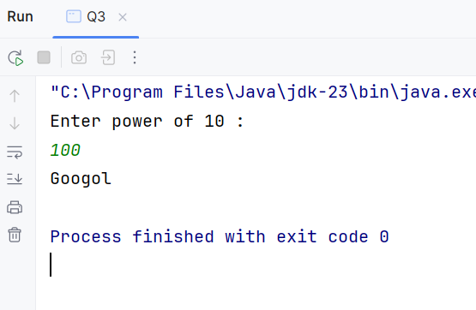

**Q_04 :**

package Q_04;  
  
import java.util.Scanner;  
  
public class Q4 {  
 public static void main(String[] args) {  
 Scanner scanner = new Scanner(System.*in*);  
  
 System.*out*.println("Enter the Year : ");  
 int year = scanner.nextInt();  
  
 if ((year % 4 == 0) && (year % 100 == 0)) {  
 if (year % 400 == 0){  
 System.*out*.println("It is a leap year.");  
 }  
 else {  
 System.*out*.println("It is not a leap year.");  
 }  
 }  
 else if ((year % 4 == 0) || (year % 100 == 0) && (year % 400 == 0) ) {  
 System.*out*.println("It is a leap year.");  
 }  
 else {  
 System.*out*.println("It is not a leap year.");  
 }  
 }  
}

**Output :**

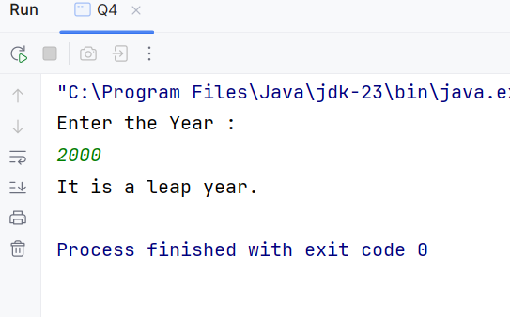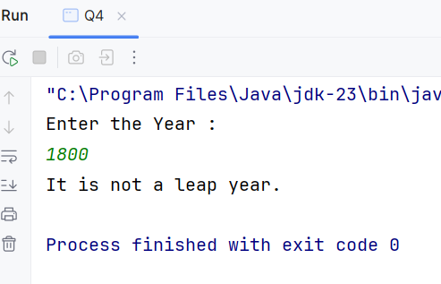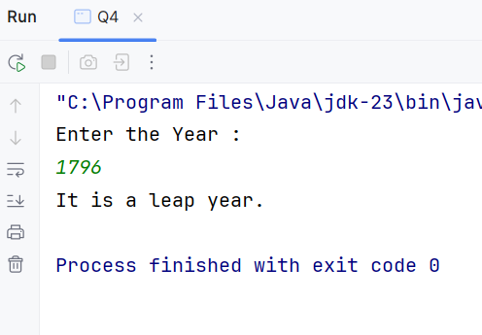

**Q_05 :**

package Q_05;  
  
import java.util.Scanner;  
  
public class Q5 {  
 public static void main(String[] args) {  
 Scanner scanner = new Scanner(System.*in*);  
 double total = 0.0;  
  
 System.*out*.println("Entree : ");  
 System.*out*.println("\t 1. Tofu Burger - $3.49");  
 System.*out*.println("\t 2. Cajun Chicken - $4.59");  
 System.*out*.println("\t 3. Buffalo Wings - $3.99 ");  
 System.*out*.println("\t 4. Rainbow Fillet - $2.99 \n");  
  
 System.*out*.println("Side Dish : ");  
 System.*out*.println("\t 5. Rice Cracker - $0.79 ");  
 System.*out*.println("\t 6. No-Salt Fries - $0.69");  
 System.*out*.println("\t 7. Zucchini - $1.09");  
 System.*out*.println("\t 8. Brown Rice - $0.59\n");  
  
 System.*out*.println("Drink : ");  
 System.*out*.println("\t 9. Cafe Mocha - $1.99");  
 System.*out*.println("\t 10. Cafe Latte - $1.90");  
 System.*out*.println("\t 11. Espresso - $2.49");  
 System.*out*.println("\t 12. Oolong Tea - $0.99\n");  
  
 System.*out*.println("Enter the Number of item in Entree : ");  
 int entree = scanner.nextInt();  
  
 System.*out*.println("Enter the Number of item in Side Dish : ");  
 int side = scanner.nextInt();  
  
 System.*out*.println("Enter the Number of item in Drink : ");  
 int drink = scanner.nextInt();  
  
  
 if (entree == 1){  
 System.*out*.println("you selected entree as Tofu Burger");  
 total = total + 3.49;  
 }  
 else if (entree == 2){  
 System.*out*.println("you selected entree as Cajun Chicken");  
 total = total + 4.59;  
 }  
 else if (entree == 3){  
 System.*out*.println("you selected entree as Buffalo Wings");  
 total = total + 3.99;  
 }  
 else if (entree == 4){  
 System.*out*.println("you selected entree as Rainbow Fillet");  
 total = total + 2.99;  
 }  
  
  
 if(side == 5) {  
 System.*out*.println("you selected side dish as Rice Cracker");  
 total = total + 0.79;  
 }  
 else if (side == 6) {  
 System.*out*.println("you selected side dish as No-Salt Fries");  
 total = total + 0.69;  
 }  
 else if (side == 7) {  
 System.*out*.println("you selected side dish as Zucchini");  
 total = total + 1.09;  
 }  
 else if (side == 8){  
 System.*out*.println("you selected side dish as Brown Rice");  
 total = total + 0.59;  
 }  
  
 if(drink == 9){  
 System.*out*.println("you selected drink as Cafe Mocha");  
 total = total + 1.99;  
 }  
 else if (drink == 10){  
 System.*out*.println("you selected drink as Cafe Latte");  
 total = total + 1.90;  
 }  
 else if (drink == 11) {  
 System.*out*.println("you selected drink as Espresso");  
 total = total + 2.49;  
 }  
 else if (drink == 12) {  
 System.*out*.println("you selected drink as Oolong Tea");  
 total = total + 0.99;  
 }  
  
 System.*out*.println("Youre total bill : " + total);  
  
  
  
 }  
}

**Output :**

