**Q_01 :**

package Q_01;  
  
public class Q1 {  
 public static void main(String[] args) {  
 int i;  
  
 for(i=10; i<50 ;i++){  
 if(i % 10 == 0){  
 System.*out*.println("\n");  
 }  
 System.*out*.print(i + "\t");  
 }  
 }  
}

**output :**

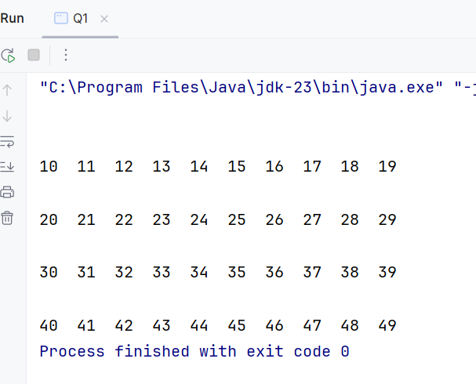

**Q_02:**

package Q_02;  
  
import java.util.Scanner;  
  
public class Q2 {  
 Scanner scanner = new Scanner(System.*in*);  
 static int *Number*;  
 int count = 0;  
 int i = *Number*;  
  
 public void Digit() {  
 while (i > 0){  
  
 while (*Number* != 0) {  
 *Number* = *Number* / 10;  
 count++;  
 }  
 System.*out*.println("Number of digits : " + count);  
 count = 0;  
  
 System.*out*.println("Enter the Number (If you wat to stop enter negative number ) : ");  
 *Number* = scanner.nextInt();  
 i = *Number*;  
 }  
  
 }  
 public static void main(String[] args) {  
 Scanner scanner = new Scanner(System.*in*);  
 System.*out*.println("Enter the Number (If you wat to stop enter negative number ) : ");  
 *Number* = scanner.nextInt();  
 Q2 meth = new Q2();  
 meth.Digit();  
 }  
  
}

**Output:**

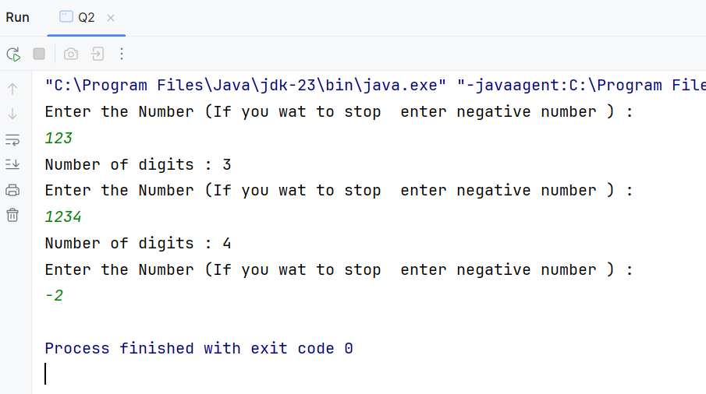

**Q_03:**

package Q_03;  
  
import java.util.Scanner;  
  
public class Q3 {  
 public static void main(String[] args) {  
 Scanner scanner = new Scanner(System.*in*);  
  
 System.*out*.println("Enter the number to get multiplication table : ");  
 int N = scanner.nextInt();  
  
 for(int i = 0; i <=10; i++){  
 System.*out*.println(N + " * " + i + " = " + N*i);  
 }  
 }  
}

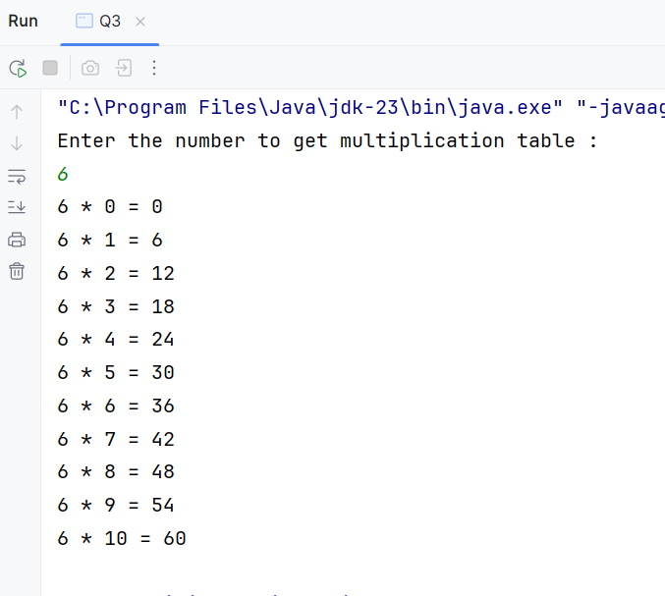**Output :**

**Q_04:**

package Q_04;  
  
import java.util.Scanner;  
  
public class Q4 {  
 public static void main(String[] args) {  
 Scanner scanner = new Scanner(System.*in*);  
  
 System.*out*.println("Enter the rows for pyramid : ");  
 int N = scanner.nextInt();  
  
 for (int i = 1; i <= N; i++){  
 for(int r = 1; r <= N - i ; r++){  
 System.*out*.print(" ");  
 }  
 for(int a = 1; a <= i; a++){  
 System.*out*.print(" *");  
 }  
 System.*out*.println("\n");  
 }  
 }  
}

**Output :**

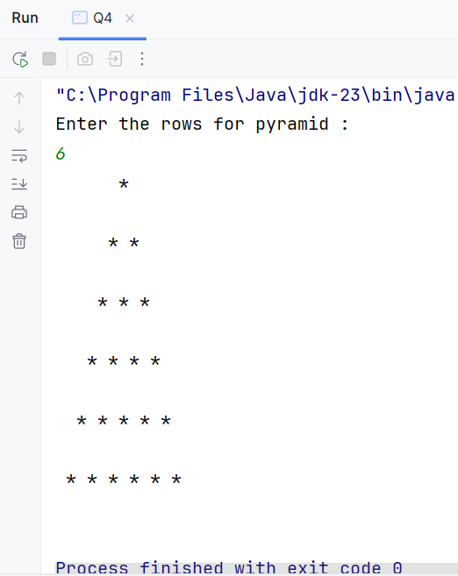

**Q_05 :**

package Q_05;  
  
import java.util.Scanner;  
  
public class Q5 {  
 public static void main(String[] args) {  
 Scanner scanner = new Scanner(System.*in*);  
  
 System.*out*.println("Enter the word or phrase : ");  
 String word = scanner.nextLine();  
  
 int length = word.length();  
 String reverse = "";  
  
 for(int i = length - 1; i>=0; i-- ){  
 reverse = reverse + word.charAt(i);  
 }  
 System.*out*.println(reverse);  
 if(word.equals(reverse)){  
 System.*out*.println("It is a palindrome word.");  
 }  
 else {  
 System.*out*.println("It is not a palindrome word.");  
 }  
  
 }  
  
  
}

**Output :**

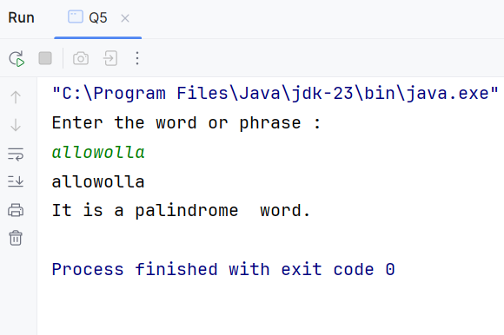

**Q_06:**

package Q_06;  
  
import java.util.Random;  
import java.util.Scanner;  
  
public class Q6 {  
 public static void main(String[] args) {  
 Scanner scanner = new Scanner(System.*in*);  
 Random rand = new Random();  
  
 int random = rand.nextInt(100);  
 int guessNo;  
 int attempt = 0;  
 do{  
 System.*out*.println("Guess the secret number (1 to 100) : ");  
 guessNo = scanner.nextInt();  
 attempt++;  
 if (guessNo > random){  
 System.*out*.println("Number is higher.");  
 }  
 else if (guessNo < random){  
 System.*out*.println("Number is lower.");  
 }  
 else{  
 System.*out*.println("You guess the secret number in " +attempt + " attempts");  
 }  
 }  
 while(guessNo != random);{  
 }  
 }  
  
}

**Output :**

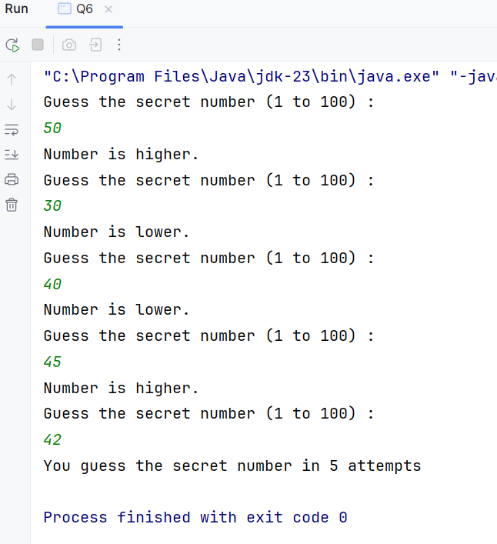

**Q_07 :**

public class Q7 {  
 public static void main(String[] args) {  
 Scanner scanner = new Scanner(System.*in*);  
  
 System.*out*.println("Enter a sentence : ");  
 String sentence = scanner.nextLine();  
  
 System.*out*.println("Enter the word to be replaced : ");  
 String word = scanner.nextLine();  
  
 System.*out*.println("Enter the replacement word : ");  
 String repWord = scanner.nextLine();  
  
 String modSentence = sentence.replaceAll(word ,repWord);  
 System.*out*.println("Modified sentence : " + modSentence);  
  
 }  
}

**Output :**

