**LAB WORK SHEET – 06 – CT/2021/025**

**Q_01:**

**Pet.java**

package Q_01;  
  
public class Pet {  
 private String name;  
 public String getName( ) {  
 return name;  
 }  
 public void setName(String petName) {  
 name = petName;  
 }  
 public String speak( ) {  
 return "I'm your cuddly little pet.";  
 }  
}

**Dog.java**

package Q_01;  
  
public class Dog extends Pet {  
 public String speak(){  
 return " ";  
 }  
 public static void main(String[] args) {  
 Dog obj1 = new Dog();  
 obj1.setName("Brown");  
 System.*out*.println(obj1.speak());  
 System.*out*.println(obj1.getName());

}  
}

**Cat.java**

package Q_01;  
  
public class Cat extends Pet{  
 public String speak(){  
 return " ";  
 }  
  
 public static void main(String[] args) {  
 Cat obj2 = new Cat();  
 obj2.setName("juki");  
 System.*out*.println(obj2.speak());  
 System.*out*.println(obj2.getName());  
 }

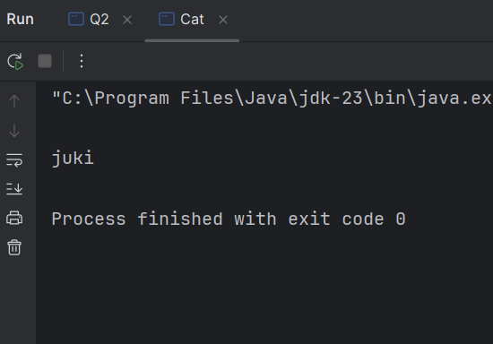**Output:**

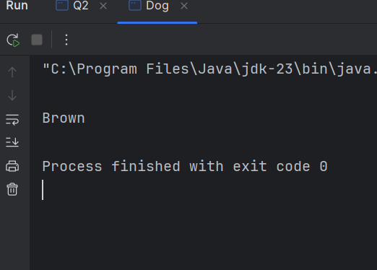

**Q_02 :**

**Pet_2.java**

package Q_02;  
  
abstract public class Pet_2 {  
 protected String name;  
  
 public Pet_2 (String name){  
 this.name = name;  
 }  
 public String getName(){  
 return name;  
 }  
 public String getType(){  
 return "Pet";  
 }  
}

**Dog_2.java**

package Q_02;  
  
public class Dog_2 extends Pet_2{  
 public Dog_2 (String name){  
 super(name);  
 }  
 public String getType(){  
 return "Dog";  
 }  
}

**Cat_2.java**

package Q_02;  
  
public class Cat_2 extends Pet_2{  
 public Cat_2(String name){  
 super(name);  
 }  
 public String getType(){  
 return "Cat";  
 }  
}

**Main.java**

package Q_02;  
  
import java.util.ArrayList;  
import java.util.Scanner;  
  
public class Main {  
 public static void main(String[] args){  
 Scanner scanner = new Scanner(System.*in*);  
 ArrayList<Pet_2> petlist = new ArrayList<>();  
 int count = 0;  
  
  
 while(true) {  
 System.*out*.print("Enter your pet name (Enter 'STOP' to terminate) : ");  
 String name = scanner.nextLine();  
  
 if(name.equalsIgnoreCase("STOP")){  
 break;  
 }  
 System.*out*.print("Enter pet type (c for cat, d for dog) : ");  
 char type = scanner.nextLine().charAt(0);  
  
 while(type != 'c' && type != 'd'){  
 System.*out*.println("Invalid input, Reenter c for cat, d for dog : ");  
 type = scanner.nextLine().charAt(0);  
 }  
 if(type == 'd'){  
 petlist.add(new Dog_2((name)));  
 }  
 else{  
 petlist.add(new Cat_2((name)));  
 }  
 count++;  
 }  
 System.*out*.println("__Pet List__");  
 for(Pet_2 pet : petlist) {  
 System.*out*.println(" Name : " + pet.getName() + " Type : " + pet.getType());  
 }  
 scanner.close();  
 }  
}

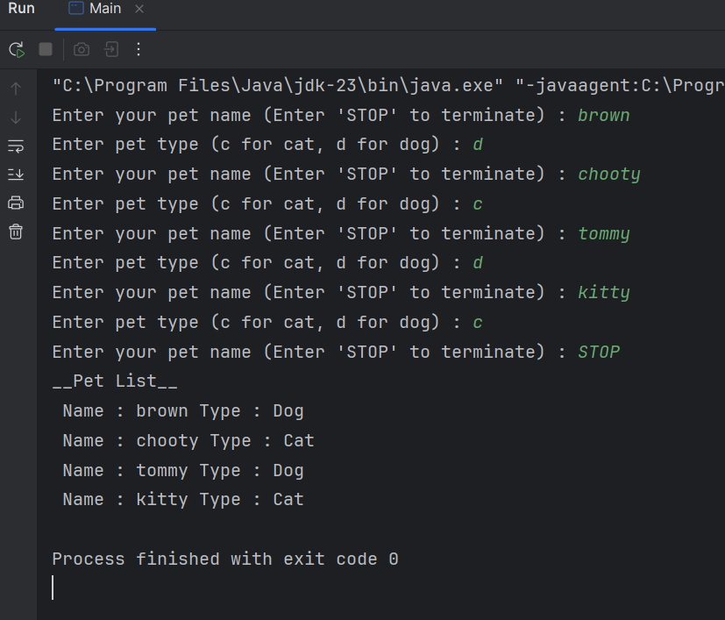

**Output:**

**Q_03 :**

**Pet_3.java**

package Q_03;  
  
abstract public class Pet_3 {  
 protected String name;  
  
 public Pet_3 (String name){  
 this.name = name;  
 }  
 public String getName(){  
 return name;  
 }  
 public String getType(){  
 return "Pet";  
 }  
}

**Dog_3.java**

package Q_03;  
  
public class Dog_3 extends Pet_3{  
 public Dog_3 (String name){  
 super(name);  
 }  
 public String getType(){  
 return "Dog";  
 }  
}

**Cat_3.java**

package Q_03;  
  
public class Cat_3 extends Pet_3{  
 public Cat_3(String name){  
 super(name);  
 }  
 public String getType(){  
 return "Cat";  
 }  
}

**Main.java**

package Q_03;  
  
import java.util.ArrayList;  
import java.util.Scanner;  
  
public class Main {  
 public static void main(String[] args){  
 Scanner scanner = new Scanner(System.*in*);  
 ArrayList<Pet_3> petlist = new ArrayList<>();  
 int count = 0;  
  
  
 while(true) {  
 System.*out*.print("Enter your pet name (Enter 'STOP' to terminate) : ");  
 String name = scanner.nextLine();  
  
 if(name.equalsIgnoreCase("STOP")){  
 break;  
 }  
 System.*out*.print("Enter pet type (c for cat, d for dog) : ");  
 char type = scanner.nextLine().charAt(0);

while(type != 'c' && type != 'd'){  
 System.*out*.println("Invalid input, Reenter c for cat, d for dog : ");  
 type = scanner.nextLine().charAt(0);  
 }  
 if(type == 'd'){  
 petlist.add(new Dog_3((name)));  
 }  
 else{  
 petlist.add(new Cat_3((name)));  
 }  
 count++;  
 }  
 System.*out*.println("\nCats : ");  
 for(Pet_3 pet : petlist) {  
 if(pet instanceof Cat_3 ){  
 System.*out*.println(pet.getName());  
 }  
 }  
 System.*out*.println("\n\nDogs : ");  
 for (Pet_3 pet : petlist){  
 if(pet instanceof Dog_3) {  
 System.*out*.println(pet.getName());  
 }  
 }  
 scanner.close();  
 }  
}

**Output :**

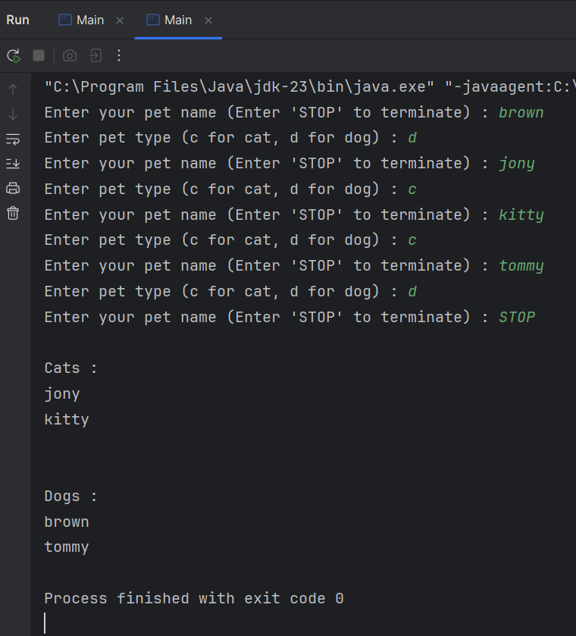

**Q_04 :**

**Pet.java**

package Q_04;  
  
public class Pet {  
 private String name ;  
  
 public Pet(String name) {  
 this.name = name;  
 }  
 public String getName(){  
 return name;  
 }  
 public String getType(){  
 return "Pet";  
 }  
}

package Q_04;  
  
public class Dog extends Pet {  
 private double weight;  
  
 public Dog(String name,double weight){  
 super(name);  
 this.weight = weight ;  
 }  
 public String getType(){  
 return "Dog";  
 }  
 public double getWeight() {  
 return weight;  
 }  
 public void setWeight(double weight) {  
 this.weight = weight;  
 }  
}

**Dog.java**

**Cat.java**

package Q_04;  
  
public class Cat extends Pet{  
 private String coatColor;  
  
 public Cat(String name, String coatColor){  
 super(name);  
 this.coatColor = coatColor;  
 }  
 public String getType(){  
 return "Cat";  
 }  
 public String getCoatColor(){  
 return coatColor;  
 }  
 public void setCoatColor(String coatColor){  
 this.coatColor = coatColor;  
 }  
}

**Main.java**

package Q_04;  
  
import java.util.ArrayList;  
import java.util.Scanner;  
  
public class Main {  
 public static void main(String[] args) {  
 Scanner scanner = new Scanner(System.*in*);  
 ArrayList<Pet> petlist = new ArrayList<>();  
  
 while(true) {  
 System.*out*.print("Enter pet name (If you want to terminate this enter 'STOP') : ");  
 String name = scanner.nextLine();  
  
 if(name.equalsIgnoreCase("STOP")){  
 break;  
 }  
 System.*out*.print("Enter pet type(c for Cat, d for Dog ) : ");  
 char type = scanner.nextLine().charAt(0);  
  
 while(type != 'c' && type != 'd') {  
 System.*out*.print("Invalid input,Reenter c for cat, d for dog : ");  
 type = scanner.nextLine().charAt(0);  
 }  
  
 if(type == 'd'){  
 System.*out*.print("Enter dog's weight (kg) : ");  
 double weight = scanner.nextDouble();  
 scanner.nextLine();  
 petlist.add(new Dog(name,weight));  
 }

else {  
 System.*out*.print("Enter cat's coat color : ");  
 String coatColor = scanner.nextLine();  
 petlist.add(new Cat(name ,coatColor));  
 }  
  
 }  
 System.*out*.println("Cats : ");  
 for(Pet pet : petlist){  
 if(pet instanceof Cat){  
 Cat cat = (Cat)pet;  
 System.*out*.println("Name : " + cat.getName() + " | Coat Color : " + cat.getCoatColor());  
 }  
  
 }  
 System.*out*.println("\nDogs : ");  
 for(Pet pet : petlist){  
 if(pet instanceof Dog) {  
 Dog dog = (Dog) pet;  
 System.*out*.println("Name : " + dog.getName() + " | Weight : " + dog.getWeight());  
 }  
 }  
 scanner.close();  
  
  
 }  
}

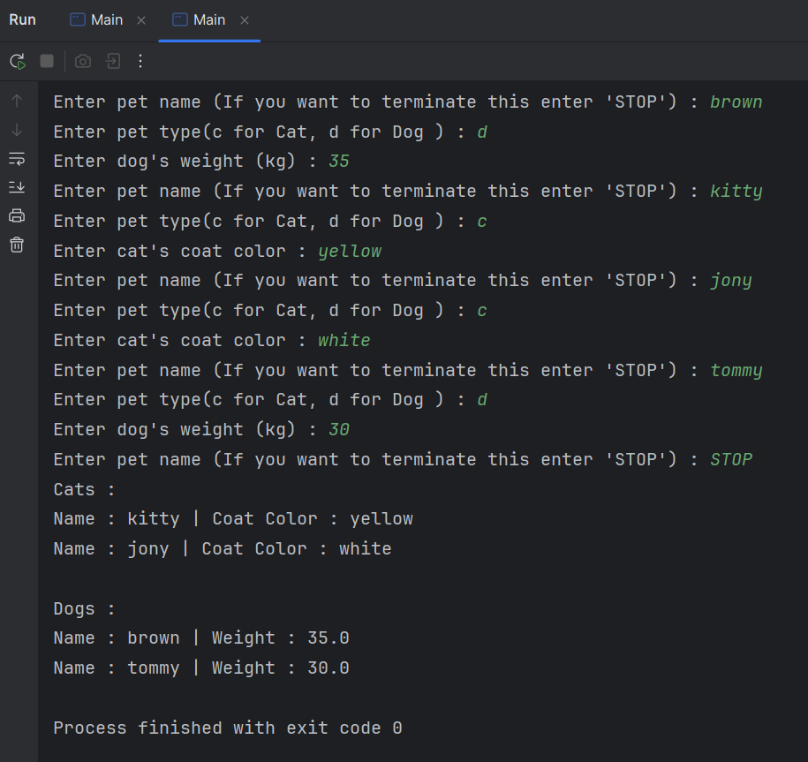**Output :**

**Q_05 :**

**Pet.java**

package Q_04;  
  
public class Pet {  
 private String name ;  
  
 public Pet(String name) {  
 this.name = name;  
 }  
 public String getName(){  
 return name;  
 }  
 public String getType(){  
 return "Pet";  
 }  
}

package Q_04;  
  
public class Dog extends Pet {  
 private double weight;  
  
 public Dog(String name,double weight){  
 super(name);  
 this.weight = weight ;  
 }  
 public String getType(){  
 return "Dog";  
 }  
 public double getWeight() {  
 return weight;  
 }  
 public void setWeight(double weight) {  
 this.weight = weight;  
 }  
}

**Dog.java**

**Cat.java**

package Q_04;  
  
public class Cat extends Pet{  
 private String coatColor;  
  
 public Cat(String name, String coatColor){  
 super(name);  
 this.coatColor = coatColor;  
 }  
 public String getType(){  
 return "Cat";  
 }  
 public String getCoatColor(){  
 return coatColor;  
 }  
 public void setCoatColor(String coatColor){  
 this.coatColor = coatColor;  
 }  
}

**Main.java**

package Q_05;  
  
import java.util.ArrayList;  
import java.util.Scanner;  
  
public class Main {  
 public static void main(String[] args) {  
 Scanner scanner = new Scanner(System.*in*);  
 ArrayList<Pet> petlist = new ArrayList<>();  
  
 while (true) {  
 System.*out*.print("Enter pet name (if you want to terminate this enter 'STOP') : ");  
 String name = scanner.nextLine();  
  
 if(name.equalsIgnoreCase("STOP")){  
 break;  
 }  
 System.*out*.print("Enter pet type (c for Cat, d for Dog) : ");  
 char type = scanner.nextLine().charAt(0);  
  
 while (type != 'c' && type != 'd') {  
 System.*out*.print("Invalid type, Reenter pet type (c for Dog,d for Dog) : " );  
 type = scanner.nextLine().charAt(0);  
 }  
 if(type == 'd') {  
 System.*out*.print("Enter dog's weight (kg) : ");  
 double weight = scanner.nextDouble();  
 scanner.nextLine();  
 petlist.add(new Dog(name, weight));  
 }

else {  
 System.*out*.print("Enter cat's coat color : ");  
 String color = scanner.nextLine();  
 petlist.add(new Cat(name, color));  
 }  
  
 }  
 ArrayList<Dog> doglist = new ArrayList<>();  
 for (Pet pet : petlist){  
 if(pet instanceof Dog) {  
 doglist.add((Dog) pet);  
 }  
 }  
 if(!doglist.isEmpty()) {  
 double totalWeight = 0;  
 double minWeight = Double.*MAX_VALUE*;  
 double maxWeight = Double.*MIN_VALUE*;  
  
 System.*out*.println("\n__________________\n");  
 System.*out*.println("Cats : ");  
 for (Pet pet : petlist) {  
 if (pet instanceof Cat) {  
 Cat cat = (Cat) pet;  
 System.*out*.println("Name : " + cat.getName() + " | Coat Color : " + cat.getCoatColor());  
 }  
 }  
 System.*out*.println("\n__________________\n");  
 System.*out*.println("Dog weight status : ");  
  
 for (Dog dog : doglist) {  
 double weight = dog.getWeight();  
 totalWeight = totalWeight + weight;  
 minWeight = Math.*min*(minWeight, weight);  
 maxWeight = Math.*max*(maxWeight, weight);  
  
 System.*out*.println("Name : " + dog.getName() + " | weight : " + weight);  
 }

double avgWeight = totalWeight / doglist.size();  
  
 System.*out*.println("________________________");  
  
 System.*out*.println("Average weight : " + avgWeight);  
 System.*out*.println("Minimum weight : " + minWeight);  
 System.*out*.println("Maximum weight : " + maxWeight);  
 System.*out*.println("Total dogs analyze : " + doglist.size());  
  
 }  
 else {  
 System.*out*.println("No dogs");  
 }  
 scanner.close();  
 }  
}

**Output :**

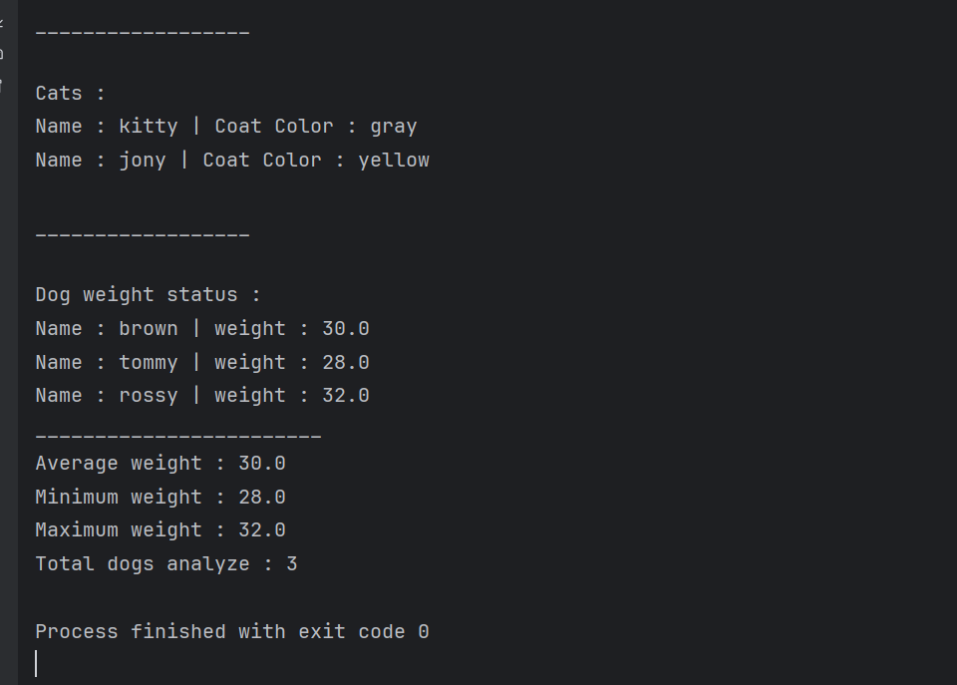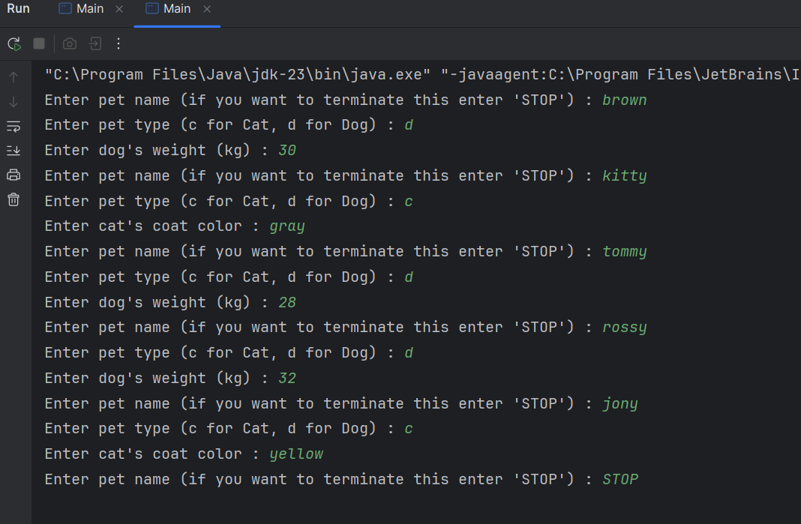

**Q_06 :**

**Pet.java**

package Q_06;  
  
public class Pet {  
 protected String name;  
  
 public Pet(String name) {  
 this.name = name;  
 }  
  
 public String getName() {  
 return name;  
 }  
}

**Dog.java**

package Q_06;  
  
public class Dog extends Pet {  
 private double weight;  
  
 public Dog(String name, double weight) {  
 super(name);  
 this.weight = weight;  
 }  
  
 public double getWeight() {  
 return weight;  
 }  
  
 public String toString() {  
 return String.*format*("Name :" + name + " | Weight : " + weight);  
 }  
}

**Cat.java**

package Q_06;  
  
  
public class Cat extends Pet {  
 private String coatColor;  
  
 public Cat(String name, String coatColor) {  
 super(name);  
 this.coatColor = coatColor;  
 }  
  
 public String getCoatColor() {  
 return coatColor;  
 }  
  
 public String toString() {  
 return String.*format*("Name : " + name + " | Coat color : " + coatColor);  
 }  
}

**Main.java**

package Q_06;  
  
import java.util.ArrayList;  
import java.util.Scanner;  
  
public class Main {  
 public static void main(String[] args) {  
 Scanner scanner = new Scanner(System.*in*);  
  
 ArrayList<Pet> pettlist = new ArrayList<>();  
 ArrayList<Dog> doglist = new ArrayList<>();  
 ArrayList<Cat> catlist = new ArrayList<>();  
  
 int choice;  
 do {  
 System.*out*.println("___Pet Management System___");  
 System.*out*.println("1. Add Cat");  
 System.*out*.println("2. Add Dog");  
 System.*out*.println("3. Remove Cat");  
 System.*out*.println("4. Remove Dog");  
 System.*out*.println("0. Quit");  
 System.*out*.print("Enter your choice: ");  
  
 while (!scanner.hasNextInt()) {  
 System.*out*.println("Please enter a number.");  
 scanner.next();  
 System.*out*.print("Enter your choice: ");  
 }  
 choice = scanner.nextInt();  
 scanner.nextLine();

switch (choice) {  
 case 1:  
 System.*out*.print("Enter cat name: ");  
 String catName = scanner.nextLine();  
 System.*out*.print("Enter cat's coat color: ");  
 String color = scanner.nextLine();  
 Cat newCat = new Cat(catName, color);  
 pettlist.add(newCat);  
 catlist.add(newCat);  
 System.*out*.println("Cat added successfully.");  
 break;  
  
 case 2:  
 System.*out*.print("Enter dog name: ");  
 String dogName = scanner.nextLine();  
 System.*out*.print("Enter dog's weight (kg): ");  
 double weight = scanner.nextDouble();  
 scanner.nextLine();  
 Dog newDog = new Dog(dogName, weight);  
 pettlist.add(newDog);  
 doglist.add(newDog);  
 System.*out*.println("Dog added successfully.");  
 break;  
  
 case 3:  
 System.*out*.print("Enter cat name to remove: ");  
 String catToRemove = scanner.nextLine();  
 boolean catRemoved = false;  
 for (int i = 0; i < catlist.size(); i++) {  
 if (catlist.get(i).getName().equalsIgnoreCase(catToRemove)) {  
 pettlist.remove(catlist.get(i));  
 catlist.remove(i);  
 catRemoved = true;  
 System.*out*.println("Cat removed successfully.");  
 break;  
 }  
 }

if (!catRemoved) {  
 System.*out*.println("Cat not found.");  
 }  
 break;  
  
 case 4:  
 System.*out*.print("Enter dog name to remove: ");  
 String dogToRemove = scanner.nextLine();  
 boolean dogRemoved = false;  
 for (int i = 0; i < doglist.size(); i++) {  
 if (doglist.get(i).getName().equalsIgnoreCase(dogToRemove)) {  
 pettlist.remove(doglist.get(i));  
 doglist.remove(i);  
 dogRemoved = true;  
 System.*out*.println("Dog removed successfully.");  
 break;  
 }  
 }  
 if (!dogRemoved) {  
 System.*out*.println("Dog not found.");  
 }  
 break;  
  
 case 0:  
 System.*out*.println("Exiting program...");  
 break;  
  
 default:  
 System.*out*.println("Invalid choice. Please try again.");  
 }  
 }

while (choice != 0);  
  
  
 System.*out*.println("Current Pets:");  
 System.*out*.println("Cats:");  
 for (Cat cat : catlist) {  
 System.*out*.println(cat);  
 }  
 System.*out*.println("\nDogs:");  
 for (Dog dog : doglist) {  
 System.*out*.println(dog);  
 }  
  
  
 scanner.close();  
 }  
 }

O

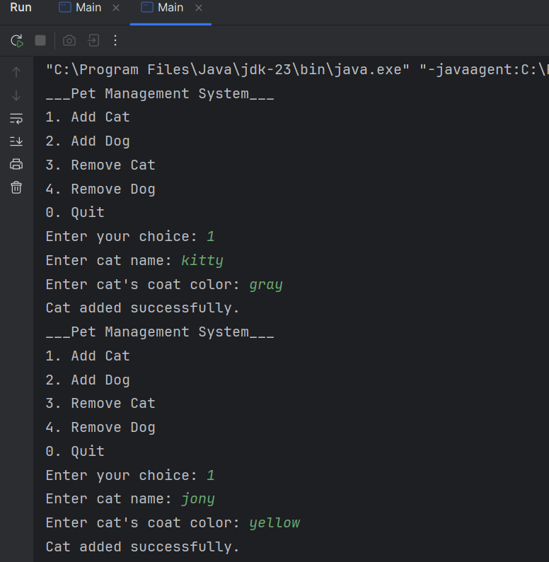**Output :**

