Q1.
package Q_01;
import javax.swing.*;
public class Q1 {
public static void main(String[] args) {
JFrame frame = new JFrame();
frame.setSize(800,600);
frame.setTitle("Welcome to Java");
frame.setVisible(true);
}
}

output :
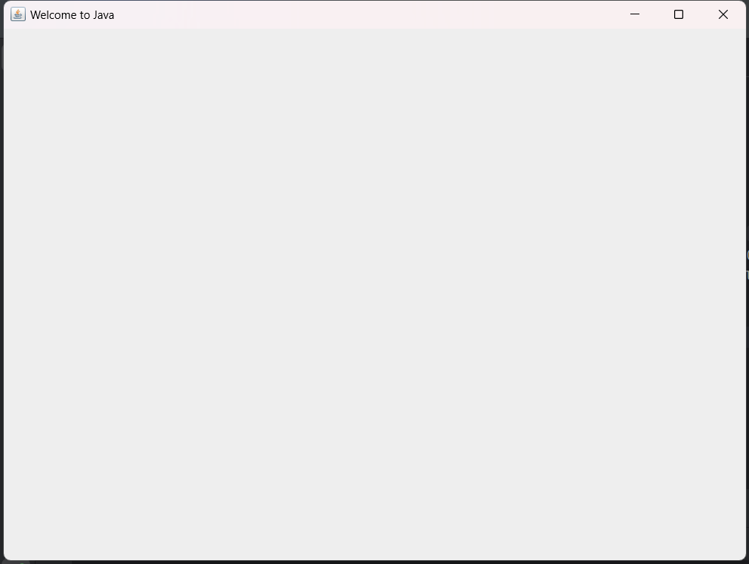

Q2.
package Q_02;
import javax.swing.*;
import java.util.Scanner;
public class Q2 {
public static void main(String[] args) {
Scanner input = new Scanner(System.in);
System.out.println("Enter your first name :");
String firstName = input.next();
System.out.println("Enter your last name : ");
String lastName = input.next();
input.close();
JFrame welcomeframe;
JFrame frame = new JFrame();
frame.setSize(250,150);
frame.setTitle(firstName + " " + lastName);
frame.setVisible(true);
}
}

Output:
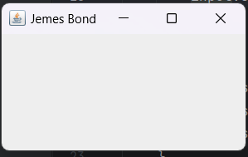

Q3.
package Q_03;
import java.util.Scanner;
public class Q3 {
public static void main(String[] args) {
Scanner input = new Scanner(System.in);
System.out.println("Enter first name :");
String firstName = input.next();
System.out.println("Enter middle name :");
String middleName = input.next();
System.out.println("Enter last name :");
String lastName = input.next();
String initial = middleName.substring(0,1);
System.out.println(firstName + " " + initial + "." + lastName);
}
}

Output:
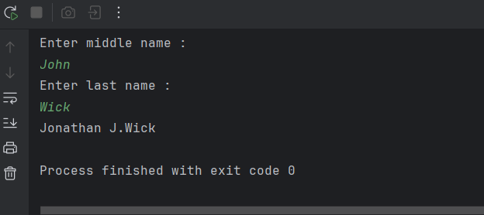

Q4.
package Q_04;
import java.text.SimpleDateFormat;
import java.util.Date;
public class Q4 {
public static void main(String[] args) {
Date today = new Date();
System.out.println(today);
SimpleDateFormat sdf = new SimpleDateFormat("dd MMM yyyy");
System.out.println(sdf.format(today));
}
}

Output:
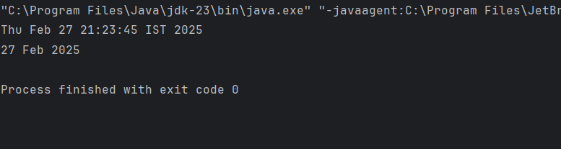

Q5.
package Q_05;
import java.text.SimpleDateFormat;
import java.util.Date;
public class Q5 {
public static void main(String[] args) {
Date today = new Date();
SimpleDateFormat dateFormat = new SimpleDateFormat("EEEE,MMMM d,yyyy");
String formattedDate = dateFormat.format(today);
System.out.println(formattedDate);
}
}

Output:
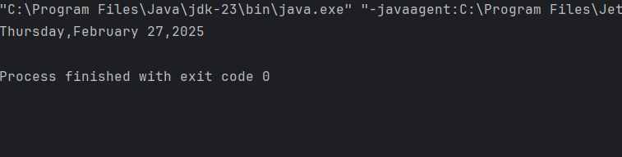

Q6.
package Q_06;
import javax.swing.*;
import java.util.Scanner;
public class Q6 {
public static void main(String[] args) {
JFrame frame = new JFrame();
Scanner Scanner = new Scanner(System.in);
System.out.println("Enter the frame width :");
int width = Scanner.nextInt();
System.out.println("Enter the frame height");
int height = Scanner.nextInt();
frame.setSize(width,height);
frame.setVisible(true);
}
}

Output:
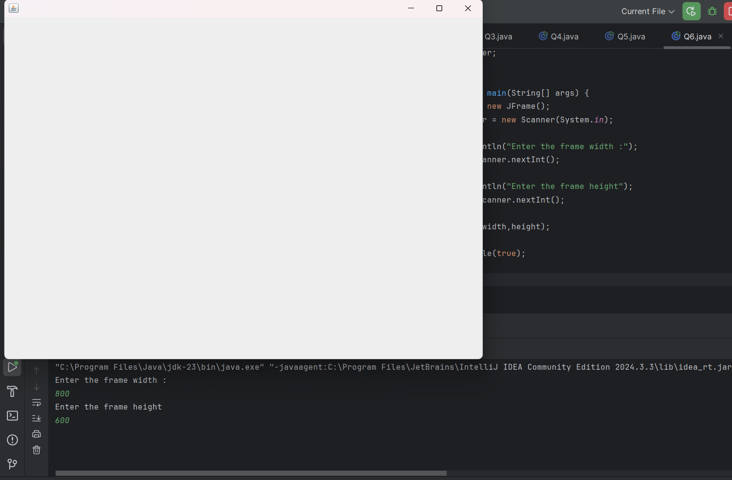

Q7.
package Q_07;
import javax.swing.*;
import java.text.SimpleDateFormat;
import java.util.Date;
public class Q7 {
public static void main(String[] args) {
JFrame frame = new JFrame();
Date date = new Date();
SimpleDateFormat sdf = new SimpleDateFormat("HH:mm:ss a");
String title = sdf.format(date);
frame.setSize(600,800);
frame.setTitle(title);
frame.setVisible(true);
}
}

Output:
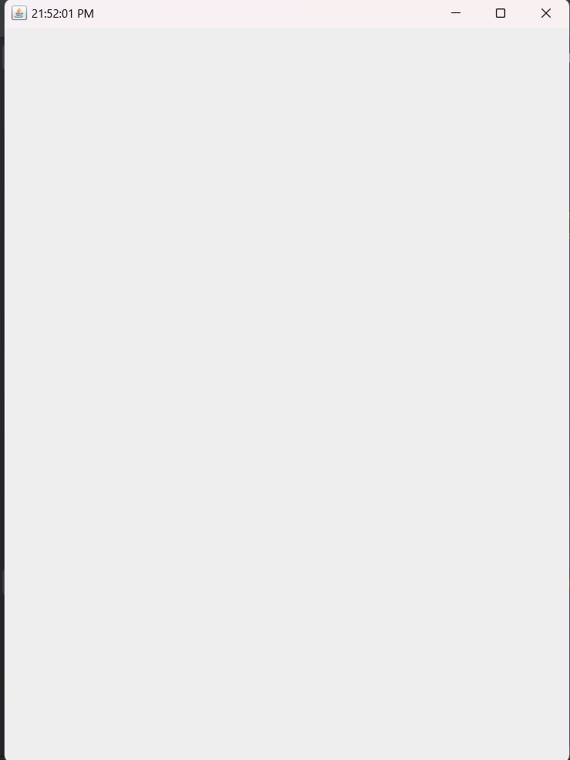
Q8.
package Q_08;
import java.util.Scanner;
public class Q8 {
public static void main(String[] args) {
Scanner scanner = new Scanner(System.in);
System.out.println("Enter a string including a single exclamation mark :");
String input = scanner.nextLine();
int exclamationIndex = input.indexOf('!');
String beforeExclamation = input.substring(0,exclamationIndex);
String afterExclamation = input.substring(exclamationIndex + 1);
System.out.println("Before exclamation mark : " + beforeExclamation);
System.out.println("After exclamation mark :" + afterExclamation);
}
}

Output:
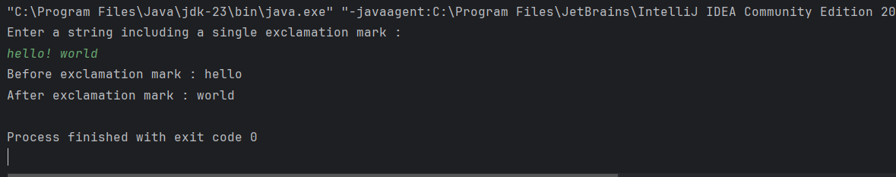

Q9.
package Q_09;
import java.util.Scanner;
public class Q9 {
public static void main(String[] args) {
Scanner scanner = new Scanner(System.in);
System.out.println("Enter a string :");
String input = scanner.nextLine();
int length = input.length();
char firstChar = input.charAt(0);
char lastChar = input.charAt(length - 1);
System.out.println("Number of characters : " + length);
System.out.println("First character :" + firstChar);
System.out.println("Last character :" + lastChar);
scanner.close();
}
}

Output:
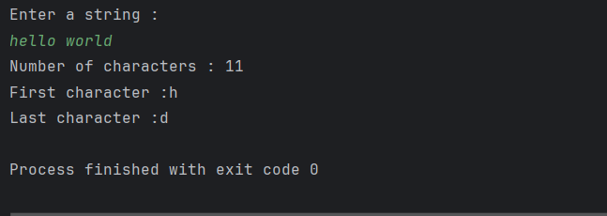

Q10.
package Q_10;
import java.util.Scanner;
public class Q10 {
public static void main(String[] args) {
Scanner scanner = new Scanner(System.in);
System.out.println("Enter an odd length word :");
String word = scanner.nextLine();
int length = word.length();
if (length % 2 == 1) {
int middleIndex = length / 2;
char middleChar = word.charAt(middleIndex);
System.out.println("The middle character is : " + middleChar);
}
else {
System.out.println("The word must have an odd length");
}
}
}

Output:
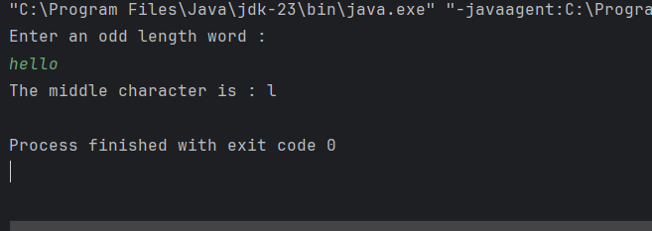

Q11.
package Q_11;
import java.util.Scanner;
public class Q11 {
public static void main(String[] args) {
Scanner Scanner = new Scanner(System.in);
System.out.println("Enter your full name(first middle last) :");
String fullName = Scanner.nextLine();
String[] nameParts = fullName.split(" ");
if (nameParts.length == 3) {
String firstName = nameParts[0];
String middleName = nameParts[1];
String lastName = nameParts[2];
char middleInitial = middleName.charAt(0);
String formattedName = lastName + " , " + firstName + " " + middleInitial + " . ";
System.out.println("Formatted name : " + formattedName);
}
else {
System.out.println("Invalid input");
}
}
}

Output:
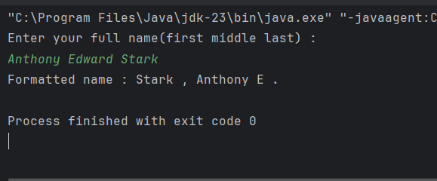

Q12.
package Q_12;
import javax.swing.*;
public class Q12 {
public static void main(String[] args) {
JFrame frame = new JFrame();
frame.setTitle("My First Frame");
frame.setSize(300,200);
frame.setLocation(100,50);
frame.setDefaultCloseOperation(JFrame.EXIT_ON_CLOSE);
frame.setVisible(true);
}
}

Output:
