
Object oriented programming
Lab Work Sheet -2


CT/2021/025

Q_01:
package Q_01;
import java.util.Scanner;
public class Q1 {
public static void main(String[] args) {
//part a:
System.out.println("PART a ");
Scanner scanner = new Scanner(System.in);
System.out.println("Enter value of A:");
double A = scanner.nextDouble();
System.out.println("Enter Value of C(C and A should not be equal) :");
double C = scanner.nextDouble();
System.out.println("Enter value of B :");
double B = scanner.nextDouble();
double root = Math.sqrt((Math.pow(B,2)) + 4 * A * C);
System.out.println("Answer is "+ root);
// Part b:
System.out.println("PART b ");
System.out.println("Enter value of X :");
double X = scanner.nextDouble();
System.out.println("Enter value of Y :");
double Y = scanner.nextDouble();
double root2 = Math.sqrt(X + (4 * Math.pow(Y,3)));
System.out.println("Answer is "+ root2);
// Part c:
System.out.println("PART c ");
System.out.println("Enter value of X :");
double x = scanner.nextDouble();
System.out.println("Enter value of Y :");
double y = scanner.nextDouble();
double root3 = Math.cbrt(x * y);
System.out.println("Answer is " + root3);
//Part d:
System.out.println("PART d ");
final double PI = 3.14;
double area; double radius ;
System.out.println("Enter radius of the circle :");
radius = scanner.nextDouble();
area = PI * Math.pow(radius , 2);
System.out.println("Area of the circle is " + area);
}
}

Output :
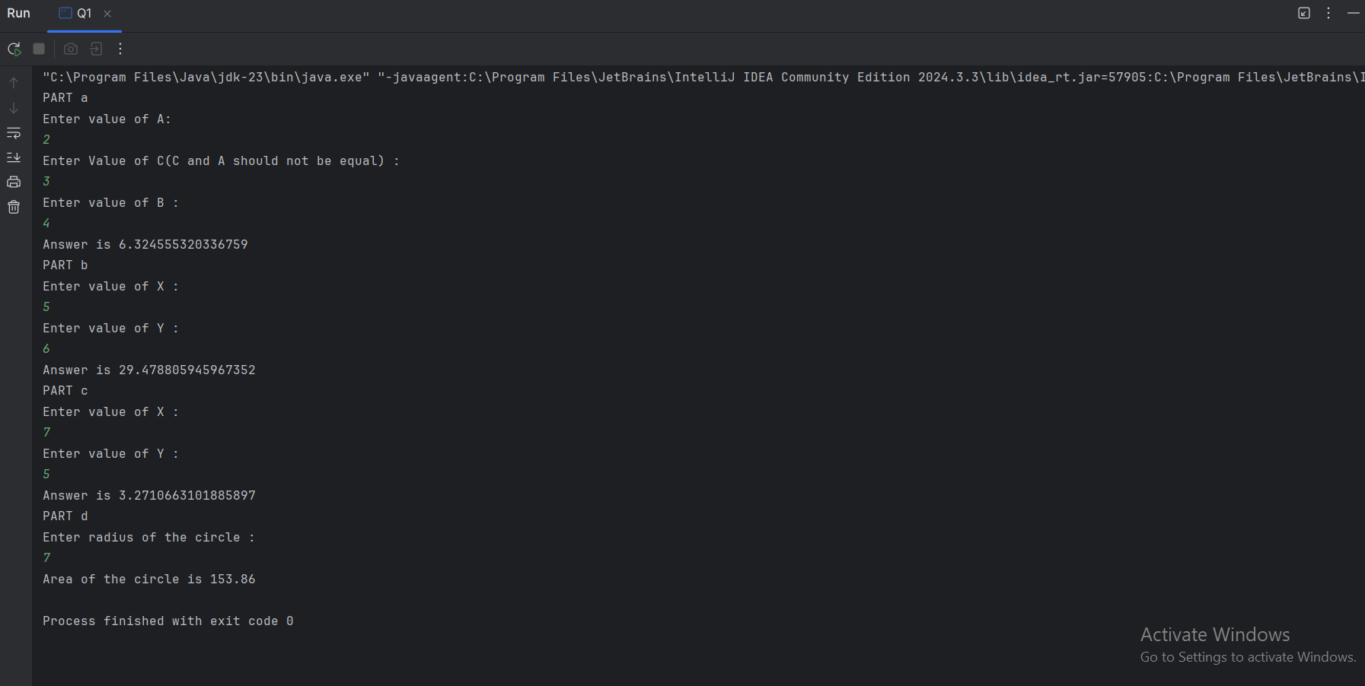

Q_02:
package Q_02;
import java.util.Scanner;
public class Q2 {
public static void main(String[] args) {
System.out.println("Enter value in centimeter :");
Scanner scanner = new Scanner(System.in);
double Cm = scanner.nextDouble();
double inch = Cm * (1/2.54);
System.out.println("Inches : " + inch);
double feet = Cm * (0.032);
System.out.println("Feets : " + feet);
}
}

Output:
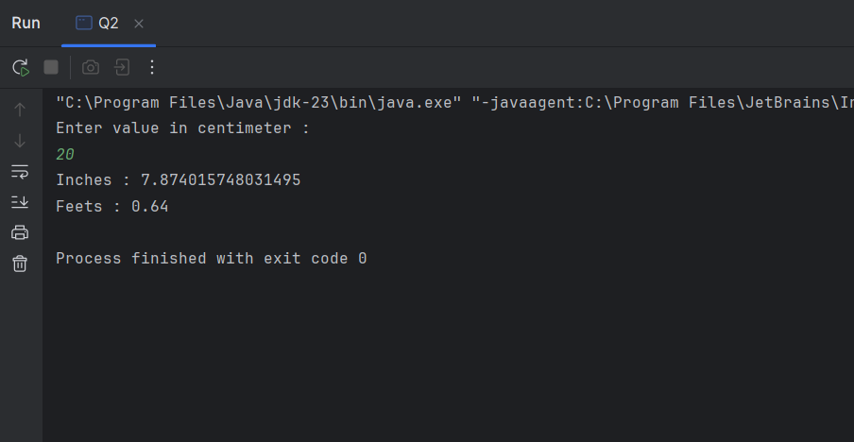

Q_03:
package Q_03;
import java.util.Scanner;
public class Q3 {
public static void main(String[] args) {
System.out.println("Enter temperature in degree celsius :");
Scanner scanner = new Scanner(System.in);
double cel = scanner.nextDouble();
double tem = (1.8 * cel) + 32;
System.out.println("Temperature in Fahrenheit : " +tem );
}
}

Output:
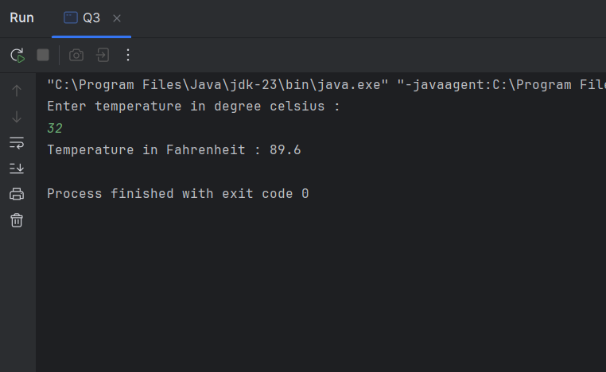

Q_04:
package Q_04;
import java.util.Scanner;
public class Q4 {
public static void main(String[] args) {
System.out.println("Enter your body weight :");
Scanner scanner = new Scanner(System.in);
double weight = scanner.nextDouble();
double calories = weight * 19;
System.out.println("Number of calories :" + calories);
}
}

Output:
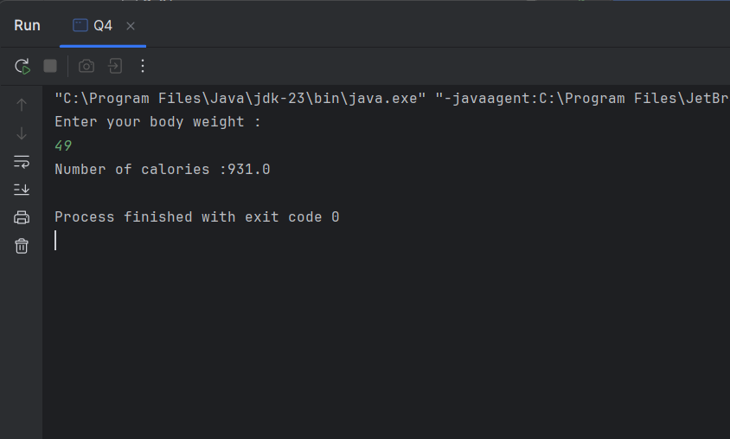

Q_05:
package Q_05;
import java.util.Scanner;
public class Q5 {
public static void main(String[] args) {
System.out.println("Enter temperature in Fahrenheit :");
Scanner scanner = new Scanner(System.in);
double fahrenheit = scanner.nextDouble();
double tem = (5.0/9.0) * (fahrenheit - 32);
System.out.println("Temperature in celsius : " + tem);
}
}

Output:
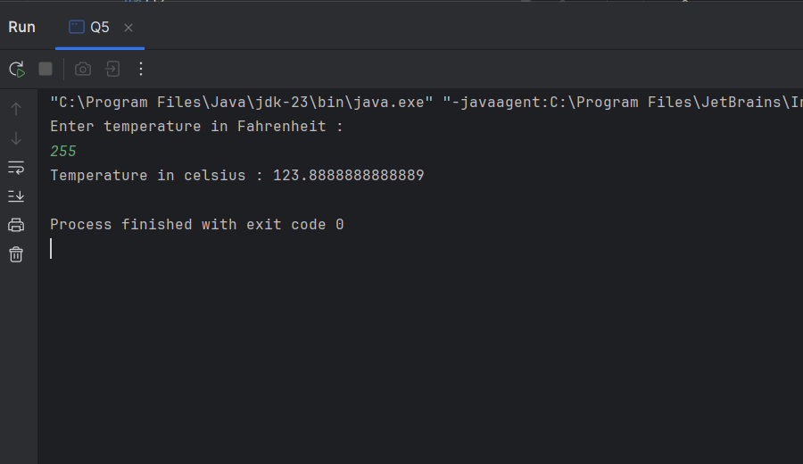

Q_06:
package Q_06;
import java.util.Scanner;
public class Q6 {
public static void main(String[] args) {
System.out.println("Enter your born year :");
Scanner scanner = new Scanner(System.in);
int year = scanner.nextInt();
int currentYear = java.time.Year.now().getValue();
int age = currentYear - year ;
System.out.println("You were born in " + year +" and will be(are) " + age + " this year.");
}
}

Output:
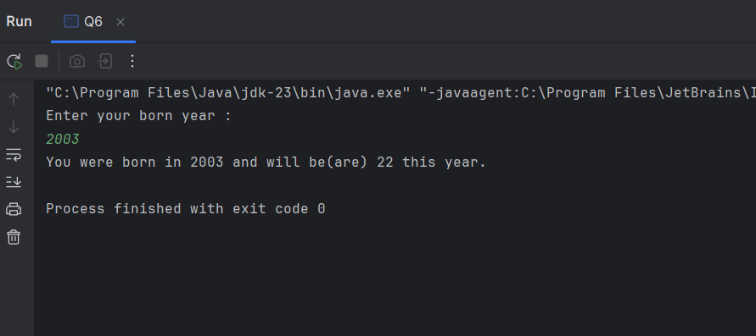

Q_07:
package Q_07;
import java.util.Scanner;
public class Q7 {
public static void main(String[] args) {
Scanner scanner = new Scanner(System.in);
System.out.println("Enter your body weight in Kg :");
double weight = scanner.nextDouble();
System.out.println("Enter your height in Cm :");
double height = scanner.nextDouble();
double BMI = weight / Math.pow((height/100.0),2);
System.out.println("Your BMI value : " + BMI);
if (BMI >20 && BMI <25) {
System.out.println("Your BMI value is normal");
}
else {
System.out.println("Take care of your body health");
}

Output:
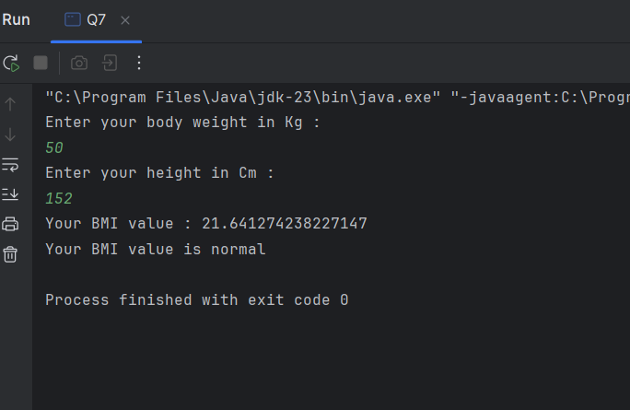

Q_08:
package Q_08;
import java.util.Scanner;
public class Q8 {
public static void main(String[] args) {
final double PI = 3.14;
System.out.println("Enter radius of the sphere in meter :");
Scanner scanner = new Scanner(System.in);
double radius = scanner.nextDouble();
double volume = (4.0/3.0) * (PI *(Math.pow(radius,2)));
System.out.println("Volume of the sphere : " + volume );
}
}

Output:
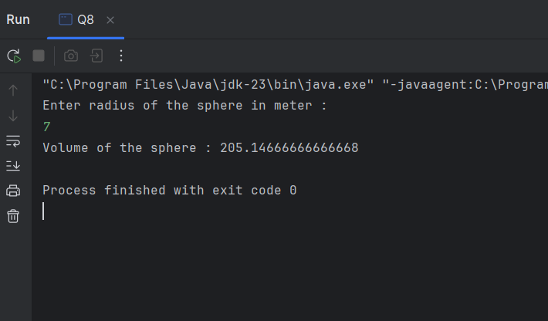

Q_09:
package Q_09;
import java.util.Scanner;
public class Q9 {
public static void main(String[] args) {
Scanner scanner = new Scanner(System.in);
System.out.println("Enter the invest money in dollar : ");
double P = scanner.nextDouble();
System.out.println("Enter the interest rate : ");
double R = scanner.nextDouble();
System.out.println("Enter number of years : ");
double N = scanner.nextDouble();
double investment = P * (Math.pow((1 + (R/100)),N));
System.out.println("Amount of money after "+N+ " years : "+ investment);
}
}

Output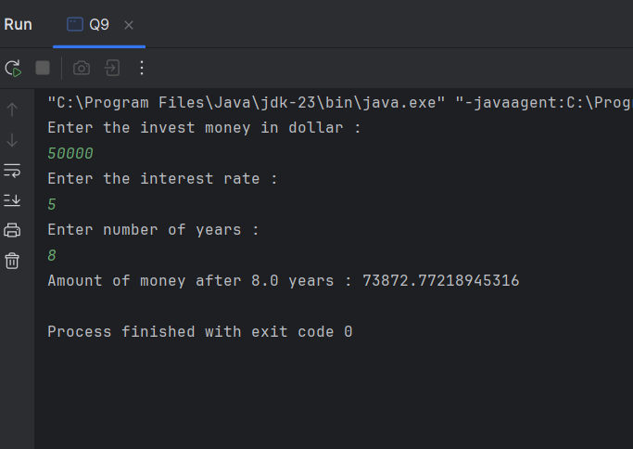
Q_10:
package Q_10;
import java.util.Scanner;
public class Q10 {
public static void main(String[] args) {
Scanner scanner = new Scanner(System.in);
System.out.println("Enter loan amount : ");
double amount = scanner.nextDouble();
System.out.println("Enter annual interest rate : ");
double AnnualRate = scanner.nextDouble();
System.out.println("Enter loan period in months: ");
double period = scanner.nextDouble();
double monthlyInterestRate = (AnnualRate / 100.0 /12);
double numberOfPayments = period * 12;
double monthlyPayment = (amount * monthlyInterestRate)/ (1- Math.pow((1/(1 + monthlyInterestRate)),numberOfPayments));
double totalPayment = monthlyPayment * numberOfPayments;
System.out.println("Monthly Payment : " + monthlyPayment);
System.out.println("Total payment : " + totalPayment);
}
}

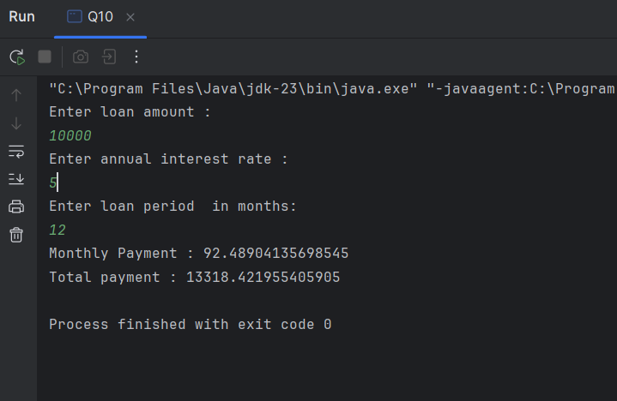
Output :

