LungPosture

Table of contents

# 1. Lung Posture Project

## 1.1 Load Packages

library(renv)

Warning: pakke 'renv' blev bygget under R version 4.3.3

Vedhæfter pakke: 'renv'

De følgende objekter er maskerede fra 'package:stats':  
  
 embed, update

De følgende objekter er maskerede fra 'package:utils':  
  
 history, upgrade

De følgende objekter er maskerede fra 'package:base':  
  
 autoload, load, remove

#install.packages("here")  
library(here)

Warning: pakke 'here' blev bygget under R version 4.3.3

here() starts at C:/Users/mada0011/Desktop/Offline Statistics/Lung_posture

#install.packages("LMMstar")  
library(LMMstar)

Warning: pakke 'LMMstar' blev bygget under R version 4.3.3

LMMstar version 1.1.0

Vedhæfter pakke: 'LMMstar'

Det følgende objekt er maskeret fra 'package:renv':  
  
 remove

Det følgende objekt er maskeret fra 'package:base':  
  
 remove

library(readxl)

Warning: pakke 'readxl' blev bygget under R version 4.3.3

#install.packages("cellranger")  
library(cellranger)  
#install.packages(c("tidyr","dplyr"))  
library(tidyr)

Warning: pakke 'tidyr' blev bygget under R version 4.3.2

library(dplyr)

Warning: pakke 'dplyr' blev bygget under R version 4.3.2

Vedhæfter pakke: 'dplyr'

Det følgende objekt er maskeret fra 'package:LMMstar':  
  
 summarize

De følgende objekter er maskerede fra 'package:stats':  
  
 filter, lag

De følgende objekter er maskerede fra 'package:base':  
  
 intersect, setdiff, setequal, union

#install.packages("ggplot2")  
library(ggplot2)

Warning: pakke 'ggplot2' blev bygget under R version 4.3.3

#install.packages("quarto")  
library(quarto)

## 1.2 Load Data

lung_data<-read_excel(  
 path = here("Data","Data_V2.xlsx")  
)

From Rie (translated by me):

This is Lung_posture data. Some tests have missing data - simply because we couldn’t measure in the given position (assumed missing art random). Positions are noted as ‘’forloeb’’:

1 = Standing.

2 = Supine.

3 = Prone.

4 = Handstand.

#Lets implement this so we dont have that as a numeric to mess up our data.  
lung_data<-  
 lung_data %>%  
 mutate(  
 posture = factor(  
 x = Forloeb,  
 levels = 1:4,  
 labels = c("Standing",  
 "Supine",  
 "Prone",  
 "Handstand")  
 ),  
 order = rep(1:4, length(lung_data$Forloeb)/4) #Contacted Rie the order is the order they appear in the excel file.  
 )  
  
test_data <-  
 data.frame(  
 x = 1:10,  
 y = 11:20,  
 color = letters[1:10]  
 )  
  
test_data%>%  
ggplot(aes(x = x, y = y, col = color))+  
 geom_point()

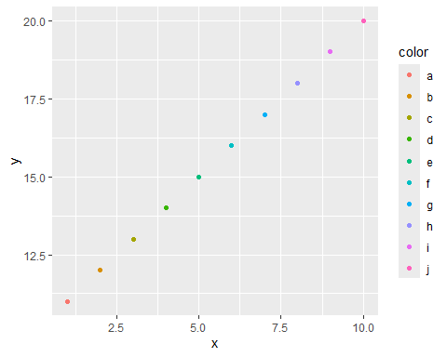

We are interested in positional differences for the following variables:

* R5.
* R5R20.
* AX.
* Vt.
* SAT.
* Puls.
* DLCOc. (primary finding)
* KCO.
* VA.

Results should be corrected for sex & height.

Se the sketch for proposed graphics for DLCOc, KCO & VA. Plots should have model means as well as individual data points. (I’ll color by sex as well to show the correction)

## 1.3 Models

### 1.3.1 DLCO

DLCO_model <-  
 lmm(  
 formula = DLCOc ~   
 Sex + Height + Visit:posture + 0+posture,  
 repetition = ~order | ID,  
 structure = "UN",  
 data = lung_data  
 )

Design matrix for the mean structure is singular.   
Coefficient "Visit:postureStanding" has been removed.

summary(DLCO_model)

Linear Mixed Model   
   
Dataset: lung_data   
  
 - 12 clusters   
 - 48 observations   
 - 4 observations per cluster   
  
Summary of the outcome and covariates:   
  
 $ DLCOc : num 9.4 10.03 10.04 10.63 9.47 ...  
 $ Sex : chr "F" "F" "F" "F" ...  
 $ Height : num 163 163 163 163 172 ...  
 $ Visit : num 1 1 2 2 1 1 2 2 1 1 ...  
 $ posture: Factor w/ 4 levels "Standing","Supine",..: 1 3 2 4 1 4 3 2 1 4 ...  
 reference level: Sex=F;posture=Standing   
  
Estimation procedure   
  
 - Restricted Maximum Likelihood (REML)   
 - log-likelihood :-61.68452  
 - parameters: mean = 9, variance = 4, correlation = 6  
 - convergence: TRUE (47 iterations)   
 largest |score| = 9.990169e-05 for rho(1,4)  
 |change|= 4.94852044925498e-05 for SexM  
   
Residual variance-covariance: unstructured   
  
 - correlation structure: ~0 + order   
 1 2 3 4  
 1 1.000 0.192 0.563 0.284  
 2 0.192 1.000 0.648 0.569  
 3 0.563 0.648 1.000 0.788  
 4 0.284 0.569 0.788 1.000  
  
 - variance structure: ~order   
 standard.deviation ratio  
 sigma.1 0.70 1.00  
 sigma.2 1.20 1.72  
 sigma.3 1.36 1.94  
 sigma.4 1.50 2.15  
  
Fixed effects: DLCOc ~ Sex + Height + Visit:posture + 0 + posture   
  
 estimate se df lower upper p.value   
 SexF -3.788 7.102 1.2 -67.547 59.971 0.677   
 SexM -0.708 7.802 1.2 -65.46 64.044 0.940   
 Height 0.078 0.043 1.2 -0.298 0.453 0.291   
 postureSupine 1.181 1.195 6.8 -1.662 4.023 0.357   
 postureProne 2.202 1.318 3.4 -1.724 6.127 0.182   
 postureHandstand 2.162 1.092 2.3 -1.981 6.305 0.169   
 Visit:postureSupine 0.362 0.637 10.5 -1.049 1.774 0.582   
 Visit:postureProne -0.765 0.694 3.9 -2.706 1.175 0.333   
 Visit:postureHandstand 0.161 0.592 4.4 -1.428 1.75 0.797   
 ---------------------------------------------------------------   
 Signif. codes: 0 '***' 0.001 '**' 0.01 '*' 0.05 '.' 0.1 ' ' 1.  
 Columns lower and upper contain 95% pointwise confidence intervals for each coefficient.  
 Model-based standard errors are derived from the observed information (column se).   
 Degrees of freedom were computed using a Satterthwaite approximation (column df).

plot(DLCO_model, type = "scatterplot")

`geom_smooth()` using method = 'loess' and formula = 'y ~ x'

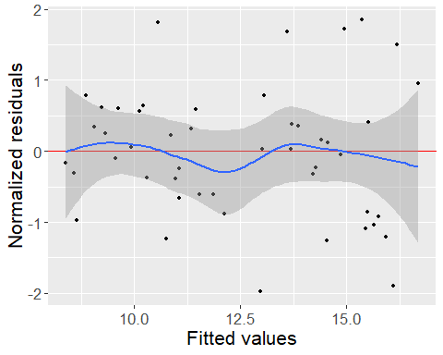

plot(DLCO_model)

