**Idea:**

The idea was first brought up as wanted to create a website to an Egyptian artist (Essam Sasa) that we found the internet lacked. The idea of the website that a user shall create an account , login in and be welcomed by our UI (that we are fundly proud of ) from the home page he will be able to choose to do multiple functionalities ex. click on the about button on the nav bar to read a brief intro about the artist in Arabic , click on the play icon to hear the latest track or even choose the release year of the song where the system should return the song name from the database where it will be able to do both show lyrics to the song or even play it via redirect link to YouTube or Spotify.

**Screenshots:**

**Sample Code:**

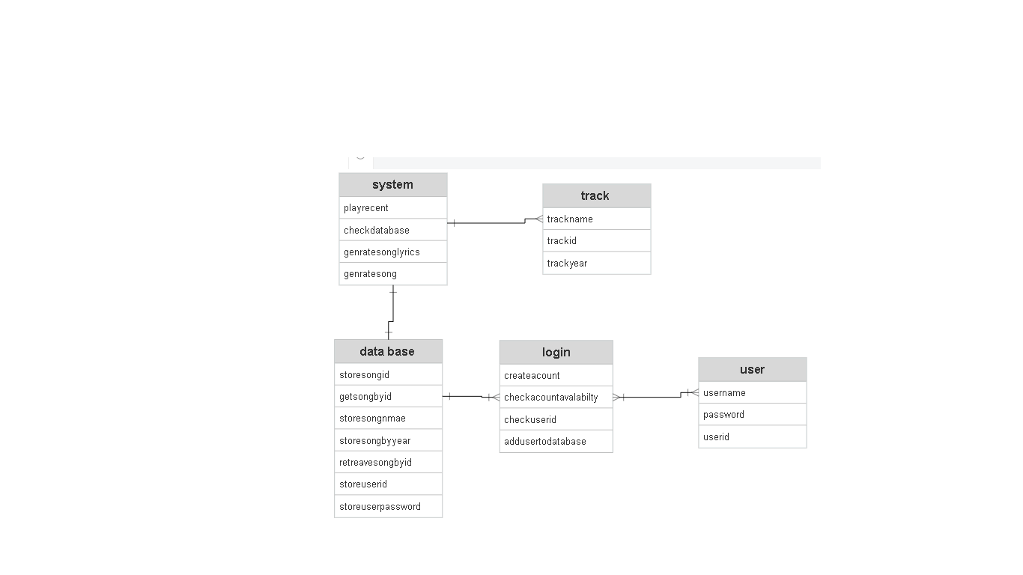**ER Diagram:**