Roll No. ..
9th 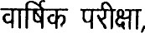 2025-26
[41 1]

ENGLISH
[Total No. of Questions: 16] [Total No. of Printed Pages: 08]
[Time; 03 Hours) [Maximum Marks: 75]
Instructions -
- All questions are compulsory.
- Marks of each question are given against them.

SECTION A
(Readinq)
Read the passage carefully and answer the questions given below -
Any fuel is derived from biomass - that is, plant or algae material or animal waste is termed as Biofuel. Since such material can be replenished readily, biofuel is considered to be a source of renewable energy, unlike fossil fuels such as petroleum, coal, and natural gas. Biofuel is commonly advocated as a cost-effective alternative to petroleum and other fossil fuels. Questions -
- Biofuel is cost-effective alternative to -
  - air (b) petroleum
(c) water (d) animal waste
- What is the meaning of "cost-effective" as used in the passage?
  - Easily available (b) Plenty

(c) Cheap (d) Limited
921-25902-A Page 1 of 8
https://www.mpboardonline.com
- What can be the source of renewable energy?
(a) fossil fuels (b) petroleum (c) coal (d) biofue'
- Which material can be replenished easily?
  - natural gas (b) coal
(c) petroleum (d) biomass
- Renewable sources of energy can be -
  - renewed (b) non-renewed
(c) depleted (d) None of the above Read the passage carefully and answer the questions given below - [5<1-51
Freedom has given us a new status and new opportunities but it also implies that we should discard selfishness, laziness and all narrowness of outlook. The greatest crime in India today is idleness, If we root our idleness, all our difficulties, including our conflicts, will gradually disappear. We should all discharge our obligations of the welfare of the country. Honest work is the fundamental law of progress. Freedom implies toil.

Questions -
- The greatest crime in India today is -
(a) idleness (b) watching films
  - using mobile (d) smoking
- If we remove idleness, all our difficulties will (a) appear (b) multiply
  - disappear (d) progress
- Freedom implies that we should give up -
(a) laziness (b) narrowness (c) selfishness (d) All of these (iv) Honest work is the law of progress.
(a) ultimate (b) only
  - fundamental (d) guiding
(v) Give one word from the passage which means 'Hard work'.
(a) idleness (b) toil
(c) discharge (d) service

Page 2 of 8
https://www.mpboardonline.com

SECTION - B
(Writinq)
Read the following passage and make notes on it and also give a suitable title to it. [3+1=41
Tourism has emerged as the world's largest industry. Growing rapidly in the last two decades, today it accounts for 6% of the world output and employs some 100 million people around the globe. It provides people with a change of place and a break from the monotony of daily life. It reveals the scenic beauty and past heritage of a country. The contribution of tourism can be nowhere seen more clearly than on the economic front. Developing counties can reap handsome benefits out of tourism which greatly boosts national income.
Q.4 You are Shivya, studying in Govt. Hr. Sec. School Padma, Indore. Write an application to your Principal requesting him to issue you character certificate.

OR
You are Mukund, residing at 26, M.G. Road, Raipur. Write a letter to your friend inviting him on your birthday.
Q.5 Write an essay on any one of the following topics in about
[51
150 words.
- Importance of English
- Technology and Science
- Population Problem in India
- My Hobby
3 of 8
Page
921-25902-A
https://www.mpboardonline.com

Look at the picture given below and wrllo a short paragraph in about 75 words.
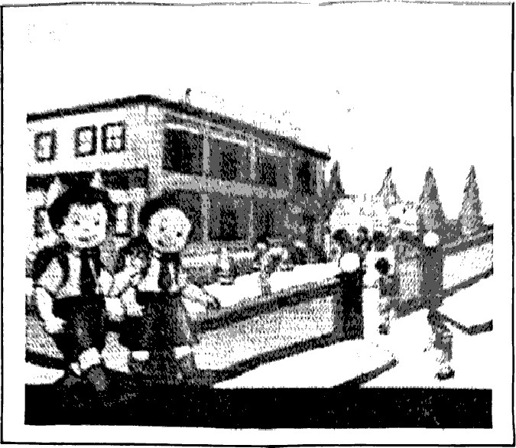

SECTION - C
(Grammar)
0.7 Fill in the blanks choosing the correct option given in the brackets -
(Any Five)
Honesty is .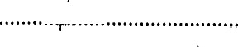. best policy, Wan/the) (ii) Mohan didn't buy .... pen. (some/any/much) (iii) Maths . not an easy subject. (islam/are)
- Gandhi Jayanti is celebrated 2nd October. (in/on/the)
- He is poor ............. . .. happy. (and/but/so)

of
Q.8 Do as directed - (Any Five) [5/1=5]
(i) My shop opens at 9 'o'clock. (Change into negative) (ii) Dinesh kills a cat. (Change the (iii) Ram is very weak. He cannot walk.
(Combine the sentences using
- Virat is playing cricket. (Change into Simple Futuro Tense)
- Look at the teacher. He is talking to his pupil,
(Combine the pair of sentences using "who") (vi) You'll feel awful if you don't finish your history lesson.
(Rewrite the sentence using 'unless' in place of 'if')

SECTION - D
(Literature)
0.9 Choose the correct option - [41
Who transformed the Pungi into a Shehnai?
(a) A farmer (b) A cobbler
(c) A barber (d) A blacksmith
Margie was surprised to see the book because (a) she liked to read books.
- it was an old book.
- it had beautiful pictures in it.
- all the stories in it were printed on paper.
(iii) What does the wind do to the strong?
(a) It befriends them (b) It helps them (e) It breaks them (d) It neglects them Who has scaled Mt. Everest twice?
(a) Santosh Yadav (b) Maria Sharapova
(c) A.P.J. Abdul Kalam (d) Bismillah Khan

921-25902-A Of
Q.IO (A) Read the extract and answer the following questions I was one of many children - a short boy with rather undistinguished looks. bom to tall and handsome parents. We lived in our ancestral house, which was buift in the mi±le of the nineteenth century. It '.vas a fairly large pucca house, made of limestone and brick. on the Mosque Street in Rameshwaram. My austere father used to avoid all inessential comforts and luxuries.

Questions -
(i) From which lesson the above extract has been taken?
(a) The Fun They Had (b) My Childhood
(c) If I Were You (d) Reach For The Top
'l' in the above lines refers to -
(a) A.P.J. Abdul Kalam (b) Gandhiji
(c) Ramanadha Sastry (d) Sivasubramania lyer (iii) The house in which Kalam lived was a fairly?
(a) Cottage (b) Hut
(G) Pucca house (d) Kachcha house
(B) Read the given extract and answer the following questions It takes much time to kill a tree,
Not a simple jab of the knife

Will do it It has grown
Slowly consuming the earth,
Rising out of it, feeding
Upon its crust, absorbing

Years of sunlight, air, water, And out of its leprous hide Sprouting leaves.

Questions -
From which poem has this extract boon takon?
(a) The Road Not Taken (b) Rain on the Roof
(c) Wind (d) On Killing a Troo
(ii) The weapon ................ is used to kill a trog, jn tho abovo extract.
(a) cutter (b) knife
(c) blade (d) sword (iii) The tree consumes......
(a) earth (b) leaves
(c) roots (d) stem
0.1 1 Answer the following questions in about 30 words - (Any Six)
Where was Margie's school? Did she have any classmates?
(ii) How old was Evelyn when she went to the Royal Academy of Music? https://www.mpboardonline.com (iii) Why was Kezia afraid of her father?
- What did the playmates call Einstein?
- Why did the snake leave the doctor's arm?
- Why was Santosh Yadav sent to the local village schooP (vii) Why did Aurangzeb ban the playing of the Pungi?
(viii) What were the two temples visited by the author in Kathmandu?
0.12 Answer the following questions — (Any Two)
(i) Where does the traveller find himself? (The Road Not taken) (ii) What did Saint Peter ask the old lady for?
(A Legend of The Northland) (iii) Why does the poet want to go to Innisfreo?
(The Lake Isle ot Innisfreo)

921-25902-A Page 7 ot 8
https://www.mpboardonline.com
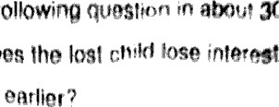
Answm the
30
does
- Why in the thinqs that wanted

- In what way is Iswaran an asset to Mahendra%' (iii) How does Toto come to qrar4a'hefls
  - How does Evelyn hoar music?
How does Kezia begin to see her father as a human needs her sympathy?
  - Write the central idea of the poem Rain on the ROOF
What are the ideas contained in the poem •Wind'?
  - Why does the disciple decide to stay in the Kngdom c! Foo'9 s a good idea?

OR
Behrman has a dream. What is it? Does it come true?

921-25902-A Puge d ot d

https:l/www.mpboardonline.com

