Both policies were trained on a total of 75600 steps (189 steps/epoch, 400 epochs).
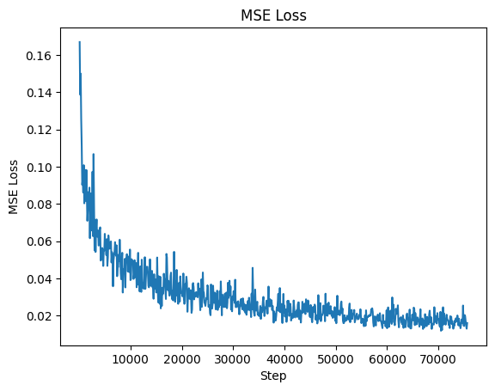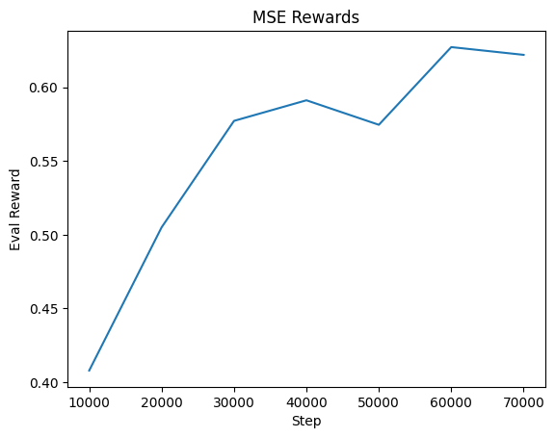
In the MSE action chunking implementation, we achieved 0.015996 loss on the final step, and 0.622 in rewards on the last evaluation which took place after training step 70000.
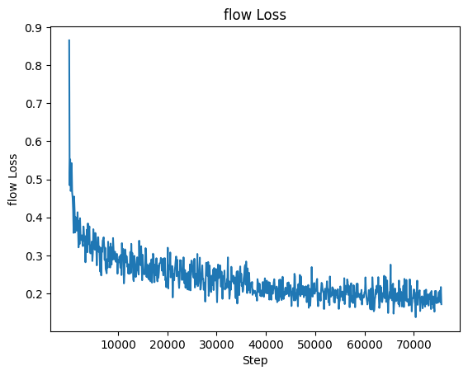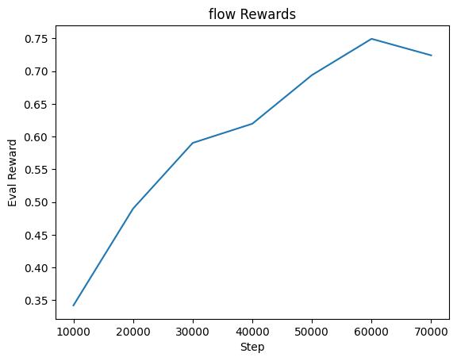
In the flow matching policy implementation, we achieved 0.17169 loss on the final step, and 0.72416 in rewards on the last evaluation which took place after training step 70000.
Judging from the video taken of the evaluation runs, the two policies most notably differed in two aspects. First, the flow matching policy actions seemed a bit jerkier. It would slightly “shudder” in place as it moved around, which I can only assume is because the number of interpolation steps required leaves it with nothing to do for a relatively simple task. Secondly, however, it is apparent that the flow matching policy pushes the block more accurately—it achieves a higher reward as is reflected in the logs, but even in the videos we can see the flow policy can make minute adjustments to push the block more precisely, while with MSE it sometimes pushes too “hard” and frequently nudges a well-positioned block out of the way.

