Pt 2.4
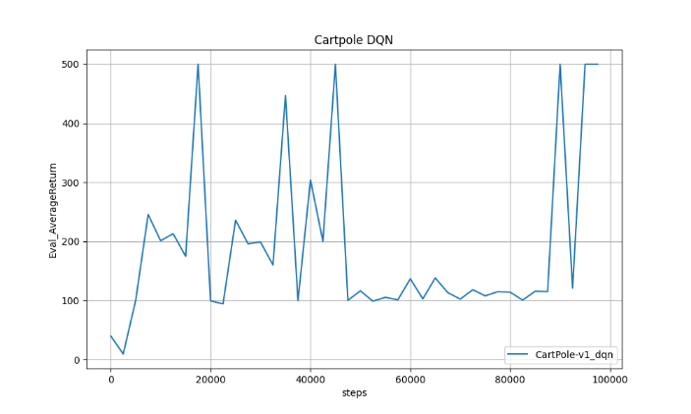
Pt 2.5
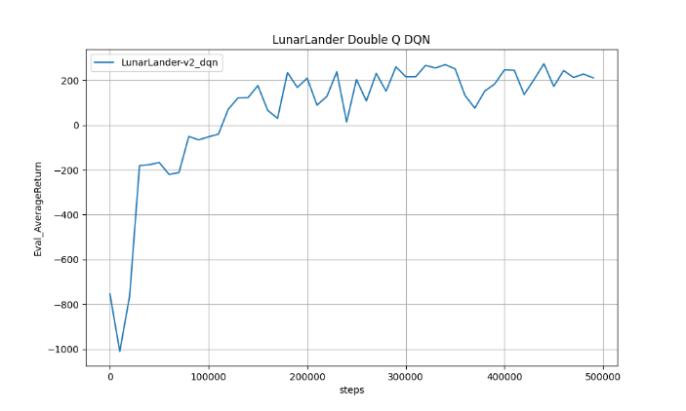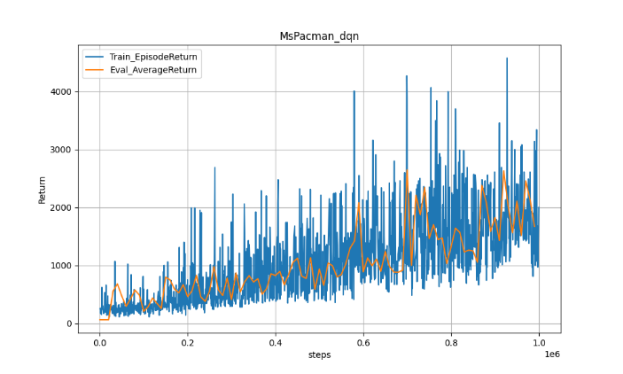
We can observe that in the MsPacman experiments, the training returns were initially generally lower than the eval returns, instead of the other way around. This might be chalked up to underestimation in the critics.
Pt 2.6
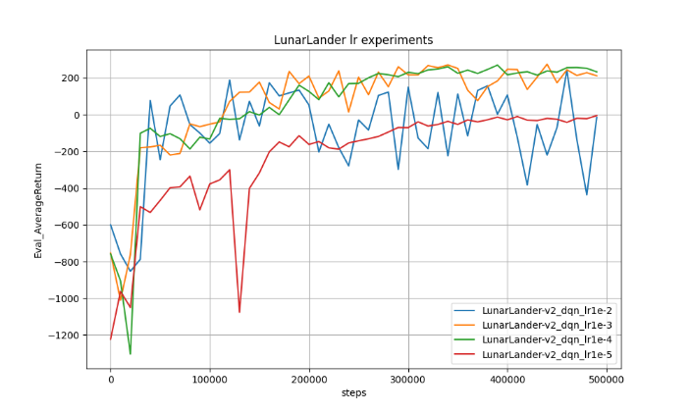
I chose to experiment with the learning rate as it was the easiest to manipulate and most commonly tweaked in any model. We can observe that the default learning rate of 1e-3 was pretty good, but still a tad high; 1e-4 was more stable, while 1e-5 was too low to learn much and 1e-2 was too aggressive to converge well.
Pt 3.4
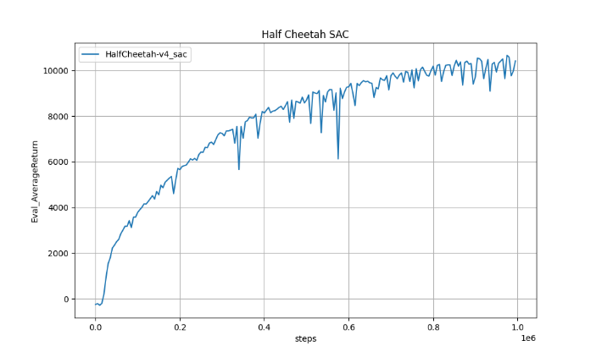
Pt 3.5
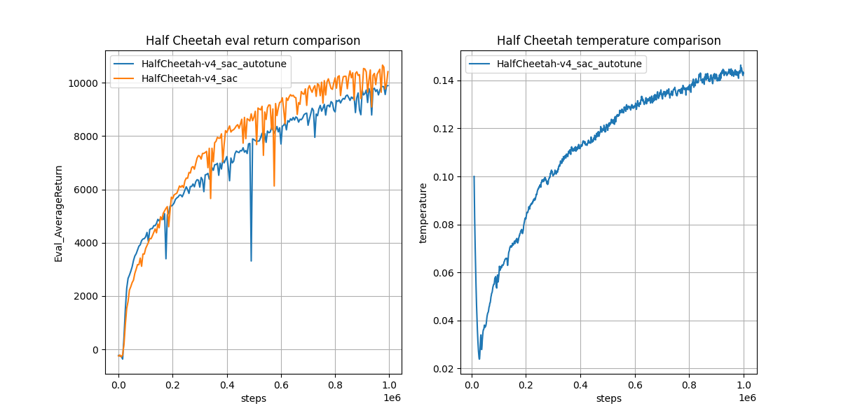
In this experiment, auto-tuning achieves roughly comparable performance to a well-selected fixed temperature. In fact, even though auto-tuning hits just a little lower than the pre-selected temperature, we can see the graph as a whole is more stable and consistent as time goes on.
The temperature first rapidly drops since its init value, then rises steadily. On the surface this feels strange, but a look through the logs yields that this might have to do with the entropy dropping very low early on, and thus the temperature increases to compensate for it; overall the entropy*temperature is about the same between this run and the fixed-temperature run.
Pt 3.6
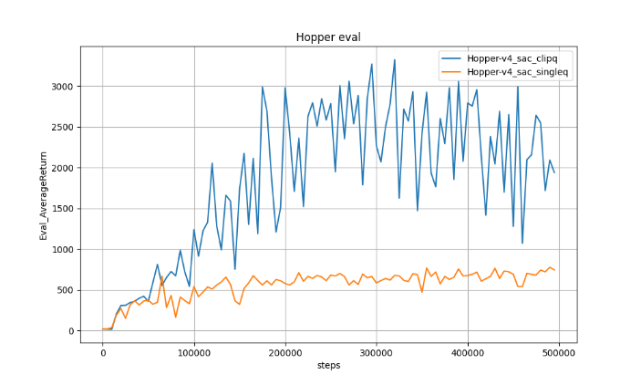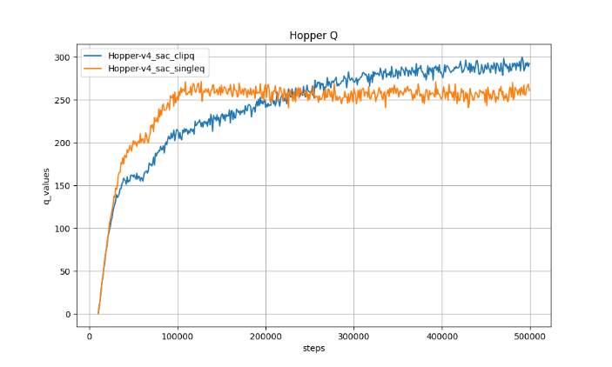
It is quite obvious here that clipped double Q outperforms single Q, and we can see that the Q values in the single Q run shoot right up early on and it takes a long time for it to slightly drop down. The intuitive explanation is that with overestimation, the critic assigns a high Q to just about any move; ie “any move is good enough”. This results in the actor not learning actually good actions, and thus gets stuck with relatively poor performance. The double Q approach veers conservative; the pessimistic estimate forces the actor to learn actually meaningfully good actions.

