Game Design Document

Fill up the following document

1. Write the title of your project.

Doctor V/S Covid

1. What is the goal of the game?

To courage people to take precaution against Covid 19 and win the battle from covid in this tough time.

1. Write a brief story of your game.

You are a doctor who is working hard to help us to prevent from covid 19

There are multiples level so in the 1st attack of virus doctor have to defeat

From covid 19 and have to do some important tasks to get a mask then doctor will get more difficulties as the Level goes up and gets award in each level like mask, senitizer and many more.

1. Which are the playing characters of this game?

* Playing characters are the ones who respond to the user based on the input from the user.
* Cars, monkeys, dinos, wizards, etc., are the playing characters in the game.

|  |  |  |
| --- | --- | --- |
| Number | Character Name | What can this character do? |
| 1 | Doctor | This character can move in any direction and also can do somespecific tasks like scrolling, hide etc. |
| 2 | virus | It can meet the player anytime  And its to small and if the player will meet or touch it the player can lost 1 life or die |
| 3 | crowd | It can be in whole game or in just in small area we have to be |
| 4 |  |  |
| 5 |  |  |
| 6 |  |  |
| 7 |  |  |
| 8 |  |  |

5.Which are the Non-Playing Characters of this game?

* Non-Playing characters are the ones that don't have an action or behavior when the user interacts with the game.
* Hurdles, stones, bananas, coins, etc., are non-playing characters in the game.

|  |  |  |
| --- | --- | --- |
| Number | Character Name | What can this character do? |
| 1 | Mask | Award 1 |
| 2 | Senitizer | Award 2 |
| 3 | Gloves | Award 3 |
| 4 | Vaccine | Award 4 |
| 5 | Lockdown | Obstacle |
| 6 | Junk food | Obstacle |
| 7 |  |  |
| 8 |  |  |

1. Draw your imagination of this game. What does this game look like?

* Draw the game either on your computer or on paper.
* Add images of the game scenes to show each of the playing and non-playing characters at least once.

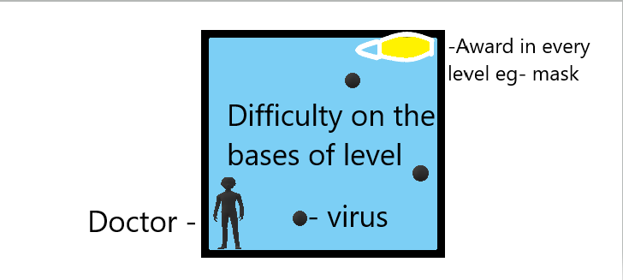

1. How do you plan to make your game engaging?

It has many different level which you will like. I have tried to make the game with more animations so that the player will love to play, and the idea of the game can make my game engaging.