Q6Word

Alec

2023-03-03

Question 4)

library(ggplot2)

## Warning: package 'ggplot2' was built under R version 4.1.3

ggplot(mtcars, aes(x = wt, y = mpg)) +  
 geom_point(color = "blue") +   
 geom_smooth(method = "lm", se = FALSE, color = "black") +  
 labs(title = "MPG vs Weight", x = "Weight (1000 lbs)", y = "Miles per gallon")

## `geom_smooth()` using formula = 'y ~ x'

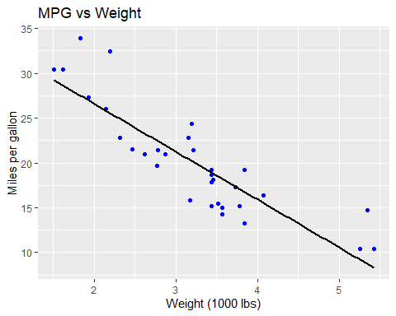

#You can change the dots to be in front of the line by swapping the code to be like this  
#geom_smooth(method = "lm", se = FALSE, color = "black") +  
#geom_point(color = "blue") +   
  
  
ggplot(mtcars, aes(x = hp, y = qsec, color = factor(cyl))) +  
 geom_point(size = 4) +  
 scale_color_manual(values = c("black", "orange", "purple")) +  
 labs(title = "Time vs Horsepower", x = "Horsepower", y = ".25 Mile Time")

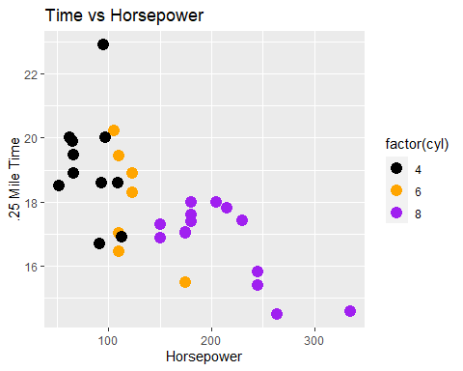

ggplot(mtcars, aes(x = hp, y = qsec, color = factor(cyl))) +  
 geom_point(size = 4) +  
 scale_color_manual(values = c("black", "orange", "purple")) +  
 labs(title = "Time vs Horsepower", x = "Horsepower", y = ".25 Mile Time") +  
 theme_dark() #This is an example of adding a theme to a plot

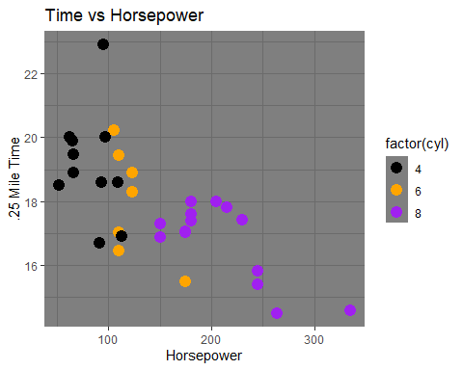

ggplot(mtcars, aes(x = wt, y = mpg)) +   
 geom_point(size = 4) +  
 facet_grid(cols=vars(cyl)) #This is faceting our data into columns pertaining to cylinders

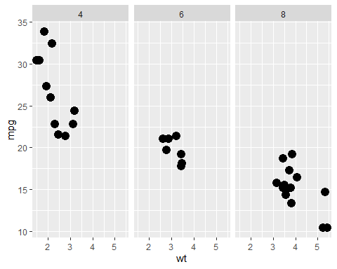

Question 5)

subset(ToothGrowth, supp == "VC")

## len supp dose  
## 1 4.2 VC 0.5  
## 2 11.5 VC 0.5  
## 3 7.3 VC 0.5  
## 4 5.8 VC 0.5  
## 5 6.4 VC 0.5  
## 6 10.0 VC 0.5  
## 7 11.2 VC 0.5  
## 8 11.2 VC 0.5  
## 9 5.2 VC 0.5  
## 10 7.0 VC 0.5  
## 11 16.5 VC 1.0  
## 12 16.5 VC 1.0  
## 13 15.2 VC 1.0  
## 14 17.3 VC 1.0  
## 15 22.5 VC 1.0  
## 16 17.3 VC 1.0  
## 17 13.6 VC 1.0  
## 18 14.5 VC 1.0  
## 19 18.8 VC 1.0  
## 20 15.5 VC 1.0  
## 21 23.6 VC 2.0  
## 22 18.5 VC 2.0  
## 23 33.9 VC 2.0  
## 24 25.5 VC 2.0  
## 25 26.4 VC 2.0  
## 26 32.5 VC 2.0  
## 27 26.7 VC 2.0  
## 28 21.5 VC 2.0  
## 29 23.3 VC 2.0  
## 30 29.5 VC 2.0

subset(ToothGrowth, supp == "VC" & dose == 0.5)

## len supp dose  
## 1 4.2 VC 0.5  
## 2 11.5 VC 0.5  
## 3 7.3 VC 0.5  
## 4 5.8 VC 0.5  
## 5 6.4 VC 0.5  
## 6 10.0 VC 0.5  
## 7 11.2 VC 0.5  
## 8 11.2 VC 0.5  
## 9 5.2 VC 0.5  
## 10 7.0 VC 0.5

subset(ToothGrowth, supp == "VC" & dose == 0.5)$len

## [1] 4.2 11.5 7.3 5.8 6.4 10.0 11.2 11.2 5.2 7.0