Name : Utsav Gohel
Enroll no. : 91900104011
Class : TC2

Experiment No: 2 Pre Lab Exercise

Q-1 | Visit the mentioned link and draw continuous signal, its quantized signal and encoded bits. For the hint one signal is encoded by PCM shown. You need to draw another signal in the same figure and its quantized, encoded bit.  http://www.netbook.cs.purdue.edu/animations/convert%20analog%20to%20digital.html  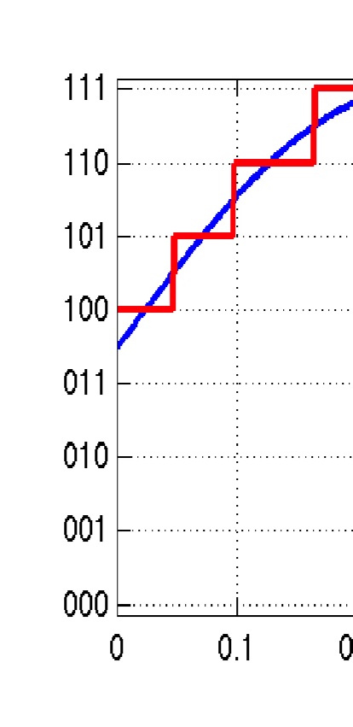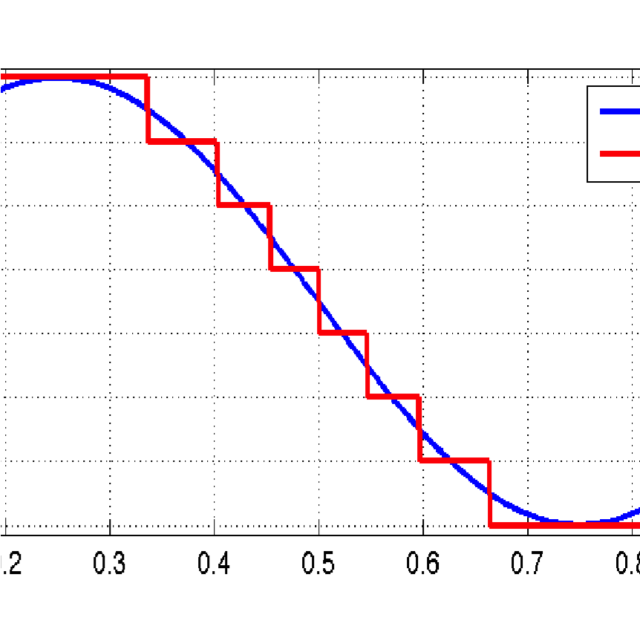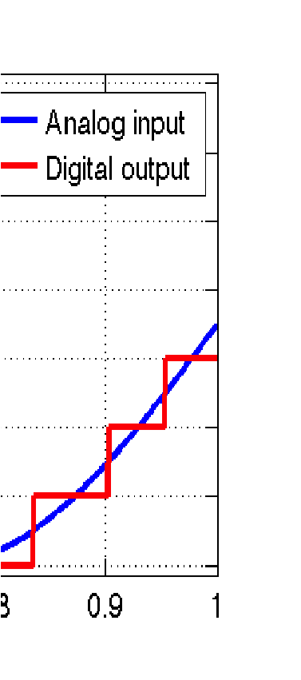  Encoded Bits for given example: 100, 101, 110, 111, 111, 111 and so on.  Draw your signal and write encoded bits:  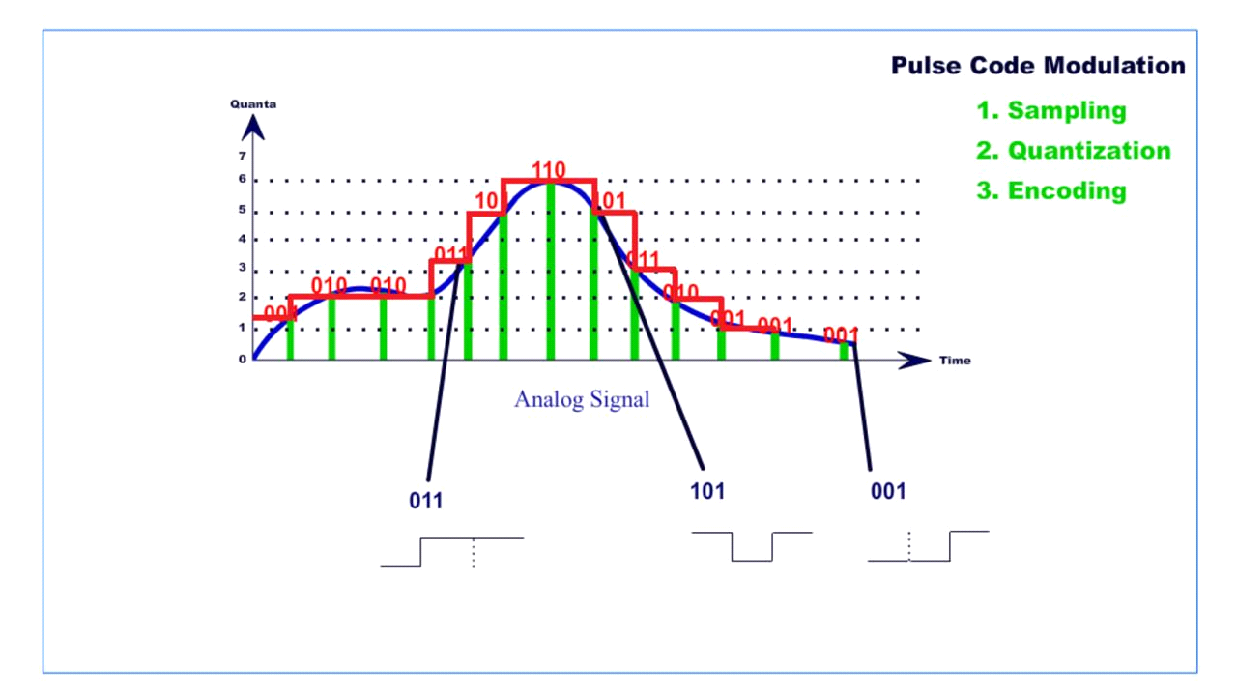  001 010 010 010 011 101 110 110 101 011 010 001 001 001
Q-2 | Visit the mentioned link and comment your review for the same.  https://netbook.cs.purdue.edu/animations/tdm.html
 | In this video one side 3 receiver are there and data A B C is transmitted from sender side to receiver side. First sender sent data then second and at last third. At a time multiple signals to be sent. First send data travel from MUX and DMUX and then after reach in first receiver then second and third receiver. TDM is to transmit or receive different data signal using common single transmission line. Its used to independent data over a single line.
Experiment 2: Perform pulse coded modulation for analog to digital conversion.
Apparatus: Computer system with NI Multisim Installed.
Theory:
Modulation is the process of varying one or more parameters of a carrier signal in accordance with the instantaneous values of the message signal.
The message signal is the signal which is being transmitted for communication and the carrier signal is a high frequency signal which has no data, but is used for long distance transmission.
There are many modulation techniques, which are classified according to the type of modulation employed. Of them all, the digital modulation technique used is Pulse Code Modulation (PCM).
A signal is pulse code modulated to convert its analog information into a binary sequence, i.e., 1s and 0s. The output of a PCM will resemble a binary sequence. The following figure shows an example of PCM output with respect to instantaneous values of a given sine wave.
Instead of a pulse train, PCM produces a series of numbers or digits, and hence this process is called as digital. Each one of these digits, though in binary code, represent the approximate amplitude of the signal sample at that instant.In Pulse Code Modulation, the message signal is represented by a sequence of coded pulses. This message signal is achieved by representing the signal in discrete form in both time and amplitude.
Basic Elements of PCM
The transmitter section of a Pulse Code Modulator circuit consists of Sampling, Quantizing and Encoding, which are performed in the analog-to-digital converter section. The low pass filter prior to sampling prevents aliasing of the message signal.
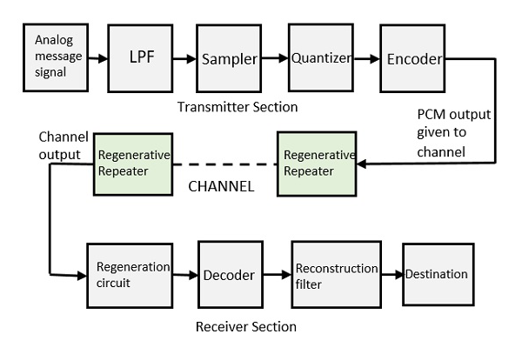
The basic operations in the receiver section are regeneration of impaired signals, decoding, and reconstruction of the quantized pulse train. Following is the block diagram of PCM which represents the basic elements of both the transmitter and the receiver sections.

Low Pass Filter
This filter eliminates the high frequency components present in the input analog signal which is greater than the highest frequency of the message signal, to avoid aliasing of the message signal.
Sampler
This is the technique which helps to collect the sample data at instantaneous values of message signal, so as to reconstruct the original signal. The sampling rate must be greater than twice the highest frequency component W of the message signal, in accordance with the sampling theorem.
Quantizer
Quantizing is a process of reducing the excessive bits and confining the data. The sampled output when given to Quantizer, reduces the redundant bits and compresses the value.
Encoder
The digitization of analog signal is done by the encoder. It designates each quantized level by a binary code. The sampling done here is the sample-and-hold process. These three sections (LPF, Sampler, and Quantizer) will act as an analog to digital converter. Encoding minimizes the bandwidth used.
Regenerative Repeater
This section increases the signal strength. The output of the channel also has one regenerative repeater circuit, to compensate the signal loss and reconstruct the signal, and also to increase its strength.
Decoder
The decoder circuit decodes the pulse coded waveform to reproduce the original signal. This circuit acts as the demodulator.
Reconstruction Filter
After the digital-to-analog conversion is done by the regenerative circuit and the decoder, a low-pass filter is employed, called as the reconstruction filter to get back the original signal.
Hence, the Pulse Code Modulator circuit digitizes the given analog signal, codes it and samples it, and then transmits it in an analog form. This whole process is repeated in a reverse pattern to obtain the original signal.

Multisim Simulation Circuit and its output waveform:
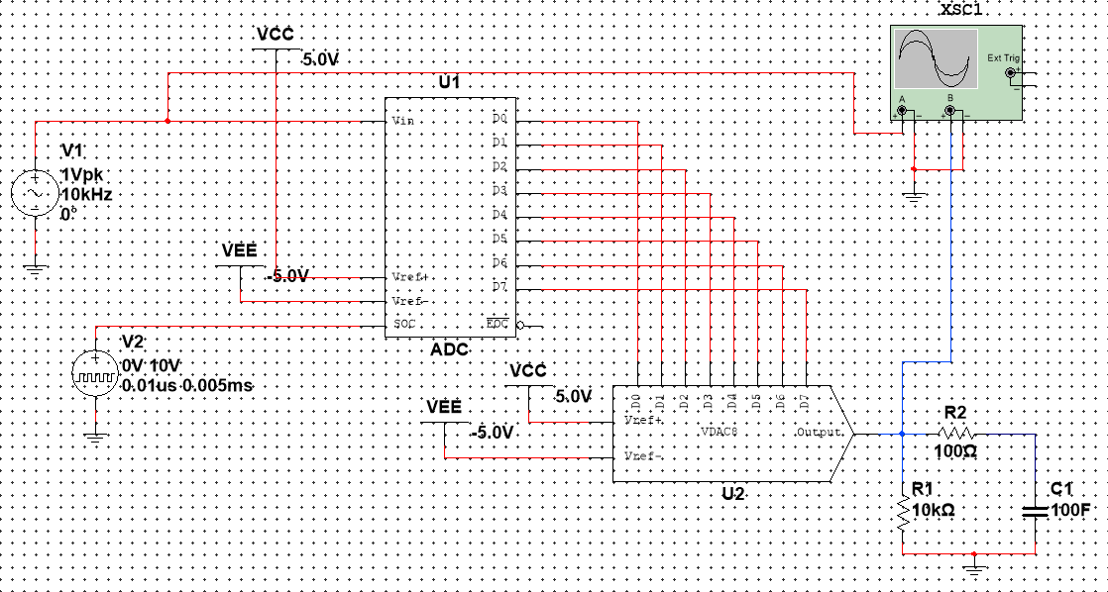
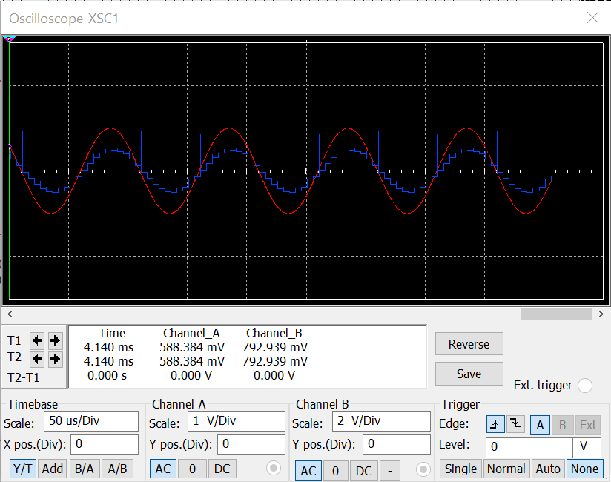
Procedure:
- Set the signal source frequency to 10kHz.
- Set the pulse generator time period 0.005ms and pulse width 0.01u second.
- Observe the waveform of ch-1 and ch-2 of input signal and output of DAC on CRO.
- Vary the the signal frequency and observe the effect on DAC output.
- Vary the pulse width and time period and observe the effect on DAC output.

Conclusion: Pulse code modulation is a method that is used to convert an analog signal into a digital signal so that a modified analog signal can be transmitted through the digital communication network. PCM is in binary form, so there will be only two possible states high and low(0 and 1).

