**Name: SHYAM MAKVANA enrollno:91900103133**

**Class: tc2 lab-C**

**Experiment No: 1 Pre Lab Exercise**

**Q-1 For the given information signal and train of pulse (of amplitude 1V). Draw sampled signal. Hint: Use Multiplication principle of two signal.**

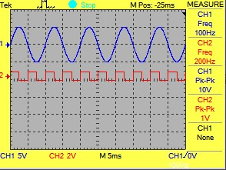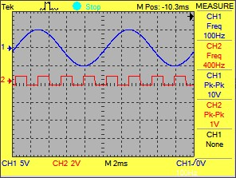

(a)

(b)

**Q-2 What is Nyquist Criterion?**

**Identify relation between fs and fm for all three frequency spectrum. (<, =, >) Comment effect of selection of fs in each case.**

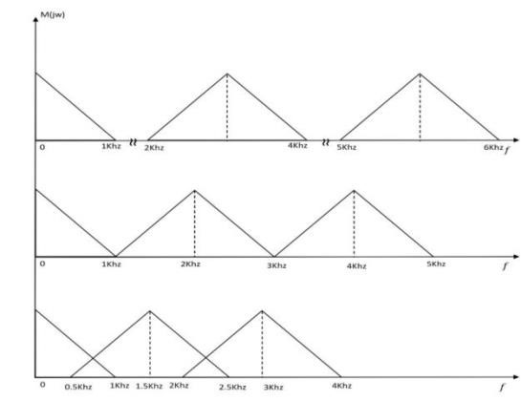

(a)

(b)

(c)

1. = over sampling and relation between fs and fm is “ fs>2fm”
2. = perfect sampling and relation between fs and fm is “ fs=2fm”.
3. = under sampling and relation between fs and fm is “ fs<2fm”.

**Experiment 1: To perform sampling of a continuous signal and verify Nyquist criteria for reconstruction of signal.**

**Apparatus:** Computer system with NI Multisim Installed.

**Theory:**

The signals we use in the real world, such as our voice, are called "analog" signals. To process these signals for digital communication, we need to convert analog signals to "digital" form. While an analog signal is continuous in both time and amplitude, a digital signal is discrete in both time and amplitude. To convert continuous time signal to discrete time signal, a process is used called as sampling. The value of the signal is measured at certain intervals in time. Each measurement is referred to as a sample. Consider an analogue signal x(t) that can be viewed as a continuous function of time, as shown in figure1. We can represent this signal as a discrete time signal by using values of x(t) at intervals of nTs to form x(nTs) as shown in figure 1. We are "grabbing" points from the function x(t) at regular intervals of time, Ts, called the sampling period.

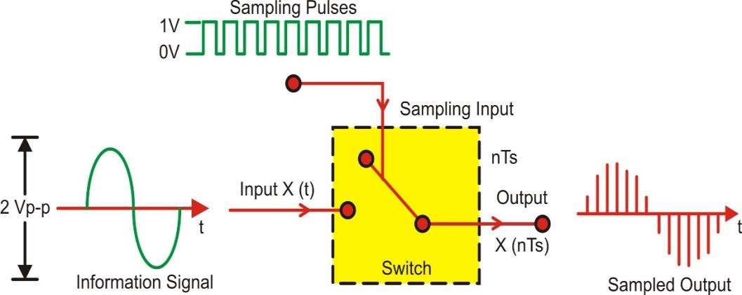

**Figure 1. BasicSamplingProcess**

Figure 2 depicts the sampling of a signal at regular interval (period) t=nTs where n is an integer. The sampling signal is a regular sequence of narrow pulses δ (t) of amplitude

1.Figure 3 shows the sampled output of narrow pulses δ (t) at regular interval of time.

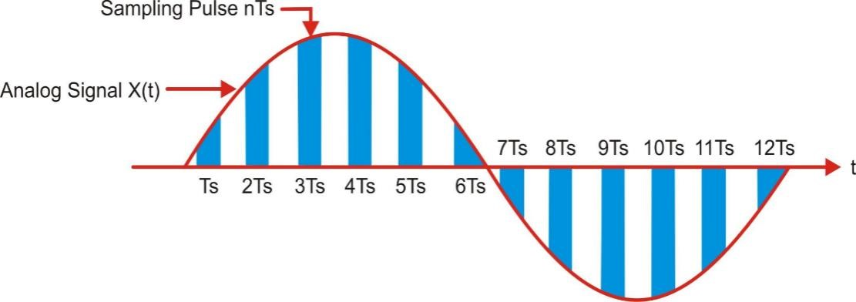

**Figure 2. Sampling of signal at sampling interval (period) Ts**

The time distance Ts is called sampling interval or sampling period, fs=1/Ts is called as sampling frequency (Hz or samples/sec), also called sampling rate.

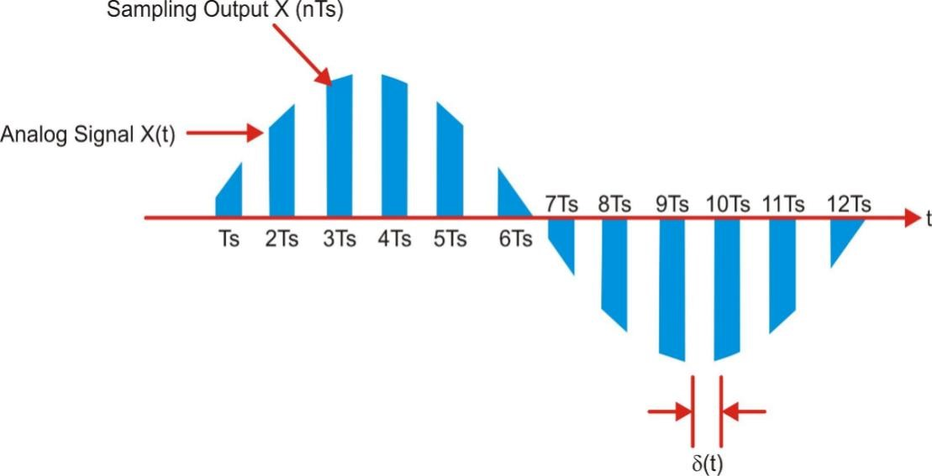

**Figure 3. Sampled Output of narrow pulses δ (t)**

**Multisim Simulation Circuit(Snapshot of your work):**

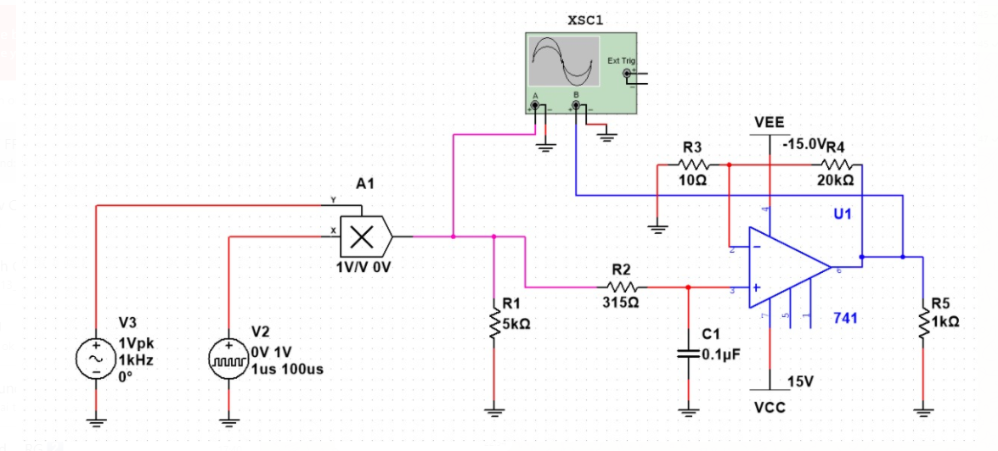

**Procedure:**

Connect the circuit as per the shown in figure above.

**Step-1 Basic Sampling& Reconstruction**

1. Set the signal source frequency 1KHz and sampler frequency 100KHz (Time period = 100us).
2. Set the pulse width of sampler 1 micro second.
3. Observe the sampled output of multiplier on CRO screen.
4. Now observe the reconstructed output of low pass filter at pin no. 6. **Step-2** 
   * 1. Now set the signal source frequency equal to last two digit of your enrollment number (i.e. Enrollment No. 150570111020 then set frequency = 20Hz)
     2. Consider the sampler frequency 10 times of your signal frequency (i.e. 20 Hz * 10 = 200 Hz). So set the time period of sampler = 1/f. (i.e. T = 0.005 Sec) 3. Set the Pulse width 1/10th of your time period (i.e. Width = 0.0005sec)

4. Observe the sampled output at multiplier.

1. Adjust the opamp filter frequency as per your signal frequency by changing the values of R

1 and C. (use formula *f* = ) 2*RC*

**Multisim Simulation Waveform (Snapshot of your work):**

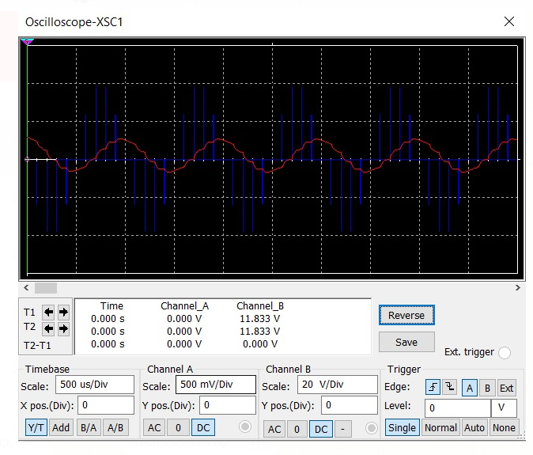

**Conclusion:**

In this experiment we learnt about simple signal and nyquist theorem and also learn about how it is work. We built circuit in multisim and we get perfect output.

**Experiment No :1 Post Lab Exercise**

* 1. **Mark True/False for the given statement. Write corrected statement if you found false.**

( The basic purpose of sampling is to discretize the analog signal.a

)

**yes, it is true** To convert a **signal** from continuous time to **discrete** time, a process called **sampling** is used.

( A band limited low pass signal is sampled at Nyquist rate with fs = 5000sps. The b signal is band limited to 2000Hz.

)

* 1. **For a case study of sampling of audio song which consist several instruments along with vocal frequency. Highest effective frequency component of instruments are listed below. Consider composite signal is band limited signal.**

**Flute : 16 KHz Tabla : 800 Hz Vocal : 3.2 KHz**

**Congo : 600 Hz Guitar : 15 KHz**

**Considering above description match the following**

* + - * 1. Highest Frequency 𝑓𝑚 A. 31.25 μs
        2. AliasingB. 16 KHz
        3. Low Pass SignalC. Band Limited Signal
        4. Nyquist FrequencyD. 𝑓𝑠 = 25 KHz
        5. Nyquist Interval E. 32 KHz

Answer

1=B , 2=C , 3=D , 4=B , 5=A

**Q-3. Determine Nyquist rate for the following signals.**

(a) y(t) = 6 sin(200t) (b) x(t) = 12 cos2(120πt)

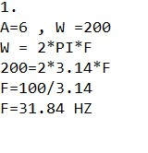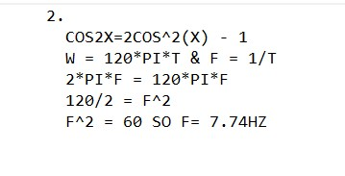



**Q-4. Determine the minimum Sampling frequency to be used to avoid sampling.**

x(t) = 5 sin (100 πt) cos (400 πt). W = 2*pi*f & t=1/f

**2sinx*cosy =** & sin(x+y) – sin(x-y) = 100 pi / f = 2 pi f **sin(x+y)-** 2cos(x+y/2)sin(x-y/2) F^2 = 50

**sin(x-y)** So, 2cos(400 pi t)sin(100 pi t) F = 7.07hz

**400 pi/f =2 pi f**

**F^2 = 200**

**F= 14.142hz**

**Q-5. To explore interpolation three cases are given with sample instances. Just mark sample point right side and join them with scale. Comment on result for 1 sample per cycle, 2 sample per cycle and 3 sample per 2 cycle.**

