Vishwakarma Awards 2026–27
THEME 6: SUSTAINABLE CITIES, IIT HYDERABAD
TEAM TECHTONICS
AQUAPULSE: A Non-Invasive Acoustic Cross-Correlation Mesh for Real-Time Leak Triangulation in Urban Water Distribution Networks
1. TITLE OF THE PROJECT / PRODUCT
Product Nomenclature: AQUAPULSE: A Non-Invasive Acoustic Cross-Correlation Mesh for Real-Time Leak Triangulation in Urban Water Distribution Networks
2. PROBLEM STATEMENT
Core Problem Statement (Single-Sentence Definition):
"Urban water utilities can measure that a leak exists on a distribution line — through a supply-versus-billed mismatch — but cannot economically or continuously determine where along that line the leak actually is, forcing them to rely on periodic, expensive, contractor-run acoustic or helium surveys instead of always-on, low-cost, automated leak localization."

Context & Severity: A 2008–09 Ministry of Urban Development pilot study across 28 Indian cities recorded average Non-Revenue Water (NRW) at 39%, and current estimates for most Indian metros range between 40% and 50%, with utilities such as the Delhi Jal Board and Kerala Water Authority reporting NRW as high as 50–60%. Physical leakage from ageing pipe joints and subterranean cracks is one of the two principal drivers of this loss, alongside commercial losses from unauthorized taps and faulty metering. Where municipal corporations have invested in locating leaks, the results are dramatic but costly: Bengaluru's BWSSB brought unaccounted-for water down from 52% to 27% across pilot zones using contracted helium and acoustic leak-detection surveys — a periodic, human-driven, high-cost process rather than a continuous, automated one. For the vast majority of Indian urban local bodies (ULBs) and educational/industrial campuses lacking budgets for repeated contractor surveys, leaks run undetected underground for months, wasting millions of litres of treated municipal water and pumping energy before detection.
3. SOLUTION PROPOSED
AQUAPULSE is a permanently installed, non-invasive clamp-on sensor mesh that listens continuously to municipal water distribution lines and pinpoints the physical location of subterranean leaks using acoustic cross-correlation — operating always-on, at a fraction of contractor costs, with zero trenching, pipe-cutting, or supply interruptions.
3.1 Node Hardware & Compute Architecture
Each AQUAPULSE node is built around an ESP32-S3 microcontroller coupled with an external 16-bit Delta-Sigma ADC (ADS1115), since typical onboard SAR ADCs lack the effective number of bits (ENOB) and dynamic range needed for sub-millivolt acoustic time-delay estimation. A temperature-compensated DS3231 precision real-time clock maintains microsecond-level synchronization across adjacent nodes — the fundamental prerequisite for millimeter-accurate acoustic triangulation.
- Non-Invasive Clamp Mounting: Each node attaches magnetically or via an adjustable tension clamp to an exposed pipe fitting, gate valve, fire hydrant, or bulk meter chamber, requiring zero excavation, tapping, or water supply shutdowns.
- Circular Waveform Buffering: Nodes continuously buffer raw acoustic samples in a circular RAM buffer. When a candidate anomaly is flagged, only the compressed timestamped waveform snippet is exchanged with immediate mesh neighbours, eliminating massive audio streaming bandwidth.
3.2 Acoustic Sensing & Signal Conditioning
Pressurized water escaping through a fissure generates continuous broadband acoustic emissions (500 Hz – 3.5 kHz) that propagate bidirectionally through the water column and pipe wall.
- Piezoelectric Contact Transducer: A high-sensitivity piezo contact accelerometer detects acoustic surface vibrations, feeding an ultra-low-noise operational amplifier (MCP6002) with active 2nd-order Sallen-Key bandpass filtering (500 Hz – 3 kHz) to reject low-frequency vehicular rumble and high-frequency RF interference before 16-bit digitization.
- Multi-Modal Noise Rejection: An auxiliary ADXL345 accelerometer cross-verifies structural pipe acceleration. Acoustic transients that do not register corresponding structural signatures are filtered out as ambient airborne noise (such as road traffic or heavy machinery).
3.3 Cross-Correlation Triangulation Engine & Consensus Validation
The core mathematical breakthrough is on-device time-difference-of-arrival (TDOA) cross-correlation. When adjacent nodes detect an acoustic energy spike above baseline, they exchange synchronized waveform windows across the mesh:
- TDOA Triangulation Formulation: Let D be the known physical distance between Node A and Node B along the pipe run, v the acoustic propagation velocity through the specific pipe material and water column (e.g., ~1,250 m/s for ductile iron, ~450 m/s for PVC), and tau the cross-correlation peak time lag between the two waveforms. The distance of the leak from Node A is computed deterministically as: Distance = (D - v * tau) / 2.
- Consensus Multi-Pair Rejection: A candidate leak is only validated if two independent neighbour pairs (e.g., Node A-B and Node B-C) report spatially consistent leak coordinates. Discrepant lags caused by localized surface traffic or pump cycling are automatically rejected.
- Adaptive Noise Floor Recalibration: Ambient urban acoustic noise drifts across day and night cycles; nodes continuously compute rolling RMS noise floors, dynamically adjusting candidate detection thresholds without manual site re-calibration.
3.4 Mesh Communication, Gateway & Dashboard
Nodes broadcast localized packets via low-overhead ESP-NOW across pipeline segments, while solar-buffered zone gateways aggregate confirmed leak coordinates over LoRaWAN or cellular NB-IoT to municipal SCADA / MQTT servers.
- Municipal Utility GIS Portal: A GIS-integrated web dashboard projects confirmed leak coordinates directly onto city utility pipe schematics, logging severity, estimated hourly discharge volume, and node battery levels for municipal repair teams.
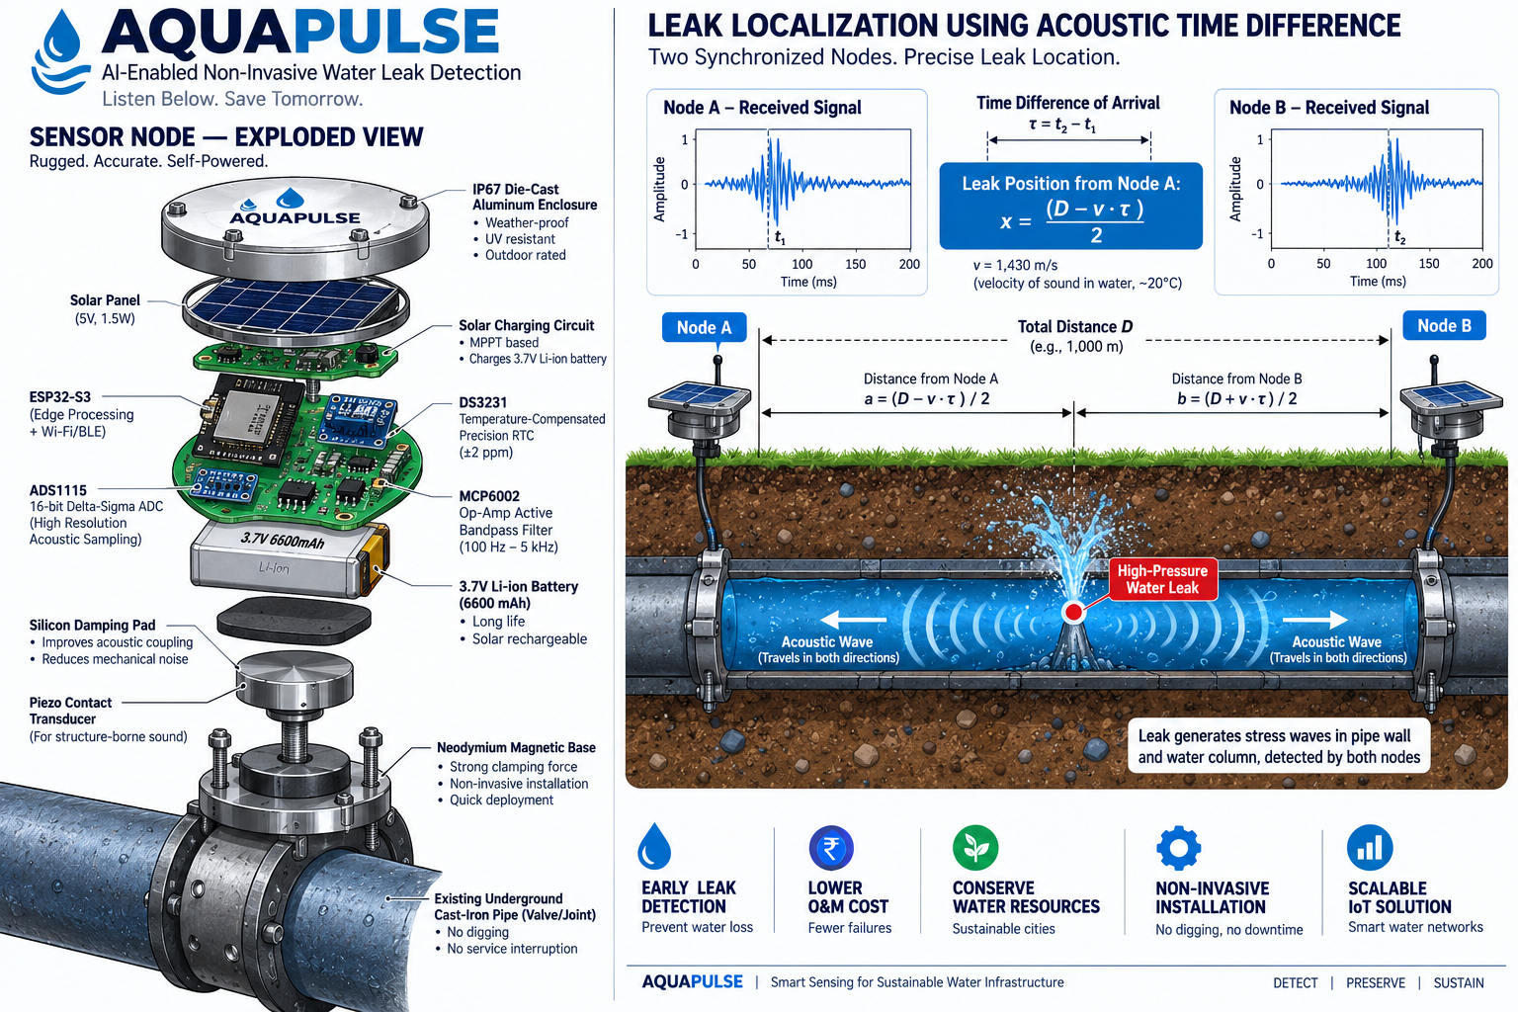

4. IMPLEMENTATION PLAN
Target Beneficiaries: Primary: Urban Local Bodies (ULBs), Jal Boards, and municipal water supply engineers tasked with reducing non-revenue water; Secondary: Large educational campuses, healthcare complexes, and industrial parks maintaining private underground distribution mains; Tertiary: Urban citizens who benefit from enhanced water pressure, consistent supply hours, and reduced roadway damage caused by unnoticed pipeline washouts.
Phase / Month | Milestone Focus | Key Engineering Tasks | Verification Deliverable
Phase 1  (M1 – M2) | Benchtop Correlation Validation | Fabrication of pressurized PVC/GI pipe-loop test rig with variable-orifice leak valves; single-pair TDOA algorithm tuning on ESP32-S3. | Functional 2-node test loop validating leak localization within ±1.5 metres of known leak orifices.
Phase 2  (M3 – M4) | Multi-Node Mesh & Consensus Logic | ESP-NOW broadcast protocol deployment; multi-pair consensus validation engine; ambient-noise floor recalibration testing. | 4-node synchronized test network demonstrating real-time false-positive rejection against simulated traffic vibration.
Phase 3  (M5) | Field Enclosure & Dashboard | IP67 weather-tight magnetic enclosure engineering; solar harvesting circuit validation; MQTT gateway and GIS map dashboard integration. | Field-ready ruggedized node prototypes; functional web dashboard rendering live simulated leak events.
Phase 4  (M6) | Pilot Campus Deployment | Installation along a 1 km operational distribution line on an institutional campus; controlled permitted test-leak verification. | Comprehensive pilot evaluation report validating localization accuracy (± metres), alert latency, and battery autonomy.

5. SAFETY AND EFFICIENCY ANALYSIS
- Non-Invasive Structural Integrity: Because nodes clamp externally to existing valves and fittings without penetrating pipe walls or altering internal hydraulic pressure, installation carries zero risk of structural pipe fatigue, water contamination, or service disruption.
- Low-Voltage Intrinsically Safe Design: All electronics operate off an isolated 3.7V LiFePO4 / Li-ion cell regulated to 3.3V with comprehensive BMS protection (over-charge, over-discharge, short-circuit), completely isolated from municipal grid mains.
- Multi-Pair False-Positive Mitigation: By enforcing dual-pair cross-confirmation before flagging an alert, AQUAPULSE prevents costly unwarranted road excavations, ensuring field maintenance crews are deployed only to verified pipe ruptures.
- Graceful Mesh Degradation: If a single node in a 10-node chain experiences battery depletion or RF obstruction, adjacent nodes automatically expand correlation windows to bridge the span, sustaining localized tracking without system blackout.
- Quantitative Efficiency Baselines: Aims for pinpoint localization accuracy within ±2.5 metres along underground pipe runs, reducing leak detection latency from an average of 45 days down to under 30 minutes of burst onset.
6. SCALABILITY AND FUTURE DEVELOPMENT
Unit Economics & Bill of Materials (BOM): Relying exclusively on standard commercial MEMS sensors, operational amplifiers, and mass-manufactured microcontrollers, AQUAPULSE eliminates the exorbitant capital cost of proprietary imported correlators.
Subsystem / Component | Part Designation | Prototype Qty | Estimated Cost (INR)
Core Processing & ADC | ESP32-S3 DevKit + ADS1115 16-Bit Precision ADC | 1 Set per node | ₹700
Acoustic Sensing & AFE | Piezo Contact Transducer + MCP6002 Op-Amp Filter | 1 Set per node | ₹500
Microsecond Sync & Clock | DS3231 Precision TCXO RTC + ESP-NOW Radio | 1 Set per node | ₹150
Power Subsystem | 3.7V 3000mAh Li-ion + TP4056 Solar Charge Controller | 1 Set per node | ₹350
Weatherproof Housing | IP67 Die-Cast Enclosure + Neodymium Clamp Assembly | 1 Assembly | ₹350

Economic Feasibility: Total Functional Prototype BOM: ₹2,050 per node | Projected High-Volume Production Cost (1,000+ Units via automated SMT): ₹900 per node. An entire municipal District Metered Area (DMA) spanning 10 km can be permanently monitored for under ₹1 Lakh — less than the cost of a single contracted one-week manual acoustic survey.
6.1 Future Technological Adaptations
- Hyperlocal Air-Quality Sentinel: Surface-level gateway nodes can be equipped with low-cost optical particulate sensors (PMS5003) at near-zero marginal cost, simultaneously creating a hyperlocal municipal air-quality monitoring grid.
- Predictive Pipe Wall Degradation: Correlating acoustic transient reflection velocities over multi-month operating spans allows the mesh to detect pipe-wall thinning, tuberculation, and structural embrittlement prior to actual blowout.
- Municipal GIS SCADA Integration: Direct API ingestion into municipal GIS and water billing platforms automatically flags anomalous consumption patterns alongside geocoded repair tickets.
7. INNOVATION ADVANTAGE
Direct comparative benchmarking against prevailing municipal leak management strategies illustrates AQUAPULSE's transformative advantages:
Technical Feature | Bulk Flow Meters | Helium Tracer Gas | Contracted Correlators | AQUAPULSE
Detects Leak Existence | Yes (Billing gap) | Yes | Yes | Yes (Real-time)
Pinpoints Physical Location | No (Bulk zone only) | Yes (Spot survey) | Yes (Spot survey) | Yes (Continuous ±2.5m)
Monitoring Regime | Continuous (Volume) | One-Off Campaign | One-Off Campaign | Permanently Always-On
Pipe Modification Required | Inline Meter Cutting | Gas Injection Tap | None (At valves) | None (External Clamp)
Deployment Model | Utility Capital Asset | Contracted Survey Crew | Contracted Survey Crew | Permanently Deployed Mesh
Approx. Cost / Asset | ₹15,000 – ₹50,000 | ₹1,50,000 / survey | ₹1,00,000 / survey | Target ₹2,050 / node

8. VISUAL IMPACT & USER JOURNEY
User Journey: Automated Municipal Subterranean Leak Pinpointing
CHALLENGE SCENARIO: A municipal water utility observes an unexplained 25% discrepancy between master bulk meters and consumer billing along a 2-kilometre distribution trunk line in an urban ward, indicating a major subterranean rupture.
• BEFORE (Conventional Spot Survey Workflow):
1. Utility reconciles monthly billing logs and discovers substantial non-revenue water loss; the leak's physical position is entirely unknown.
2. The corporation tenders and schedules an external acoustic or helium survey team, requiring 3 to 6 weeks of procurement lead time.
3. Survey crew walks the 2 km corridor with handheld acoustic microphones over several days, impeded by daytime traffic noise.
4. Millions of litres of treated municipal drinking water flood subterranean strata, undermining road foundations and risking contamination.
5. Consequence: Severe volumetric loss, delayed response, recurring survey costs, and extensive trenching along the road.
• AFTER (With AQUAPULSE Mesh Deployment):
1. Permanent clamp-on nodes continuously monitor the 2 km line 24/7 without requiring human operator intervention.
2. The minute a fissure forms under pressure, acoustic shock waves propagate to adjacent Nodes #4 and #5.
3. Both nodes capture microsecond-synchronized waveforms, compute the cross-correlation lag tau, and triangulate the exact distance.
4. A secondary node pair (Nodes #5 and #6) validates the triangulation, instantly confirming the physical leak location within ±2 metres.
5. Municipal dispatch receives an automated geocoded alert on the GIS dashboard within 15 minutes of occurrence; repair crews excavate directly at the pinpointed rupture with zero guesswork.



