Contents

Chapter 1: Introduction 1

1.1 - Introduction to the project 3

1.2 - Background of the project: 3

1.3 - Problem Statement 3

1.4 - Description of the project 4

1.4.1 Features of project: 4

1.5 - Overview of the project 4

Chapter 2: Scope of the project 5

2.1 - Scope 5

2.2 - Limitations: 5

2.3 - Aims: 5

2.4 - Objectives: 5

2.5 - Overview of the scope: 5

Chapter 3: Development methodology 6

3.1 - Description of methodology chosen: 6

3.2 - Design Patterns: 7

3.3 - Architecture: 7

Chapter 4: Project Planning 8

4.1 - Work Breakdown Structure (WBS): 8

4.2 - Milestones: 10

4.3 - Gantt chart: 11

Chapter 5: Risk Management: 13

Chapter 6: Configuration Management: 14

Conclusion: 15

References 16

# 

Figure 1: Waterfall Model: 6

Figure 2: MVC Pattern 7

Figure 3: Client-Server Architecture 7

Figure 4: Work Breakdown Structure 8

Figure 5: Work Breakdown Structure with time estimate. 9

Figure 6: Milestone with day’s details. 10

Figure 7: Gantt Chart Table 11

Figure 8: Gantt chart 12

Figure 9: Project Directory 14

Figure 10: Project Backup Directory 14

Figure 11: Github Profile 15

# Chapter 1: Introduction

## 1.1 - Introduction to the project

Technology, a human life easier word. By some clicks only, we can get what we want at your place. We already know about online shopping, e-commerce etc. similarly, this project is about to create online Car Rental Management System for business. This system will be web based application. It will contain two parts with the purpose of customer and user. This will be most helpful to find out the details of car and reserve by customer. Customer can log in to the system and search for desired vehicle and book them for renting. On the view to business they can update details about new cars, payment details and so on. This system will help people to save their valuable time and make life easier.

## 1.2 - Background of the project:

This time is an era of interact with internet technology as World Wide Web (WWW). Most in past people visit the company by travelling company to reserve the vehicles so that they ship their valuable and important work. And also waste their time when they do not match their needs in that company. They again have to reach next company to hire a car or vehicle so this is the reasons this project has to succeed. This will really help to search and reserve the car by sitting home. This system is user friendly. Business view also lots of mistakes occurs when the system is not execute. The messy clients or customer’s records which is hard to submit if the boss of the company ask for any of the clients details the staff have to look all record which is loss of time efforts, leads to loss of business.

## 1.3 - Problem Statement

The current system has storing problem due to paperwork, manual system. Due to the manual system recording the data security is not assured. The individual’s person who need a car must contact a rental car company and contract out for a vehicles.it can be easily damage or misplaced by anything or anyone. Some of the problem are also describe below:

**Performance to the administration user:**

Since the car management performs recording manually, it consumes much time. Data retrieving and searching mechanisms cannot perform well. (Naulla, 2019)

**Information of customers:**

Input:

Data collection is not based on timely manner.

Manual system is difficult to add, replace, delete and edit the needed information.

Validity checking cannot perform.

Output:

Since the information is not accurate the output cannot be precise and on time.

Hard to check whether the output data is valid or invalid.

## 1.4 - Description of the project

I will use PHP as programming language and MySQL for the database. This system is user friendly. It divided into two parts according to user parts and customer parts. System consist of all the required function related to business and the customers. This system will allow user to update the new things like details of car, availability, details of driver etc. whereas in the case of customer they can login and then create or reserve the car by fill in the required form.

### 1.4.1 Features of project:

In the case of system administrator:

* Add new vehicles, delete and update vehicles details.

In the case of customer:

* Create profile including basic information.
* Search for the desired car view details.
* View availability of the car
* Reserve the suitable cars and view cost details.
* Leave comments about the service provided.

## 1.5 - Overview of the project

There are many systems for car renting systems but they don’t provide easy search mechanisms for the customer and availability of vehicles and drivers. Also they were not user friendly. Upgrade of existing systems will take unnecessarily long time in the case of expanding of the vehicle. And the detail information about the car will be provide on the system. The GUI of the system will be user friendly which helps customer to use in efficient and easily. Admin can create, update and deleted the car on the system with its detail information. Customer login will login the system and hire the car as their capability of payment. The cash transaction is done on cash on hire. The car hired by the customer will be shown on their dashboard.

# Chapter 2: Scope of the project

## 2.1 - Scope

Online car rental management system’s functions as a system which storing, processing and handling customer information and the information of the most valuable assets which are the cars for the company. As a security the unregistered members or users are restricted to view, update or delete any information about the registered member’s information such as car reservation history.

## 2.2 - Limitations:

* Money transaction is done in cash in hand.
* System can’t run properly when the internet connection is weak due to web based application.
* Customer cannot get detail information about the car available on the system.
* Customer cannot get sufficient satisfaction of the ride.

## 2.3 - Aims:

* To computerized the system of car management rather than use paperwork.
* Help people to attract towards technology and many their valuable time.
* Supply their desired car in flexible price.

## 2.4 - Objectives:

* To transfer manual process of car hiring into computerized process.
* To provide the complete functionality of listing and booking car.
* The user is able to enter the company’s website for searching and reserving their car as per their need.
* View tracking history and update personal information.
* View price as per the cars.
* Also can post complains, suggestions, and comments how they feel.
* Allow the gift hampers if they hire mostly.
* Allow customer to update their personal detail if necessary with their own valid username and password.
* Allow customer to view the latest promotion and travel guides.

## 2.5 - Overview of the scope:

The propose system are able to allow the company to reply their customer by direct mailing to customer’s electronic mailbox. The system able to generate reports such as monthly car reservation reports and monthly GPS navigation device reservation reports to the management.

# Chapter 3: Development methodology

## 3.1 - Description of methodology chosen:

In this project I will choose waterfall model or also known as System Development Life Cycle. It is often called classic approach to the software development life cycle. The perceived advantages of waterfall model is it allows for departmentalized and managerial control. One disadvantage of this development methodology is once an application is in testing stage it is difficult to go back and change something that was not thought in any stage. This method helps to deliver entire project in time because each phase has been planned in details. The waterfall model are below:

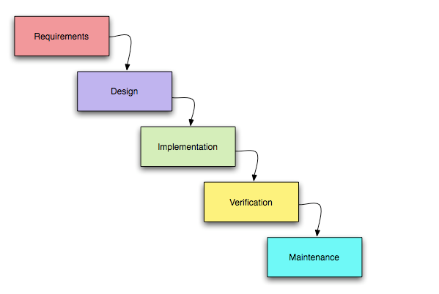

Figure 1: Waterfall Model:

I have chosen waterfall model than agile methodology because agile methodology need very high degree of customer involvement while may create problems for some customers who simply may not have interest. Agile methodology works well when members are completely dedicated or allocated space for the project whereas in waterfall methodology except for reviews and some meetings a customer need not required strictly for entire project. It is so because design is completed early in development lifecycle.

## 3.2 - Design Patterns:

MVC is known as model, view and controller. It is a popular way of organizing code. The vast idea is each section of code has ambition and those ambition are different. This design pattern is a way to neatly organized boxes.

The following figure illustrates the interaction between model, view and controller.

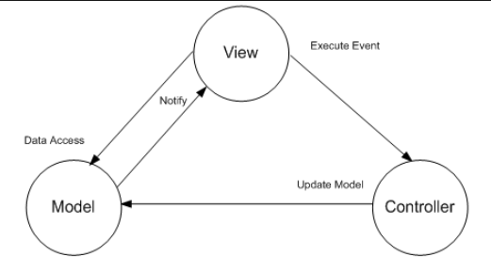

Figure 2: MVC Pattern

Hence, model is a data and business logic, view is a user interface and controller is a request handler.

## 3.3 - Architecture:

Client-server architecture is a network in which clients request and receive service from a centralized server. Server waits for request from clients and then respond to them. Many clients can connect to the one server.

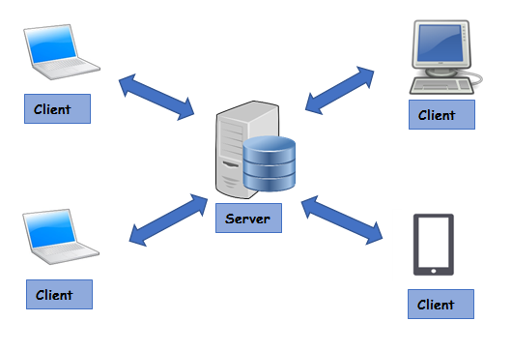

Figure 3: Client-Server Architecture

In the above figure for better knowledge about client-server architecture, we would suppose that client are located in different geographic and are connected via web. This architecture helps to improved data sharing. It also helps to shared resources among different platform so I need this to be in my project. (google, 2019)

# Chapter 4: Project Planning

## 4.1 - Work Breakdown Structure (WBS):

A key project deliverable that organizes the work into manageable sections. (Reddy, 2016) Work breakdown Structure is an easy way to think about a work as an outline map of the specific project. The Work Breakdown Structure of my project is below:

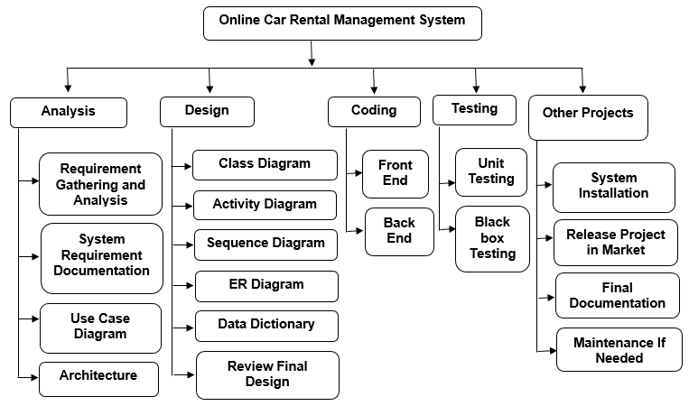

Figure 4: Work Breakdown Structure

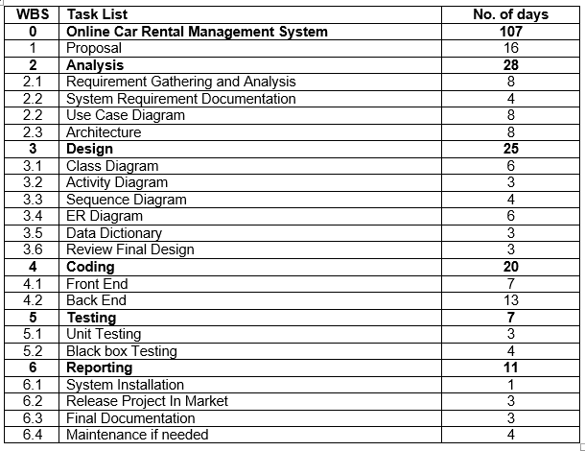

Figure 5: Work Breakdown Structure with time estimate.

Hence, the structure of work breakdown will boost productivity of the project. It allows team to see the delineation of steps which is needed in giving the right products. I will be able to take good action much faster and save project from getting ruined.

## 4.2 - Milestones:

A project milestone is a tool used to delineate a point in a project schedule, where the start and finish date of the project can mark the completion of a major phase of work. Milestones are commonly found in project management software and represent as Gantt chart. The screenshot of milestone is below:

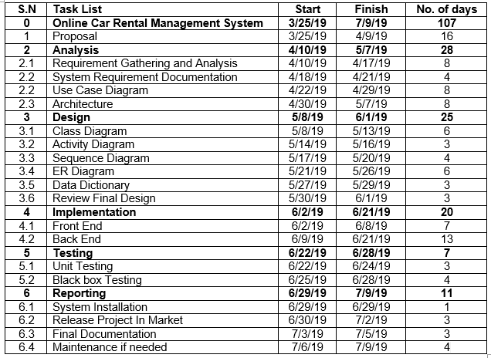

Figure 6: Milestone with day’s details.

According to above milestone table I have given 107 days for my whole online car rental management System. For proposal 16 days, for analysis 28 days where 8 days is separated for requirement gather and the analysis, system requirement documentation for 4 days, Use Case Diagram for 8 days because it has to show the action which will be use by the user on the system and Architecture contains 8 days of the project. For design 25 days is separated because in this phase there will be construction of the diagram which helps us to build a complete system without any error and the user friendly GUI design. For implementation 20 days is separated because there will be the work of coding the system. This phase determines the whole system which the user will be using in the future. For testing 7 days is separated because there will be testing of unit testing and Black box testing. And finally for reporting 11 days because in this phase the final documentation is created and maintenance is done. I have provided more days for analysis because this phase is requirements determination. Least days for testing, check how well the software works or rather the objectives met or not. The starting and ending date also mention in above milestone as start in 25th march 2019 and end in 9th July 2019.

## 4.3 - Gantt chart:

Gantt chart, used in project management use to show activities or tasks displayed against time. On the left of the chart is a list of the activities and along the top is a suitable time scale. (gantt, 2019) Each activity is represented by a bar, the position and length of the bar reflects the start date, duration and end date of the activity. The following Screenshot is my projects Gantt chart.

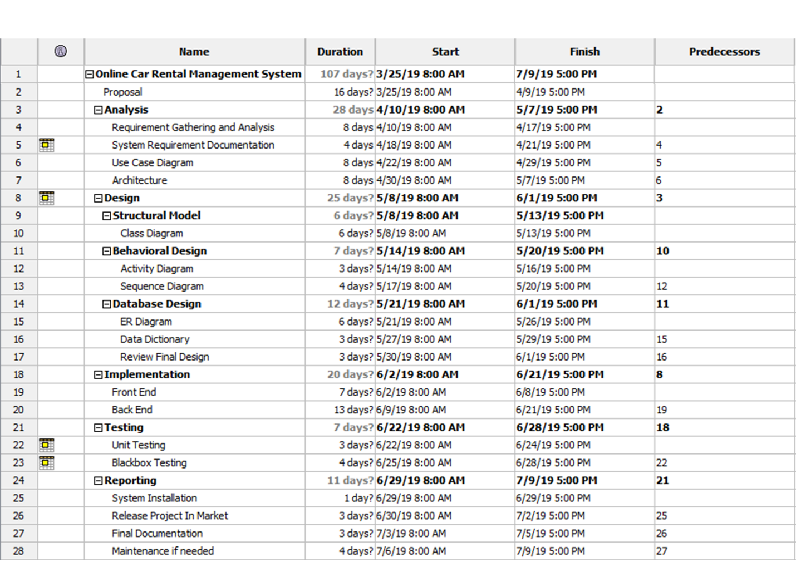

Figure 7: Gantt Chart Table

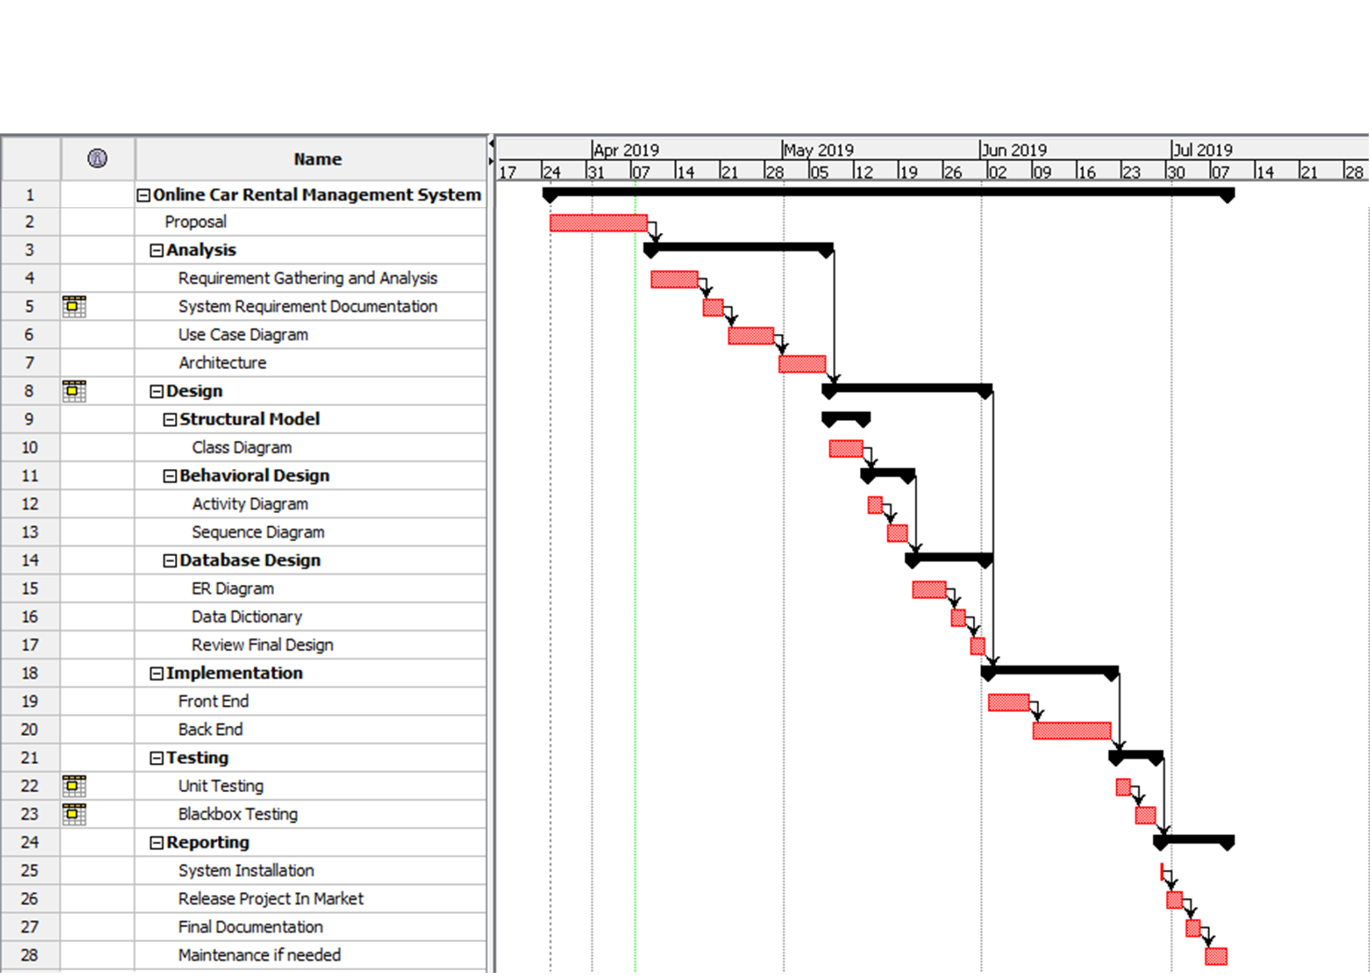

Figure 8: Gantt chart

# Chapter 5: Risk Management:

The process of identifying any potential threats that may occur during the investment process and doing anything possible to mitigate those dangers is known as risk management. Risk management should be part of the panning process to figure out the risk that might be arise in the project. I have chosen qualitative values for likelihood, consequences and risk levels.

|  |  |
| --- | --- |
| **Value** | **Likelihood** |
| **1** | Low |
| **2** | Medium |
| **3** | High |

Fig: Risk Likelihood

|  |  |
| --- | --- |
| **Value** | **Consequences** |
| **1** | Very low |
| **2** | Low |
| **3** | Medium |
| **4** | High |
| **5** | Very High |

Fig: Risk Consequences

The formula use to identify the impact is:

**Impact = Likelihood X Consequences**

|  |  |  |  |  |  |  |
| --- | --- | --- | --- | --- | --- | --- |
| **S.N** | **Risk** | **Likelihood** | **Consequences** | **Impact** | **Action** | **Remarks** |
| **1** | Software crash | 1 | 5 | 5 | Backup is data should be kept. |  |
| **2** | Unauthorized Access | 2 | 4 | 8 | Encrypted data is needed. |  |
| **3** | Hardware failure | 2 | 4 | 8 | Hardware should maintain time to time. |  |
| **4** | Technical risk | 2 | 3 | 6 | Latest technology should be introduce. |  |
| **5** | Human mistakes | 2 | 5 | 10 | Training should maintain. |  |
| **6** | Dos Attack | 2 | 4 | 8 | Firewall should be install. |  |

# Chapter 6: Configuration Management:

Configuration management should be practice so that baselines are identified and changes are tracked to those baselines for system from the moment any work on the software begins when support ceases. It must not delay or impede the rapid software development schedule necessary to meet harsh condition to people needs. My project is in local disk D as CP_project.

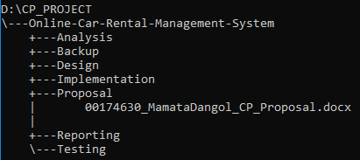

Figure 9: Project Directory

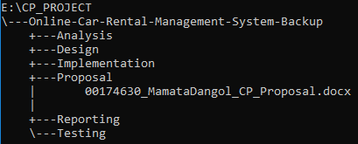

Figure 10: Project Backup Directory

I have create backup in disk E for save from data loss and hardware failure.

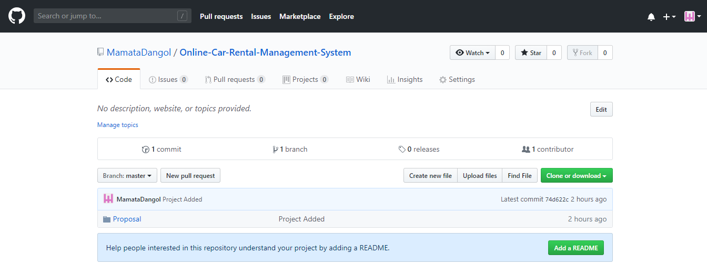

Figure 11: Github Profile

I have also backup my project online in GitHub. GitHub is the version control system where developers store their project and network likeminded people.

**GitHub Profile Name:** https://github.com/MamataDangol

**GitHub repository profile**: <https://github.com/MamataDangol/Online-Car-Rental-Management-System>

# Conclusion:

Hence, this system is all about user friendly, user helpful, easy to use and computerized management system which is the priority of today’s generation. This project is need of the current generation. I think online car rental management system has not been used too much in the context of Nepal so I decided to create this system. I will include save customer’s profile for future so that if they revisit the system they can directly enter their username and password for smooth running of the system.

# References

gantt, 2019. *What is a Gantt Chart? Gantt Chart Software, Information, and History.* [Online]   
Available at: https://www.gantt.com/

google, 2019. *client-server Architecture.* [Online]   
Available at: https://sites.google.com/site/clientserverarchitecture/advantages-of-client-server-architecture

Naulla, R. H., 2019. [Online]   
Available at: https://www.scribd.com/document/307500542/Car-Renting-Management-System-Proposal

Reddy, C., 2016. *Wise Step.* [Online]   
Available at: https://content.wisestep.com/work-breakdown-structure-advantages-disadvantages/