# Design

Design, the third phase of software development life cycle. The objective of this phase is to transform business requirements identified during previous phases, into detailed system architecture which is feasible and valuable to organization. This system will provide the benefit for the customers, car owners and Car Rental Organization. Currently available system is providing the rental process between the customers and CarRental Organization. The objective of this phase is to transform business **requirements** identified during previous phases, into a **detailed**system architecture which is **feasible, robust** and brings **value**to the **organization.**

## 3.1 – Structural Design

Design phase is third phase in SDLC model. This phase details and describes necessary features, operations and specification that will justify the proposed functional requirements. The design constructed in this phase will be later implemented in the implementation phase. The system is graphically represented for better understanding and sight of the context and the system. It helps to build architecture of the system. Once the designs are approved it is documented and directed towards development. There are many design models available, for this project I will be using the models are: Structural Model, Behavioral Model, Database Model, UI design.

### 3.1.1 – Class Diagram

### 3.1.2 – Flow chart

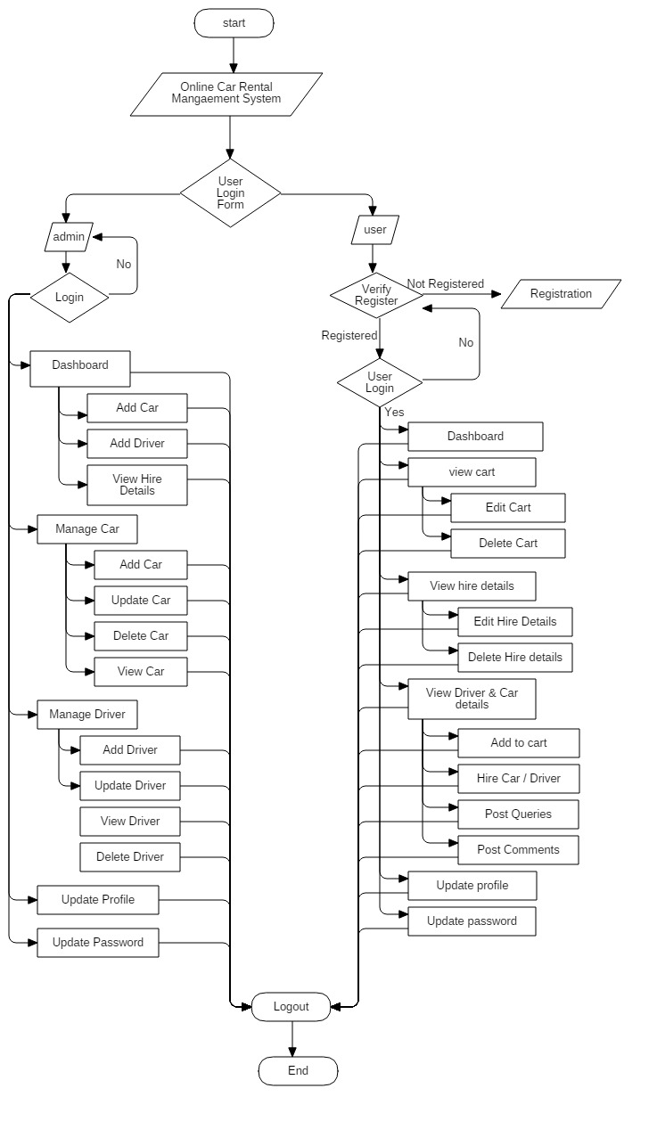

## 3.2 – Behavioral Design

### 3.2.1 – Activity DiagramC:\Users\Mamata Dangol\AppData\Local\Microsoft\Windows\INetCache\Content.Word\Activity Diagram Admin.jpg

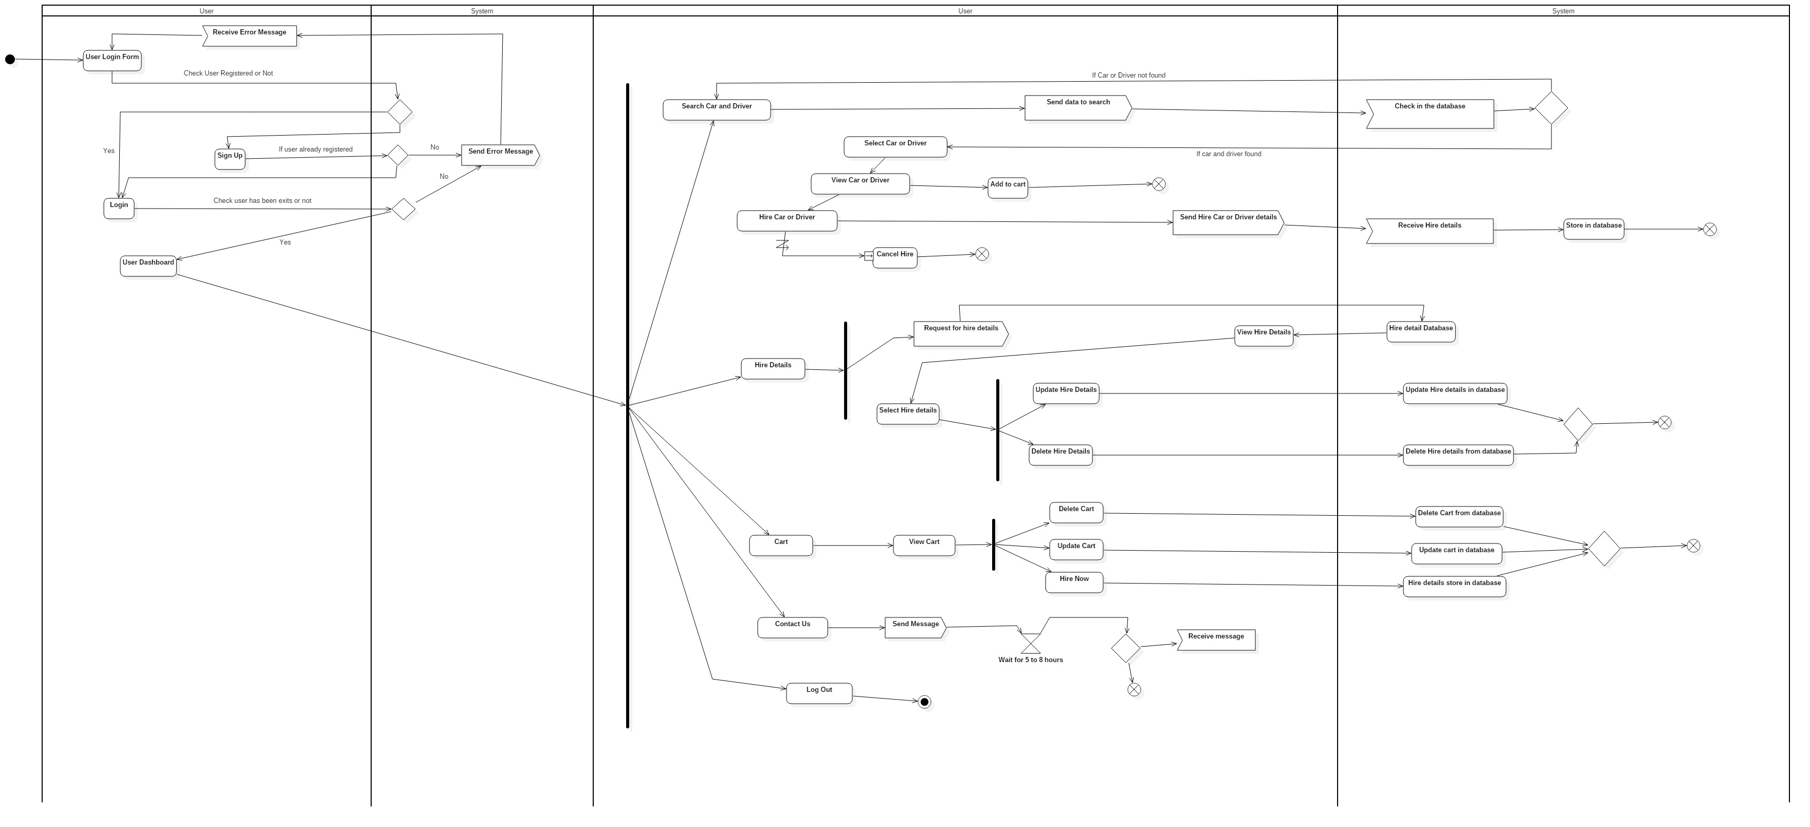

### 3.2.2 – Sequence Diagram

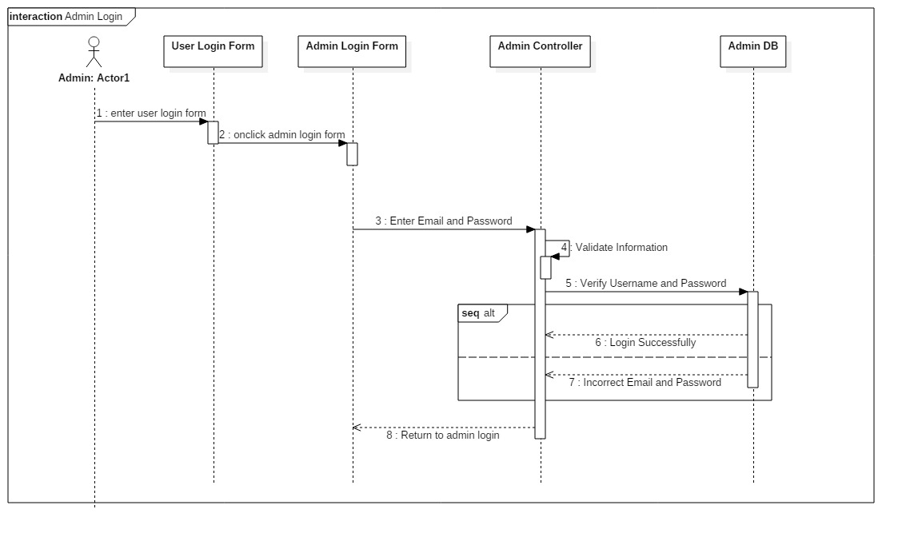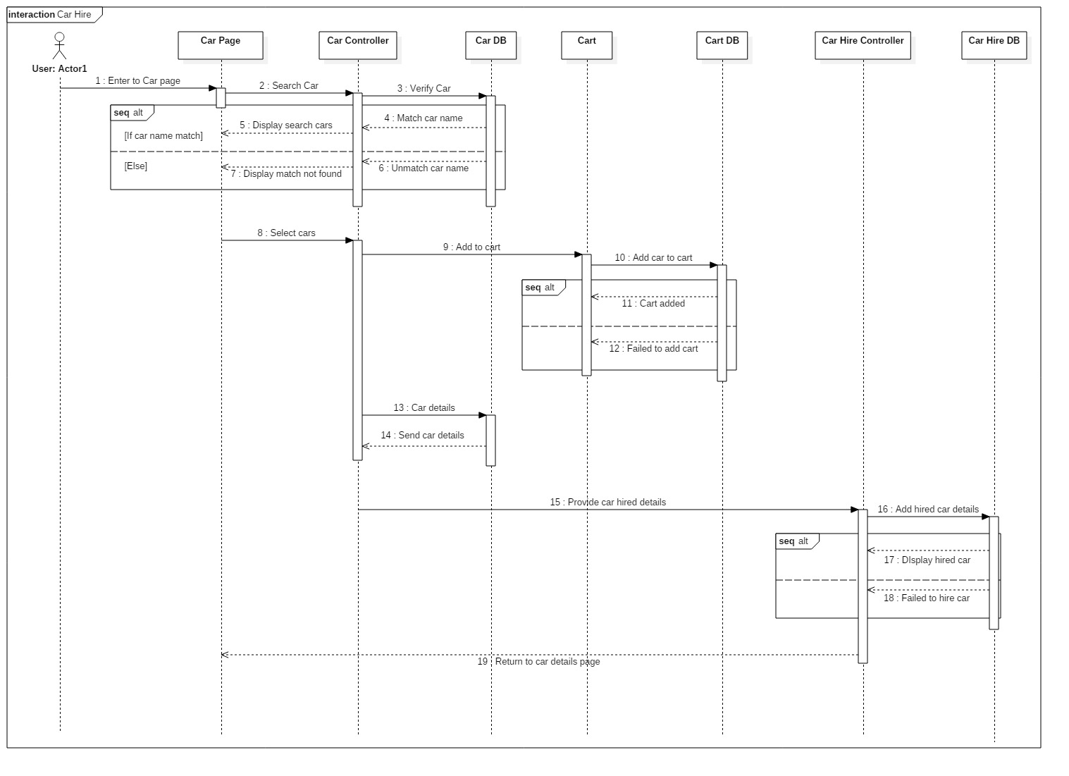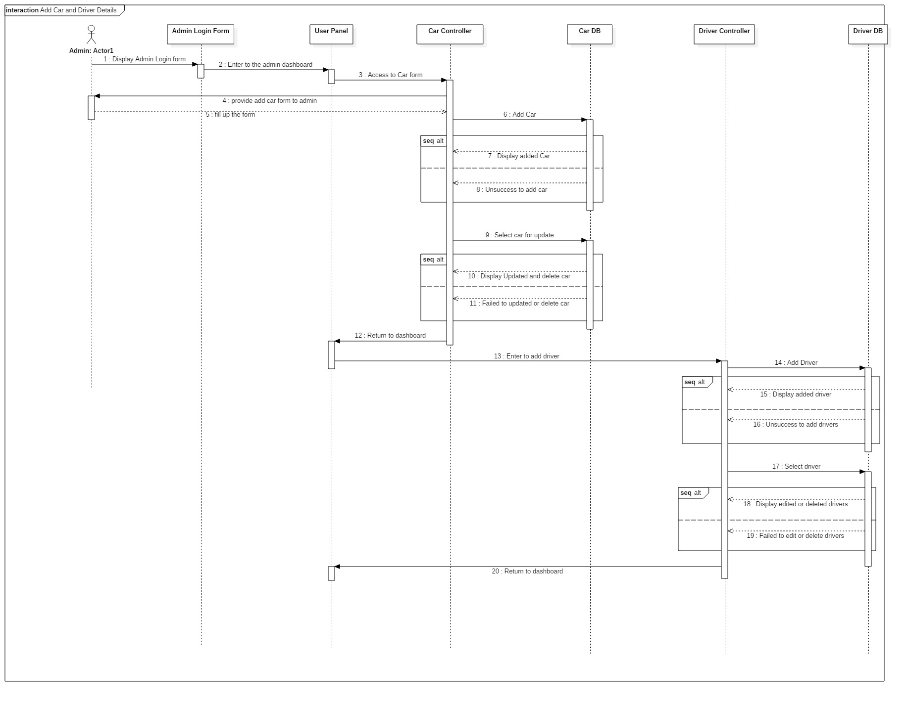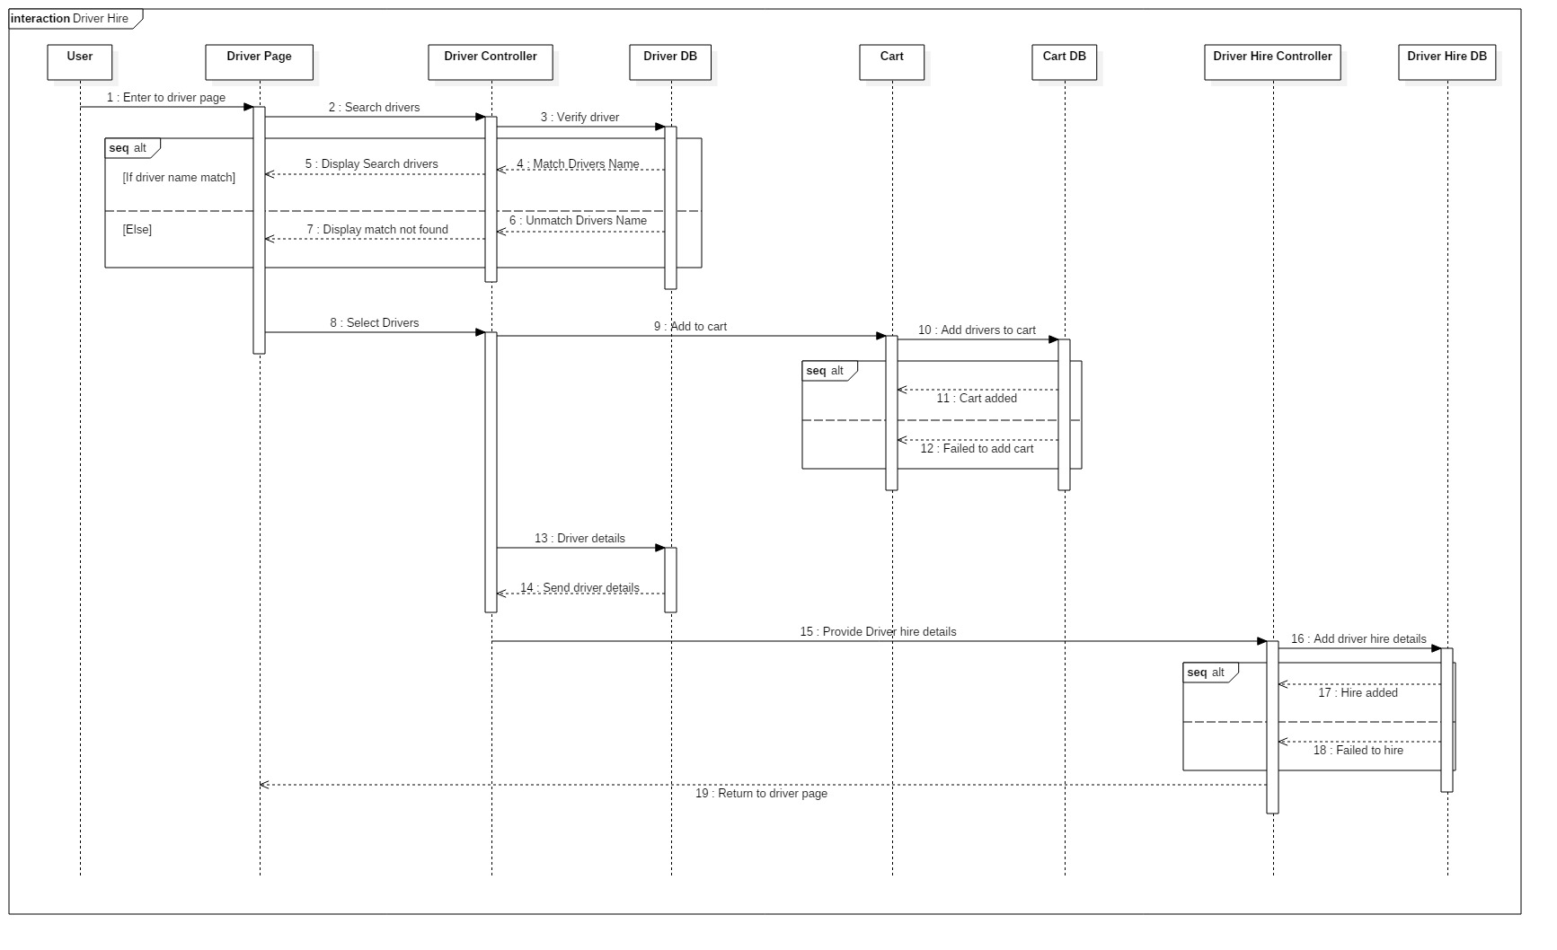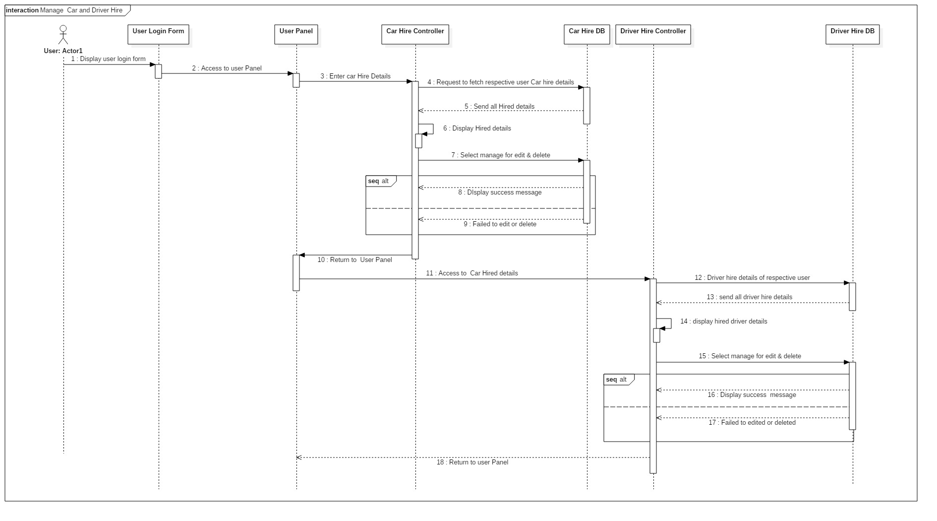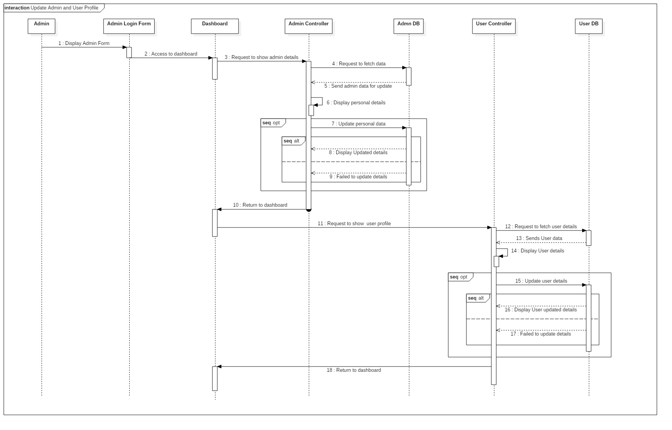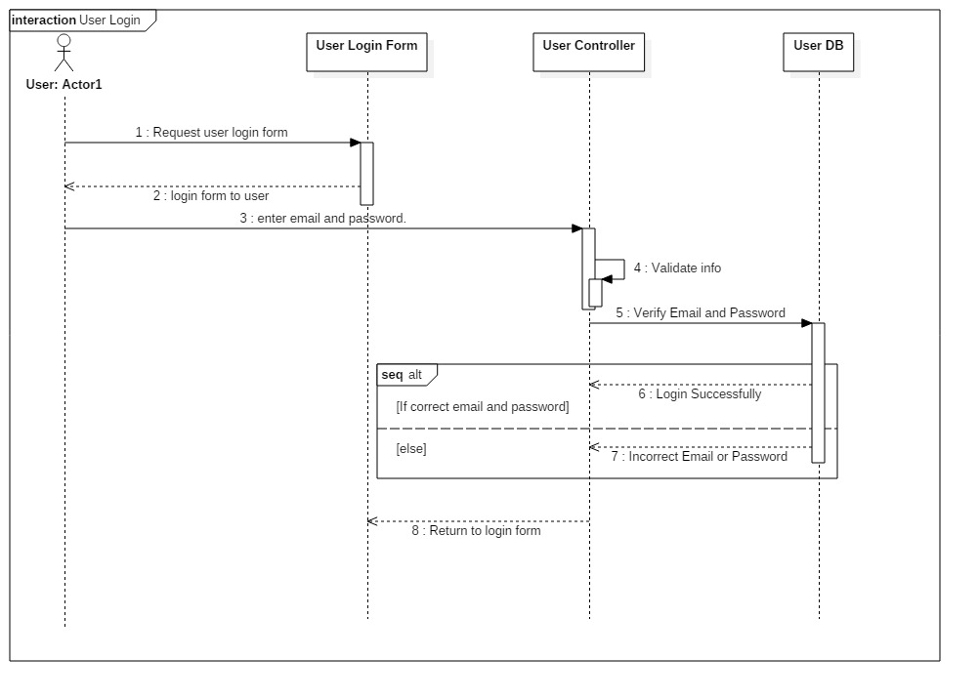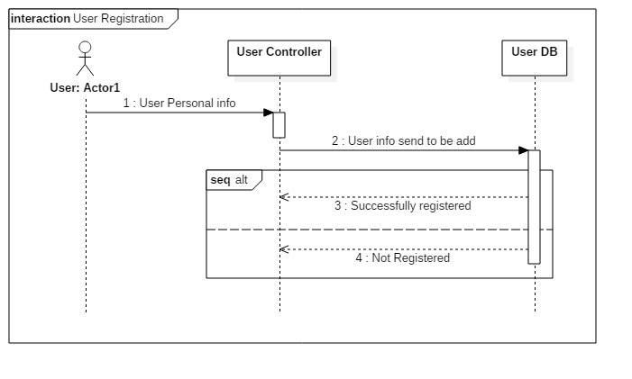

## 3.3 – Database Modeling

### 3.3.1 – Data Dictionary

Data dictionary is a set of files that includes a database’s metadata. It contains record about other objects in the database. It is used to confirming data requirements and for database developers to create and maintain a database system. The data type used in data dictionary are integer, date, varchar and time. I have separated the primary key and foreign key of the entities and also the maximum length. The data dictionary I have created for my project are below:

|  |  |  |  |  |
| --- | --- | --- | --- | --- |
| **Car Table** | | | | |
| **Column Name** | **Data Type** | **Primary Key** | **Foreign Key** | **Nullable** |
| car_id | integer(10) | Yes | No | No |
| model | varchar(100) | No | No | Yes |
| brand | varchar(100) | No | No | Yes |
| type | varchar(100) | No | No | Yes |
| No_of_doors | varchar(100) | No | No | Yes |
| No_of_seats | varchar(100) | No | No | Yes |
| luggage | varchar(100) | No | No | Yes |
| transmission | varchar(100) | No | No | Yes |
| mileage | varchar(100) | No | No | Yes |
| Air_conditioner | varchar(100) | No | No | Yes |
| Engine | varchar(100) | No | No | Yes |
| Fuel_type | varchar(100) | No | No | Yes |
| image | varchar(100) | No | No | Yes |
| Price | varchar(100) | No | No | Yes |
| date | date | No | No | Yes |
| Admin_id | Integer(10) | No | Yes | No |

|  |  |  |  |  |
| --- | --- | --- | --- | --- |
| **Driver Table** | | | | |
| **Column Name** | **Data Type** | **Primary Key** | **Foreign Key** | **Nullable** |
| Driver_id | integer(10) | Yes | No | No |
| First_name | varchar(100) | No | No | Yes |
| Last_name | varchar(100) | No | No | Yes |
| Date_of_birth | Date | No | No | Yes |
| Age | integer(10) | No | No | Yes |
| Phone_no | varchar(100) | No | No | Yes |
| Liscence_no | varchar(100) | No | No | Yes |
| address | varchar(100) | No | No | Yes |
| Image | varchar(100) | No | No | Yes |
| price | varchar(100) | No | No | Yes |
| date | date | No | No | Yes |
| Admin_id | Integer(10) | No | Yes | No |

|  |  |  |  |  |
| --- | --- | --- | --- | --- |
| **Car Hire Table** | | | | |
| **Column Name** | **Data Type** | **Primary Key** | **Foreign Key** | **Nullable** |
| Car_hire_id | integer(10) | Yes | No | No |
| From_location | Varchar(100) | No | No | Yes |
| Pick_up | date | No | No | Yes |
| Pick_up_time | time | No | No | Yes |
| To_location | varchar(100) | No | No | Yes |
| Drop_off | Date | No | No | Yes |
| Price | varchar(100) | No | No | Yes |
| Date | date | No | No | Yes |
| User_id | integer(10) | No | Yes | No |
| Car_id | integer(10) | No | Yes | No |

|  |  |  |  |  |
| --- | --- | --- | --- | --- |
| **User Table** | | | | |
| **Column Name** | **Data Type** | **Primary Key** | **Foreign Key** | **Nullable** |
| user_id | integer(10) | Yes | No | No |
| First_name | varchar(100) | No | No | Yes |
| Last_name | varchar(100) | No | No | Yes |
| Address | varchar(100) | No | No | Yes |
| Email | varchar(100) | No | No | Yes |
| Password | varchar(100) | No | No | Yes |
| gender | varchar(100) | No | No | Yes |
| Phone_number | varchar(100) | No | No | Yes |

|  |  |  |  |  |
| --- | --- | --- | --- | --- |
| **Driver Hire Table** | | | | |
| **Column Name** | **Data Type** | **Primary Key** | **Foreign Key** | **Nullable** |
| Driver_hire_id | integer(10) | Yes | No | No |
| Car_model | Varchar(100) | No | No | Yes |
| From_location | Varchar(100) | No | No | Yes |
| Pick_up | date | No | No | Yes |
| Pick_up_time | time | No | No | Yes |
| To_location | varchar(100) | No | No | Yes |
| Drop_off | date | No | No | Yes |
| price | Varchar(100) | No | No | Yes |
| date | date | No | No | Yes |
| User_id | integer(10) | No | Yes | No |
| Driver_id | integer(10) | No | Yes | No |

|  |  |  |  |  |
| --- | --- | --- | --- | --- |
| **Admin Table** | | | | |
| **Column Name** | **Data Type** | **Primary Key** | **Foreign Key** | **Nullable** |
| admin_id | integer(10) | Yes | No | No |
| username | varchar(100) | No | No | Yes |
| password | varchar(100) | No | No | Yes |
| email | Varchar(100) | No | No | Yes |
| Phone_number | Varchar(100) | No | No | No |
| gender | Varchar(100) | No | No | Yes |

|  |  |  |  |  |
| --- | --- | --- | --- | --- |
| **Question Table** | | | | |
| **Column Name** | **Data Type** | **Primary Key** | **Foreign Key** | **Nullable** |
| Question_id | integer(10) | Yes | No | No |
| Question | varchar(100) | No | No | Yes |
| Date | date | No | No | Yes |
| User_id | varchar(100) | No | Yes | No |

|  |  |  |  |  |
| --- | --- | --- | --- | --- |
| **Comment Table** | | | | |
| **Column Name** | **Data Type** | **Primary Key** | **Foreign Key** | **Nullable** |
| Comment_id | integer(10) | PK | No | No |
| Comment | varchar(100) | No | No | Yes |
| Date | Date | No | No | Yes |
| User_id | integer(10) | No | Yes | No |
| question_id | integer(10) | No | Yes | No |

|  |  |  |  |  |
| --- | --- | --- | --- | --- |
| **Cart Table** | | | | |
| **Column Name** | **Data Type** | **Primary Key** | **Foreign Key** | **Nullable** |
| Cart_id | integer(10) | Yes | No | No |
| driver_id | Integer(10) | No | Yes | No |
| car_id | integer(10) | No | Yes | No |

### 3.3.2 – ER-Diagram

An Entity Relationship diagram manifest the relationship of entity sets stored in a database. It is a representation of data within a domain. An entity is identifying by extracting objects that are relevant and meaningful to the problem domain and the system to be develop. In entity relation modelling, the term entity has synonyms “table”, “database table” and “entity-type”.

The notations used in ER diagram are:

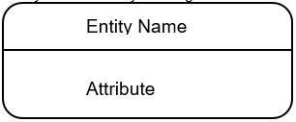

The relations used in ER diagram are:

* One to one 
* One to many 
* Many to many 

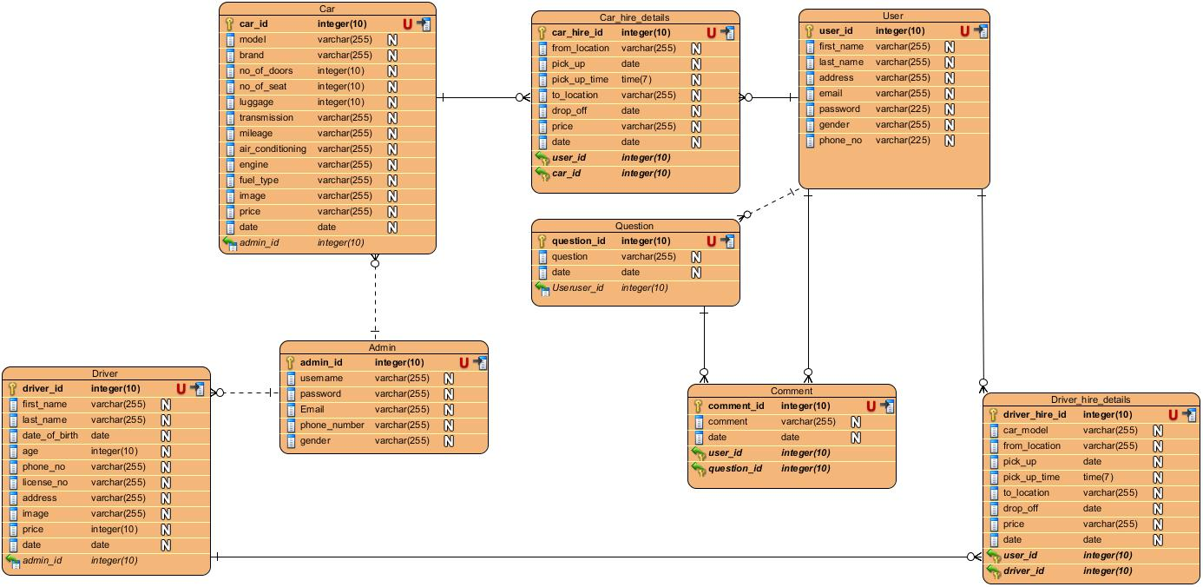

Fig: Entity relation diagram of online car rental management system.

Justification of creating ER diagram in my project are:

1. ER helps to highlights the entities of my system and the relationship between those entities.
2. Helps to reveals if any errors occurs.
3. Helps to visualize how data connected in general ways.
4. The model can be reverse enginerred to create database.
5. It amplify the logical structure of database.

## 3.4 – Architecture Diagram

## 3.5 – Prototype Design

