# Introduction

Technology, a human life easier word. By some clicks only, we can get what we want at any place. We already know about online shopping, e-commerce etc. similarly, this project is about to create online Car Renting management System for business. This system will be web based application. It will contain two parts with the purpose of customer and user. This will be most helpful to find out the details of car and reserve by customer. Customer can log in to the system and search for desired vehicle and book them for renting. On the view to business they can update details about new cars, payment details and so on. This system will help people to save their valuable time and make life easier.

# Background of the project:

This time is an era of interact with internet technology as World Wide Web (WWW).Most in past people visit the company by travelling company to reserve the vehicles so that they ship their valuable and important work. And also waste their time when they do not match their needs in that company. They again have to reach next company to hire a car or vehicle so this is the reasons this project have to succeed. This will really help to search and reserve the car by sitting home. This system is user friendly. Business view also lots of mistakes occurs when the system is not execute. The messy clients or customers records which is hard to submit if the boss of the company ask for any of the clients details the staff have to look all record which is loss of time efforts, leads to loss of business.

# Problem Statement

The current system has storing problem due to paperwork, manual system. Due to the manual system recording the data security is not assured.it can be easily damage or misplaced by anything or anyone. Some of the problem are also describe below:

## Performance to the administration user:

Since the car management performs recording manually, it consumes much time. Data retrieving and searching mechanisms cannot perform well.

Information of customers:

### Input:

Data collection is not based on timely manner.

Manual system is difficult to add, replace, delete and edit the needed information.

Validity checking cannot perform.

### Output:

Since the information is not accurate the output cannot be precise and on time.

Hard to check whether the output data is valid or invalid.

# Description of the project

This system is user friendly. It divided into two parts according to user parts and customer parts. System consist of all the required function related to business and the customers. This system will allow user to update the new things like details of car, availability, details of driver etc. whereas in the case of customer they can login and then create or reserve the car by fill in the required form.

# Features of project:

In the case of system administrator:

* Add new vehicles and update vehicles details.

In the case of customer:

* Create profile including basic information.
* Search for the desired car view details.
* View availability of the car
* Reserve the suitable cars and view cost details.
* Leave comments about the service provided.

# Overview of the project

There are many systems for car renting systems but they don’t provide easy search mechanisms for the customer and availability of vehicles and drivers. Also they were not user friendly. Upgrade of existing systems will take unnecessarily long time in the case of expanding of the vehicle.

# Scope of the project

## Scope

Online car rental management system’s functions as a system which storing, processing and handling customer information and the information of the most valuable assets which are the cars for the company. As a security the unregistered members or users are restricted to view, update or delete any information about the registered member’s information such as car reservation history.

## Limitations:

* Restricts only banking transaction.
* Cash on hired.

## Aims:

* To computerized the system of car management rather than use paperwork.
* Help people to attract towards technology and many their valuable time.
* Supply their desired car in flexible price.

## Objectives:

* To transfer manual process of car hiring into computerized process.
* To provide the complete functionality of listing and booking car.
* The user are able to enter the company’s website for searching and reserving their car as per their need.
* View tracking history and update personal information.
* View price as per the cars.
* Also can post complains, suggestions, and comments how they feel.
* Allow the gift hampers if they hire mostly.
* Allow customer to update their personal detail if necessary with their own valid username and password.
* Allow customer to view the latest promotion and travel guides.

## Overview of the scope:

The propose system are able to allow the company to reply their customer by direct mailing to customers electronic mailbox. The system able to generate reports such as monthly car reservation reports and monthly GPS navigation device reservation reports to the management.

# 

# Development methodology

## Description of methodology chosen:

In this project I will choose waterfall model or also known as System Development Life Cycle. It is often called classic approach to the software development life cycle. The perceived advantages of waterfall model is it allows for departmentalized and managerial control. One disadvantage of this development methodology is once an application is in testing stage it is difficult to go back and change something that was not thought in any stage. This method helps to deliver entire project in time because each phase has been planned in details. The waterfall model are below:

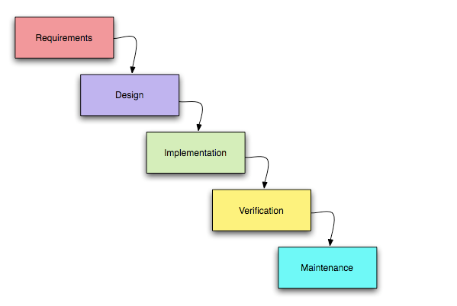

Screenshot: Waterfall Model.

## Design Patterns:

MVC is known as model, view and controller. It is a popular way of organizing code. The vast idea is each section of code has ambition and those ambition are different. This design pattern is a way to neatly organized boxes.

The following figure illustrates the interaction between model, view and controller.

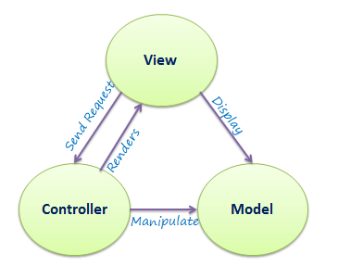

Hence, model is a data and business logic, view is a user interface and controller is a request handler.

Screenshot: MVC Architecture.

## Architecture:

Client-server architecture is a network in which clients request and receive service from a centralized server. Server waits for request from clients and then respond to them. Many clients can connect to the one server.

# Project Planning

## Work Breakdown Structure (WBS):

A key project deliverable that organizes the work into manageable sections. Work breakdown Structure is an easy way to think about a work as an outline map of the specific project.

The Work Breakdown Structure of my project is below:

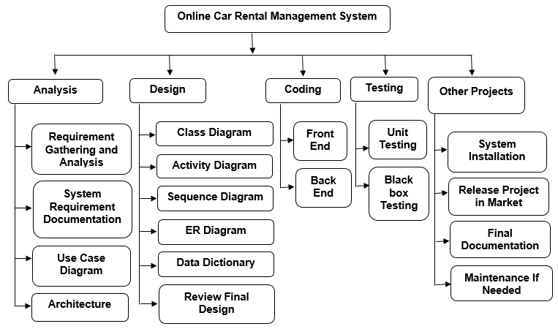

Screenshot: Work Breakdown Structure

With Time estimated:

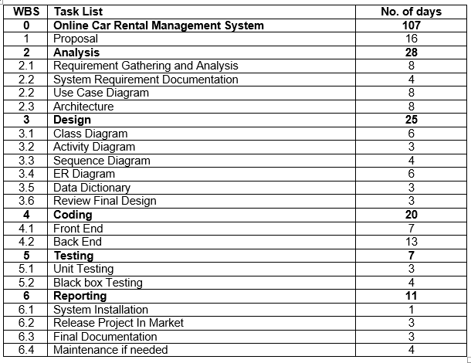

Screenshot: Work Breakdown Structure with time estimate.

## Milestones:

A project milestone is a tool used to delineate a point in a project schedule, where the start and finish date of the project can mark the completion of a major phase of work. Milestones are commonly found in project management software and represent as Gantt chart.

|  |  |
| --- | --- |
| Milestones | Delivery Dates |
| Project Proposal | 9th April 2019 |
| Analysis | 7th May 2019 |
| Design | 1st June 2019 |
| Implementation | 21st June 2019 |
| Testing | 28th June 2019 |
| Reporting | 9th July 2019 |

## Gantt chart:

Gantt chart, used in project management use to show activities or tasks displayed against time. On the left of the chart is a list of the activities and along the top is a suitable time scale. Each activity is represented by a bar, the position and length of the bar reflects the start date, duration and end date of the activity. The following Screenshot is my projects Gantt chart.

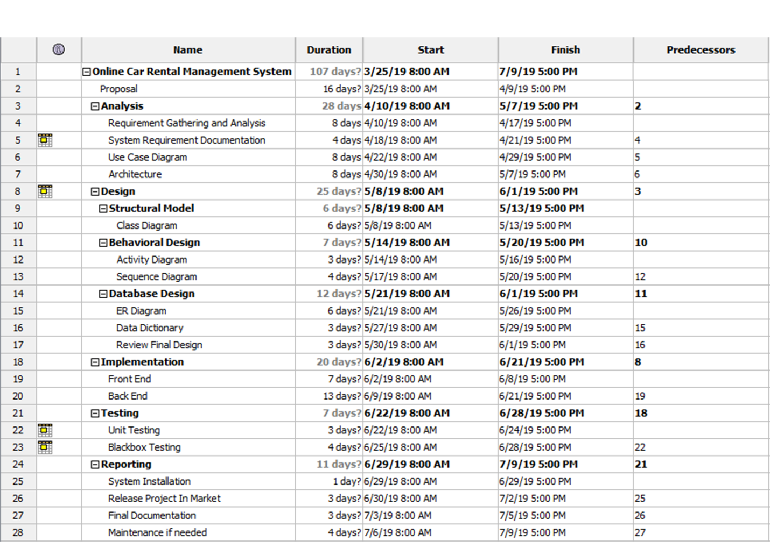

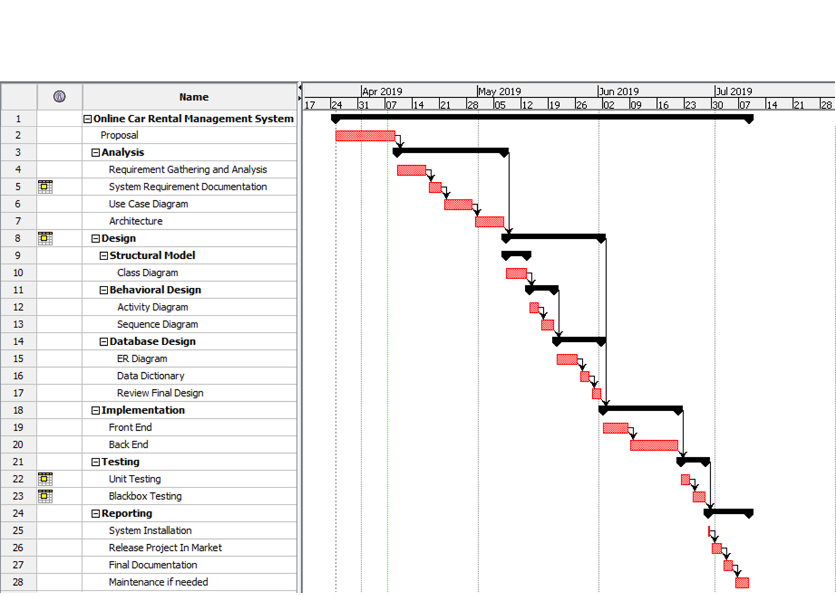

Screenshot: Gantt Chart

# Risk Management:

The process of identifying any potential threats that may occur during the investment process and doing anything possible to mitigate those dangers.

|  |  |
| --- | --- |
| **Value** | **Likelihood** |
| **1** | Low |
| **2** | Medium |
| **3** | High |

Fig: Risk Likelihood

|  |  |
| --- | --- |
| **Value** | **Consequences** |
| **1** | Very low |
| **2** | Low |
| **3** | Medium |
| **4** | High |
| **5** | Very High |

Fig: Risk Consequences

|  |  |  |  |  |  |
| --- | --- | --- | --- | --- | --- |
| **S.N** | **Risk** | **Likelihood** | **Consequences** | **Impact** | **Action** |
| **1** | Software crash | 1 | 5 | 5 |  |
| **2** | Unauthorized Access | 2 | 4 | 8 |  |
| **3** | Hardware failure | 2 | 4 | 8 |  |
| **4** | Technical risk | 2 | 3 | 6 |  |
| **5** | Human mistakes | 2 | 5 | 10 |  |
| **6** | Dos Attack | 2 | 4 | 8 |  |

# Configuration Management:

Configuration management should be practice so that baselines are identified and changes are tracked to those baselines for system from the moment any work on the software begins when support ceases. It must not delay or impede the rapid software development schedule necessary to meet harsh condition to people needs.

# Conclusion:

Hence, this system is all about user friendly, user helpful, easy to use and computerized management system which is the priority of today’s generation. This project is need of the current generation. I think online car rental management system has not been used too much in the context of Nepal so I decided to create this system.

# References and Bibliography: