# https://softwarica.edu.np/wp-content/uploads/2019/01/cropped-Softwarica-logo.png

**Smart Aquarium**

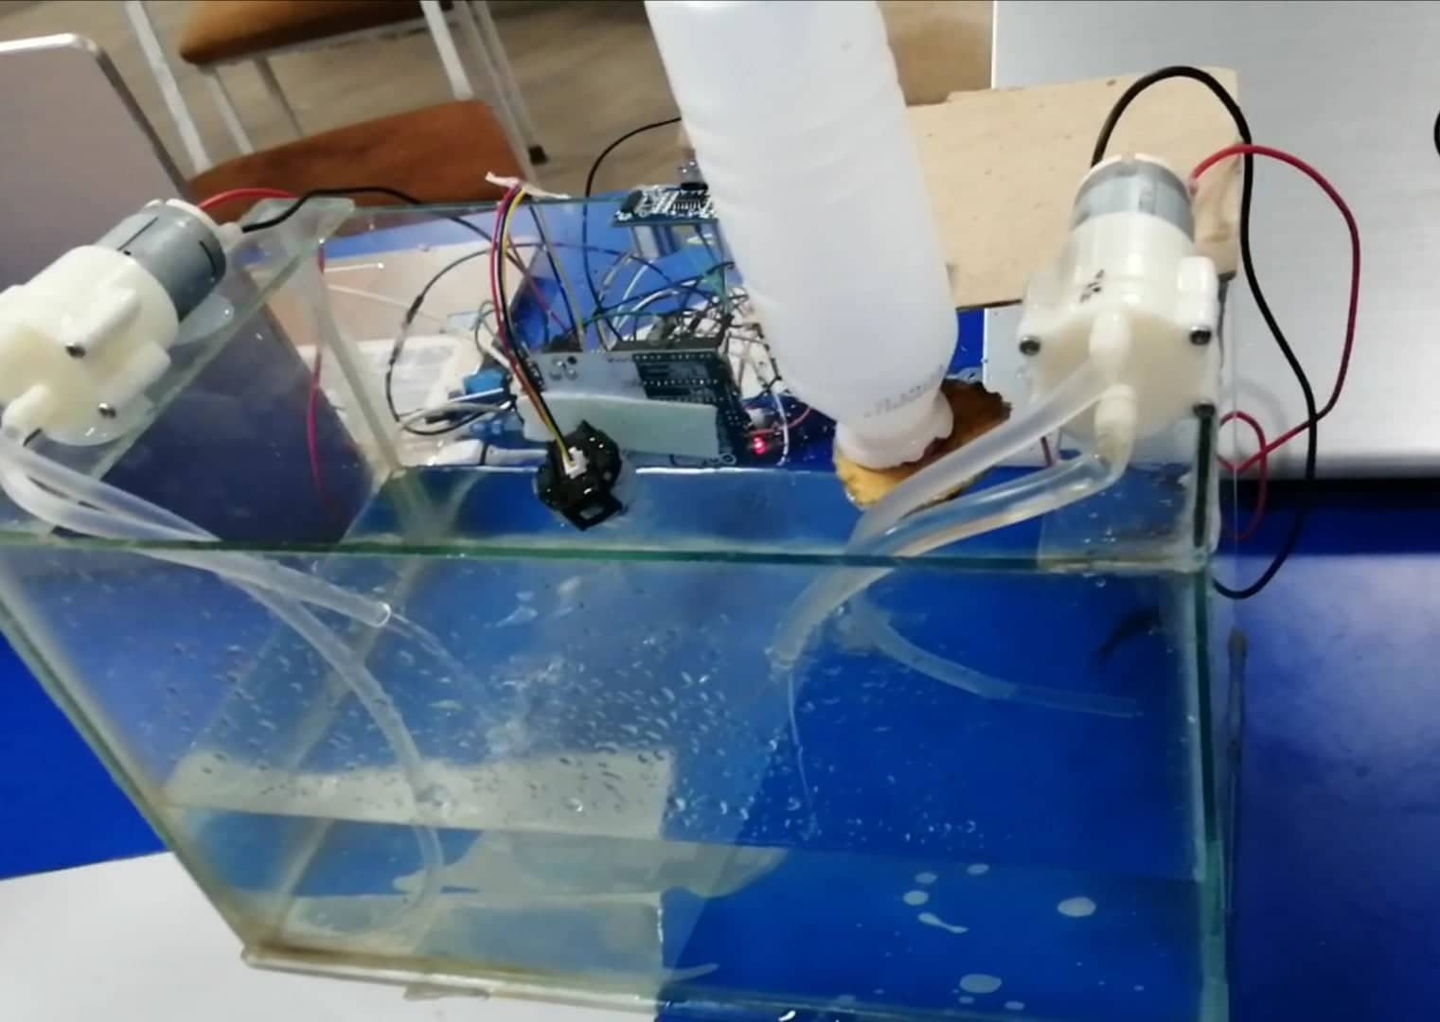

**Module: STW307CR-Interactive Pervasive Computing**

**Softwarica college of IT and E-Commerce**

**Dillibazar, Kathmandu, Nepal**

**Submitted by: Submitted to:**

**Devish Baidawar Chhetri Manoj Shrestha**

**Deepak Maharjan**

**Mamata Dangol**

**Saugat Subedi**

**Anish Kumar Thakur**

**November Batch C (22 C)**

Table of Contents

1. Introduction 3

1.1. Aims 3

1.2. Objectives 3

2. Research and background 3

3. Justification 3

4. System design and implementation 7

1.1. Devices and sensors used in the prototype 8

1.2. The build or circuit layout 11

1.3. Sketch 14

1.4. How it works 16

5. Development 16

6.1. Risk analysis and plan 16

6.2. Project Plan 18

6.3. Gantt Chart 19

6. Testing 20

7. Privacy and Ethics 21

8. Personal Challenges 21

9. Conclusion 22

10. References 22

Figure 1: Problem of changing water and solution is turbidity sensor. 5

Figure 2: ultrasonic detect water level and throw dirty water 6

Figure 3: Light on off through LDR sensor 6

Figure 4: Servo motors feed fish automatically. 7

Figure 5: Arudino 8

Figure 6:Breadboard 8

Figure 7:Turbidity Sensor 9

Figure 8: Ultrasonic Sensor 9

Figure 9: Servo Motor 10

Figure 10: Node mcu 10

Figure 11: Water Pump 11

Figure 12: Relay 11

Figure 13: Circuit Diagram 12

Figure 14: Sketch 15

Figure 15:Risk Matrics 16

Figure 16:Risk Log 17

Figure 17: Gantt Chart 18

# Introduction

Fish aquarium is a trendy topic among all as a hobby and also as an eye-pleasing apparatus. The aquarium system found in market is simple and the owner has to work manually to maintain the aquarium. It shows house beautiful and charm but it’s hard to maintain. It’s difficult to feed fish manually and check the water dust for the people of busy scheduled. The risk of forgetting to feed fish arises and chances of loss fish.

To overcome the problems of keeping aquarium home, the smart aquarium have to develop which is eye catchy and automatic in terms of fish feeding, water level detect, dust detect and also automatic light turn on/off. Smart aquarium is developed by keeping mind about the busy people who can’t separate time to take care about fish.

## 1.1 Aims

The aim of the smart aquarium is to replace the manual task to take care of fish to smart automated system which help to make life easier.

## Objectives

1. To design and construct an automatic aquarium with automatic feeder, water changer and LCD display.
2. Helps to them who cannot keep an eye on their on fish daily.
3. Provide a food supplier system.
4. Save time and utilized in other work.

# Research and background

In this modern age everyone needs aquarium for their home. But, maintaining aquarium is hard and refuses the idea to buy aquarium. The research I have done shows the difficulties to maintain aquarium is too many. Some of the difficulties are feeding the fish manually and change or check the water condition. Therefore, the aquarium needs to be smart. Here we have implement the system based on IOT which monitor and control the entire aquarium through our smart phone application. The system measures the quality of water and maintains it to ideal condition. The smart aquarium does all task automatic and feed the fish through our phone whenever we press the button on phone through the application.

# Justification

Owning an aquarium is an extra work to the owner itself. The owner have to separate a time from their daily life for the care of the fishes. As fishes in an aquarium are very fragile they need continuous and proper care. Irresponsible care and negligence towards the fish can result in death of the fish. Timely water change is compulsory for the fish, feeding the fish in time, such activities should be carried out with diligence.

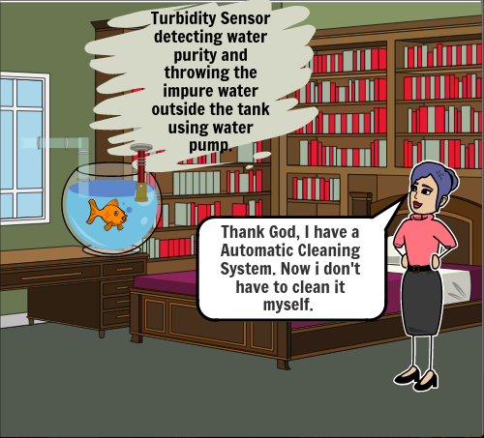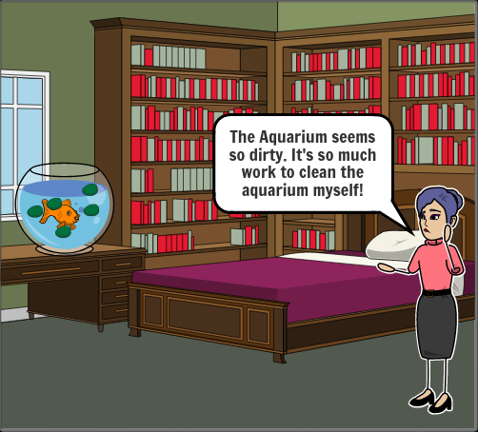

Figure : Problem of changing water and solution is turbidity sensor.

The first image displays, the fish tank being dirty. With such problem there may be a problem of the fish being sick so urgent change of water is a must.

Relating to the first problem, Second picture shows the problem being solved using Turbidity Sensor. It Detects the water purity and impurity and when the water impurity rate reached to a defined rate, Automatically a motor attached to the turbidity sensor starts functioning and starts throwing water from the tank.

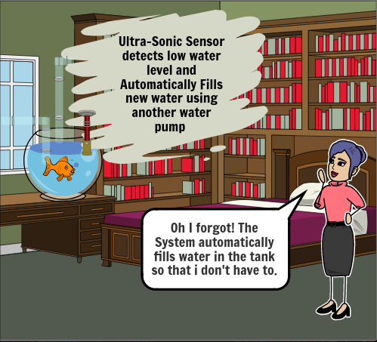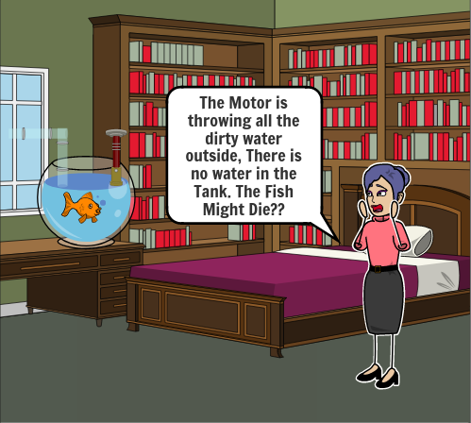

Figure : ultrasonic detect water level and throw dirty water

In the second scene, The first picture shows the turbidity sensor throwing all the dirty water from the tank and making the tank empty which can result in making the life of the fish at risk.

So, in response to the problem the second picture uses a Ultrasonic Sensor to measure the water level in the tank. When the water level of the tank decrease then the fixed level then automatically a different motor attached starts supplying water to the aquarium until the water level meets the required level.

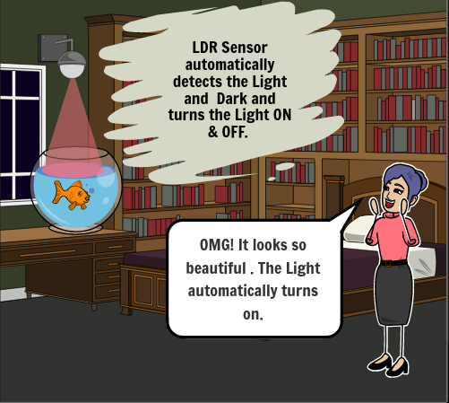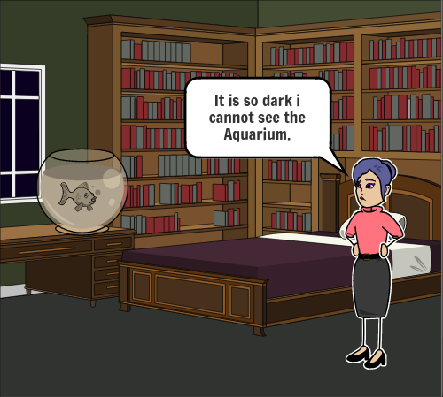

Figure : Light on off through LDR sensor

In the third scene, we can see the first picture being dark and making the owner not being able to see the aquarium. So, in response to the first problem we have used LDR sensor to detect the dark & light room. When the Room becomes dart it automatically lights up the tank with an led and when the room is light it automatically off the led.

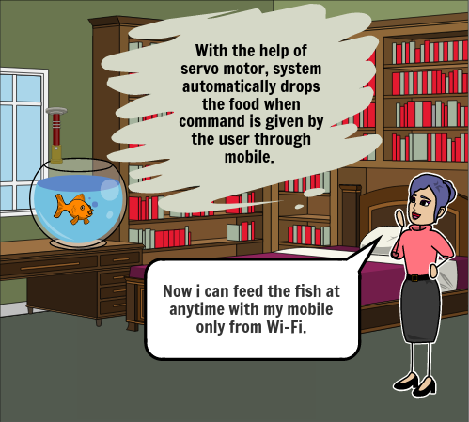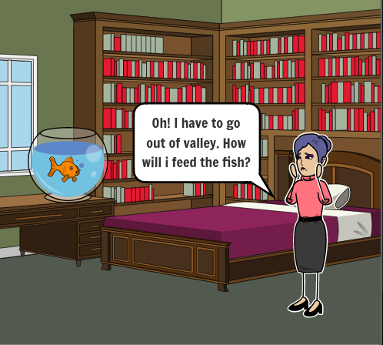

Figure : Servo motors feed fish automatically.

In the fourth scene, We can see that the owner is about to go out of valley leaving the fish alone at the house. The owner is stressing over how to feed the fish because she has no one other to feed the fish.

So, in response to the first image using a servo motor we have created an automatic fish feeder that operates from our mobile through Wi-Fi. Even if the owner is outside the owner can simply access Wi-Fi and press “Feed” in a mobile UI and the servo motor will automatically drop fish food in the tank.

# System design and implementation

The system design is the stage of software development and focused on user requirements and the detailed analysis of the system derived from the implementation of the system. The design of the program effectively transforms the specifications into attainable reality. The goal of this system design is to establish a technical solution that meets the functional requirements. System implementation is the process of defining how the information system should be built.

## 4.1 Devices and sensors used in the prototype

The sensors and the devices used in the project are shown below:

1. **Arudino**

Arduino is an open source platform used to build projects in the field of electronics. Arduino is also called microcontroller. It consists of both a physically programmable circuit board and a piece of software, (Arduino IDE) Integrated Development Environment.

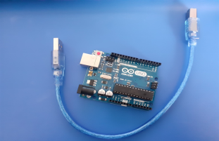

Figure : Arudino

1. **Breadboard**

A thin plastic board used to hold attached wired electronic parts like transistors, resistors, chips etc. the boards are used to build electronic circuit designs, and can be reused for future work. The typically arranged spring clip contacts in matrices with certain blocks of clips are contains in the breadboard.

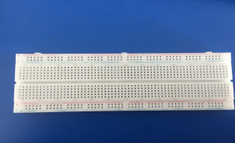

Figure :Breadboard

1. **Turbidity Sensor**

Turbidity sensor detects the impurity of the water. In the smart aquarium the turbidity sensor detects the quality of water and through water pump fill and empty the aquarium.

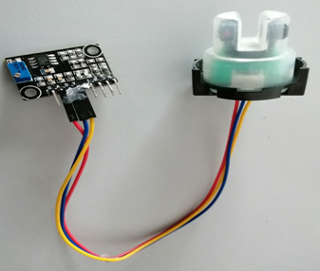

Figure :Turbidity Sensor

1. **Ultrasonic Sensor**

Ultrasonic Sensor measures distance to an objects through sound waves. It measures the distance of water in the aquarium.

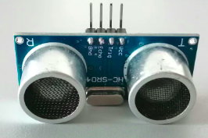

Figure : Ultrasonic Sensor

1. **Servo Motor**

Servo motor is an electronic device which can rotate an object with great accuracy. It helps to rotate the fish feeder at a certain angle or distance as open and close the fish feeder.

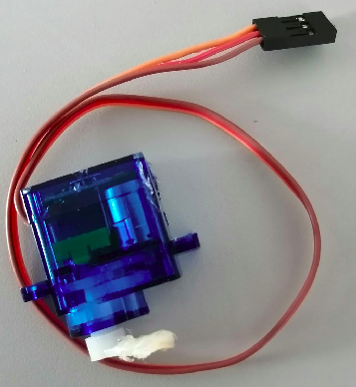

Figure : Servo Motor

1. **Node MCU**

Node MCU is an accessible source and development kit design to help develop the IOT devices. It runs the ESP8266 Wi-Fi SoC from Espressif Systems and hardware which based on ESP-12 module.

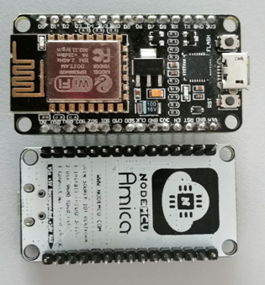

Figure : Node mcu

1. **Water Pump**

Water pump is used in smart aquarium as fill in the water and throw water by sensing the water quality.

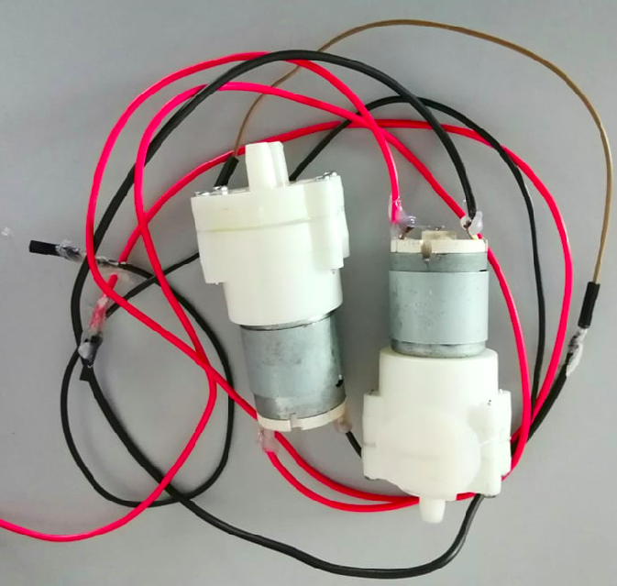

Figure : Water Pump

1. **Relay**

Relay is a device which is controlled electrically. This includes of a series of input series for signal and a set of terminals for operations.

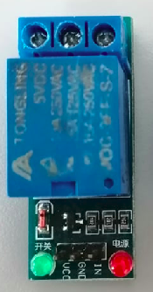

Figure : Relay

## The build or circuit layout

A graphic circuit diagram utilizes graphical circuit diagrams, whereas a schematic diagram displays the circuit modules as typical graphical symbols. Arranging interconnections of the modules on the diagram may not lead to their physical locations in the finished unit. The circuit diagram of the smart aquarium is shown below in different parts:

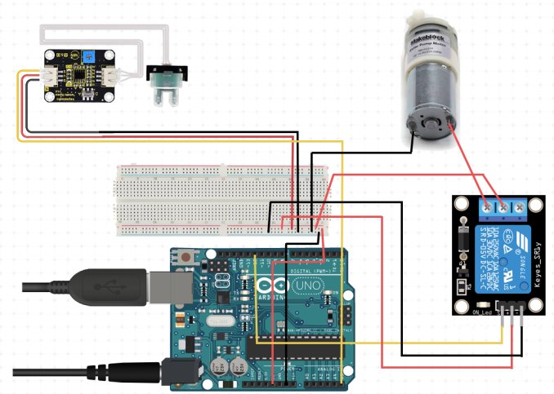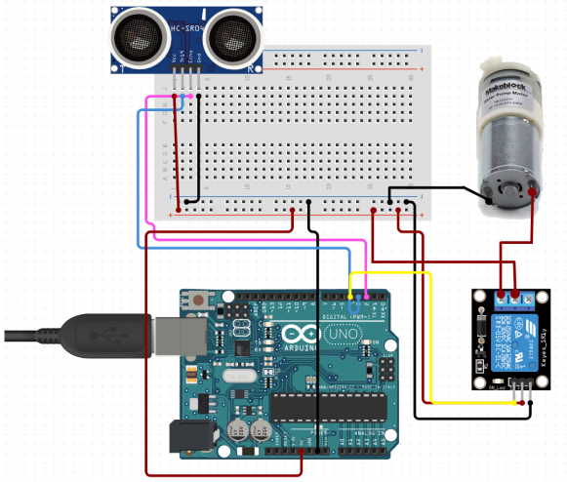

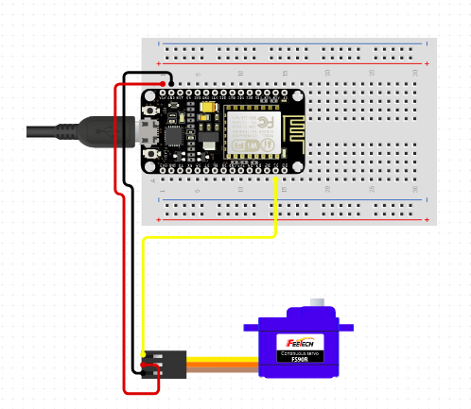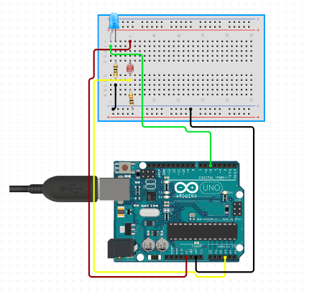

Figure : Circuit Diagram

## Sketch

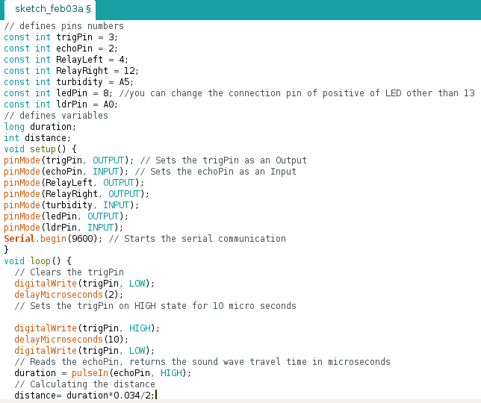

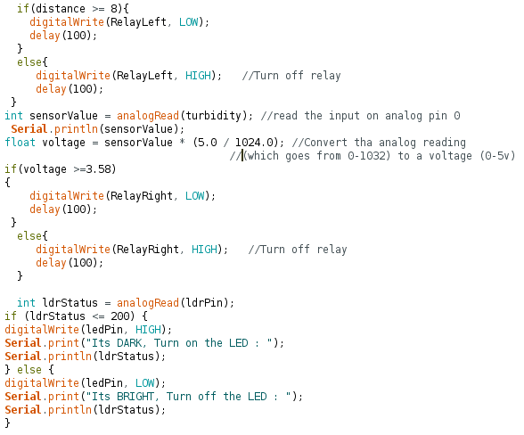

s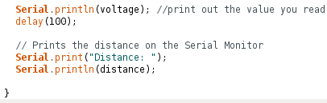

s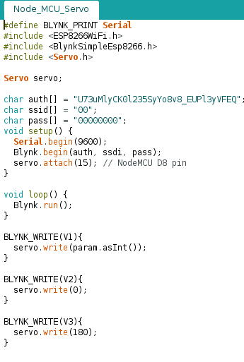

Figure : Sketch

## How it works

The smart aquarium works from the android application built by nodemcu which allows programming our system. Controllers are connected to relay which feeds the fish. NodeMcu connected with server and for android app the blink app which is web based for monitoring and controlled and then works for feed fish.

# Development

## 5.1. Risk analysis and plan

The main risk was to decide the dimensions and design of the mechanical structure of the aquarium. Our objective was to design a light weighted and low cost smart aquarium. The circuit and the sensors that we had to select should not be a heavy and that they could not create any trouble for the fish in the aquarium or fish could not damage them. And also some of other risk analysis which will be chance to be occurs while developing smart aquarium following risk are listed below:-“

* Risk in changing the aquarium water.
* Risk in controlling the turbidity of the water in an aquarium.
* Risk in figuring out when the water is to be filtered.
* Risk in maintaining the temperature of the aquarium.

To minimize the risk of fish keepers or aquarists by shifting it from manual to the automatic mode. Fish keepers or aquarists now would not have to watch out and keep an eye on their aquarium and fish again and again. SMART aquarium would be there. If any risk/problems occur, the aquarium would generate a report and send it on cell phone via GSM mobile. So these are the plan for minimizing the risk while developing this project.”

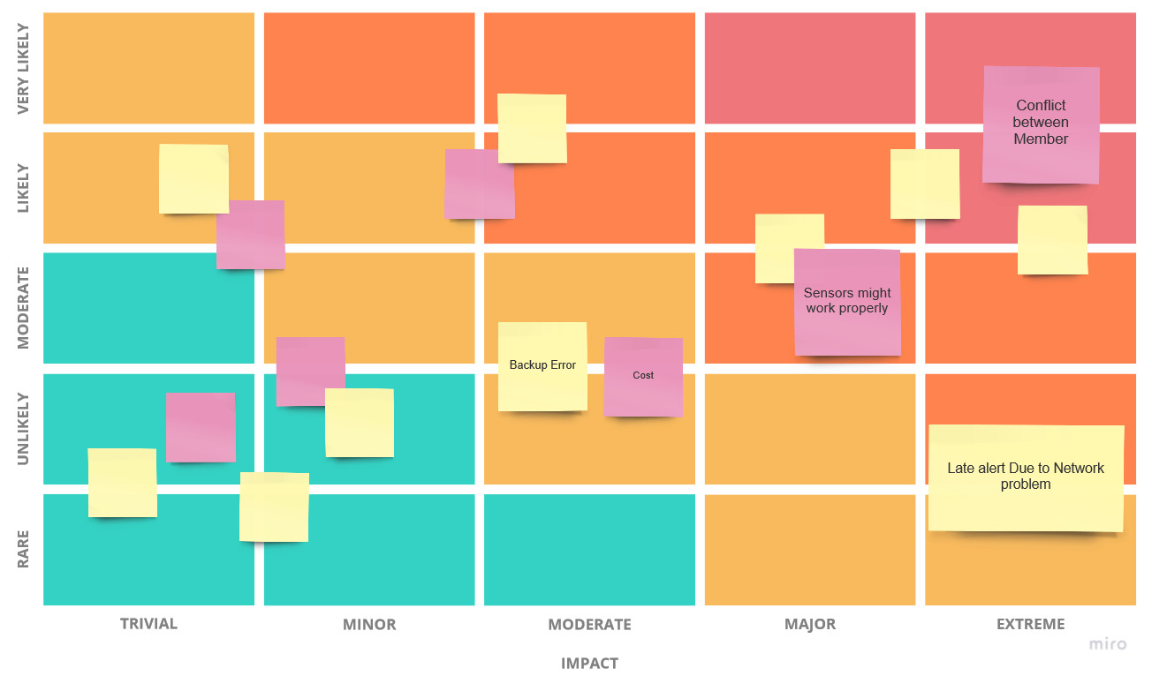

Figure :Risk Matrics

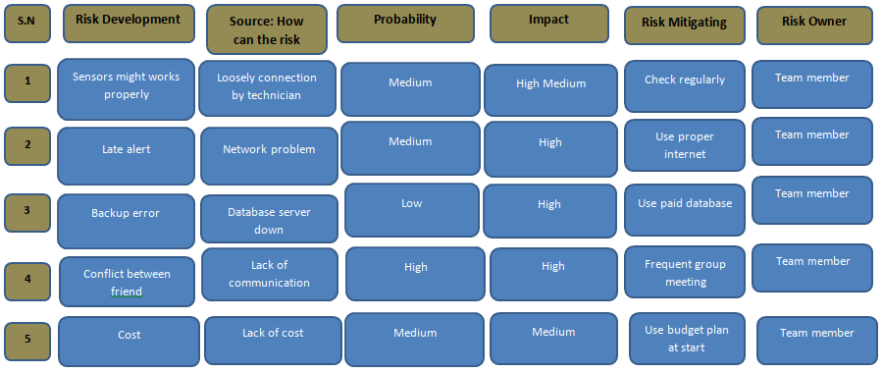

Figure :Risk Log

## 5.2. Gantt Chart

Gantt chart is the bar chart contains name of project and duration after confirming the project name. It is useful to develop any project because it help to track the status of task to be done in the project. This chart lists the tasks to be performed in vertical axis and time in horizontal axis. All the project plans to develop the smart aquarium are listed in the below chart along with plan name, duration, start date and finish date.

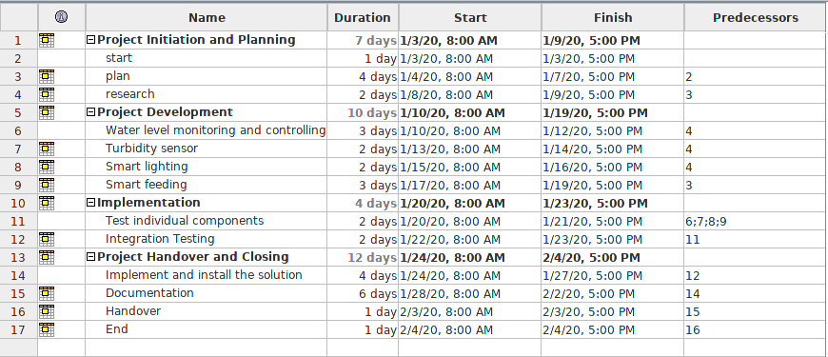

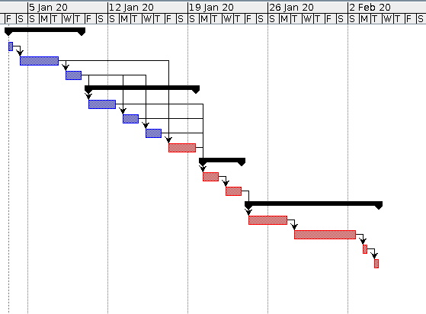

Figure : Gantt Chart

# Testing

Testing is the most important stage of building a project. It is important to know whether a project is efficiently functioning or not. All the sensors and devices embedded in the project works effectively or not. Does made project meets the expected requirement or not? We ultimately tested our project and we came through various difficulties and obstacles in which we were helplessly stuck for some time. There was problem in the pet feeder where the NODE MCU would not connect to the mobile app. We were unable to operate the pet feeder. We reviewed our code, checked all the connections, asked helped with our module teacher and also asked for seniors for support. Finally we were able to solve the problem which was a simple error in the connecting code. After that there was problem in Ultrasonic Sensor which would not give a correct value in its reading so we were advised to change the device itself and ultimately we were able to fix that problem as well. After all this we were successful in the testing of our automatic aquarium.

# Privacy and Ethics

The project is based on pervasive computing which collects enormous amount of data which are communicated through various sensors and devices and analyzed to increase efficiency. These data if handled carelessly, the data of the users will be compromised. Therefore, various measures are taken to ensure data privacy such as use of secret key for authorization in third party API, POST server requests with HTTPS connection for data encryption.”

“Moreover, the project has taken ethical consideration for data collection and manipulation. Only necessary data are collected through sensors and demonstrated to devices for common good. The data processing does not have adverse effects on environmental factors or personal privacy. Lastly, collected data are fully transparent to the users through means of dashboard and feeds.

# Personal Challenges

Working in a team is a very challenging task. A team requires communication, trust, inspiration among team, dependent among each other and many other things for a team to achieve success. This Project is the first time experience for each of us. So, eventually we faced expected problems in our team. We were not able to decide a fixed place to construct our project. We were lacing in communication making us hard to rely on each other. Assembling the required parts and working in a crowed was indeed a challenging task. We were not able to concentrate and were not able to focus to our target at first but eventually in time we got along and distributed the task equally and worked in our assigned task to our full capacity with diligence and activeness. We helped each other and corrected each other, all the team came for help whenever we were stuck in a problem and we solved it as a team.

ssEven if a lot of problem were faced, working in a team taught us the value of a team. We were realized that the merits of working as a team are greater then working alone. We learned new views; new ways to do a task and most of them all we learned to communicate and work on the basic of communication.

# Conclusion

IOT project can be implementing in many topics. One of the best topics is the development of IOT technology in smart aquarium. Smart aquarium is the concept of hobby keeping fish with combining IOT technology. Smart aquarium is emerging and real concept for the world of modern hobby keeping fish that combines with IOT. At conclusion, we showed to feed fish through combined automatic and manual feeder, change the water after sensing the water quality through turbidity sensor and through or fill water through water pump. Such that the fish neither over nor under fed nor at that time owner can easily enjoy watching aquarium remotely.

# References