AbleSpace — Part 2
Product Understanding: Caseload → Take Data Workflow
Objective: Explore the AbleSpace Take Data workflow from the Caseload tab, explain the workflow in your own words, and identify UX/UI and functionality improvements.

Workflow Overview
The AbleSpace workflow connects the Caseload student list directly to a goal-based data collection session. A user locates a student, selects Take Data, chooses the relevant goal, records trial data, and can add notes for additional session context.
1 | Caseload | Locate the student and access Take Data.
2 | Take Data | Open the data collection session.
3 | Goal | Choose the target goal.
4 | Capture | Record trial data.
5 | Review | Use Graph, Stats and Info views.
6 | Notes | Add observations and context.

Detailed Workflow

Step 1 — Open the Caseload
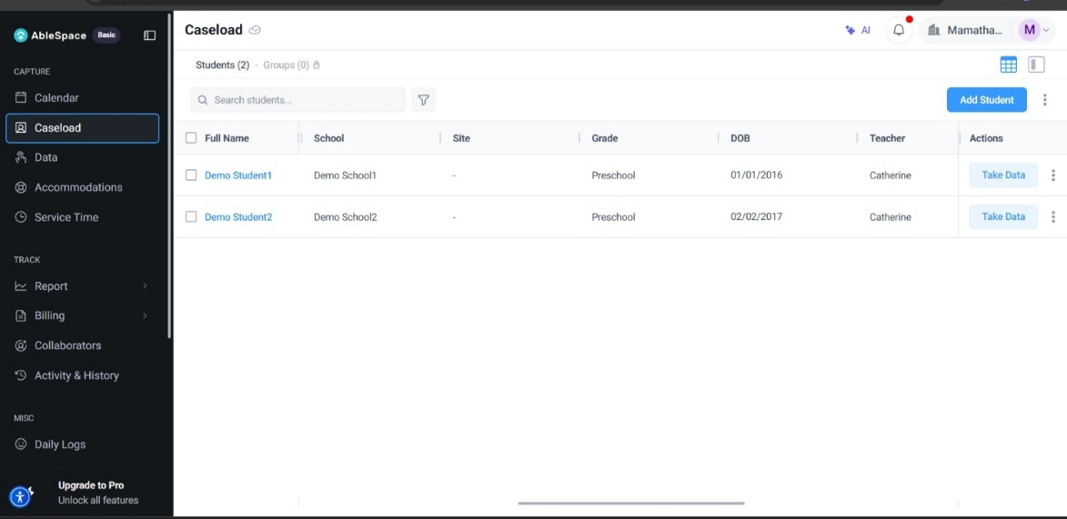
The Caseload page provides a structured list of students. The Actions column places the Take Data button directly beside each student, making the primary data-collection action easy to find.
Figure 1. Caseload view with the Take Data action.

Step 2 — Review Student Context
The Caseload can display useful context such as teacher, room, case manager, eligibility, guardians, IEP/evaluation dates, collaborators, and service time. Visible columns can vary by view.

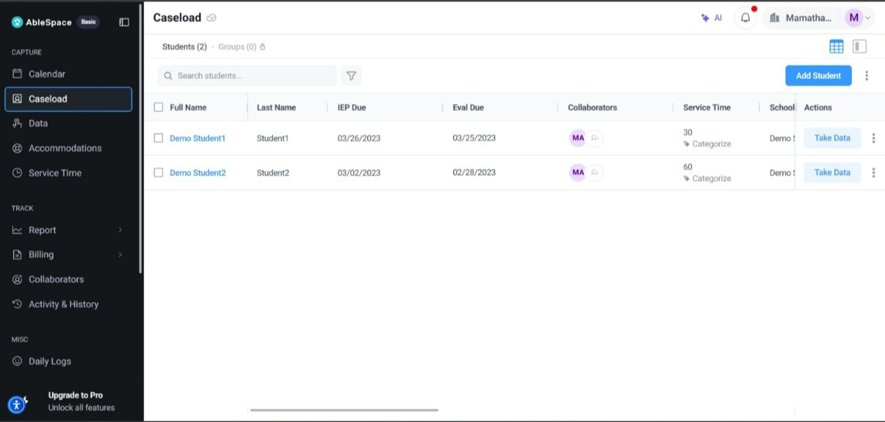
Figure 2. Caseload view with additional student information.

Step 3 — Enter the Take Data Session
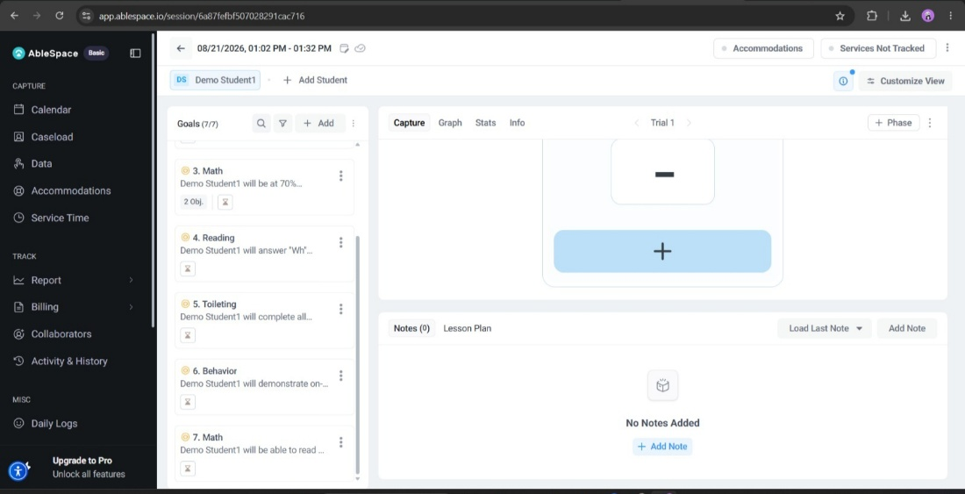
Selecting Take Data opens a dedicated session for the chosen student. The Goals panel is separated from the main Capture workspace, keeping goal selection and data entry organized.
Figure 3. Take Data session workspace.

Step 4 — Select the Goal
The Goals panel lists the student's available goals. Selecting a goal loads its description into the Capture area, keeping the measurement target visible during data entry.
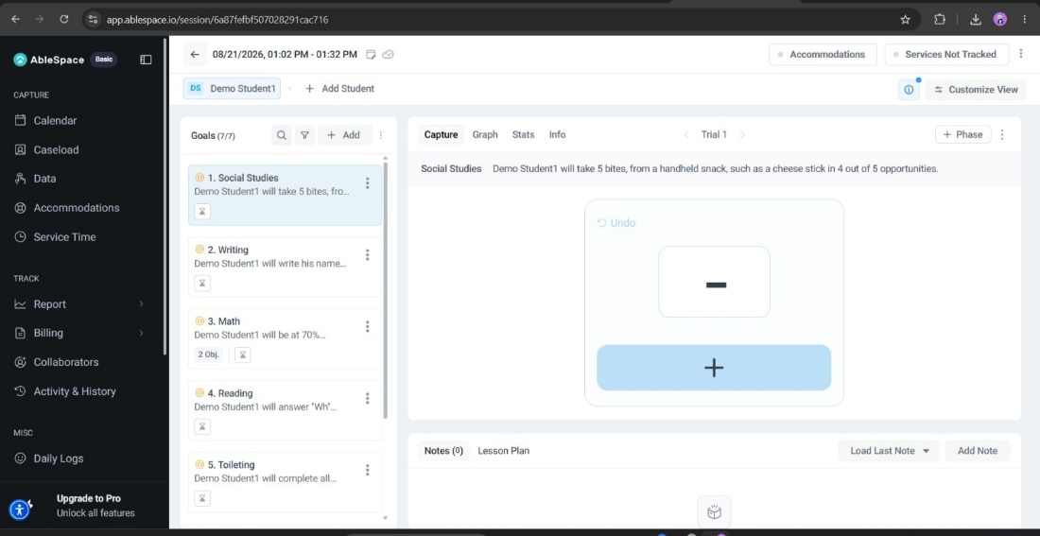

Step 5 — Record Trial Data
Figure 4. Selected goal and target description.

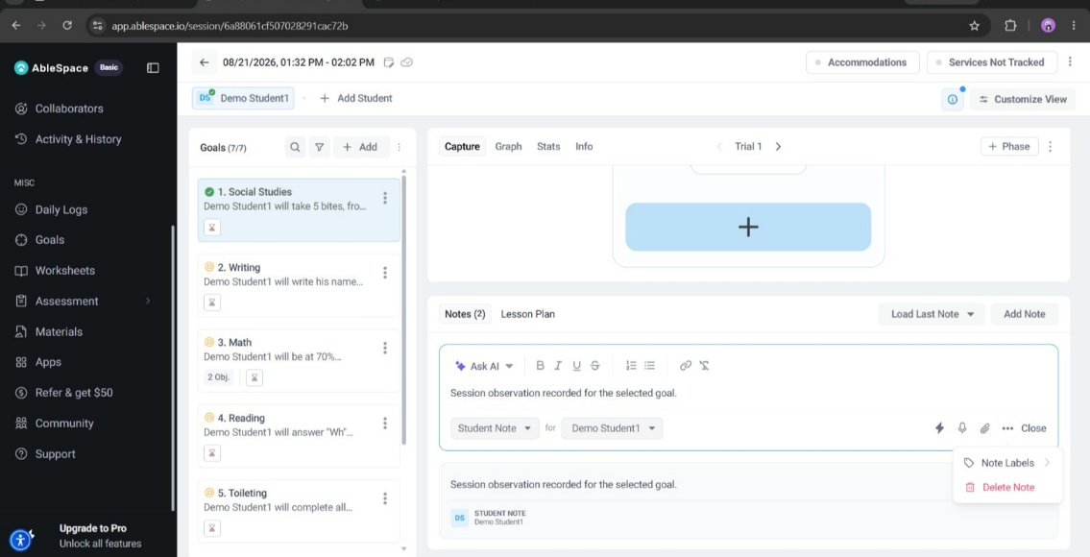
The Capture area provides the primary interaction for recording trial results. The recorded value becomes visible and an Undo option is available for correcting an accidental entry.
Figure 5. Capture view showing a recorded trial value.

Step 6 — Add Session Notes
The Notes section provides a place for qualitative observations alongside captured data. Notes can be associated with the student to preserve additional session context.

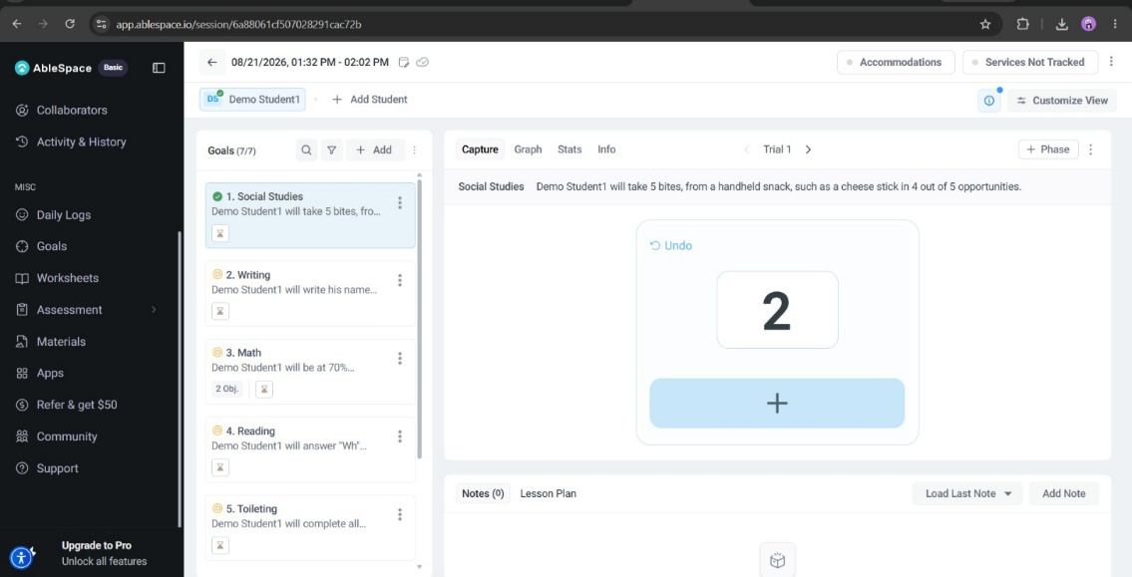
Figure 6. Notes area with a session observation.

Step 7 — Review the Session
The session includes Graph, Stats, and Info views, providing a natural transition from entering data to reviewing the collected information.
End-to-end flow: Caseload → Student → Take Data → Goal → Capture → Review → Notes

UX/UI Evaluation

Strengths
  - Clear entry point: Take Data is available directly from the student row.
  - Good visual hierarchy: navigation, student/goal information, and the capture workspace are clearly separated.
  - Goal context stays visible: the selected goal and target are shown in the Capture area.
  - Immediate feedback: recorded values are displayed and Undo is available.
  - Quantitative + qualitative data: Capture and Notes work together.
  - Review support: Graph, Stats, and Info provide additional views.

Recommended UX/UI Improvements
Area | Recommendation
Save status | Add a visible “Saved” / “Saving…” indicator near the session header.
Trial feedback | Briefly highlight a newly recorded result without interrupting rapid entry.
Goal context | Keep the selected goal and measurement definition visible while scrolling.
Undo & recovery | Make Undo keyboard-accessible and provide brief confirmation after an undo.
Notes | Provide a quick-note shortcut for recording observations efficiently.
Responsive design | Collapse secondary panels on smaller screens while keeping core actions accessible.
Accessibility | Use strong focus states, descriptive labels, sufficient contrast, and non-color-only status indicators.
Goal discovery | Add search, favorites, or recently used goals to reduce scrolling.

Functionality Improvements
The existing workflow covers the core requirement of structured data collection. The following changes could improve efficiency and reliability while preserving the current workflow.

Explicit Autosave / Session State
Show a clear saving state near the session header, such as “Saving…” followed by “Saved just now.”

Quick-Entry Mode
Provide keyboard-friendly controls for repeated trials so users can record multiple outcomes quickly.

Goal Search and Favorites
Add goal search, favorites, or recently used goals to make frequent targets faster to access.

Clear Completion Feedback
When a goal or session reaches its required completion condition, provide a clear, non-blocking completion state.

Cross-View Continuity
Keep the selected student and goal visually anchored when moving between Capture, Graph, Stats, and Info.

Accessibility-First Interaction
Support full keyboard navigation, visible focus indicators, accessible control names, and non-color-only status communication.
Highest-priority improvement: Make save/session status explicit. It directly addresses user confidence during data entry without changing the core workflow.

Conclusion
The AbleSpace Take Data workflow provides a clear path from a student’s Caseload record to goal-based data collection. The direct Take Data action, visible goal context, simple Capture interaction, Undo control, Notes area, and review views create a practical workflow for structured session recording.
The main opportunities are stronger save-state feedback, faster repeated-trial entry, better goal discovery, accessibility enhancements, and clearer responsive behavior. These changes would improve confidence, efficiency, and usability while preserving the existing mental model.

Part 2 Requirement Coverage

Assessment requirement | Coverage
Explore the Take Data screen from Caseload | Caseload and Take Data workflow explained step by step.
Document with screenshots | Seven screenshots are integrated with explanations and captions.
Explain in your own words | Original descriptions are provided for each stage.
Identify UX/UI improvements | Dedicated UX/UI evaluation and recommendations.
Identify functionality improvements | Dedicated functionality improvement section.

