1.While Saving a Reseller Registration once Register button is clicked the DMS pre-load should be displayed.

2. Once the new reseller registration is successfully created when the user clicks the dms login it should force the user to change the password

3. First login the reseller page is throwing error

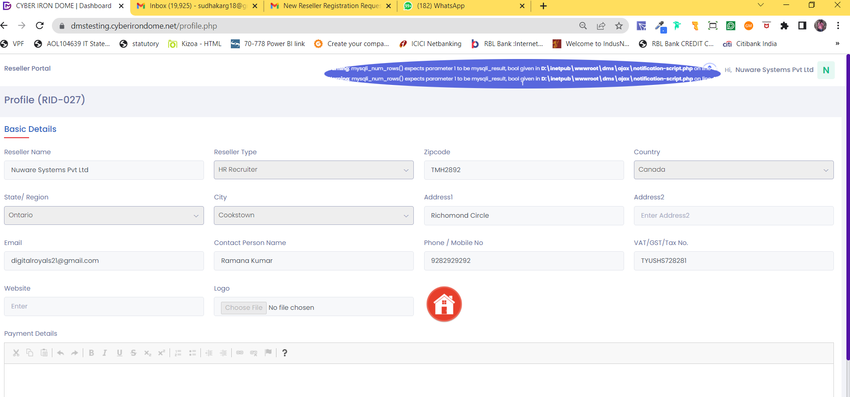

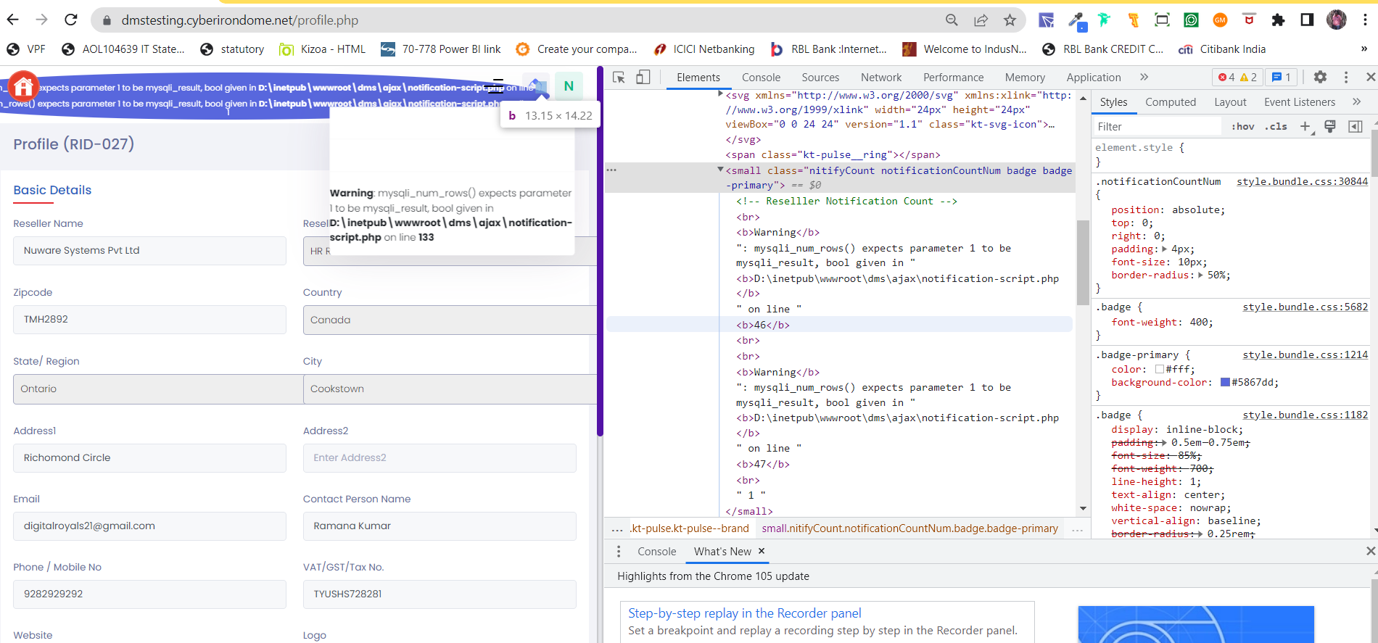

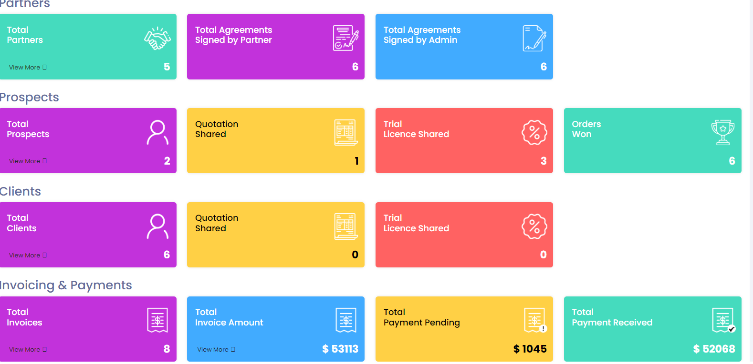

In Admin page when I select the reseller from the grid again the following error throws

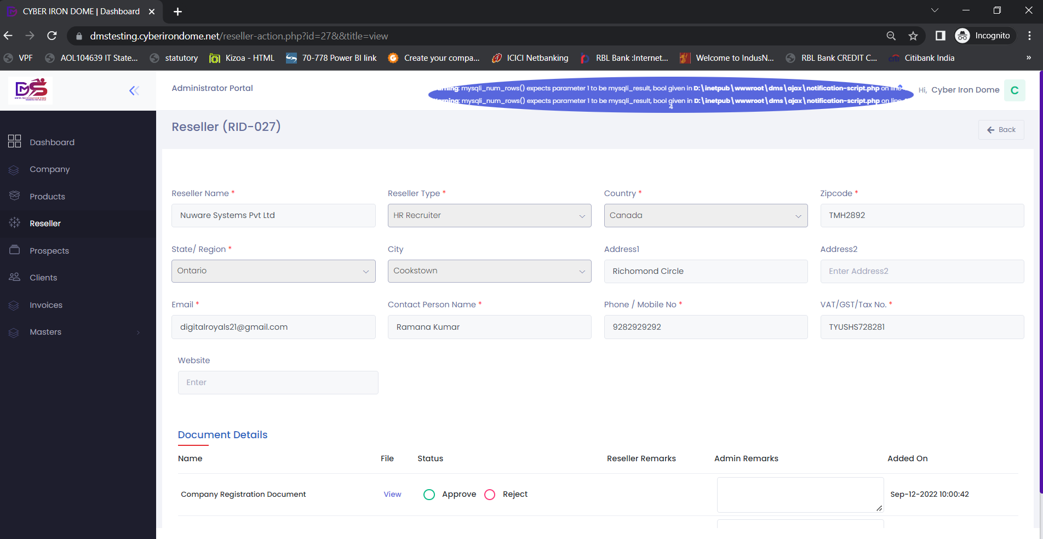

Unable to generate agreement the following error is throwing and unable to save the reseller to generate agreement

Total signed partner in the dashboard is getting updated perfectly. No issues

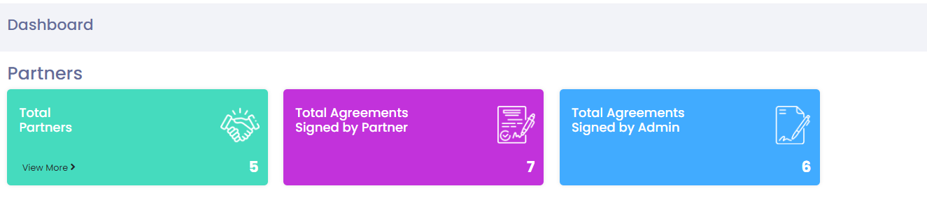

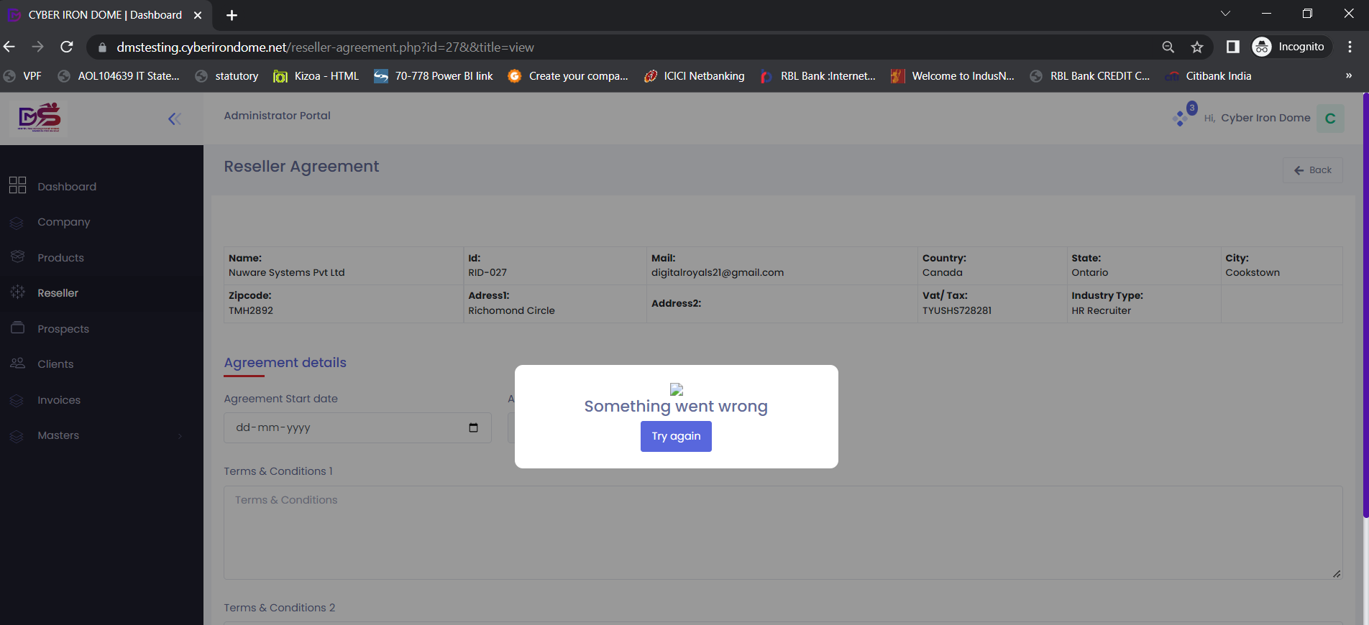c

[8:36 am, 13/09/2022] ɢ ֆʊɖɦǟӄǟʀ: Your NeuShield agreement "Filename.pdf for has been rejected by the admin. Click View to know the details

[8:37 am, 13/09/2022] ɢ ֆʊɖɦǟӄǟʀ: Your NeuShield agreement "Filename.pdf for has been Approved by the admin. Click View to know the details

[8:37 am, 13/09/2022] ɢ ֆʊɖɦǟӄǟʀ: Your CID agreement "Filename.pdf for has been rejected by the admin. Click View to know the details

[8:37 am, 13/09/2022] ɢ ֆʊɖɦǟӄǟʀ: Your CID agreement "Filename.pdf for has been Approved by the admin. Click View to know the details

Notification is not showing in all screens

Below is the reseller edit screen its showing count 3

But in the grid screen its displaying blank

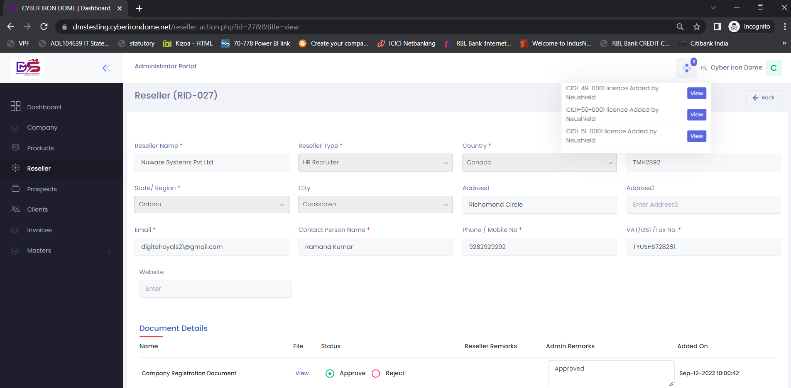

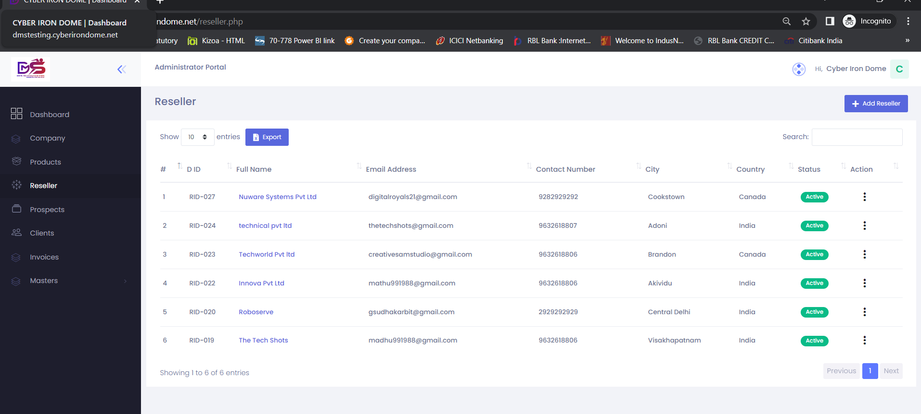

After signing the agreement by the admin the card count is displaying perfectly

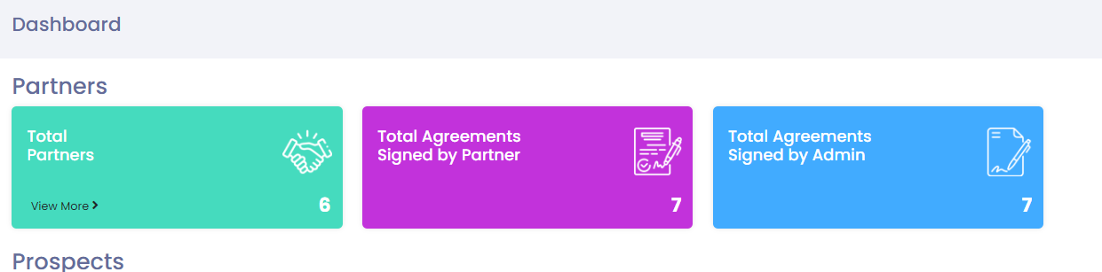

Prospects before adding

GST or VAT in the prospect should allow alpha numeric. Currently its allowing only numbers

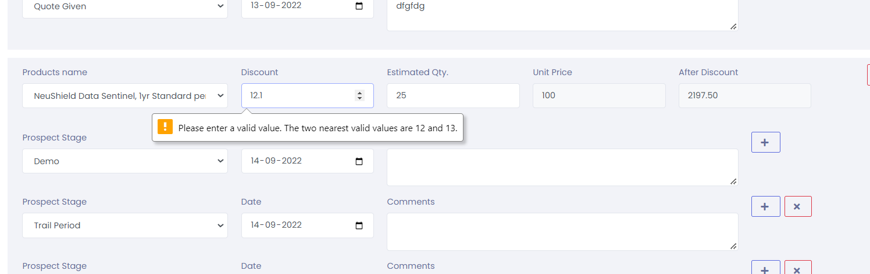

Discount should allow to accept decimals



I have updated the stage as Quote given but ideally I have not generated any quote from the application. Not sure whether the logic is correct

Notification for a new Propsects

Whenever a new prospect has been added there should be a notification for Admin

mentioning that a New Prospect <<Prospect Name>> on <<Date Created>> has been added by the Reseller <<Reseller Name>> . Click to view

For Reseller Dashboard

You have added new prospect <<Prospect name>> on <<Date Created>>

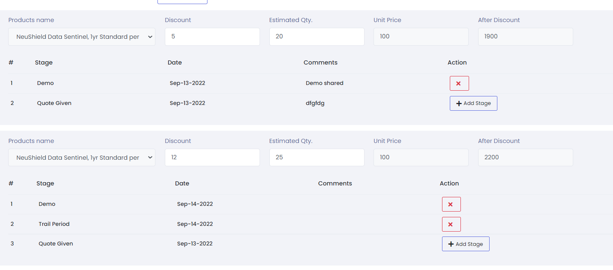

While in edit mode the + Add Stage is displaying. Similarly when a new prospect is being added that time it shows only + symbol please add + Add Stage too in while adding new prospect

Before updating status as Order Won

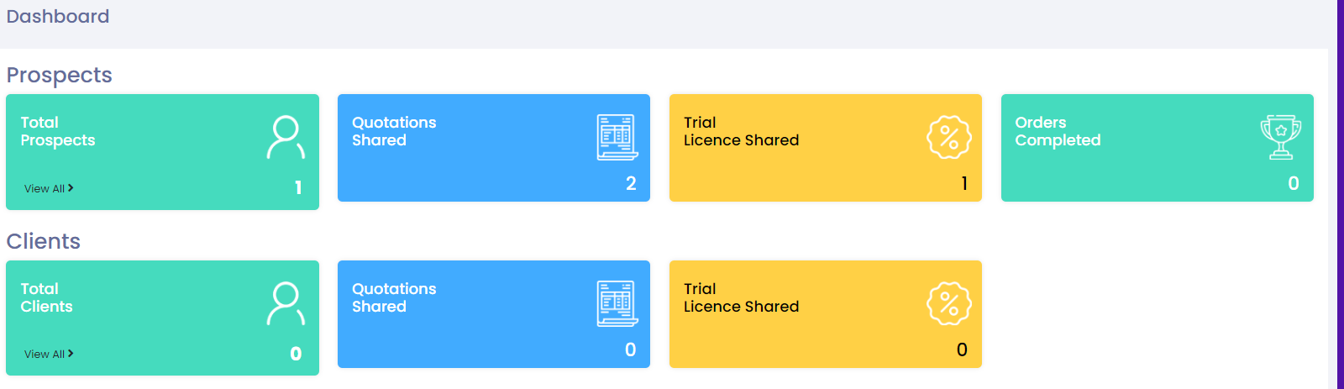

As soon as order won the prospects details are transferred to clients. Ideally it should retain the prospects count as it is and clients should get updated. To be discussed. How come Prospects are Zero and Orders Completed is 1 this gives a wrong impression.

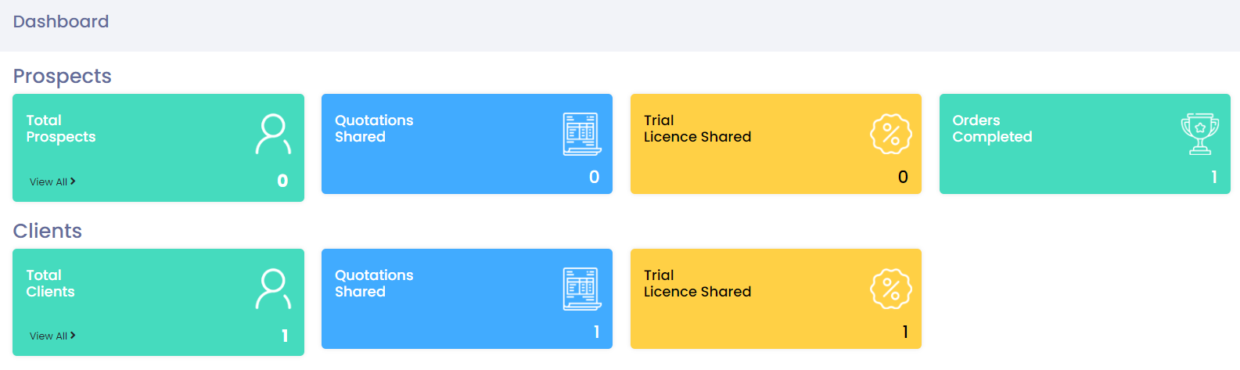

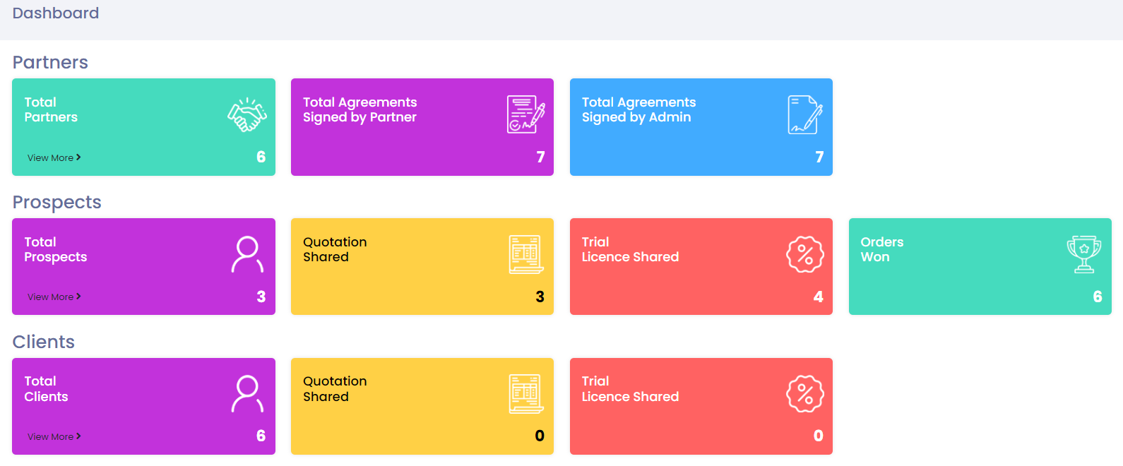

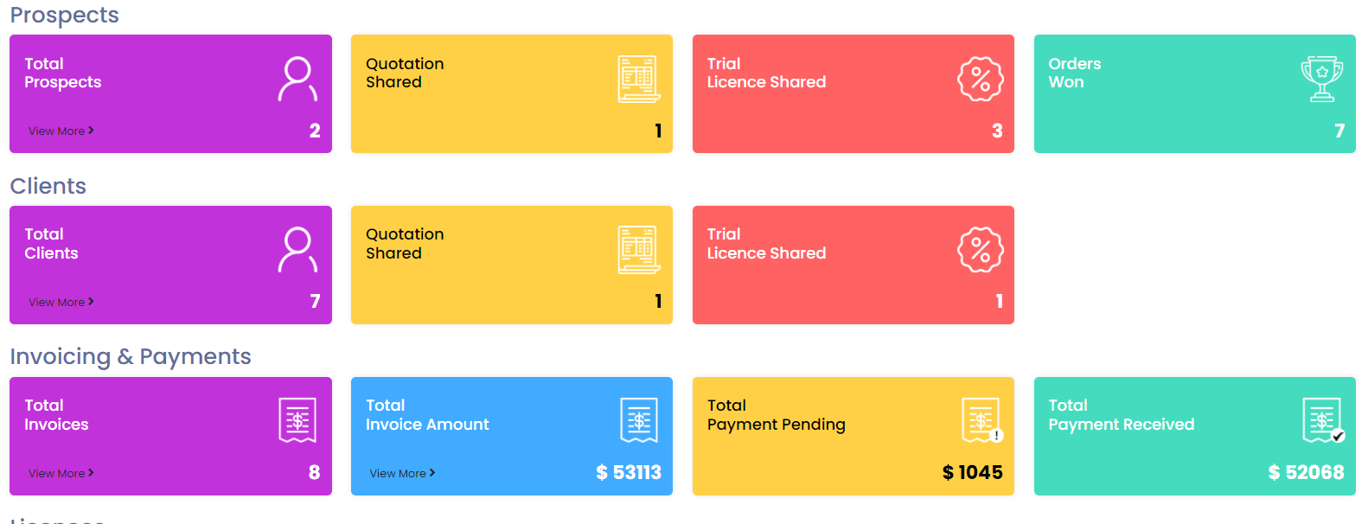

Generated one invoice for a reseller. Below is the invoicing & payment details before

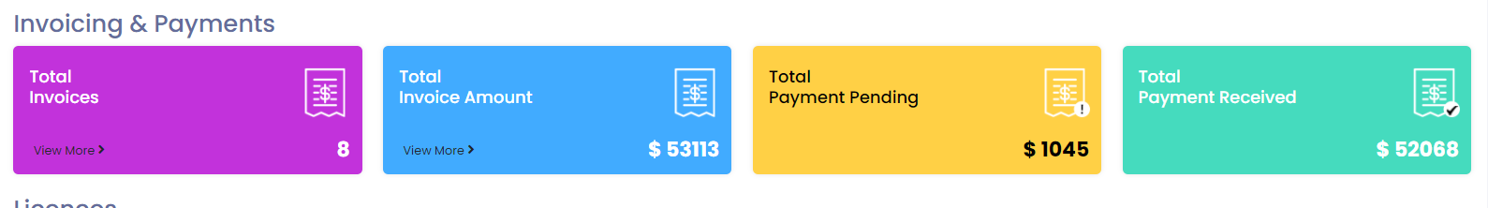

After generating invoice

[10:15 am, 13/09/2022] ɢ ֆʊɖɦǟӄǟʀ: After generating invoice notification should be displayed in the admin and reseller dashboard

[10:17 am, 13/09/2022] ɢ ֆʊɖɦǟӄǟʀ: a New Invoice for client << Client Name>> - <<Invoice Number>> has been generated on <<Date Created>> by the Reseller \* <<Reseller Name>>\*. Click to view

For Reseller Dashboard

You have added new Invoice for client << Client Name>> Invoice No<<Invoice Number>> on <<Date Created>>. Click to view

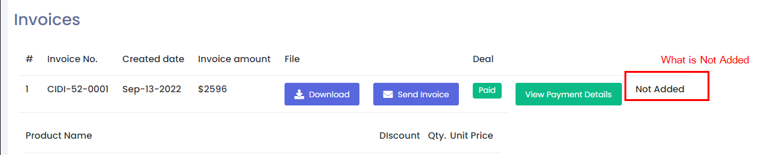

[10:21 am, 13/09/2022] ɢ ֆʊɖɦǟӄǟʀ: For Admin

Payment details for the Invoice <<Invoice Number>> has been updated on <<Date>> by the <<Reseller Name>>

[10:22 am, 13/09/2022] ɢ ֆʊɖɦǟӄǟʀ: For Reseller

You have updated the payment details for the Invoice <<Invoice Number>> has been updated on <<Date>>

Checking Payment details cards is getting updated before approving the payment by admin

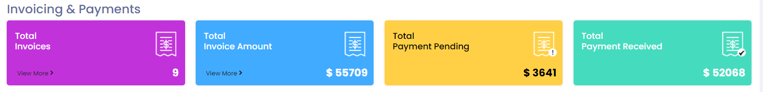

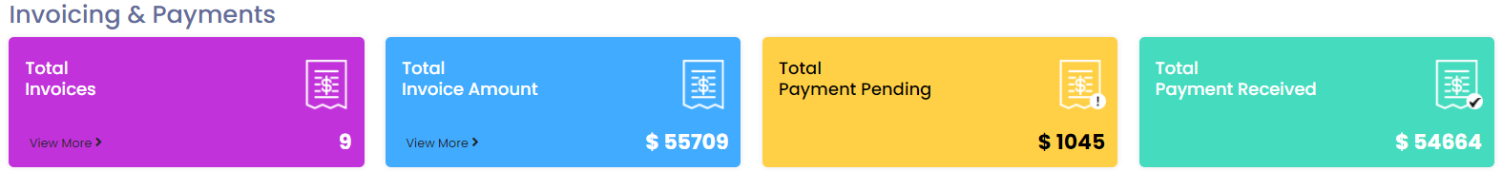

Ideally the total Payment received should get updated only after approving the payment received by the admin

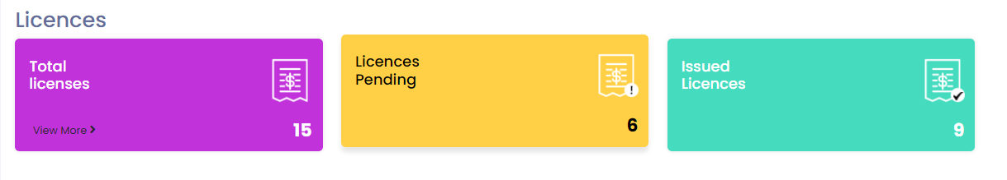

A notification has to be sent to the reseller after approving the payment details.

Admin has approved the Payment Details for the Invoice No <<Invoice Number>> Dated on <<Date>> for the client <<Client Name>>

Below error is coming after uploading the license excel upload

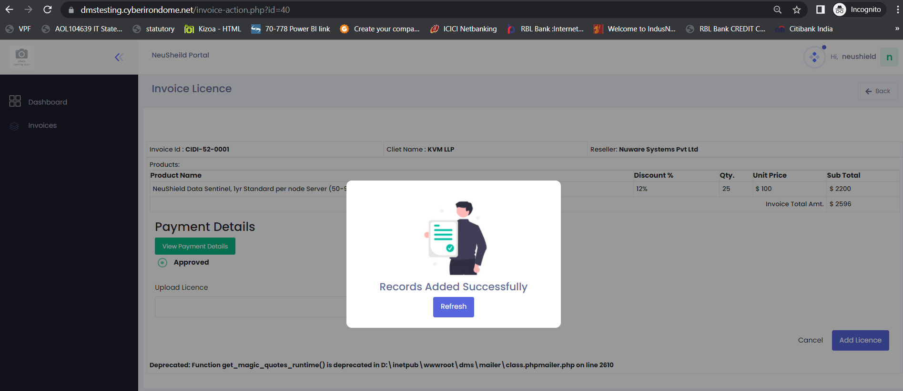

Issued Licenses count is not matching as I have updated excel only 1 record. Not sure how the license issued count is taking