**Music Group Assignment**

**Introduction**:

I have developed a music group application in Visual Studio 2022 with the project template as “ASP.NET Core with Angular”

**Technology and Tools used:**

* Visual Studio 2022
* Angular 14
* Json files used a database

**About the Application**

**The Application contains:**

* Home page with a background picture, a sample logo and some text.
* Albums page with a list of albums and ability to add, update and delete album
* Concerts page with a list of concerts and ability to add, update and delete concert
* Contact Us page with some social media icons.

**Project Structure:**

* ***components***
  + home
  + background
  + album
  + concert
  + contactus
* ***assets***
  + images - for logo
  + jsonFiles - for album and concert list
* ***Controllers***
  + Album
  + Concert
* ***Model***
  + Album
  + Concert

**Screens**

**Home Page:**

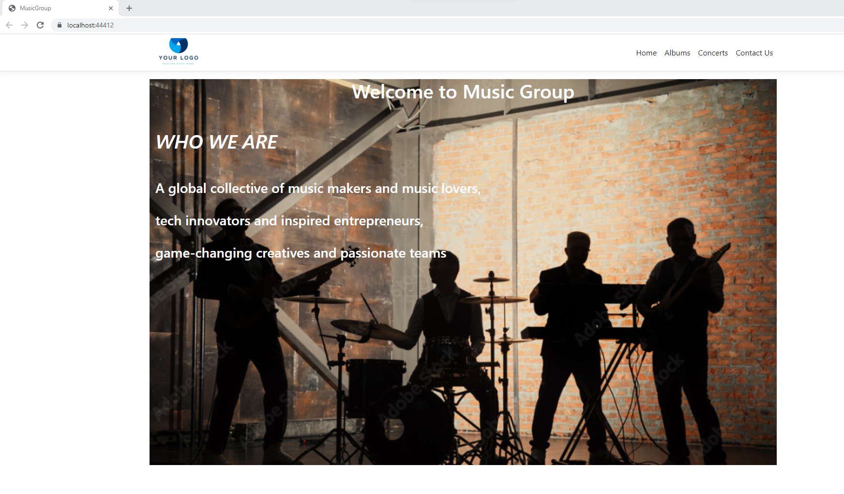

**Albums:**

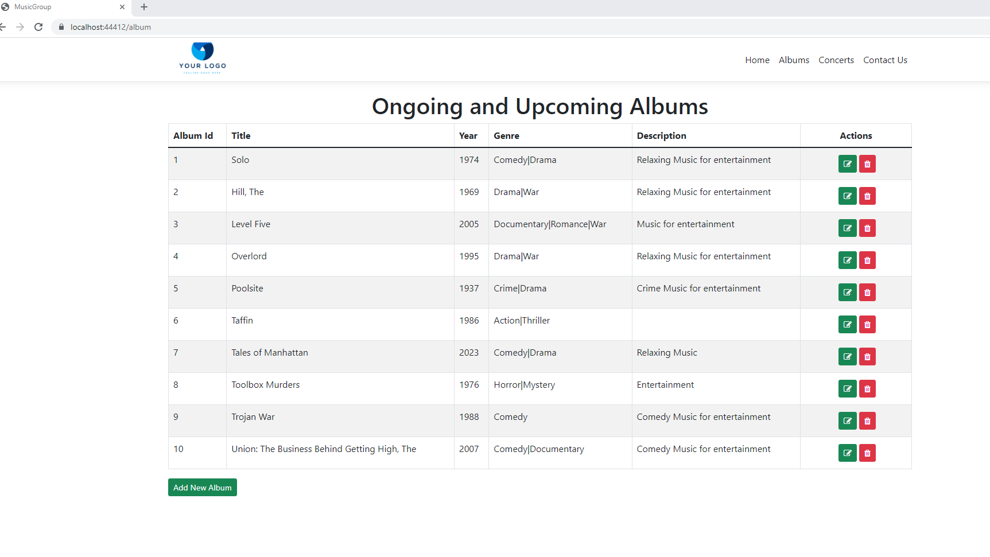

***Album Adding:***

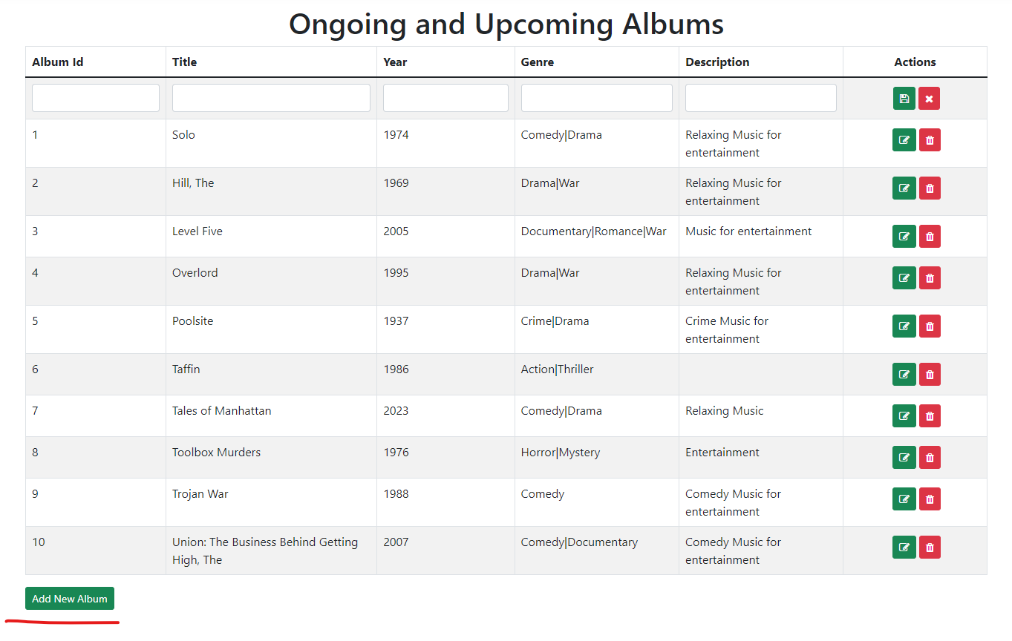

***Album Editing and Deleting :***

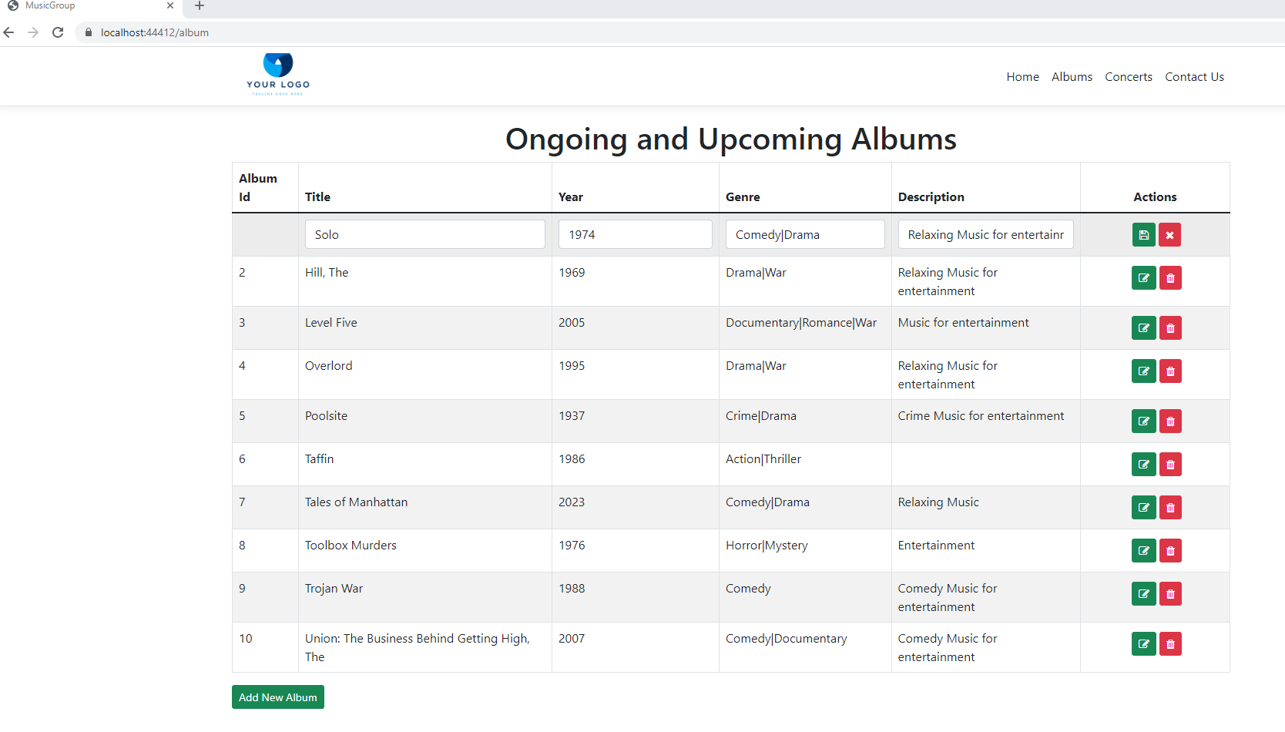

**Concerts**:

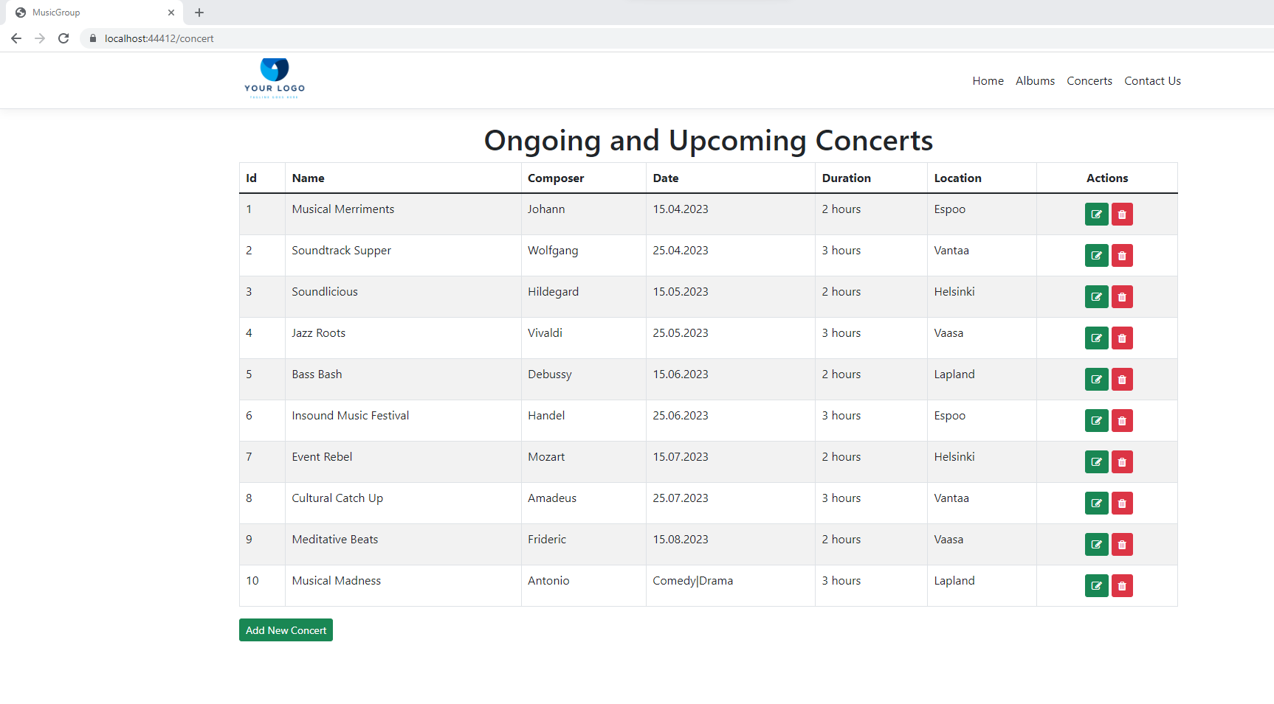

***Adding New Concert:***

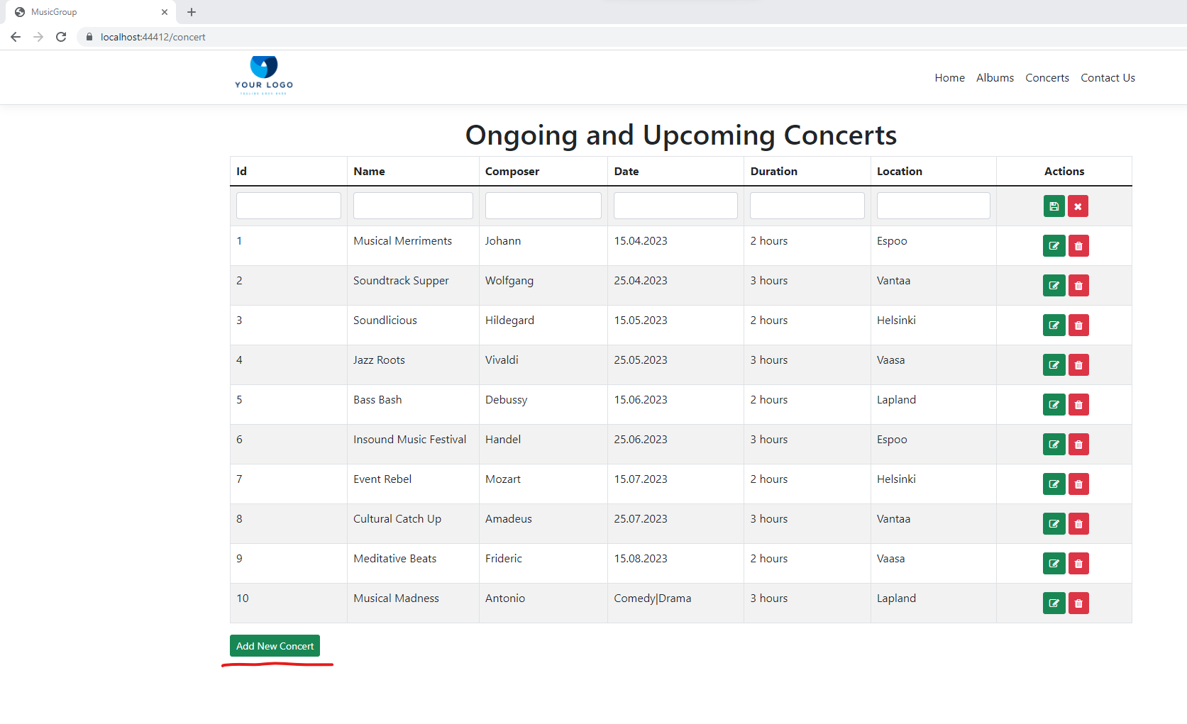

***Editing and Deleting Concert:***

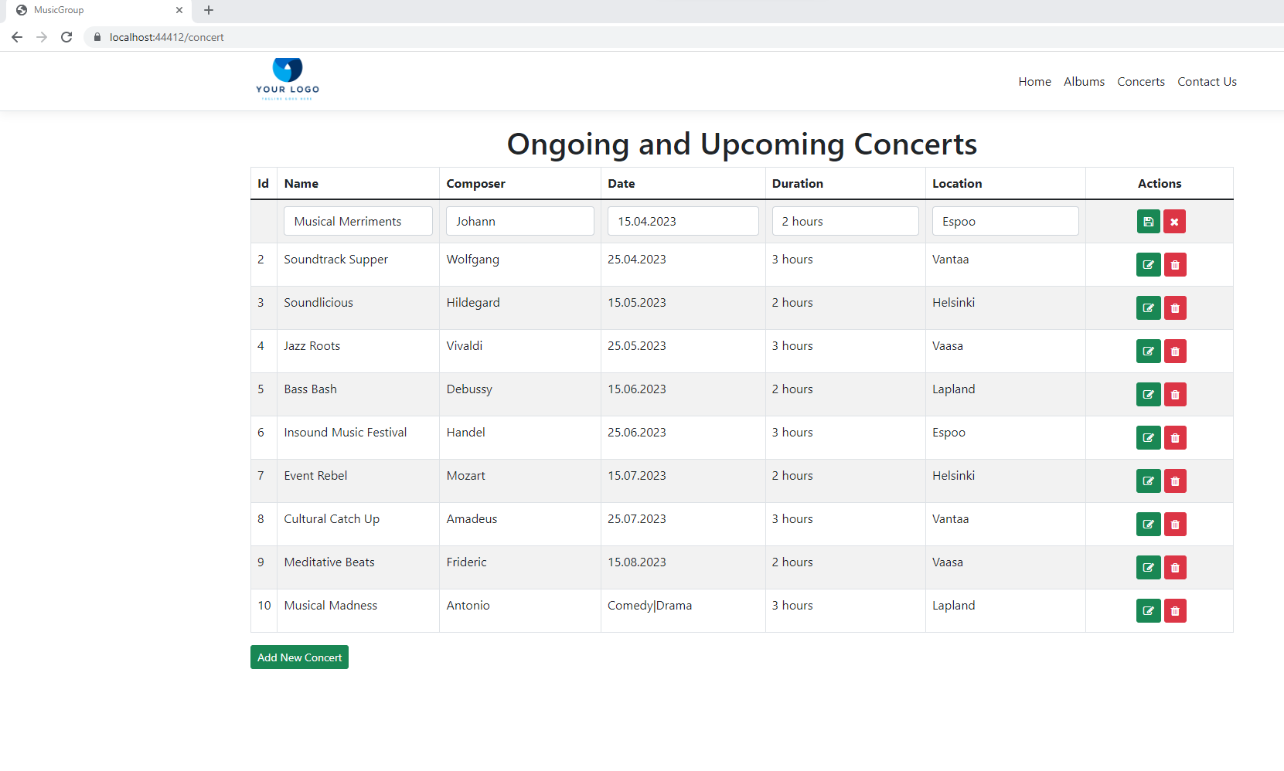

**Contact Us:**

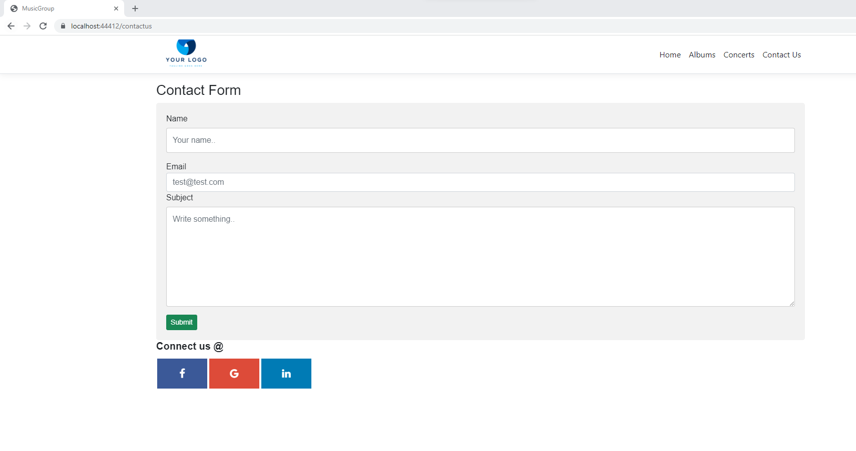

***After Submit click:***

