Visit https://www.saucedemo.com/

Login Success

* Login with standard_user
* Test for Successful login

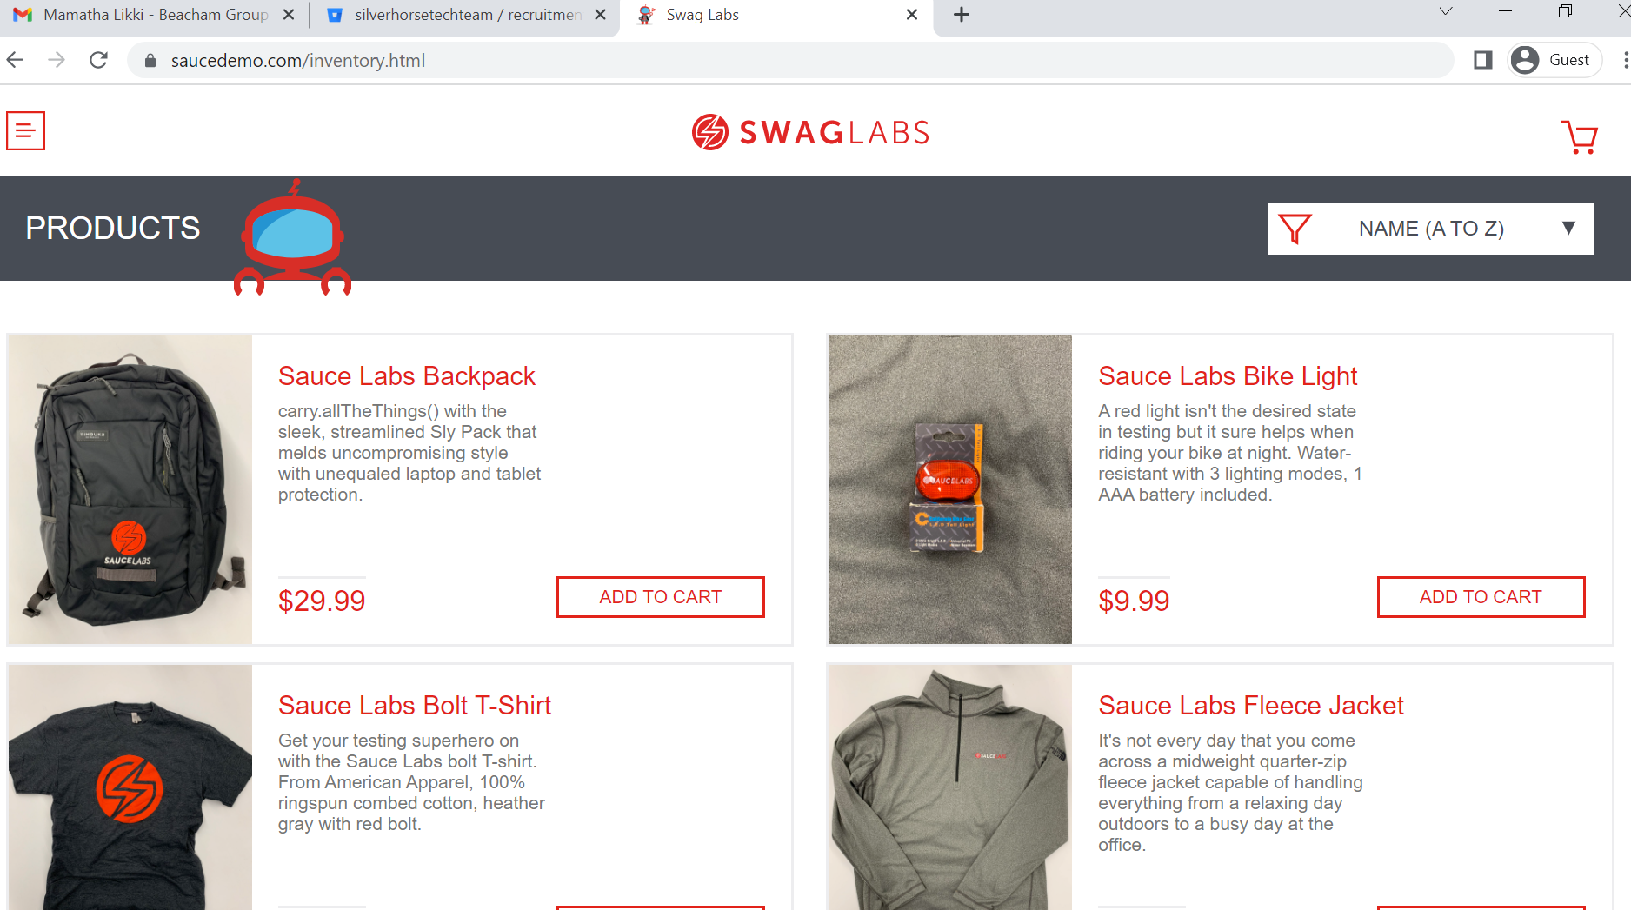

Login Failure

* Login with standard_user
* use wrong password
* Test for error message

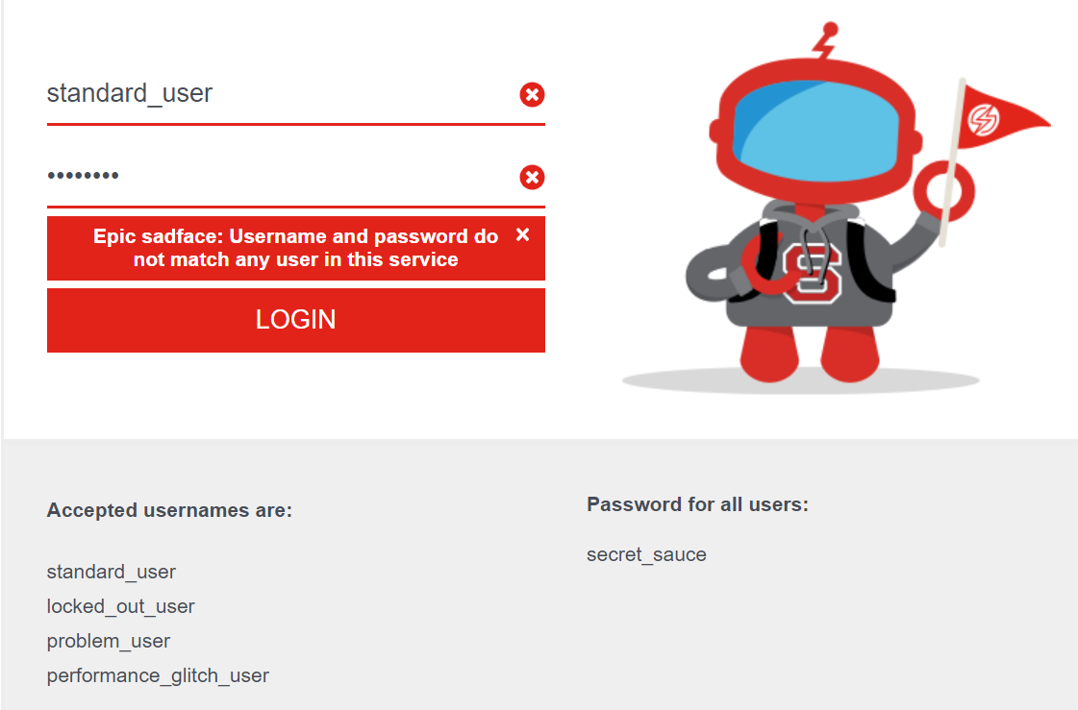

Login Locked out user

* Login with locked_out_user
* Test for error message

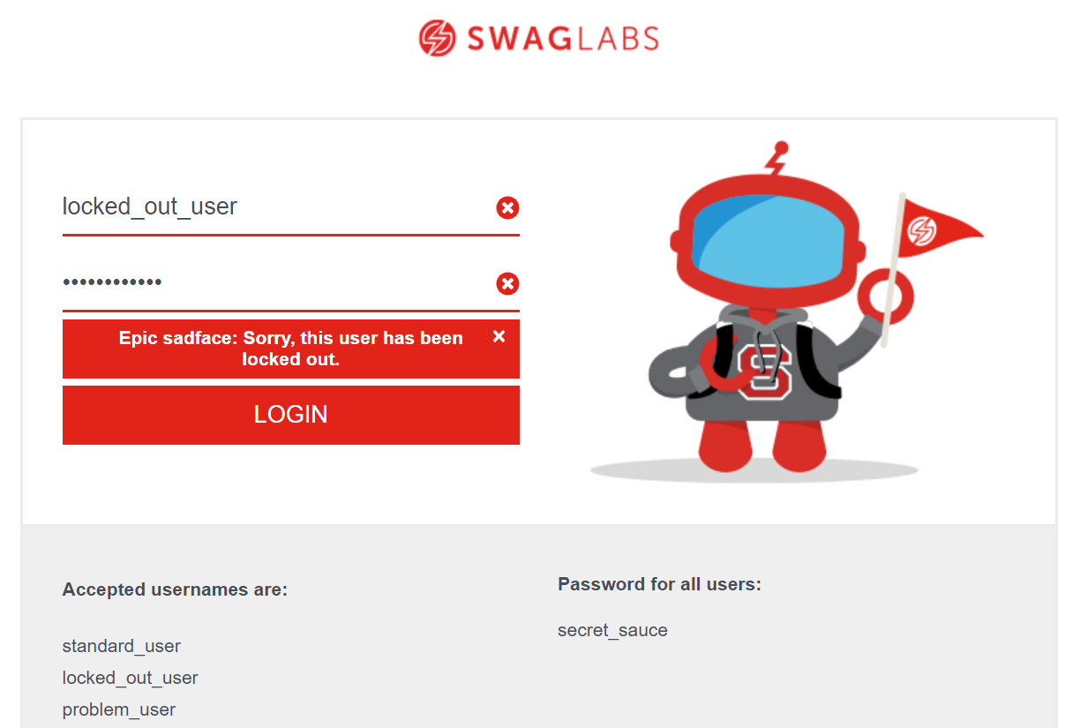

Add to cart

* Login with standard_user
* Add 3 items to cart
* Visit cart, test that items are there

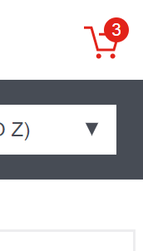

Checkout form

* Add items to cart
* Go to checkout and fill out the form
* Test for various states

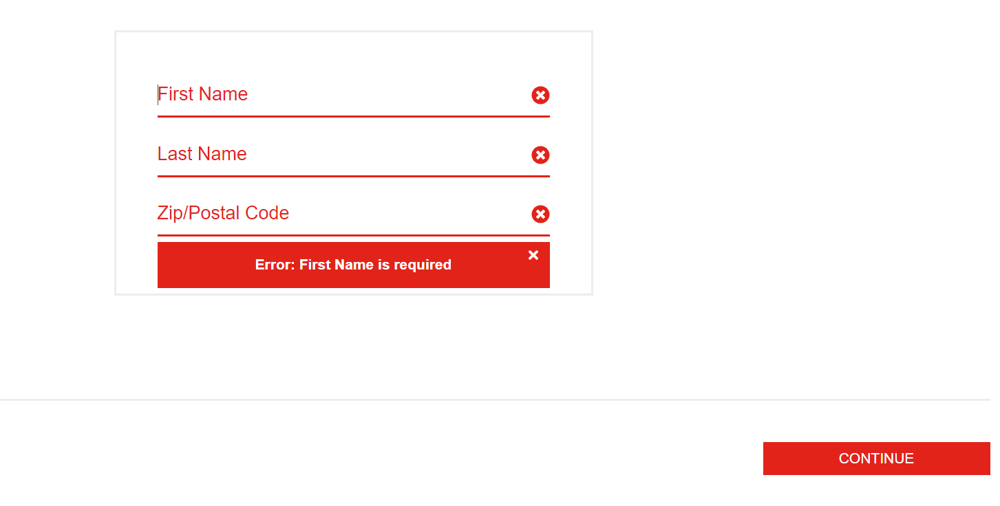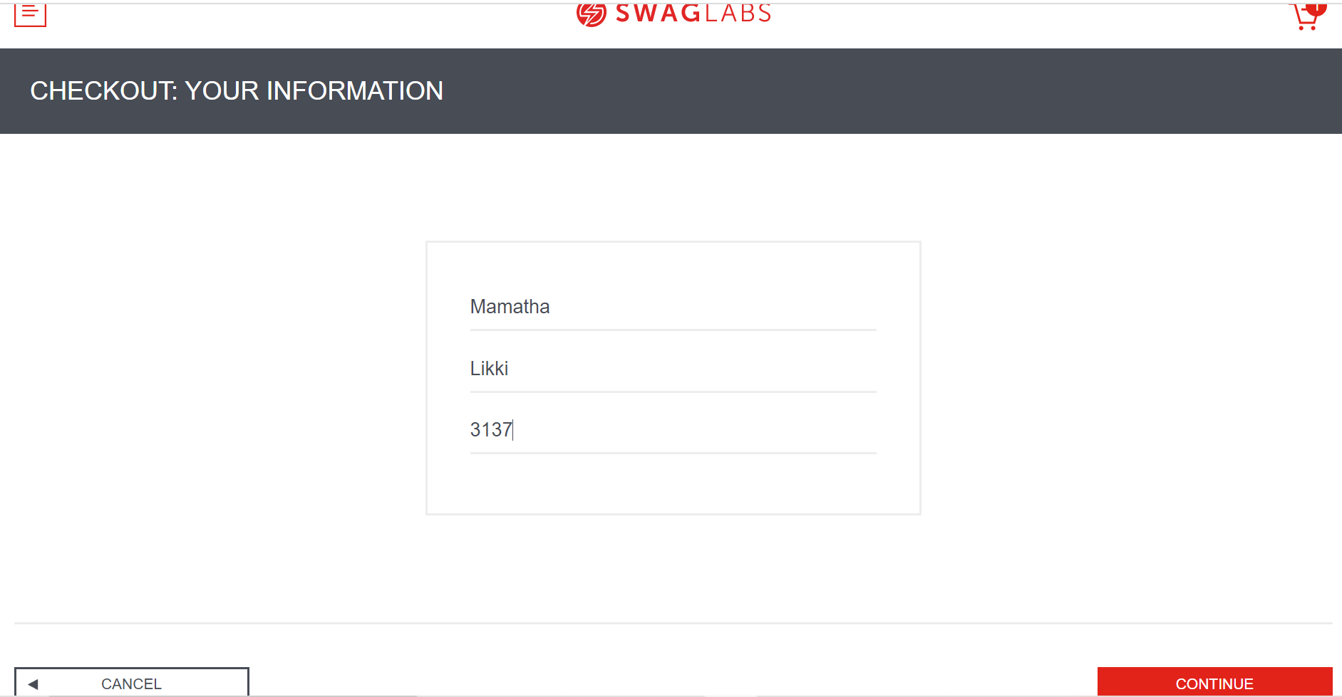

Checkout overview

* Add items to cart
* Go to checkout and fill out the form
* Click continue
* test that items are there
* Validate the total against the items in cart
* Click finish and validate for success/error state

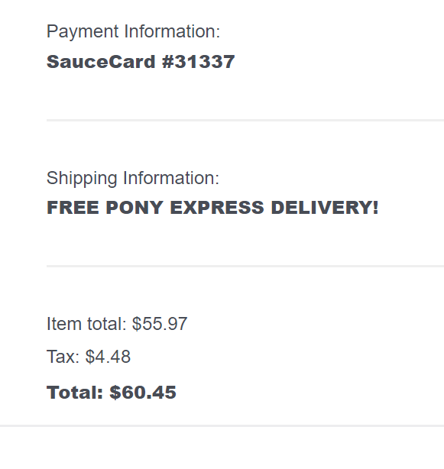

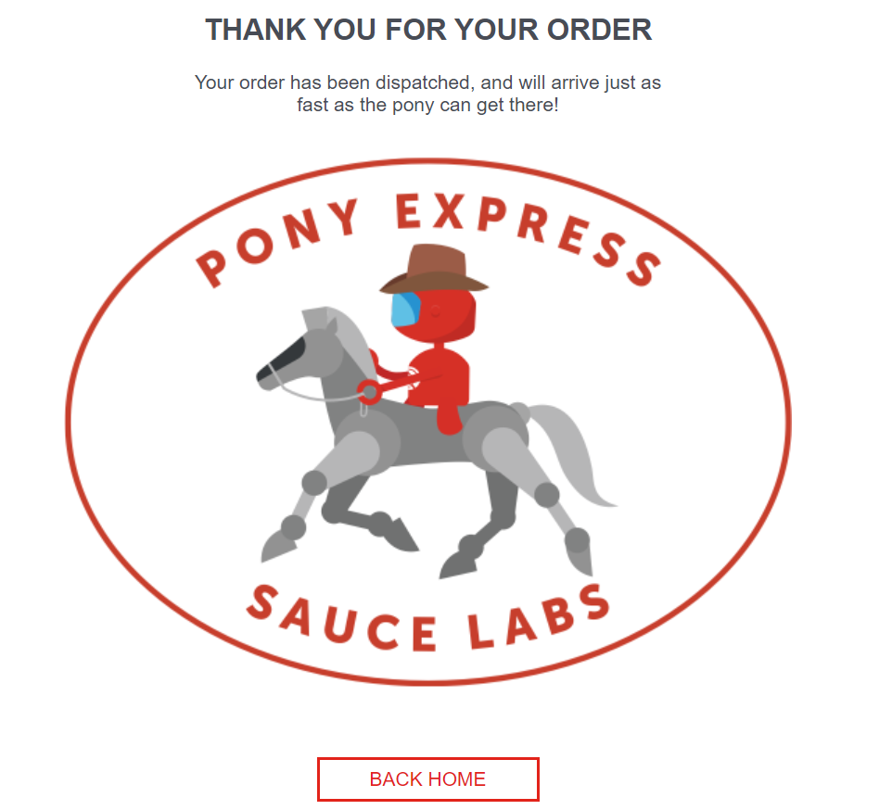Bonus points

* Visit the product list under all items
* Sort by price high to low, and test out the validity of the sort

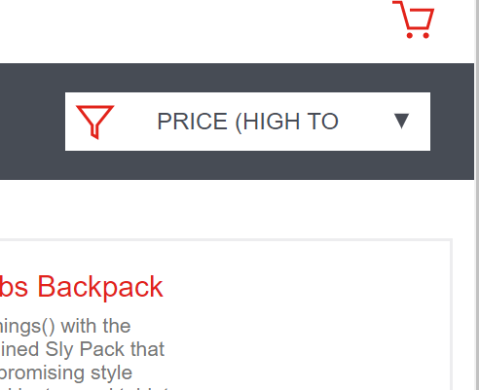

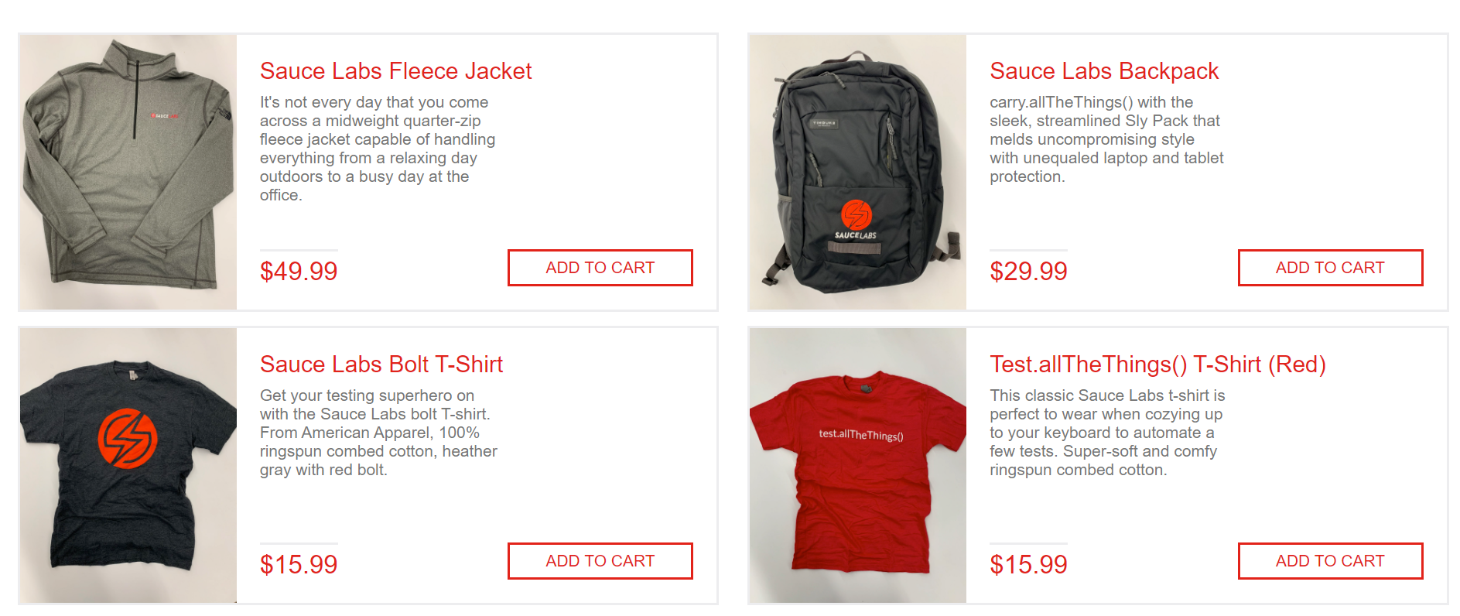

* Sort by name Z to A, and test out the validity of the sort

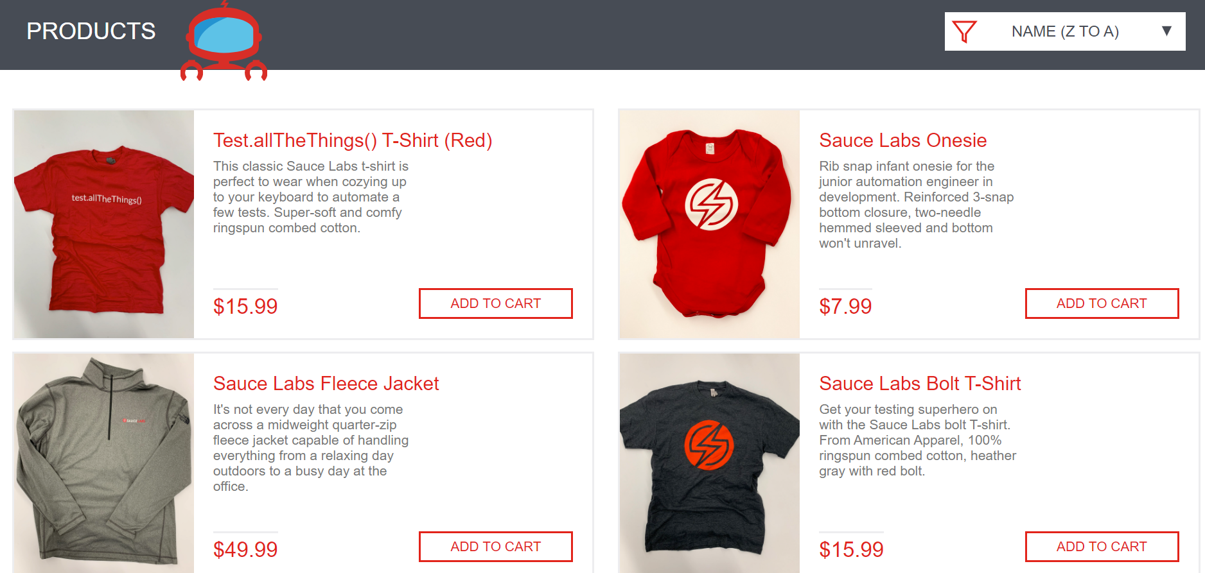

* Reset the app state and test that it is indeed reset

