PROJECT REPORT
Retail Sales Analysis with AI
Customer Segmentation and Profit Prediction using Python

IBM SkillsBuild – Data Analytics with AI Academic Internship Program
Conducted by BharatCares in association with AICTE

Submitted by: Bavisetti Mamatha
Final-year BBA, Aditya Degree College, Vizianagaram

1. Abstract
This project studies a retail sales dataset of 5,000 orders (2023–2025) to understand what drives sales and profit. The data was cleaned, explored with charts, and analysed using two machine-learning techniques: K-Means clustering to group customers into behaviour-based segments, and a Random Forest model to predict the profit of an order. The analysis shows that discounting is the biggest threat to profit: orders with a 20% or higher discount were loss-making 69% of the time, compared with only 1% of orders with no discount. The Random Forest model predicted order profit with an R² of 0.882, clearly better than a Linear Regression baseline (R² = 0.588).

2. Introduction and Problem Statement
Retail businesses collect large amounts of order data but often do not use it to decide discount policy, customer retention, or stock planning. This project answers four practical business questions:
- Which categories and regions generate the most sales and profit?
- How do discounts affect profit?
- Can customers be grouped into meaningful segments for targeted marketing?
- Can the profit of an order be predicted from its details?

3. Objectives
- Clean and prepare the retail dataset for analysis.
- Perform exploratory data analysis (EDA) with clear visualisations.
- Segment customers using RFM features and K-Means clustering.
- Build and compare machine-learning models to predict order profit.
- Give data-driven business recommendations.

4. Dataset Description
The dataset is a simulated superstore-style retail dataset created in Python with a fixed random seed (42) so that every result can be reproduced. It contains 5,025 raw rows and 11 columns. A small number of missing values and duplicate rows were included on purpose to demonstrate data cleaning. The dataset file is included in the project repository.
Column | Description
Order_ID | Unique order identifier
Order_Date | Date of the order (Jan 2023 – Dec 2025)
Customer_ID | Customer identifier (about 800 customers)
Segment | Customer type: Consumer, Corporate, Home Office
Region | North, South, East, West, Central
Category | Furniture, Technology, Office Supplies
Quantity / Unit_Price | Units ordered and price per unit
Discount | Discount given (0%, 5%, 10%, 20%, 30%)
Sales / Profit | Order revenue after discount and order profit

5. Tools and Technologies
Python 3, Pandas and NumPy for data handling; Matplotlib and Seaborn for visualisation; Scikit-learn for K-Means, Linear Regression and Random Forest; Jupyter Notebook / Google Colab as the working environment.

6. Methodology

6.1 Data cleaning
- Removed 25 duplicate rows (5,025 → 5,000 orders).
- Converted Order_Date to a date format.
- Filled 30 missing Region values using the same customer's other orders (otherwise the most common region).
- Filled 30 missing Discount values with the median discount.
- Created new columns: Year, Month, Year_Month and Profit Margin %.

6.2 Exploratory data analysis
Sales and profit were studied over time, by category, by region and by discount level, and a correlation heatmap was prepared for the numeric columns.

6.3 Customer segmentation (AI part 1)
Each customer was described by three RFM features: Recency (days since last order), Frequency (number of orders) and Monetary value (total sales). The features were standardised and grouped using K-Means with k = 3, chosen with the elbow method.

6.4 Profit prediction (AI part 2)
Order profit was predicted from Category, Region, Segment, Quantity, Unit Price, Discount and Month. Categorical columns were one-hot encoded and the data was split 80% training (4,000 rows) and 20% testing (1,000 rows). Linear Regression was used as a baseline and compared with a Random Forest (200 trees, maximum depth 12) using R², MAE and RMSE.

7. Results and Analysis

7.1 Business summary
Measure | Value
Total orders | 5,000
Total customers | 799
Total sales | 7,510,891
Total profit | 867,587
Overall profit margin | 11.55%
Loss-making orders | 17.2%

7.2 Sales trend
Sales and profit follow a clear seasonal pattern, with the highest sales in the year-end months (peak in December).
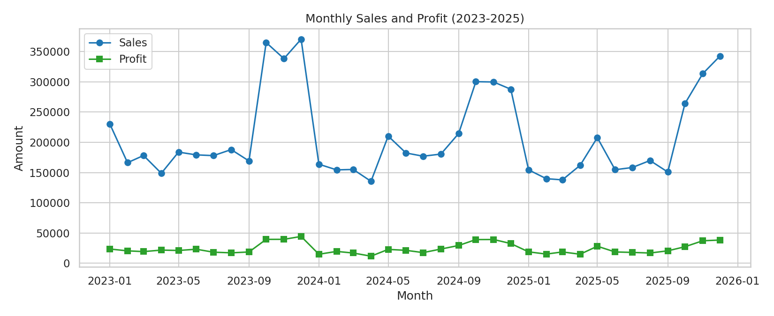
Figure 1: Monthly sales and profit, 2023–2025

7.3 Category and region performance
Technology earns the most sales and profit and has the best margin (15.9%). Furniture has high sales but the lowest margin (3.7%), so it earns little profit for its revenue. East is the most profitable region.
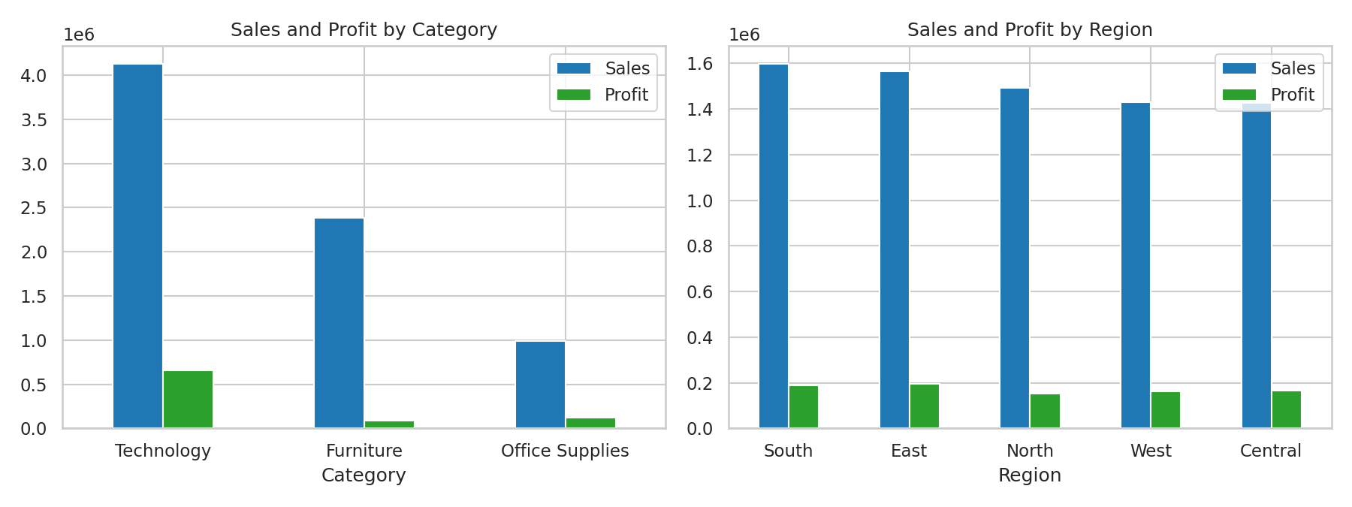
Figure 2: Sales and profit by category and region

7.4 Impact of discounts
Discount | Average profit per order | Average margin
0% | 288.33 | 16.88%
5% | 201.95 | 12.31%
10% | 133.67 | 8.22%
20% | -16.60 | -1.40%
30% | -103.90 | -9.53%
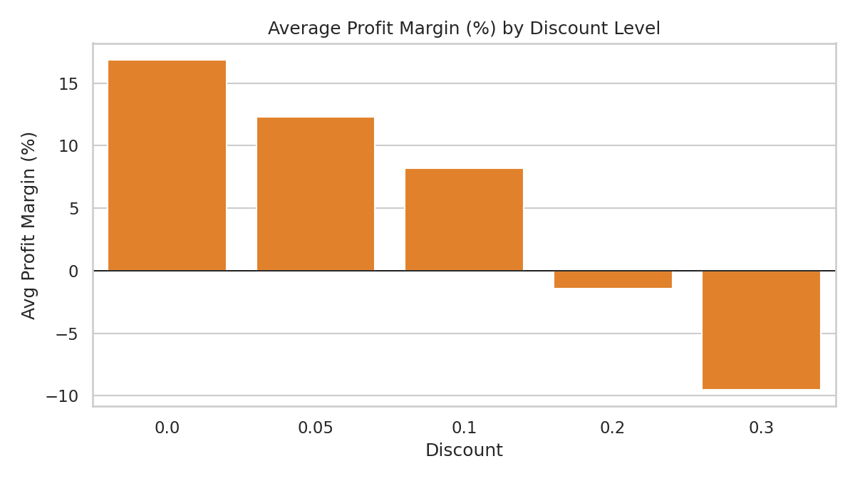
Figure 3: Average profit margin by discount level
Profit falls steadily as the discount rises and becomes negative from 20% onwards. Orders with a 20%+ discount were loss-making 69% of the time versus 1% with no discount.

7.5 Correlation analysis
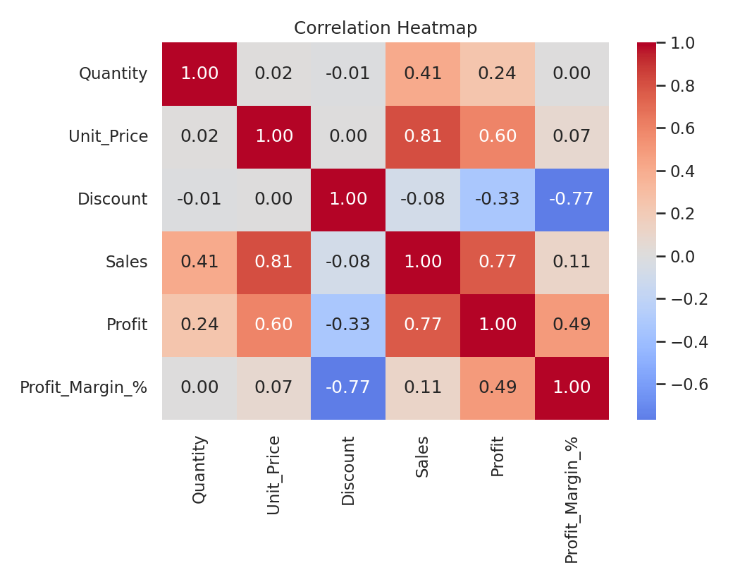
Figure 4: Correlation heatmap of numeric columns
Sales and profit are strongly related, while discount has a negative relationship with profit margin.

7.6 Customer segments
The elbow curve supported using three clusters.
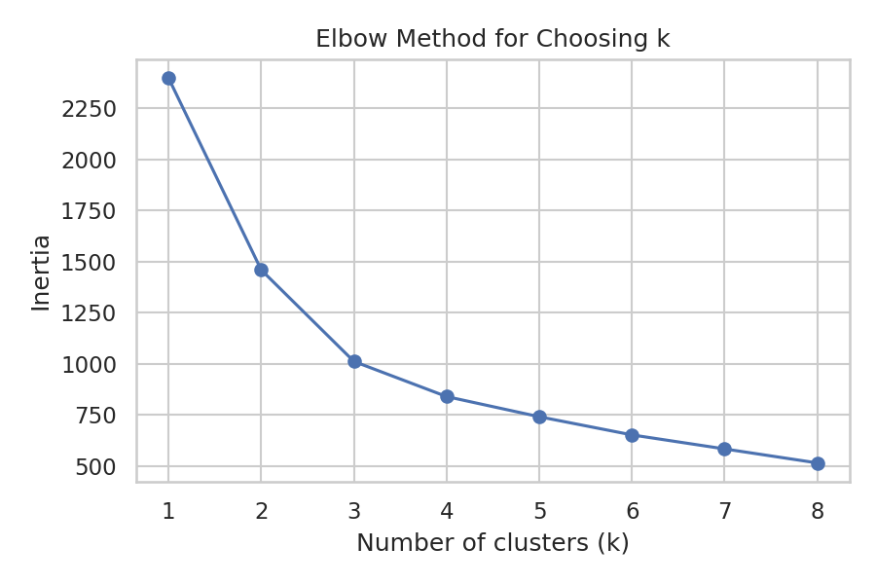
Figure 5: Elbow method
Segment | Customers | Avg days since last order | Avg orders | Avg total spend
Loyal High-Value | 297 | 90.7 | 8.6 | 15,258
Regular | 372 | 92.5 | 5.2 | 6,048
At-Risk / Inactive | 130 | 445.3 | 4.0 | 5,611
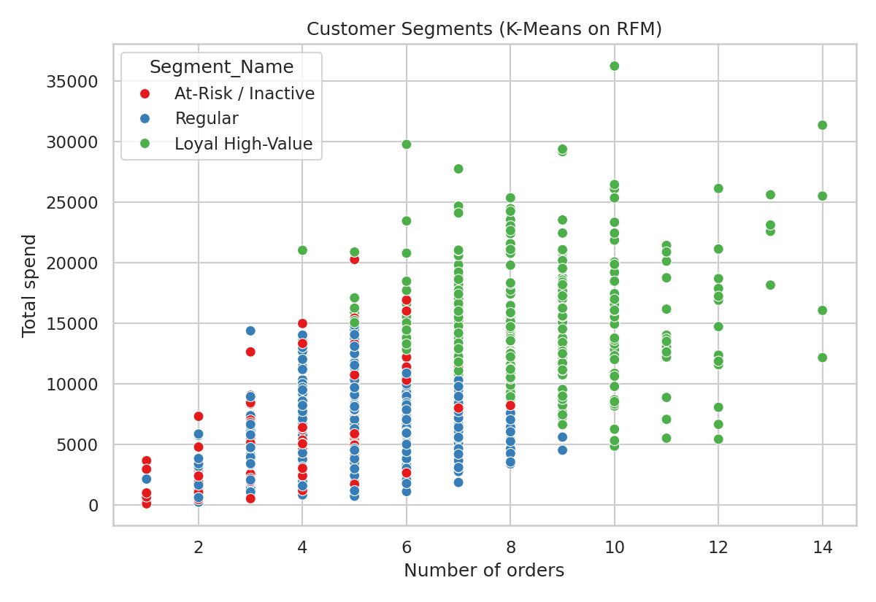
Figure 6: Customer segments (K-Means on RFM)
Loyal High-Value customers order often and spend more than twice as much as the other groups. At-Risk / Inactive customers have not ordered for over a year on average and are the main target for win-back offers.

7.7 Profit prediction
Model | R² | MAE | RMSE
Linear Regression | 0.588 | 152.68 | 248.80
Random Forest | 0.882 | 65.66 | 132.95

Random Forest performed much better because profit depends on non-linear combinations of price, quantity, discount and category, which a straight-line model cannot capture.
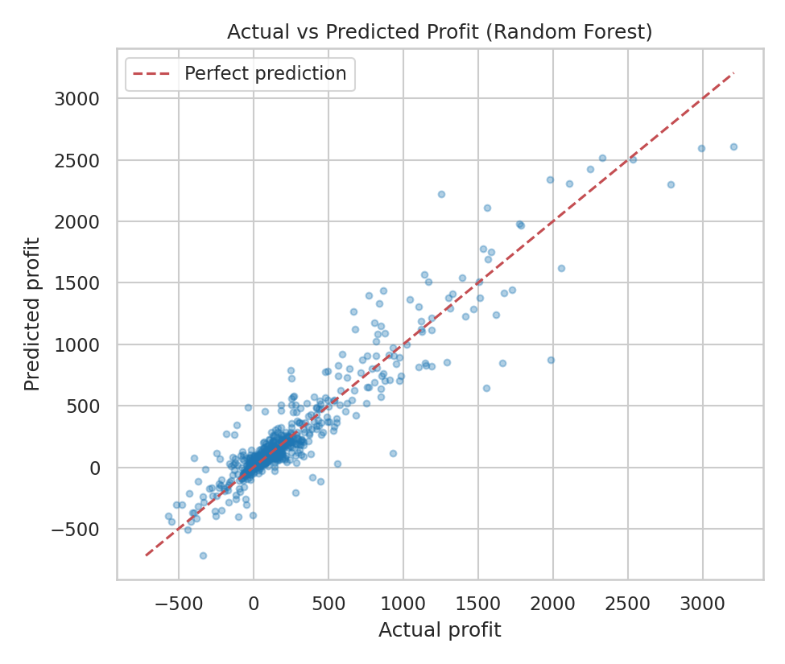
Figure 7: Actual vs predicted profit (Random Forest)
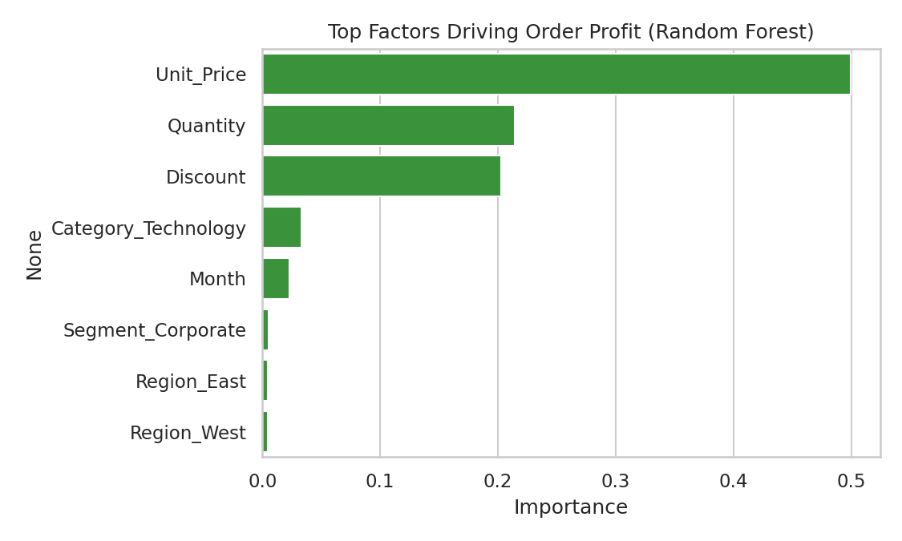
Figure 8: Top factors driving order profit
The most important factors were unit price (0.50), quantity (0.21) and discount (0.20).

8. Key Insights
- Technology is the most profitable category; Furniture earns a very low margin (3.7%).
- Heavy discounts destroy profit: 20%+ discounts lose money on about 7 out of 10 orders.
- Sales peak in the Oct–Dec season.
- About 37% of customers (297 of 799) are Loyal High-Value, while 16% (130) are At-Risk.
- Random Forest can estimate order profit reasonably well (R² = 0.882).

9. Business Recommendations
- Limit discounts to 10% or less, especially on low-margin categories such as Furniture.
- Launch win-back offers for At-Risk / Inactive customers and loyalty rewards for Loyal High-Value customers.
- Increase stock and marketing before the October–December peak.
- Use the profit-prediction model to check an order's expected profit before approving large discounts.

10. Limitations and Future Scope
- The dataset is simulated, so the findings demonstrate the method rather than real market behaviour.
- Future work: apply the same pipeline to a real company dataset, add time-series sales forecasting, and deploy the model as a simple web app or Power BI dashboard.

11. Conclusion
The project cleaned a retail sales dataset, explored its patterns, segmented customers with K-Means and predicted order profit with a Random Forest model. The main lesson is that discount policy and customer-specific retention are the biggest levers for improving profit. The work shows how Python and machine learning can turn raw order data into clear, practical business decisions.

12. Project Files
File | Purpose
Bavisetti_Mamatha_RetailSalesAnalysis.ipynb | Complete code with outputs
requirements.txt | Python libraries required
Bavisetti_Mamatha_ProjectReport.docx | This report
README.md | Project overview and run instructions
retail_sales_data.csv | Dataset

