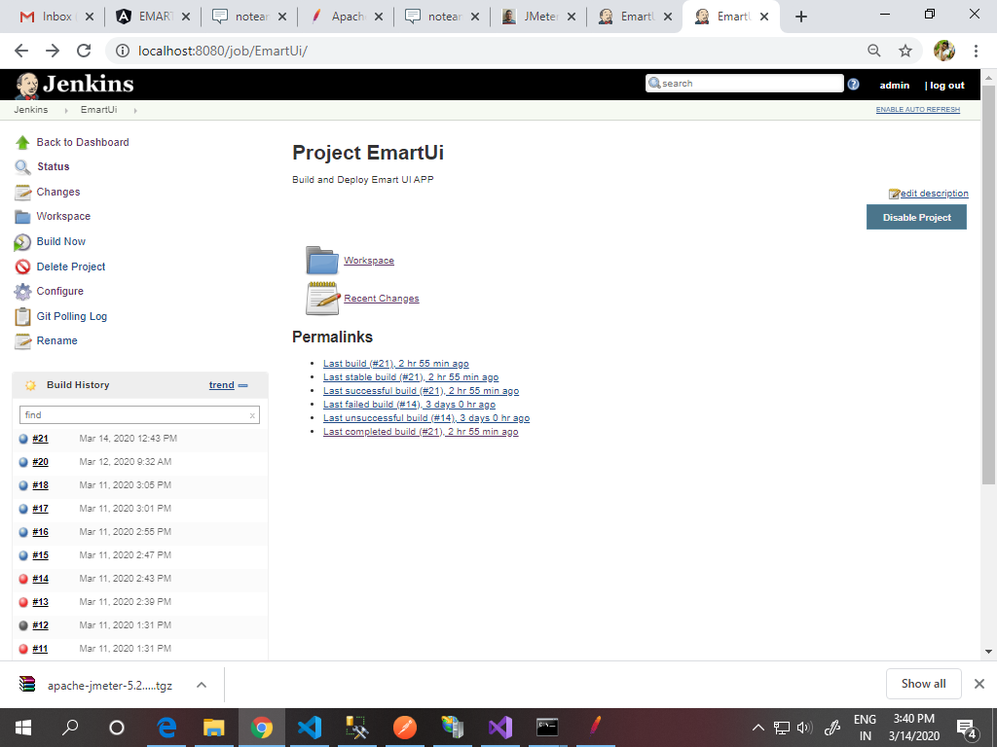

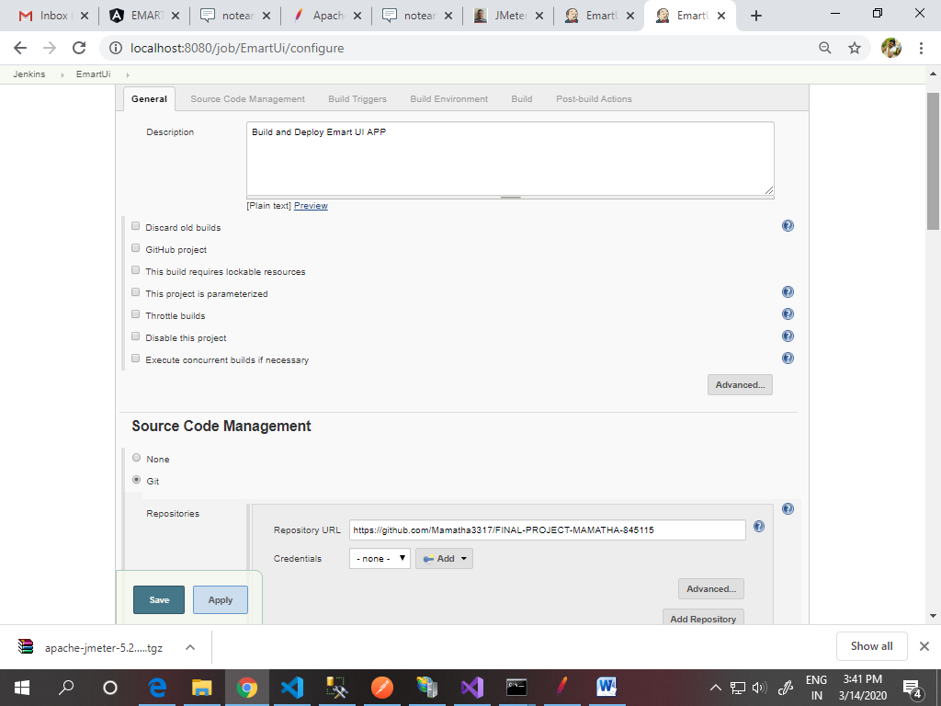

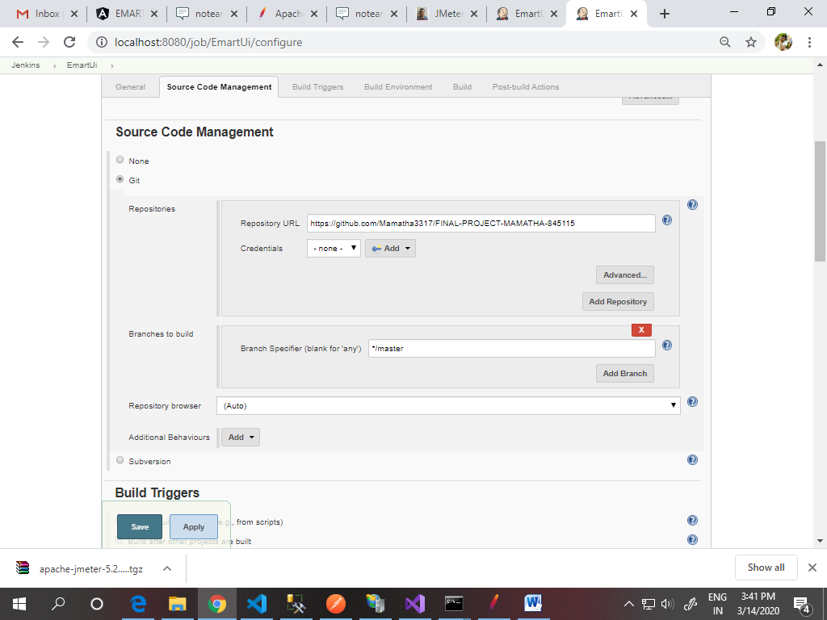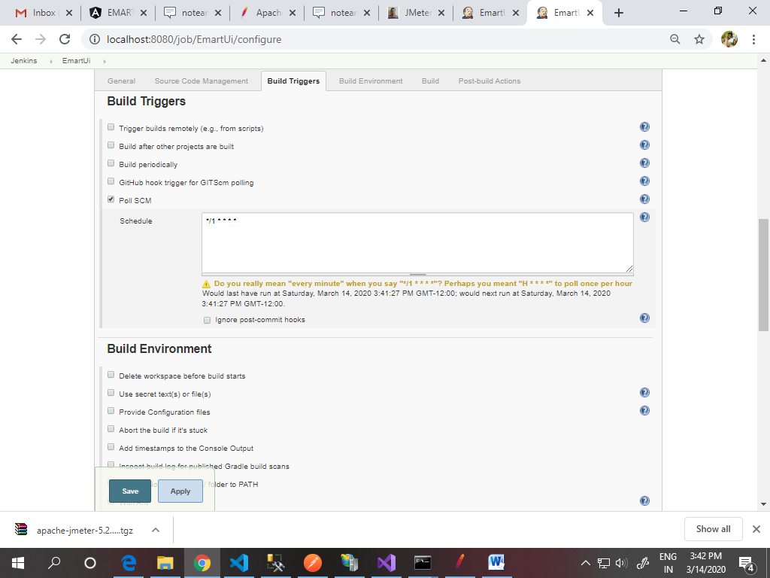

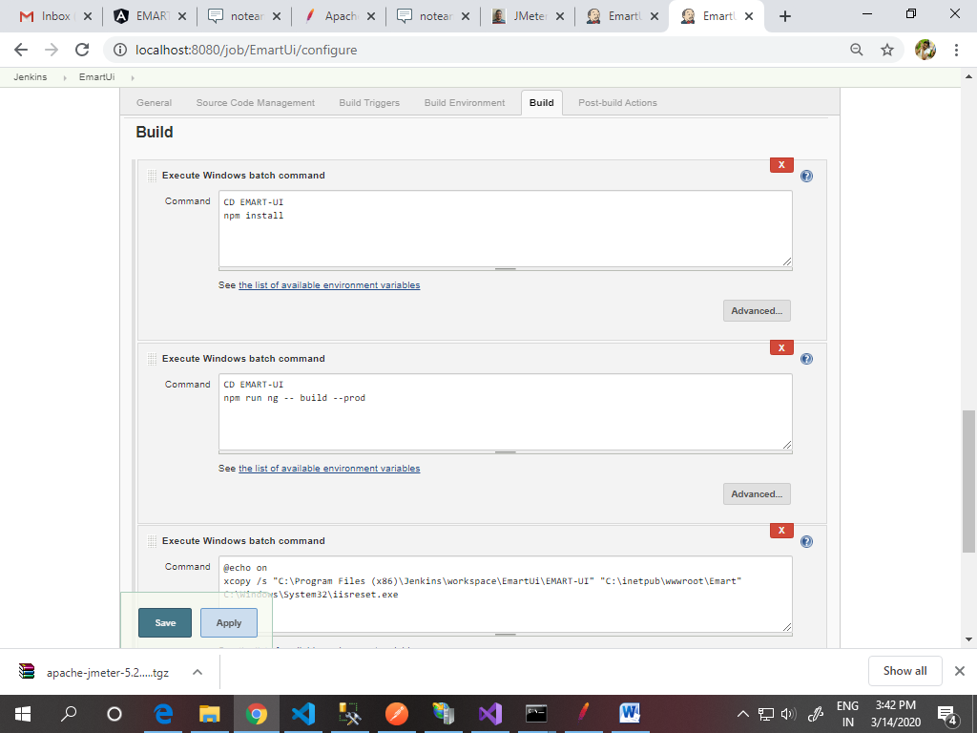

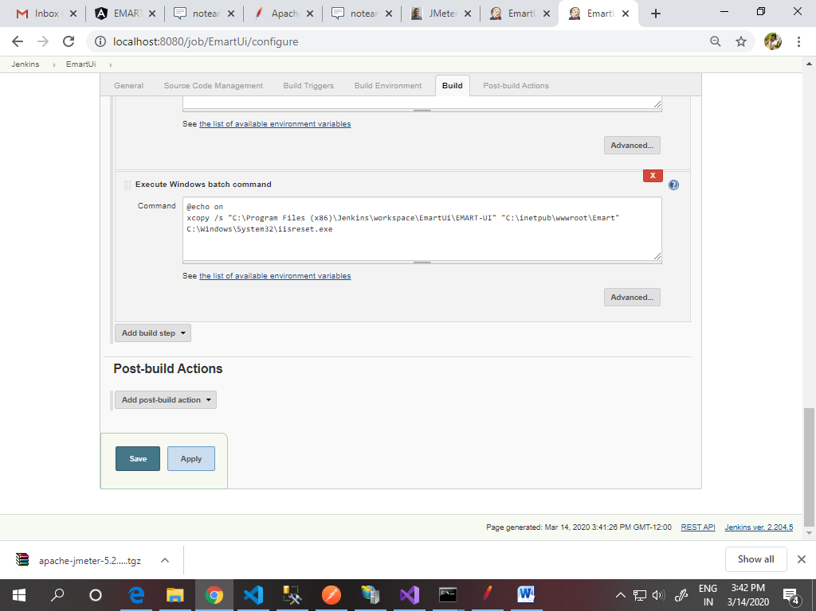

**SuccessConsole Output**

Skipping 3,439 KB.. [Full Log](http://localhost:8080/job/EmartUi/21/consoleFull)

there-yet\tracker.js

C:\Program Files (x86)\Jenkins\workspace\EmartUi\EMART-UI\node_modules\webpack-dev-server\node_modules\fsevents\node_modules\balanced-match\.npmignore

C:\Program Files (x86)\Jenkins\workspace\EmartUi\EMART-UI\node_modules\webpack-dev-server\node_modules\fsevents\node_modules\balanced-match\index.js

C:\Program Files (x86)\Jenkins\workspace\EmartUi\EMART-UI\node_modules\webpack-dev-server\node_modules\fsevents\node_modules\balanced-match\LICENSE.md

C:\Program Files (x86)\Jenkins\workspace\EmartUi\EMART-UI\node_modules\webpack-dev-server\node_modules\fsevents\node_modules\balanced-match\package.json

C:\Program Files (x86)\Jenkins\workspace\EmartUi\EMART-UI\node_modules\webpack-dev-server\node_modules\fsevents\node_modules\balanced-match\README.md

C:\Program Files (x86)\Jenkins\workspace\EmartUi\EMART-UI\node_modules\webpack-dev-server\node_modules\fsevents\node_modules\brace-expansion\index.js

C:\Program Files (x86)\Jenkins\workspace\EmartUi\EMART-UI\node_modules\webpack-dev-server\node_modules\fsevents\node_modules\brace-expansion\LICENSE

C:\Program Files (x86)\Jenkins\workspace\EmartUi\EMART-UI\node_modules\webpack-dev-server\node_modules\fsevents\node_modules\brace-expansion\package.json

C:\Program Files (x86)\Jenkins\workspace\EmartUi\EMART-UI\node_modules\webpack-dev-server\node_modules\fsevents\node_modules\brace-expansion\README.md

C:\Program Files (x86)\Jenkins\workspace\EmartUi\EMART-UI\node_modules\webpack-dev-server\node_modules\fsevents\node_modules\chownr\chownr.js

C:\Program Files (x86)\Jenkins\workspace\EmartUi\EMART-UI\node_modules\webpack-dev-server\node_modules\fsevents\node_modules\chownr\LICENSE

C:\Program Files (x86)\Jenkins\workspace\EmartUi\EMART-UI\node_modules\webpack-dev-server\node_modules\fsevents\node_modules\chownr\package.json

C:\Program Files (x86)\Jenkins\workspace\EmartUi\EMART-UI\node_modules\webpack-dev-server\node_modules\fsevents\node_modules\chownr\README.md

C:\Program Files (x86)\Jenkins\workspace\EmartUi\EMART-UI\node_modules\webpack-dev-server\node_modules\fsevents\node_modules\code-point-at\index.js

C:\Program Files (x86)\Jenkins\workspace\EmartUi\EMART-UI\node_modules\webpack-dev-server\node_modules\fsevents\node_modules\code-point-at\license

C:\Program Files (x86)\Jenkins\workspace\EmartUi\EMART-UI\node_modules\webpack-dev-server\node_modules\fsevents\node_modules\code-point-at\package.json

C:\Program Files (x86)\Jenkins\workspace\EmartUi\EMART-UI\node_modules\webpack-dev-server\node_modules\fsevents\node_modules\code-point-at\readme.md

C:\Program Files (x86)\Jenkins\workspace\EmartUi\EMART-UI\node_modules\webpack-dev-server\node_modules\fsevents\node_modules\concat-map\.travis.yml

C:\Program Files (x86)\Jenkins\workspace\EmartUi\EMART-UI\node_modules\webpack-dev-server\node_modules\fsevents\node_modules\concat-map\index.js

C:\Program Files (x86)\Jenkins\workspace\EmartUi\EMART-UI\node_modules\webpack-dev-server\node_modules\fsevents\node_modules\concat-map\LICENSE

C:\Program Files (x86)\Jenkins\workspace\EmartUi\EMART-UI\node_modules\webpack-dev-server\node_modules\fsevents\node_modules\concat-map\package.json

C:\Program Files (x86)\Jenkins\workspace\EmartUi\EMART-UI\node_modules\webpack-dev-server\node_modules\fsevents\node_modules\concat-map\README.markdown

C:\Program Files (x86)\Jenkins\workspace\EmartUi\EMART-UI\node_modules\webpack-dev-server\node_modules\fsevents\node_modules\concat-map\example\map.js

