**1.VWOmegamenu.html**

<!DOCTYPE html>

<html lang="en">

<head>

<meta charset="UTF-8">

<meta name="viewport" content="width=device-width, initial-scale=1.0">

<title>Document</title>

<link rel="stylesheet" href="/megamenu.css">

</head>

<body>

<div class="header">

<img src="/vwologo.png" alt="AOt">

<ul>

<li><a href="/Capabilities.html">Capabilities</a></li>

<li><a href="/Pricing.html">Pricing</a></li>

<li><a href="/Solutions.html">Solutions</a></li>

<li><a href="/Why VWO.html">Why VWO?</a></li>

<li><a href="/Resources.html">Resources</a></li>

</ul>

<ul>

<li><a href="#">Contact</a></li>

<li><a href="#">Login</a></li>

<li><a href="#">EN</a></li>

</ul>

</div>

<img src="/vwo2.svg" alt="" style="width: 600px;height: 500px;position: fixed;top: 200px; left: 400px;opacity: 200%;">

</body>

</html>

**2.megamenu.css**

body{

background-color: black;

}

.header{

border: 2px solid rgb(121, 58, 121);

width: 100%;

height: 100px;

background-color: rgb(121, 58, 121);

}

img{

width: 100px;

height: 100px;

border-radius: 20px;

opacity: 80%;

position: fixed;

top: 10px;

left: 30px;

}

.header li {

list-style: none;

text-decoration: none;

color: black;

width: 90px;

font-size: 20px;

margin-left: 85px;

float: left;

border-radius: 10px;

text-align: center;

}

.main{

border: 2px solid white;

width: 80%;

height: 600px;

position: fixed;

top: 110px;

left: 150px;

background-color: white;

}

.side_nav{

border: 2px solid rgb(207, 148, 207);

background-color: rgb(207, 148, 207);

width: 300px;

height: 550px;

position: fixed;

top: 110px;

left: 150px;

}

.side_nav ul{

background-color: rgb(207, 148, 207);

}

a.active,a:link,a:visited{

color: black;

text-decoration: none;

}

.header li:hover{

width: 100px;

height: 30px;

border: 2px solid white;

background-color: white;

border-radius: 4px;

}

.side_nav li{

margin-top: 50px;

background-color: transparent;

list-style: none;

color: black;

width: 200px;

font-size: 20px;

border-radius: 10px;

}

.side_nav li:hover{

width: 280px;

height: 50px;

background-color: white;

text-align: justify;

}

.main h1{

color: darkred;

font-size: 20px;

position: fixed;

top: 120px;

left: 480px;

background-color: white;

}

.main p{

color: black;

font-size: 15px;

position: fixed;

top: 160px;

left: 480px;

background-color: white;

}

.T1{

width: 250px;

color: black;

background-color: white;

font-size: 20px;

position: fixed;

left: 500px;

top: 250px;

visibility: none;

}

.TC1{

width: 250px;

color: black;

background-color: white;

font-size:15px;

}

.T2{

width: 250px;

color: black;

background-color: white;

font-size: 20px;

position: fixed;

left: 500px;

top:400px;

}

.TC2{

width: 250px;

color: black;

background-color: white;

font-size:15px;

}

.T3{

width: 250px;

color: black;

background-color: white;

font-size: 20px;

position: fixed;

left: 500px;

top: 550px;

}

.TC3{

width: 250px;

color: black;

background-color: white;

font-size:15px;

}

.features{

color: black;

background-color: white;

font-size: 20px;

position: fixed;

top: 225px;

left: 825px;

}

.f{

list-style: none;

color: black;

background-color: white;

font-size: 15px;

position: fixed;

top: 275px;

left: 800px;

}

.f li{

background-color: white;

margin-top: 15px;

}

.more {

color: red;

font-size: 15px;

background-color: white;

position: fixed;

top:475px;

left: 850px;

}

.PO{

color: black;

background-color: white;

font-size: 20px;

position: fixed;

top: 670px;

left: 200px;

}

.T1:hover{

content: url(/WB.jpg);

width: 300px;

height: 300px;

opacity: 80%;

position: fixed;

top: 400px;

left: 1000px;

}

.T2:hover{

content: url(/MA.jpg);

width: 300px;

height: 300px;

opacity: 80%;

position: fixed;

top: 400px;

left: 1000px;

}

.T3:hover{

content: url(/ST.png);

width: 340px;

height: 300px;

opacity: 200%;

position: fixed;

top: 400px;

left: 1000px;

}

**3.Capabilties.html**

<!DOCTYPE html>

<html lang="en">

<head>

<meta charset="UTF-8">

<meta name="viewport" content="width=device-width, initial-scale=1.0">

<title>Document</title>

<link rel="stylesheet" href="/megamenu.css">

</head>

<body>

<div class="header">

<img src="/vwologo.png" alt="AOt">

<ul>

<li><a href="/Capabilities.html">Capabilities</a></li>

<li><a href="/Pricing.html">Pricing</a></li>

<li><a href="/Solutions.html">Solutions</a></li>

<li><a href="/Why VWO.html">Why VWO?</a></li>

<li><a href="/Resources.html">Resources</a></li>

</ul>

<ul>

<li><a href="#">Contact</a></li>

<li><a href="#">Login</a></li>

<li><a href="#">EN</a></li>

</ul>

</div>

<div class="main">

<nav class="side_nav">

<ul>

<li><a href="/Testing.html">Testing</a></li>

<li><a href="/Behavior Analytics.html">Behavior Analytics</a></li>

<li><a href="/Personalization.html">Personalization</a></li>

<li><a href="/Web Rollouts.html">Web Rollouts</a></li>

<li><a href="/Customer Data Platform.html">Customer Data Platform</a></li>

<li><a href="/Program Management.html">Program Management</a></li>

</ul>

</nav>

</div>

</body>

</html>

**4.Testing.html**

<!DOCTYPE html>

<html lang="en">

<head>

<meta charset="UTF-8">

<meta name="viewport" content="width=device-width, initial-scale=1.0">

<title>Document</title>

<link rel="stylesheet" href="/megamenu.css">

</head>

<body>

<div class="header">

<img src="/vwologo.png" alt="AOt">

<ul>

<li><a href="/Capabilities.html">Capabilities</a></li>

<li><a href="/Pricing.html">Pricing</a></li>

<li><a href="/Solutions.html">Solutions</a></li>

<li><a href="/Why VWO.html">Why VWO?</a></li>

<li><a href="/Resources.html">Resources</a></li>

</ul>

<ul>

<li><a href="#">Contact</a></li>

<li><a href="#">Login</a></li>

<li><a href="#">EN</a></li>

</ul>

</div>

<div class="main">

<nav class="side_nav">

<ul>

<li><a href="/Testing.html">Testing</a></li>

<li><a href="/Behavior Analytics.html">Behavior Analytics</a></li>

<li><a href="/Personalization.html">Personalization</a></li>

<li><a href="/Web Rollouts.html">Web Rollouts</a></li>

<li><a href="/Customer Data Platform.html">Customer Data Platform</a></li>

<li><a href="/Program Management.html">Program Management</a></li>

</ul>

</nav>

<h1>Testing Overview -></h1>

<p>&nbsp;Build winning experiences across web,mobile app and server-side</p>

<hr style="margin-top: 100px;">

<section>

<span class="T1">Web Testing <br>

<span class="TC1">Test and create web experiences that convert</span>

</span>

</section>

<section>

<span class="T2">Mobile App Testing <br>

<span class="TC2">Delight mobile app users with optimized experiences</span>

</span>

</section>

<section>

<span class="T3">Server-side Testing <br>

<span class="TC2">Test complex features across any tech stack or device</span>

</span>

</section>

<section>

<h3 class="features">Features</h3>

<ul class="f">

<li>Split Testing</li>

<li>Multivariate Testing</li>

<li>Integrations</li>

<li>Hypothesis</li>

<li>Bayesian Stats Engine</li>

</ul>

<a class="more" href="#">(+125 more) </a>

</section>

<section>

<a class="PO" href="#"> Platform Overview -></a>

</section>

</body>

</html>

**5.BehaviorAnalytics.html**

<!DOCTYPE html>

<html lang="en">

<head>

<meta charset="UTF-8">

<meta name="viewport" content="width=device-width, initial-scale=1.0">

<title>Document</title>

<link rel="stylesheet" href="/megamenu.css">

</head>

<body>

<div class="header">

<img src="/vwologo.png" alt="AOt">

<ul>

<li><a href="/Capabilities.html">Capabilities</a></li>

<li><a href="/Pricing.html">Pricing</a></li>

<li><a href="/Solutions.html">Solutions</a></li>

<li><a href="/Why VWO.html">Why VWO?</a></li>

<li><a href="/Resources.html">Resources</a></li>

</ul>

<ul>

<li><a href="#">Contact</a></li>

<li><a href="#">Login</a></li>

<li><a href="#">EN</a></li>

</ul>

</div>

<div class="main">

<nav class="side_nav">

<ul>

<li><a href="/Testing.html">Testing</a></li>

<li><a href="/Behavior Analytics.html">Behavior Analytics</a></li>

<li><a href="/Personalization.html">Personalization</a></li>

<li><a href="/Web Rollouts.html">Web Rollouts</a></li>

<li><a href="/Customer Data Platform.html">Customer Data Platform</a></li>

<li><a href="/Program Management.html">Program Management</a></li>

</ul>

</nav>

<center><span style="color: black;background-color: lightslategrey;font-size: 50px;position: fixed;top: 350px;left:750px;border-radius: 10px;">Behavior Analytics</span></center>

<section>

<a class="PO" href="#"> Platform Overview -></a>

</section>

</body>

</html>

**6.CutsomerdataPlatform.html**

<!DOCTYPE html>

<html lang="en">

<head>

<meta charset="UTF-8">

<meta name="viewport" content="width=device-width, initial-scale=1.0">

<title>Document</title>

<link rel="stylesheet" href="/megamenu.css">

</head>

<body>

<div class="header">

<img src="/vwologo.png" alt="AOt">

<ul>

<li><a href="/Capabilities.html">Capabilities</a></li>

<li><a href="/Pricing.html">Pricing</a></li>

<li><a href="/Solutions.html">Solutions</a></li>

<li><a href="/Why VWO.html">Why VWO?</a></li>

<li><a href="/Resources.html">Resources</a></li>

</ul>

<ul>

<li><a href="#">Contact</a></li>

<li><a href="#">Login</a></li>

<li><a href="#">EN</a></li>

</ul>

</div>

<div class="main">

<nav class="side_nav">

<ul>

<li><a href="/Testing.html">Testing</a></li>

<li><a href="/Behavior Analytics.html">Behavior Analytics</a></li>

<li><a href="/Personalization.html">Personalization</a></li>

<li><a href="/Web Rollouts.html">Web Rollouts</a></li>

<li><a href="/Customer Data Platform.html">Customer Data Platform</a></li>

<li><a href="/Program Management.html">Program Management</a></li>

</ul>

</nav>

<center><span style="color: black;background-color: lightslategrey;font-size: 50px;position: fixed;top: 350px;left:750px;border-radius: 10px;">Customer Data Platform</span></center>

<section>

<a class="PO" href="#"> Platform Overview -></a>

</section>

</body>

</html>

**7.Personalization.html**

<!DOCTYPE html>

<html lang="en">

<head>

<meta charset="UTF-8">

<meta name="viewport" content="width=device-width, initial-scale=1.0">

<title>Document</title>

<link rel="stylesheet" href="/megamenu.css">

</head>

<body>

<div class="header">

<img src="/vwologo.png" alt="AOt">

<ul>

<li><a href="/Capabilities.html">Capabilities</a></li>

<li><a href="/Pricing.html">Pricing</a></li>

<li><a href="/Solutions.html">Solutions</a></li>

<li><a href="/Why VWO.html">Why VWO?</a></li>

<li><a href="/Resources.html">Resources</a></li>

</ul>

<ul>

<li><a href="#">Contact</a></li>

<li><a href="#">Login</a></li>

<li><a href="#">EN</a></li>

</ul>

</div>

<div class="main">

<nav class="side_nav">

<ul>

<li><a href="/Testing.html">Testing</a></li>

<li><a href="/Behavior Analytics.html">Behavior Analytics</a></li>

<li><a href="/Personalization.html">Personalization</a></li>

<li><a href="/Web Rollouts.html">Web Rollouts</a></li>

<li><a href="/Customer Data Platform.html">Customer Data Platform</a></li>

<li><a href="/Program Management.html">Program Management</a></li>

</ul>

</nav>

<center><span style="color: black;background-color: lightslategrey;font-size: 50px;position: fixed;top: 350px;left:750px;border-radius: 10px;">Personalization</span></center>

<section>

<a class="PO" href="#"> Platform Overview -></a>

</section>

</body>

</html>

**8.Pricing.html**

<!DOCTYPE html>

<html lang="en">

<head>

<meta charset="UTF-8">

<meta name="viewport" content="width=device-width, initial-scale=1.0">

<title>Document</title>

<link rel="stylesheet" href="/megamenu.css">

</head>

<body>

<div class="header">

<img src="/vwologo.png" alt="AOt">

<ul>

<li><a href="/Capabilities.html">Capabilities</a></li>

<li><a href="/Pricing.html">Pricing</a></li>

<li><a href="/Solutions.html">Solutions</a></li>

<li><a href="/Why VWO.html">Why VWO?</a></li>

<li><a href="/Resources.html">Resources</a></li>

</ul>

<ul>

<li><a href="#">Contact</a></li>

<li><a href="#">Login</a></li>

<li><a href="#">EN</a></li>

</ul>

<div class="main">

<nav class="side_nav">

<ul>

<li><a href="/Testing.html">Testing</a></li>

<li><a href="/Behavior Analytics.html">Behavior Analytics</a></li>

<li><a href="/Personalization.html">Personalization</a></li>

<li><a href="/Web Rollouts.html">Web Rollouts</a></li>

<li><a href="/Customer Data Platform.html">Customer Data Platform</a></li>

<li><a href="/Program Management.html">Program Management</a></li>

</ul>

</nav>

</div>

<div class="main">

<nav class="side_nav">

<center><span style="color: black;background-color: lightslategrey;font-size: 50px;position: fixed;top: 350px;left:750px;border-radius: 10px;">PRICING</span></center>

</nav>

</body>

</html>

**9.ProgramManagement.html**

<!DOCTYPE html>

<html lang="en">

<head>

<meta charset="UTF-8">

<meta name="viewport" content="width=device-width, initial-scale=1.0">

<title>Document</title>

<link rel="stylesheet" href="/megamenu.css">

</head>

<body>

<div class="header">

<img src="/vwologo.png" alt="AOt">

<ul>

<li><a href="/Capabilities.html">Capabilities</a></li>

<li><a href="/Pricing.html">Pricing</a></li>

<li><a href="/Solutions.html">Solutions</a></li>

<li><a href="/Why VWO.html">Why VWO?</a></li>

<li><a href="/Resources.html">Resources</a></li>

</ul>

<ul>

<li><a href="#">Contact</a></li>

<li><a href="#">Login</a></li>

<li><a href="#">EN</a></li>

</ul>

</div>

<div class="main">

<nav class="side_nav">

<ul>

<li><a href="/Testing.html">Testing</a></li>

<li><a href="/Behavior Analytics.html">Behavior Analytics</a></li>

<li><a href="/Personalization.html">Personalization</a></li>

<li><a href="/Web Rollouts.html">Web Rollouts</a></li>

<li><a href="/Customer Data Platform.html">Customer Data Platform</a></li>

<li><a href="/Program Management.html">Program Management</a></li>

</ul>

</nav>

<center><span style="color: black;background-color: lightslategrey;font-size: 50px;position: fixed;top: 350px;left:750px;border-radius: 10px;">Program Management</span></center>

<section>

<a class="PO" href="#"> Platform Overview -></a>

</section>

</body>

</html>

**10.Resources.html**

<!DOCTYPE html>

<html lang="en">

<head>

<meta charset="UTF-8">

<meta name="viewport" content="width=device-width, initial-scale=1.0">

<title>Document</title>

<link rel="stylesheet" href="/megamenu.css">

</head>

<body>

<div class="header">

<img src="/vwologo.png" alt="AOt">

<ul>

<li><a href="/Capabilities.html">Capabilities</a></li>

<li><a href="/Pricing.html">Pricing</a></li>

<li><a href="/Solutions.html">Solutions</a></li>

<li><a href="/Why VWO.html">Why VWO?</a></li>

<li><a href="/Resources.html">Resources</a></li>

</ul>

<ul>

<li><a href="#">Contact</a></li>

<li><a href="#">Login</a></li>

<li><a href="#">EN</a></li>

</ul>

</div>

<div class="main">

<nav class="side_nav">

<center><span style="color: black;background-color: lightslategrey;font-size: 50px;position: fixed;top: 350px;left:750px;border-radius: 10px;">Resources</span></center>

</nav>

</body>

</html>

**11.Solutions.html**

<!DOCTYPE html>

<html lang="en">

<head>

<meta charset="UTF-8">

<meta name="viewport" content="width=device-width, initial-scale=1.0">

<title>Document</title>

<link rel="stylesheet" href="/megamenu.css">

</head>

<body>

<div class="header">

<img src="/vwologo.png" alt="AOt">

<ul>

<li><a href="/Capabilities.html">Capabilities</a></li>

<li><a href="/Pricing.html">Pricing</a></li>

<li><a href="/Solutions.html">Solutions</a></li>

<li><a href="/Why VWO.html">Why VWO?</a></li>

<li><a href="/Resources.html">Resources</a></li>

</ul>

<ul>

<li><a href="#">Contact</a></li>

<li><a href="#">Login</a></li>

<li><a href="#">EN</a></li>

</ul>

</div>

<div class="main">

<nav class="side_nav">

<center><span style="color: black;background-color: lightslategrey;font-size: 50px;position: fixed;top: 350px;left:750px;border-radius: 10px;">SOLUTIONS</span></center>

</nav>

</body>

</html>

**12.WebRollouts.html**

<!DOCTYPE html>

<html lang="en">

<head>

<meta charset="UTF-8">

<meta name="viewport" content="width=device-width, initial-scale=1.0">

<title>Document</title>

<link rel="stylesheet" href="/megamenu.css">

</head>

<body>

<div class="header">

<img src="/vwologo.png" alt="AOt">

<ul>

<li><a href="/Capabilities.html">Capabilities</a></li>

<li><a href="/Pricing.html">Pricing</a></li>

<li><a href="/Solutions.html">Solutions</a></li>

<li><a href="/Why VWO.html">Why VWO?</a></li>

<li><a href="/Resources.html">Resources</a></li>

</ul>

<ul>

<li><a href="#">Contact</a></li>

<li><a href="#">Login</a></li>

<li><a href="#">EN</a></li>

</ul>

</div>

<div class="main">

<nav class="side_nav">

<ul>

<li><a href="/Testing.html">Testing</a></li>

<li><a href="/Behavior Analytics.html">Behavior Analytics</a></li>

<li><a href="/Personalization.html">Personalization</a></li>

<li><a href="/Web Rollouts.html">Web Rollouts</a></li>

<li><a href="/Customer Data Platform.html">Customer Data Platform</a></li>

<li><a href="/Program Management.html">Program Management</a></li>

</ul>

</nav>

<center><span style="color: black;background-color: lightslategrey;font-size: 50px;position: fixed;top: 350px;left:750px;border-radius: 10px;">Web Rollouts</span></center>

<section>

<a class="PO" href="#"> Platform Overview -></a>

</section>

</body>

</html>

**13.Why VWO.html**

<!DOCTYPE html>

<html lang="en">

<head>

<meta charset="UTF-8">

<meta name="viewport" content="width=device-width, initial-scale=1.0">

<title>Document</title>

<link rel="stylesheet" href="/megamenu.css">

</head>

<body>

<div class="header">

<img src="/vwologo.png" alt="AOt">

<ul>

<li><a href="/Capabilities.html">Capabilities</a></li>

<li><a href="/Pricing.html">Pricing</a></li>

<li><a href="/Solutions.html">Solutions</a></li>

<li><a href="/Why VWO.html">Why VWO?</a></li>

<li><a href="/Resources.html">Resources</a></li>

</ul>

<ul>

<li><a href="#">Contact</a></li>

<li><a href="#">Login</a></li>

<li><a href="#">EN</a></li>

</ul>

</div>

<div class="main">

<nav class="side_nav">

<center><span style="color: black;background-color: lightslategrey;font-size: 50px;position: fixed;top: 350px;left:750px;border-radius: 10px;">Why VWO?</span></center>

</nav>

</body>

</html>

**OUTPUT :**

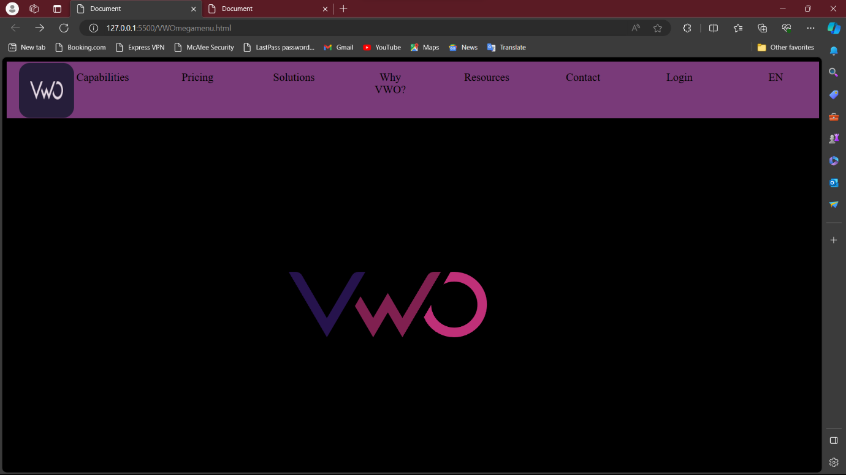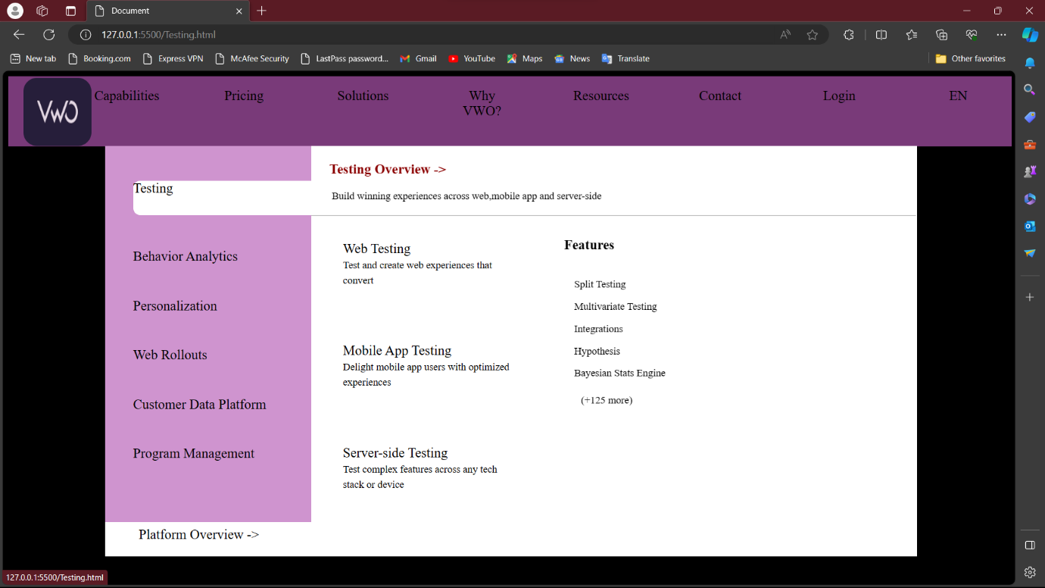**1**

2

**3**



4

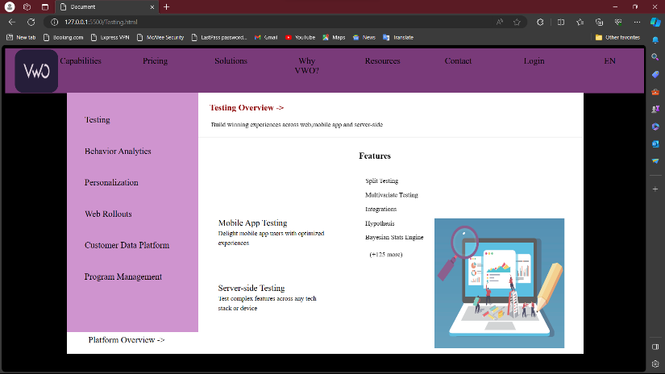

6

5

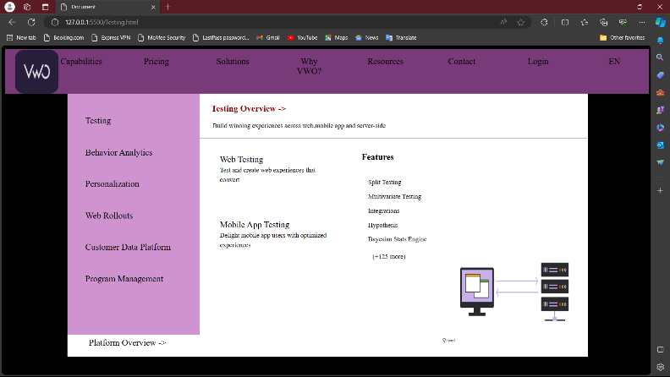

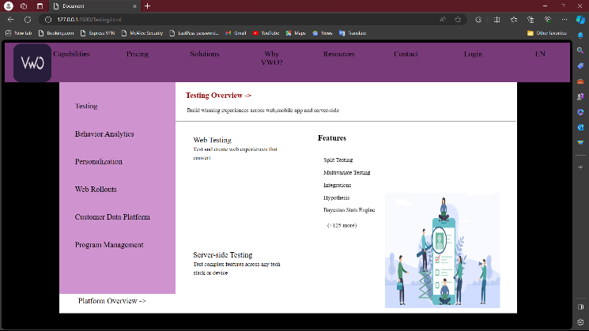

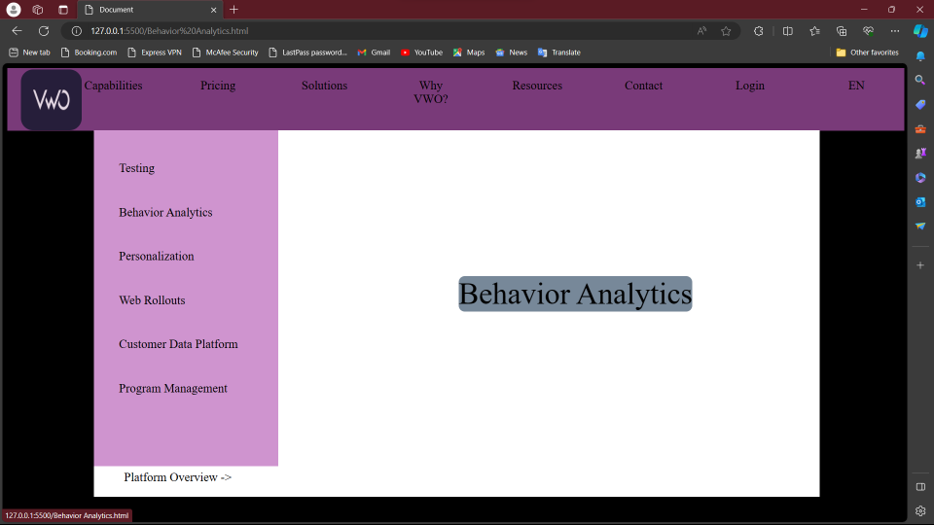**7.**

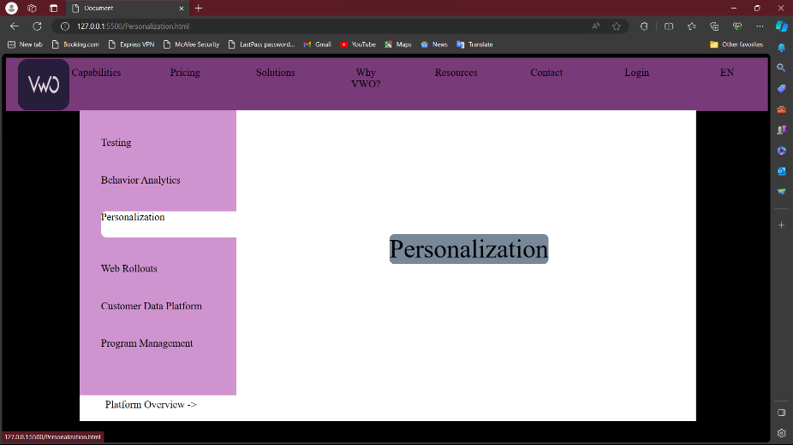

**8.**

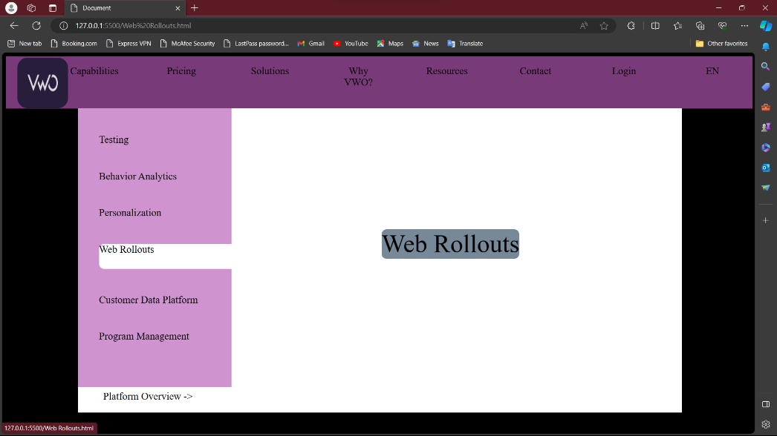

9

**10.**

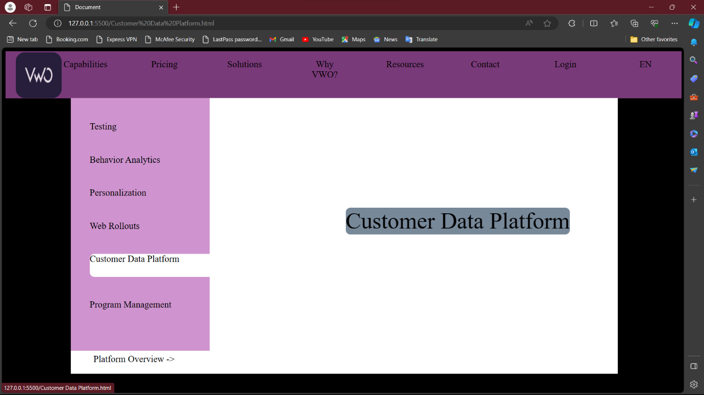

**11.**

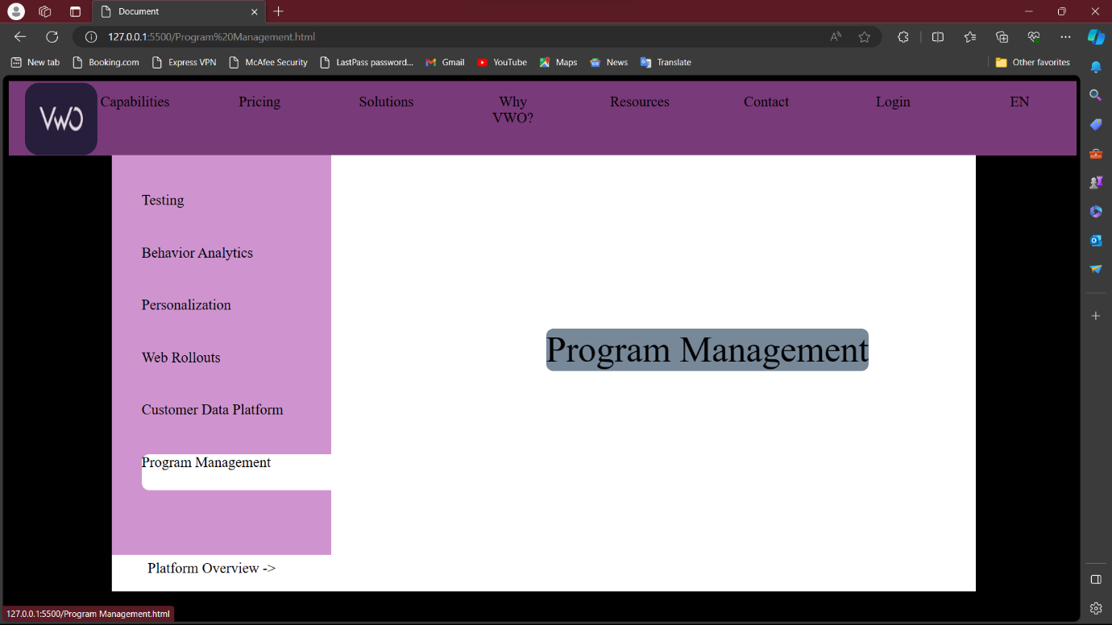

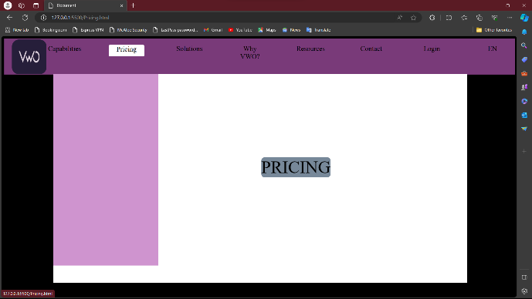**12. 13.**

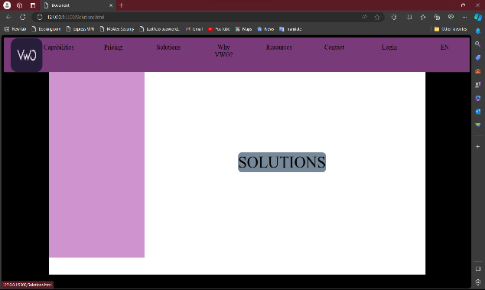

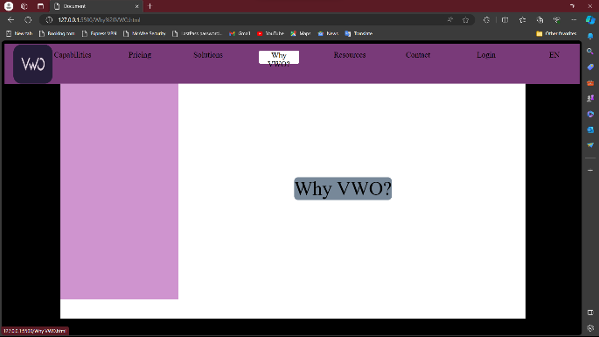**11. 12.**

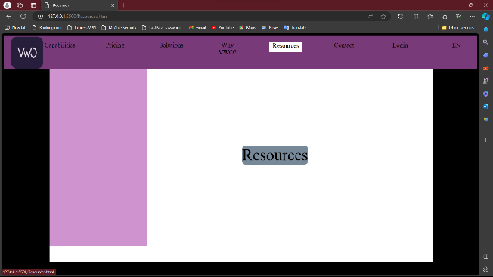

**1.VWOmegamenu.html**

<!DOCTYPE html>

<html lang="en">

<head>

<meta charset="UTF-8">

<meta name="viewport" content="width=device-width, initial-scale=1.0">

<title>Document</title>

<link rel="stylesheet" href="/megamenu.css">

</head>

<body>

<div class="header">

<img src="/vwologo.png" alt="AOt">

<ul>

<li><a href="/Capabilities.html">Capabilities</a></li>

<li><a href="/Pricing.html">Pricing</a></li>

<li><a href="/Solutions.html">Solutions</a></li>

<li><a href="/Why VWO.html">Why VWO?</a></li>

<li><a href="/Resources.html">Resources</a></li>

</ul>

<ul>

<li><a href="#">Contact</a></li>

<li><a href="#">Login</a></li>

<li><a href="#">EN</a></li>

</ul>

</div>

<img src="/vwo2.svg" alt="" style="width: 600px;height: 500px;position: fixed;top: 200px; left: 400px;opacity: 200%;">

</body>

</html>

**2.megamenu.css**

body{

background-color: black;

}

.header{

border: 2px solid rgb(121, 58, 121);

width: 100%;

height: 100px;

background-color: rgb(121, 58, 121);

}

img{

width: 100px;

height: 100px;

border-radius: 20px;

opacity: 80%;

position: fixed;

top: 10px;

left: 30px;

}

.header li {

list-style: none;

text-decoration: none;

color: black;

width: 90px;

font-size: 20px;

margin-left: 85px;

float: left;

border-radius: 10px;

text-align: center;

}

.main{

border: 2px solid white;

width: 80%;

height: 600px;

position: fixed;

top: 110px;

left: 150px;

background-color: white;

}

.side_nav{

border: 2px solid rgb(207, 148, 207);

background-color: rgb(207, 148, 207);

width: 300px;

height: 550px;

position: fixed;

top: 110px;

left: 150px;

}

.side_nav ul{

background-color: rgb(207, 148, 207);

}

a.active,a:link,a:visited{

color: black;

text-decoration: none;

}

.header li:hover{

width: 100px;

height: 30px;

border: 2px solid white;

background-color: white;

border-radius: 4px;

}

.side_nav li{

margin-top: 50px;

background-color: transparent;

list-style: none;

color: black;

width: 200px;

font-size: 20px;

border-radius: 10px;

}

.side_nav li:hover{

width: 280px;

height: 50px;

background-color: white;

text-align: justify;

}

.main h1{

color: darkred;

font-size: 20px;

position: fixed;

top: 120px;

left: 480px;

background-color: white;

}

.main p{

color: black;

font-size: 15px;

position: fixed;

top: 160px;

left: 480px;

background-color: white;

}

.T1{

width: 250px;

color: black;

background-color: white;

font-size: 20px;

position: fixed;

left: 500px;

top: 250px;

visibility: none;

}

.TC1{

width: 250px;

color: black;

background-color: white;

font-size:15px;

}

.T2{

width: 250px;

color: black;

background-color: white;

font-size: 20px;

position: fixed;

left: 500px;

top:400px;

}

.TC2{

width: 250px;

color: black;

background-color: white;

font-size:15px;

}

.T3{

width: 250px;

color: black;

background-color: white;

font-size: 20px;

position: fixed;

left: 500px;

top: 550px;

}

.TC3{

width: 250px;

color: black;

background-color: white;

font-size:15px;

}

.features{

color: black;

background-color: white;

font-size: 20px;

position: fixed;

top: 225px;

left: 825px;

}

.f{

list-style: none;

color: black;

background-color: white;

font-size: 15px;

position: fixed;

top: 275px;

left: 800px;

}

.f li{

background-color: white;

margin-top: 15px;

}

.more {

color: red;

font-size: 15px;

background-color: white;

position: fixed;

top:475px;

left: 850px;

}

.PO{

color: black;

background-color: white;

font-size: 20px;

position: fixed;

top: 670px;

left: 200px;

}

.T1:hover{

content: url(/WB.jpg);

width: 300px;

height: 300px;

opacity: 80%;

position: fixed;

top: 400px;

left: 1000px;

}

.T2:hover{

content: url(/MA.jpg);

width: 300px;

height: 300px;

opacity: 80%;

position: fixed;

top: 400px;

left: 1000px;

}

.T3:hover{

content: url(/ST.png);

width: 340px;

height: 300px;

opacity: 200%;

position: fixed;

top: 400px;

left: 1000px;

}

**3.Capabilties.html**

<!DOCTYPE html>

<html lang="en">

<head>

<meta charset="UTF-8">

<meta name="viewport" content="width=device-width, initial-scale=1.0">

<title>Document</title>

<link rel="stylesheet" href="/megamenu.css">

</head>

<body>

<div class="header">

<img src="/vwologo.png" alt="AOt">

<ul>

<li><a href="/Capabilities.html">Capabilities</a></li>

<li><a href="/Pricing.html">Pricing</a></li>

<li><a href="/Solutions.html">Solutions</a></li>

<li><a href="/Why VWO.html">Why VWO?</a></li>

<li><a href="/Resources.html">Resources</a></li>

</ul>

<ul>

<li><a href="#">Contact</a></li>

<li><a href="#">Login</a></li>

<li><a href="#">EN</a></li>

</ul>

</div>

<div class="main">

<nav class="side_nav">

<ul>

<li><a href="/Testing.html">Testing</a></li>

<li><a href="/Behavior Analytics.html">Behavior Analytics</a></li>

<li><a href="/Personalization.html">Personalization</a></li>

<li><a href="/Web Rollouts.html">Web Rollouts</a></li>

<li><a href="/Customer Data Platform.html">Customer Data Platform</a></li>

<li><a href="/Program Management.html">Program Management</a></li>

</ul>

</nav>

</div>

</body>

</html>

**4.Testing.html**

<!DOCTYPE html>

<html lang="en">

<head>

<meta charset="UTF-8">

<meta name="viewport" content="width=device-width, initial-scale=1.0">

<title>Document</title>

<link rel="stylesheet" href="/megamenu.css">

</head>

<body>

<div class="header">

<img src="/vwologo.png" alt="AOt">

<ul>

<li><a href="/Capabilities.html">Capabilities</a></li>

<li><a href="/Pricing.html">Pricing</a></li>

<li><a href="/Solutions.html">Solutions</a></li>

<li><a href="/Why VWO.html">Why VWO?</a></li>

<li><a href="/Resources.html">Resources</a></li>

</ul>

<ul>

<li><a href="#">Contact</a></li>

<li><a href="#">Login</a></li>

<li><a href="#">EN</a></li>

</ul>

</div>

<div class="main">

<nav class="side_nav">

<ul>

<li><a href="/Testing.html">Testing</a></li>

<li><a href="/Behavior Analytics.html">Behavior Analytics</a></li>

<li><a href="/Personalization.html">Personalization</a></li>

<li><a href="/Web Rollouts.html">Web Rollouts</a></li>

<li><a href="/Customer Data Platform.html">Customer Data Platform</a></li>

<li><a href="/Program Management.html">Program Management</a></li>

</ul>

</nav>

<h1>Testing Overview -></h1>

<p>&nbsp;Build winning experiences across web,mobile app and server-side</p>

<hr style="margin-top: 100px;">

<section>

<span class="T1">Web Testing <br>

<span class="TC1">Test and create web experiences that convert</span>

</span>

</section>

<section>

<span class="T2">Mobile App Testing <br>

<span class="TC2">Delight mobile app users with optimized experiences</span>

</span>

</section>

<section>

<span class="T3">Server-side Testing <br>

<span class="TC2">Test complex features across any tech stack or device</span>

</span>

</section>

<section>

<h3 class="features">Features</h3>

<ul class="f">

<li>Split Testing</li>

<li>Multivariate Testing</li>

<li>Integrations</li>

<li>Hypothesis</li>

<li>Bayesian Stats Engine</li>

</ul>

<a class="more" href="#">(+125 more) </a>

</section>

<section>

<a class="PO" href="#"> Platform Overview -></a>

</section>

</body>

</html>

**5.BehaviorAnalytics.html**

<!DOCTYPE html>

<html lang="en">

<head>

<meta charset="UTF-8">

<meta name="viewport" content="width=device-width, initial-scale=1.0">

<title>Document</title>

<link rel="stylesheet" href="/megamenu.css">

</head>

<body>

<div class="header">

<img src="/vwologo.png" alt="AOt">

<ul>

<li><a href="/Capabilities.html">Capabilities</a></li>

<li><a href="/Pricing.html">Pricing</a></li>

<li><a href="/Solutions.html">Solutions</a></li>

<li><a href="/Why VWO.html">Why VWO?</a></li>

<li><a href="/Resources.html">Resources</a></li>

</ul>

<ul>

<li><a href="#">Contact</a></li>

<li><a href="#">Login</a></li>

<li><a href="#">EN</a></li>

</ul>

</div>

<div class="main">

<nav class="side_nav">

<ul>

<li><a href="/Testing.html">Testing</a></li>

<li><a href="/Behavior Analytics.html">Behavior Analytics</a></li>

<li><a href="/Personalization.html">Personalization</a></li>

<li><a href="/Web Rollouts.html">Web Rollouts</a></li>

<li><a href="/Customer Data Platform.html">Customer Data Platform</a></li>

<li><a href="/Program Management.html">Program Management</a></li>

</ul>

</nav>

<center><span style="color: black;background-color: lightslategrey;font-size: 50px;position: fixed;top: 350px;left:750px;border-radius: 10px;">Behavior Analytics</span></center>

<section>

<a class="PO" href="#"> Platform Overview -></a>

</section>

</body>

</html>

**6.CutsomerdataPlatform.html**

<!DOCTYPE html>

<html lang="en">

<head>

<meta charset="UTF-8">

<meta name="viewport" content="width=device-width, initial-scale=1.0">

<title>Document</title>

<link rel="stylesheet" href="/megamenu.css">

</head>

<body>

<div class="header">

<img src="/vwologo.png" alt="AOt">

<ul>

<li><a href="/Capabilities.html">Capabilities</a></li>

<li><a href="/Pricing.html">Pricing</a></li>

<li><a href="/Solutions.html">Solutions</a></li>

<li><a href="/Why VWO.html">Why VWO?</a></li>

<li><a href="/Resources.html">Resources</a></li>

</ul>

<ul>

<li><a href="#">Contact</a></li>

<li><a href="#">Login</a></li>

<li><a href="#">EN</a></li>

</ul>

</div>

<div class="main">

<nav class="side_nav">

<ul>

<li><a href="/Testing.html">Testing</a></li>

<li><a href="/Behavior Analytics.html">Behavior Analytics</a></li>

<li><a href="/Personalization.html">Personalization</a></li>

<li><a href="/Web Rollouts.html">Web Rollouts</a></li>

<li><a href="/Customer Data Platform.html">Customer Data Platform</a></li>

<li><a href="/Program Management.html">Program Management</a></li>

</ul>

</nav>

<center><span style="color: black;background-color: lightslategrey;font-size: 50px;position: fixed;top: 350px;left:750px;border-radius: 10px;">Customer Data Platform</span></center>

<section>

<a class="PO" href="#"> Platform Overview -></a>

</section>

</body>

</html>

**7.Personalization.html**

<!DOCTYPE html>

<html lang="en">

<head>

<meta charset="UTF-8">

<meta name="viewport" content="width=device-width, initial-scale=1.0">

<title>Document</title>

<link rel="stylesheet" href="/megamenu.css">

</head>

<body>

<div class="header">

<img src="/vwologo.png" alt="AOt">

<ul>

<li><a href="/Capabilities.html">Capabilities</a></li>

<li><a href="/Pricing.html">Pricing</a></li>

<li><a href="/Solutions.html">Solutions</a></li>

<li><a href="/Why VWO.html">Why VWO?</a></li>

<li><a href="/Resources.html">Resources</a></li>

</ul>

<ul>

<li><a href="#">Contact</a></li>

<li><a href="#">Login</a></li>

<li><a href="#">EN</a></li>

</ul>

</div>

<div class="main">

<nav class="side_nav">

<ul>

<li><a href="/Testing.html">Testing</a></li>

<li><a href="/Behavior Analytics.html">Behavior Analytics</a></li>

<li><a href="/Personalization.html">Personalization</a></li>

<li><a href="/Web Rollouts.html">Web Rollouts</a></li>

<li><a href="/Customer Data Platform.html">Customer Data Platform</a></li>

<li><a href="/Program Management.html">Program Management</a></li>

</ul>

</nav>

<center><span style="color: black;background-color: lightslategrey;font-size: 50px;position: fixed;top: 350px;left:750px;border-radius: 10px;">Personalization</span></center>

<section>

<a class="PO" href="#"> Platform Overview -></a>

</section>

</body>

</html>

**8.Pricing.html**

<!DOCTYPE html>

<html lang="en">

<head>

<meta charset="UTF-8">

<meta name="viewport" content="width=device-width, initial-scale=1.0">

<title>Document</title>

<link rel="stylesheet" href="/megamenu.css">

</head>

<body>

<div class="header">

<img src="/vwologo.png" alt="AOt">

<ul>

<li><a href="/Capabilities.html">Capabilities</a></li>

<li><a href="/Pricing.html">Pricing</a></li>

<li><a href="/Solutions.html">Solutions</a></li>

<li><a href="/Why VWO.html">Why VWO?</a></li>

<li><a href="/Resources.html">Resources</a></li>

</ul>

<ul>

<li><a href="#">Contact</a></li>

<li><a href="#">Login</a></li>

<li><a href="#">EN</a></li>

</ul>

<div class="main">

<nav class="side_nav">

<ul>

<li><a href="/Testing.html">Testing</a></li>

<li><a href="/Behavior Analytics.html">Behavior Analytics</a></li>

<li><a href="/Personalization.html">Personalization</a></li>

<li><a href="/Web Rollouts.html">Web Rollouts</a></li>

<li><a href="/Customer Data Platform.html">Customer Data Platform</a></li>

<li><a href="/Program Management.html">Program Management</a></li>

</ul>

</nav>

</div>

<div class="main">

<nav class="side_nav">

<center><span style="color: black;background-color: lightslategrey;font-size: 50px;position: fixed;top: 350px;left:750px;border-radius: 10px;">PRICING</span></center>

</nav>

</body>

</html>

**9.ProgramManagement.html**

<!DOCTYPE html>

<html lang="en">

<head>

<meta charset="UTF-8">

<meta name="viewport" content="width=device-width, initial-scale=1.0">

<title>Document</title>

<link rel="stylesheet" href="/megamenu.css">

</head>

<body>

<div class="header">

<img src="/vwologo.png" alt="AOt">

<ul>

<li><a href="/Capabilities.html">Capabilities</a></li>

<li><a href="/Pricing.html">Pricing</a></li>

<li><a href="/Solutions.html">Solutions</a></li>

<li><a href="/Why VWO.html">Why VWO?</a></li>

<li><a href="/Resources.html">Resources</a></li>

</ul>

<ul>

<li><a href="#">Contact</a></li>

<li><a href="#">Login</a></li>

<li><a href="#">EN</a></li>

</ul>

</div>

<div class="main">

<nav class="side_nav">

<ul>

<li><a href="/Testing.html">Testing</a></li>

<li><a href="/Behavior Analytics.html">Behavior Analytics</a></li>

<li><a href="/Personalization.html">Personalization</a></li>

<li><a href="/Web Rollouts.html">Web Rollouts</a></li>

<li><a href="/Customer Data Platform.html">Customer Data Platform</a></li>

<li><a href="/Program Management.html">Program Management</a></li>

</ul>

</nav>

<center><span style="color: black;background-color: lightslategrey;font-size: 50px;position: fixed;top: 350px;left:750px;border-radius: 10px;">Program Management</span></center>

<section>

<a class="PO" href="#"> Platform Overview -></a>

</section>

</body>

</html>

**10.Resources.html**

<!DOCTYPE html>

<html lang="en">

<head>

<meta charset="UTF-8">

<meta name="viewport" content="width=device-width, initial-scale=1.0">

<title>Document</title>

<link rel="stylesheet" href="/megamenu.css">

</head>

<body>

<div class="header">

<img src="/vwologo.png" alt="AOt">

<ul>

<li><a href="/Capabilities.html">Capabilities</a></li>

<li><a href="/Pricing.html">Pricing</a></li>

<li><a href="/Solutions.html">Solutions</a></li>

<li><a href="/Why VWO.html">Why VWO?</a></li>

<li><a href="/Resources.html">Resources</a></li>

</ul>

<ul>

<li><a href="#">Contact</a></li>

<li><a href="#">Login</a></li>

<li><a href="#">EN</a></li>

</ul>

</div>

<div class="main">

<nav class="side_nav">

<center><span style="color: black;background-color: lightslategrey;font-size: 50px;position: fixed;top: 350px;left:750px;border-radius: 10px;">Resources</span></center>

</nav>

</body>

</html>

**11.Solutions.html**

<!DOCTYPE html>

<html lang="en">

<head>

<meta charset="UTF-8">

<meta name="viewport" content="width=device-width, initial-scale=1.0">

<title>Document</title>

<link rel="stylesheet" href="/megamenu.css">

</head>

<body>

<div class="header">

<img src="/vwologo.png" alt="AOt">

<ul>

<li><a href="/Capabilities.html">Capabilities</a></li>

<li><a href="/Pricing.html">Pricing</a></li>

<li><a href="/Solutions.html">Solutions</a></li>

<li><a href="/Why VWO.html">Why VWO?</a></li>

<li><a href="/Resources.html">Resources</a></li>

</ul>

<ul>

<li><a href="#">Contact</a></li>

<li><a href="#">Login</a></li>

<li><a href="#">EN</a></li>

</ul>

</div>

<div class="main">

<nav class="side_nav">

<center><span style="color: black;background-color: lightslategrey;font-size: 50px;position: fixed;top: 350px;left:750px;border-radius: 10px;">SOLUTIONS</span></center>

</nav>

</body>

</html>

**12.WebRollouts.html**

<!DOCTYPE html>

<html lang="en">

<head>

<meta charset="UTF-8">

<meta name="viewport" content="width=device-width, initial-scale=1.0">

<title>Document</title>

<link rel="stylesheet" href="/megamenu.css">

</head>

<body>

<div class="header">

<img src="/vwologo.png" alt="AOt">

<ul>

<li><a href="/Capabilities.html">Capabilities</a></li>

<li><a href="/Pricing.html">Pricing</a></li>

<li><a href="/Solutions.html">Solutions</a></li>

<li><a href="/Why VWO.html">Why VWO?</a></li>

<li><a href="/Resources.html">Resources</a></li>

</ul>

<ul>

<li><a href="#">Contact</a></li>

<li><a href="#">Login</a></li>

<li><a href="#">EN</a></li>

</ul>

</div>

<div class="main">

<nav class="side_nav">

<ul>

<li><a href="/Testing.html">Testing</a></li>

<li><a href="/Behavior Analytics.html">Behavior Analytics</a></li>

<li><a href="/Personalization.html">Personalization</a></li>

<li><a href="/Web Rollouts.html">Web Rollouts</a></li>

<li><a href="/Customer Data Platform.html">Customer Data Platform</a></li>

<li><a href="/Program Management.html">Program Management</a></li>

</ul>

</nav>

<center><span style="color: black;background-color: lightslategrey;font-size: 50px;position: fixed;top: 350px;left:750px;border-radius: 10px;">Web Rollouts</span></center>

<section>

<a class="PO" href="#"> Platform Overview -></a>

</section>

</body>

</html>

**13.Why VWO.html**

<!DOCTYPE html>

<html lang="en">

<head>

<meta charset="UTF-8">

<meta name="viewport" content="width=device-width, initial-scale=1.0">

<title>Document</title>

<link rel="stylesheet" href="/megamenu.css">

</head>

<body>

<div class="header">

<img src="/vwologo.png" alt="AOt">

<ul>

<li><a href="/Capabilities.html">Capabilities</a></li>

<li><a href="/Pricing.html">Pricing</a></li>

<li><a href="/Solutions.html">Solutions</a></li>

<li><a href="/Why VWO.html">Why VWO?</a></li>

<li><a href="/Resources.html">Resources</a></li>

</ul>

<ul>

<li><a href="#">Contact</a></li>

<li><a href="#">Login</a></li>

<li><a href="#">EN</a></li>

</ul>

</div>

<div class="main">

<nav class="side_nav">

<center><span style="color: black;background-color: lightslategrey;font-size: 50px;position: fixed;top: 350px;left:750px;border-radius: 10px;">Why VWO?</span></center>

</nav>

</body>

</html>

**OUTPUT :**

**1**

2

**3**



4



6

5





**7.**



**8.**



9

**10.**



**11.**



**12. 13.**



**11. 12.**

