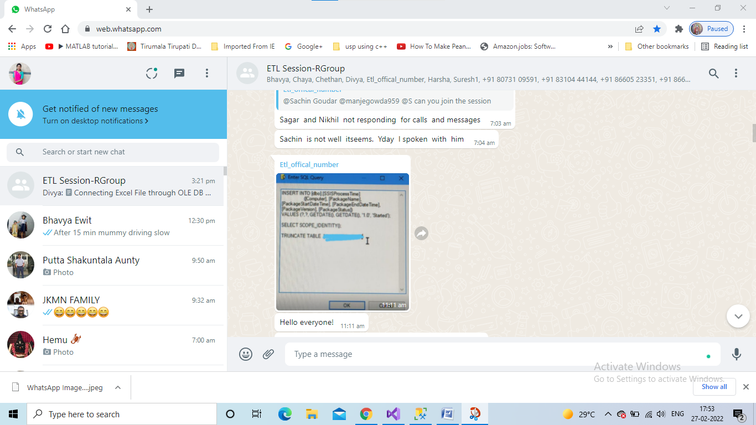
- Customized Audit

- Before inserting the customized audit record. It should be created in sql server by table name SSISProcessTime
- Insert the value into the table SSISProcessTime through Execute sql Task Transformation by entering the query into sql statement.
- Values(?,?, getdate(),getdate(),’1.0’,’started’) these are the columns
- First 2 ? columns should be mapped in parameter mapping .
- 3, 4 columns specified with getdate() function which will update the startdatetime, enddatetime with will change whenever the package executed.
- ‘1.0’ column value package version will be constant value.
- Package status column value will be constant.
- Select scope_identity() function: returns the IDENTITY value inserted in Table SSISProcessTime . This was the last insert that occurred in the same scope.

2. Can we connect excel file through oledb source transformation?

- Select Oledb source transformation. Double click on this in Oledb Connection Manager select New connection and select the provider

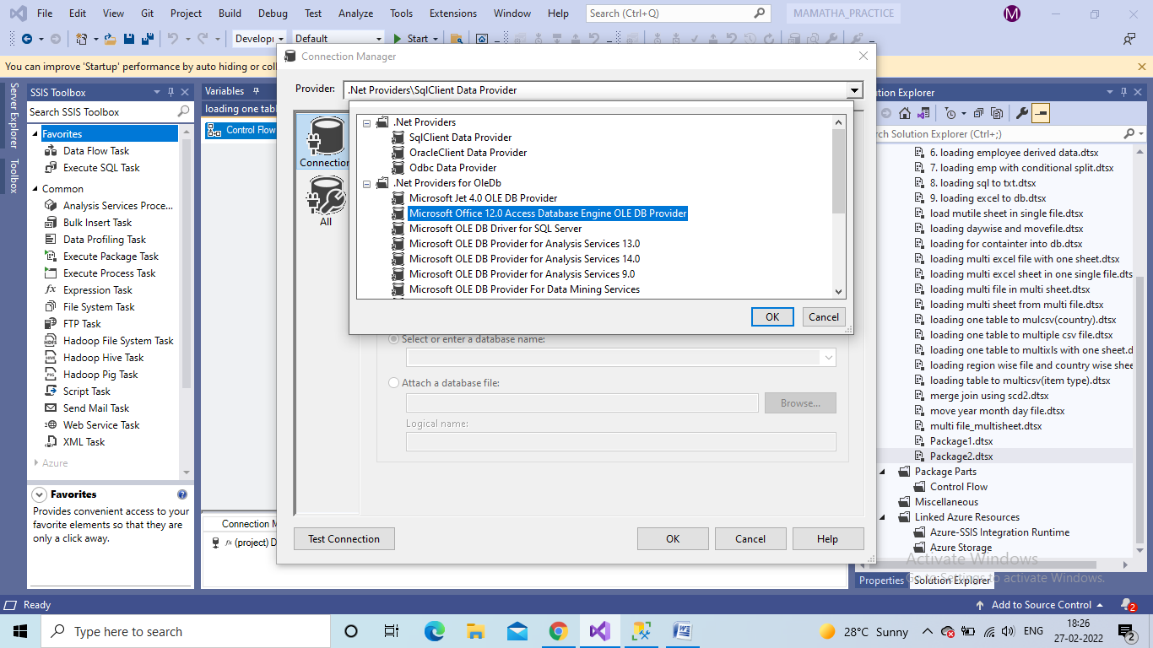

- Select the provider MS office 12.0 Access Database engine OLE DB provider or Jet 8.0.
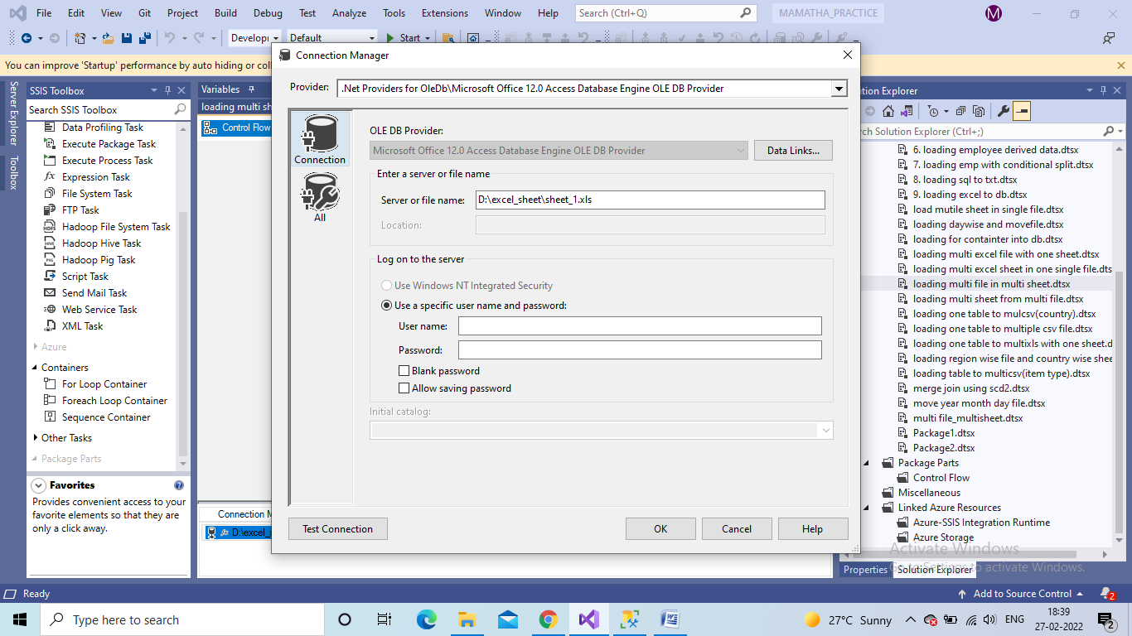

- Give the server or filename path were the excel file is stored.

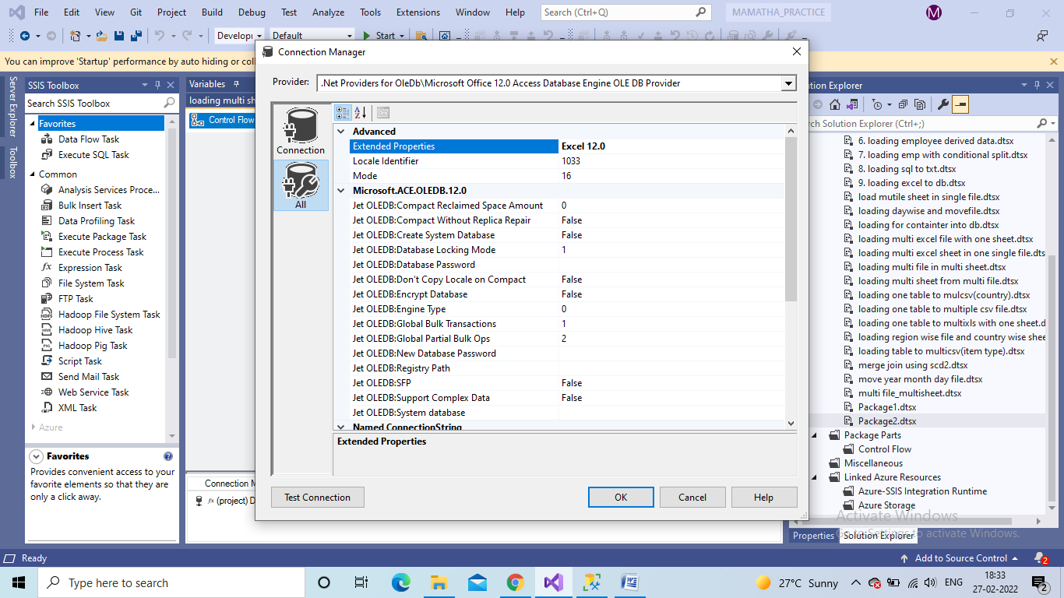

4

- Type Excel 12.0 or Excel 8.0 in the extended Properties.
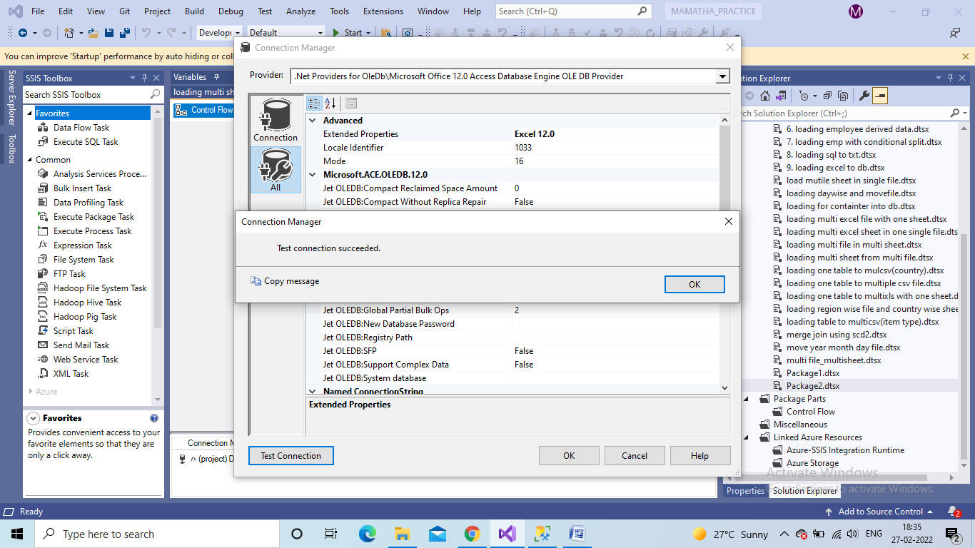

- Test connection if connected it will display the dialog box test connection succeeded.

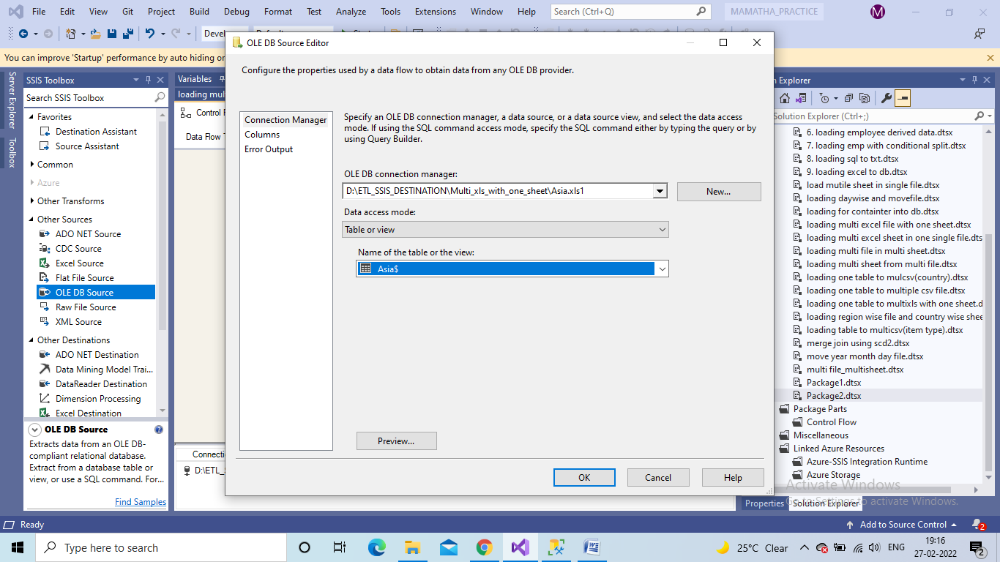
- Select Data access mode as Table or view. Then select the sheetname.

