Please wait while the report is generating……

Project Definition Report/ Overall Transition Plan
(Overall Service Backlog Plan)

Document Control Section
Revision History
Version | Date | Authors | Change Description

Revision History
Date of this revision: | Date of next revision: (date)

Revision Number | Revision Date | Summary of Changes | Changes Marked
0.1 |  | First version | N

Authors

Role | Name | E-Mail ID

Reviewers

Role | Name | E-Mail ID
<Role> | <Reviewer Name> | <e-mail ID>
<Role> | <Reviewer Name> | <e-mail ID>

Approvers

Role | Name | E-Mail ID
<Role> | <Approver Name> | <e-mail ID>
<Role> | <Approver Name> | <e-mail ID>

Table of contents
Acronyms 6
1 Introduction 7
1.1 Background 7
1.2 Purpose 7
1.3 Transition Scope 7
1.4 Overall Transition Approach 7
1.5 Key Pre-requisites 8
2 Application Transition 8
2.1 Application Transition Objective 9
2.2 Application Transition Approach 9
2.3 Application Transition Scope 10
2.3.1 Scope 10
2.3.2 Scope Exclusion 10
2.3.3 Applications Transition Deliverables & Acceptance Criteria 11
2.3.4 Applications Transition Work Products 11
2.3.5 Transition Tools, Templates & Checklist 11
2.4 Application Transition Planning Framework 12
2.4.1 Application Transition Schedule 12
2.4.2 Applications Transition Key Assumptions 12
2.4.3 Applications Transition Key Dependencies 12
2.4.4 Application Transition Risks and Issues 12
2.5 KT Assessment 13
3 Service Process Transition 13
3.1 Service Process Transition Objective 13
3.2 Service Process Transition Approach 13
3.3 Service Process Transition Scope 14
3.3.1 Scope 14
3.3.2 Scope Exclusion 14
3.3.3 Service Process Transition Deliverables & Acceptance Criteria 14
3.3.4 Service Process Transition Work Products 15
3.3.5 Transition Tools, Templates & Checklist 15
3.4 Service Process Transition Planning Framework 15
3.4.1 Service Process Transition Schedule 15
3.4.2 Service Process Transition Key Assumptions 16
3.4.3 Service Process Transition Key Dependencies 16
3.4.4 Service Process Transition Risks and Issues 16
4 Governance plan 16
4.1 Organization 17
4.1.1 <Client Name> Transition Organization 17
4.1.2 IBM Transition Organization 17
5 Communication Plan 21
5.1 Meeting Charter 21
5.2 Planned Meetings 21
5.2.1 Sprint Backlog Planning Meeting 22
5.2.2 Sprint Learn Sessions (KT Sessions) 22
5.2.3 Daily Stand up Meeting (Applicable for all individual sprints) 22
5.2.4 Application Transition Review Team (ATRT) Meeting 23
5.2.5 Transition Governance Board (Based on the agreement with client) 23
5.3 Escalation Path 23
6 Project Management System for Transition 24
6.1 Deliverables Management 24
6.2 Transition Change Management 24
6.3 Transition Issues Management 25
6.4 Transition Risk Management 25
6.5 Transition Quality Management 25
6.5.1 Agile Metrics 25
7 Knowledge Management System (KMS) for Transition Deliverables 25
8 References 26

Acronyms

# | Terminology / Acronyms | Definition
1 | AD | Application Development
2 | AID | Application Information Document
3 | AM | Application Maintenance
4 | AMS | Application Management Services
5 | ASCP | Application Support Control Plan
6 | ATRT | Application Transition Review Team
7 | DPE | Delivery Project Executive
8 | GD | Global Delivery
9 | GoV | Governance
10 | IAL | In scope Application List
11 | ITIL | Information Technology, Information Library
12 | KS / KT | Knowledge Sharing / Knowledge Transfer
13 | Learn | In this phase of KT, classroom type of session to be conducted, IBM KT recipient team will solve production ticket with taking assistance from Trainer.
14 | PAW | Process Adoption Workshop
15 | PDR | Project Definition Report
16 | Perform | In this phase of KT, IBM KT recipient team will solve production ticket independently at parallel with resources who joined IBM from <Client Name>
17 | PP | Perform Phase
18 | OTP | Overall Transition Plan
19 | SCD | Service Commencement Date
20 | SDM | Service Delivery Manager
21 | SL | Service Level
22 | SLM | Service Level Management
23 | SME | Subject Matter Expert
24 | SPOC | Single Point of Contact
25 | SPT | Service Process Transition
26 | SS | Steady State
27 | TBD | To Be Decided
28 | TR | Training Record

Introduction

Background
The purpose of the Transition project is to prepare for and execute a smooth transfer of responsibility from <Client Name> to IBM for In-scope Applications and related maintenance and development services.
Transition is a project with a defined start and end, a specific business objective and several key deliverables. Transition includes the creation of a new IBM team, set up of the physical infrastructure required for the new team to perform their functions, the Sharing of application knowledge from the existing <Client Name> team to the new IBM team via a structured and centralized documentation and the establishment of processes and procedures for IBM to take-up responsibility for service delivery once transition is complete.
The Transition project is broken down into logical phases and sub-projects as depicted, which enable both <Client Name> and IBM to manage the transition in an orderly manner, reducing both business and technical risks and thereby ensuring a smooth transition of service to IBM.

Purpose
The purpose of the document is to describe all the aspects of this transition project covering the transition objective, transition scope, timeline, deliverables, tools, exit criteria, transition governance & communication and risks.

Transition Scope
The Scope of this transition is to Transition Managed services which are currently being managed by incumbent service provider <incumbent_vendor_name> and personnel from <Client Name>.

Overall Transition Approach
IBM has structured transition methodology, which is based on Agile approach, as described in below picture at high level.

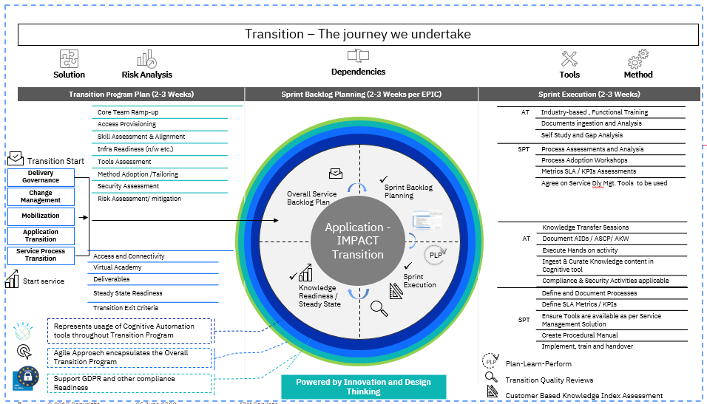

Key Pre-requisites
Following are key pre-requisites to effectively execute the transition.
- Timely setup of necessary infrastructure
- <Client Name> should provide all required access to the application and environments.
- Established <Client Name> counterparts to Governance, Processes and Service Level Management work streams
- Availability of process SMEs and experts to walk through the existing processes and method of working
- Timely Delivery, review, feedback and approval of agreed deliverables
- <Client Name> to provide all existing As-Is processes and service delivery tool documentation to IBM in due time for delivery in order to enable set up of As-is process framework.
- <Client Name> to facilitate and help get commitment from all 3rd party vendors who are involved in the AMS lifecycle activities, on adhering to the Service Transition timelines and SME availability for KT within the agreed upon timelines for KT.

Application Transition

Application Transition Objective
IBM’s primary objective during the transition of work from <Client_Name> and <incumbent_vendor_name> to IBM is to take on knowledge of, and to manage the current application landscape with minimal disruption to <Client_Name>’s business operations. Application Transition adopts Agile sprints-based approach to undertake knowledge transfer activities required to gain application knowledge and to demonstrate ability to support the applications Each Partition may be executed across one or multiple Sprints, with a stage gate (quality gate) check to assure the Sprint backlog items or Sprint’s scope are accomplished.

Application Transition Approach

For this transition scope, IBM will apply its “NexGen” Transition Methodology based on Agile principles. Our Agile knowledge transition follows an iterative approach for undertaking knowledge transition and knowledge base retention, and to accomplish other transition tasks and deliverables. Below Diagram depicts the Transition Approach.
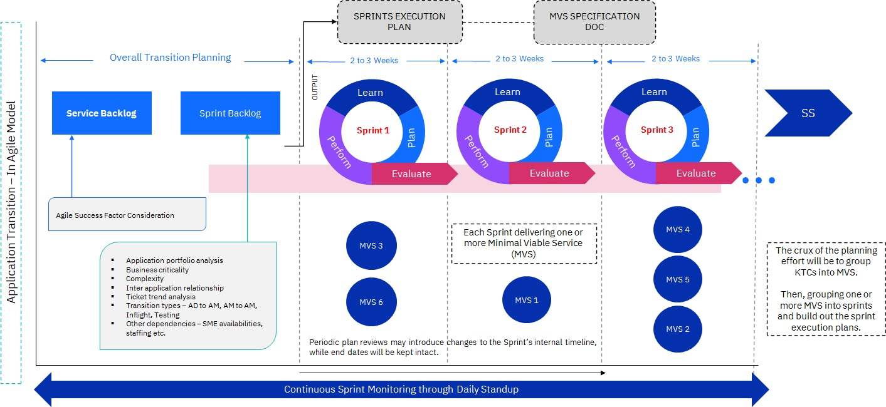
Overall Transition Planning
Below are the activities performed as part of the Overall Transition Planning Phase.
- Define Overall Knowledge Transfer Timelines
- Setup Transition Governance
- Identify key stakeholders from <Client Name> and IBM
- Skills and staffing analysis completed
- Network Setup Initiated
- Access Requirements Initiated
- Testing of WebEx (Remote Knowledge Transfer Tool)
- Knowledge Transfer Logistics requirement define
Sprint Specific Detailed Planning
Below are the activities performed as part of the Sprint Specific Detailed Planning Phase.
- Detailed Transition Plan defined
- VPN Access requests raised with <Client Name>
- Application Access Requirements Validated
- Knowledge assessment parameters base-lined
- IBM team staffed to undergo Knowledge Transfer
Sprint Execution
Sprint Execution is further divided into three sub activities Learn, Evaluate and Perform.
Learn
As part of Learn sub activity, IBM Team will undergo the Knowledge Transfer sessions from <Client Name> or <incumbent_vendor_name> and the sessions will through WebEx, which would be recorded and stored in IBM Repository for future reference.
Perform
As part of the Perform sub-activity, IBM Team members will perform hands-on activities which are either analysis of the historical tickets of involving in the analysis of current incidents.
Evaluate
As part of the Evaluate sub-activity, IBM Team members will provide the playback session which will be attended by the SMEs.

Application Transition Scope

Scope
The following applications are in scope for this transition project.

Scope Exclusion

The following areas are not within the scope of the transition project are:
# | Out of Scope Details
1
2
3

Applications Transition Deliverables & Acceptance Criteria
The following are the deliverables & acceptance criteria for Application Transition.
# | Deliverable Category | Deliverable | Owner | Reviewer | Approver | Acceptance Criteria

Applications Transition Work Products
The following are the work products for Application Transition.
# | Category | Work Products

Transition Tools, Templates & Checklist

# | Tool/Templates | Purpose/Description | Sample Template
 | Deliverables | Application Information Document
 | Deliverables | Application Specific Control Plan
 | Deliverables | Service Level Management Handbook

Application Transition Planning Framework

Application Transition Schedule

Applications Transition High Level Schedule

Detail Schedule

2.4.2 Entry & Exit Criteria
Transition Phase | Entry Criteria | Exit Criteria | Transition Work products
Service Backlog | 1. Contract has been signed with <Client> to proceed with the Overall Transition Planning activities  2. Transition team members (Key <Client> and IBM resources) have been assigned to the project |  | 1.Joint Verification Report  2. Risk Assessment Outcome  3. Application Profile
Sprint Backlog | 1. Overall Transition Plan agreed with client  2. Staffing in progress  3. High-level Process Gap Analysis Completed |  | 1. Sprint Execution Plan (i.e., Knowledge topics, SME name, schedule)  2. Learning (KT) assessment criteria
Transition Execution  (Plan-Learn-Perform) | 1.Sprint Backlog Plan created  2.Required SMEs / Staff available  3.Process Gap Analysis available |  | 1.Steady State Readiness Checklist  2. Learning (KT) Assessment

Applications Transition Key Assumptions
List the key assumptions which, include here all assumptions concerning application delivery, i.e. applications to be managed by the DPE, until the defined solution (respective parts of it) is delivered by the transition project manager and approved by the DPE.
Adjust this list as necessary.
Assumption list is as DDMMYYYY, Pls refer the IPWC / document repository link where Assumption log is updated

Applications Transition Key Dependencies
This section lists dependencies upon other projects and external organizations that have been identified. External organizations are any organization that is outside of the direct control of the Transition Project Manager. They can be subcontractors, vendors, other projects, or <Client Name>.

Application Transition Risks and Issues
Below are the risks identified during the planning phase. The risks are subject to revalidation and will be merged into the overall project risk plan at start of project execution.

KT Assessment

One of the critical elements during knowledge transfer is to evaluate the Knowledge acquisition level by IBM SMEs during the Transition Sprints. IBM SMEs’ Knowledge levels are demonstrated throughout the Transition Sprints through Play Back sessions, Hands on Activity Tracking, Development of Transition Deliverables (AIDs), Ability to Support independently etc.
Criteria for assessment during the various activities of the Transition Sprint. This could include parameters such as technical knowledge, participation level, and communication skills etc.
The stakeholders who will be performing the assessment (e.g., <Client Name> SMEs) as per the standard templates across Sprint Learn & Sprint Perform Phases.

Service Process Transition

Service Process Transition Objective
The objective of Service Process Transition is to provide guidance and undertake process setup activities for the transition of services in the operational business environment. In addition to basic operational processes for incident and problem management, it covers the broader, long-term change management role, release and deployment practices so that risks, benefits, delivery mechanisms and the support of ongoing operational services are considered.
In addition to process setup activities, service process transition also sets up metrics [service level agreements (SLAs) and key performance indicators (KPIs)] and reporting framework as per the contract and coordinate customization and deployment of tools to deliver metrics and reporting framework.
IBM will start with understanding the contract from the point of view of finalizing the scope to deliver in terms of processes and SLAs/KPIs to be modified and reported.

Service Process Transition Approach
IBM has structured service process transition, which is based on Agile approach, as described in below pic at high level.

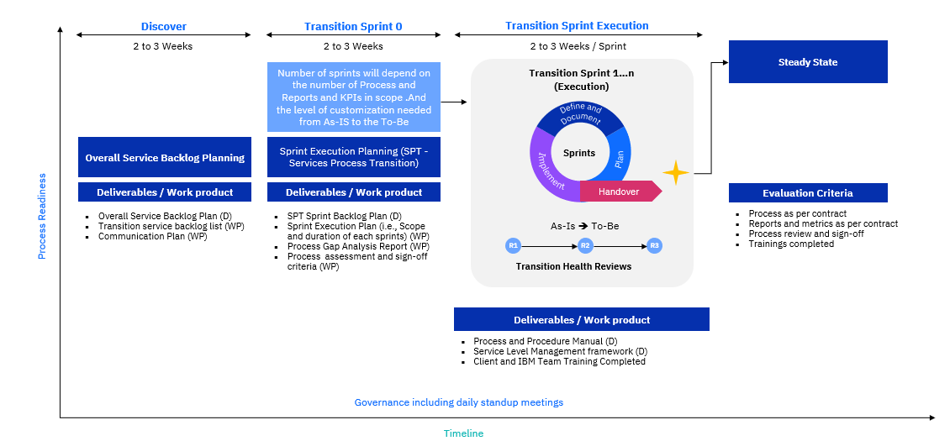

Service Process Transition Scope

Scope

The following services are in scope for this transition project.

Scope Exclusion

The following areas are not within the scope of the transition project are:

# | Out of Scope Details
1
2
3

Service Process Transition Deliverables & Acceptance Criteria
The following are the deliverables & acceptance criteria for Service Process Transition.

# | Deliverable Category | Deliverable | Owner | Reviewer | Approver | Acceptance Criteria

Service Process Transition Work Products
The following are the work products for Service Process Transition.

# | Category | Work Products

Transition Tools, Templates & Checklist

# | Tool/Templates | Purpose/Description | Sample Template

Service Process Transition Planning Framework

Service Process Transition Schedule

Service Process Transition High Level Schedule

Detail Schedule
2.4.2 Entry & Exit Criteria
Transition Phase | Entry Criteria | Exit Criteria | Transition Work products
Service Backlog | 1.Contract has been signed with <Client> to proceed with the Overall Transition Planning activities  2. Transition team members (Key <Client> and IBM resources) have been assigned to the project |  | 1.Transition service backlog list  2. Communication Plan
Sprint Backlog | 1. Overall Transition Plan agreed with client  2. Required SMEs available  3. High-level Process Gap Analysis Completed |  | 1. Sprint Execution Plan (i.e., Scope and duration of each sprints) (WP)  2. Process Gap Analysis Report (WP)  3. Process assessment and sign-off criteria (WP)
Transition Execution  (Plan-Define-Implement-Handover) | 1. Sprint Backlog Plan created  2. Required SMEs / Staff available  3. Process Gap Analysis available |  | 1. Process Gap Analysis Report

Service Process Transition Key Assumptions
List the key assumptions which, include here all assumptions concerning interim service delivery, i.e. services and processes to be managed by the DPE, until the defined solution (respective parts of it) is delivered by the transition project manager and approved by the DPE.
Adjust this list as necessary.
Assumption list is as DDMMYYYY, Pls refer the IPWC / document repository link where Assumption log is updated

Service Process Transition Key Dependencies
This section lists dependencies upon other projects and external organizations that have been identified. External organizations are any organization that is outside of the direct control of the Transition Project Manager. They can be subcontractors, vendors, other projects, or <Client Name>.

Service Process Transition Risks and Issues
Below are the risks identified during the planning phase. The risks are subject to revalidation and
will be merged into the overall project risk plan at start of project execution.

Governance plan
Following sections shows the Transition Organization, Reporting & Escalation paths & Meeting plan summary for the Governance of the Transition.

Organization

<Client Name> Transition Organization
This section may be defined in the Overall Transition OTP, insert client organization chart.

IBM Transition Organization
Provide information about the Transition organization. This would include information about contractors, if appropriate.
The overall Transition organization is defined in the Overall Transition Plan OTP
Insert Org chart and update below table w.r.t Org chart

Role | Name | Responsibility
Project Executive / GBS Partner |  | - Has the overall <Client Name> Contract responsibility within IBM and is the IBM sponsor for the Transition Project
Delivery Project Executive |  | - IBM Service Delivery Executive.  - Manages the ongoing delivery of services after the transition is complete
Transition Integration Manager |  | - Responsible for managing all transition projects on behalf of the PE for Full Scope Transition (FST)  - Is the primary customer interface for overall transition.  - Provides the PE, with a management focal point for overall transition status and progress through completion
Services Transition Manager |  | - Responsibility for the Services Transition sub-project.  - Provides Transition status for Services Transition  - Reports to the Project Executive, the Delivery Project Executive or the Transition Integration Manager
Sr. Application Transition Manager |  | - Responsibility for the Application Transition sub-projects.  - Provides Transition status for Application Transition  - Reports to the Project Executive, the Delivery Project Executive or the Transition Integration Manager  - Subsequent Application Transition manager report to this manager.
Application Transition Manager |  | - Project Management / Facilitate / Coordinate Transition  related activities for the Wave including  - Transition Communication  - Training Plan preparation  - Transition Status reporting  - Issue Resolution and risk mitigation  - Plan for Steady State cut over activities  - Cut over Activities  - First level of escalation for all Transition related activities  - Chair ATRT (Application Transition Review Team): work hand in hand with the <<CLIENT>> Managers to coordinate weekly ATRT sessions
Infrastructure Specialist |  | - Coordinates with Customer and IBM network teams to establish RKT tool  - Provides RKT infrastructure support during transition  - Provides training on RKT tools to the transition team (client SMEs and IBM delivery team)  - Understands the complexity of applications and suggest appropriate access method (Citrix/remote desktop) from GDC
AT KT FM (if applicable) |  | - Conduct transition methodology workshops for the offshore delivery team  - Ensure KT meeting invites are sent out and accepted by SMEs at least 2 days before KT starts  - Ensure Transition deliverables are reviewed internally before submission to client  - Assists TM in following up and managing RAIL items
PE Management System (Governance) Deployment Specialist and Project Manager |  | - Establishes a comprehensive set of Contract Business Office and Governance processes based upon contract and operational requirements.  - Works with the IBM Contract Business Office and <Client Name> to deploy the processes.
Process Change Specialist |  | - Customize the MS according to MS Customization Guide and maintains according to MS Procedure for Process Improvement  - Adopt the MS "Work Classification Guide", the MS "Tailoring Guidelines" and the MS "Tailoring Guidelines Supplement"  - Install and maintains the MS at the account
Delivery Process Owner |  | - Receives mentoring from the TTS PCS  - Leads the institutionalization of process assets in the account  - Maintains the account’s process assets
Metrics Specialist |  | - Provides expertise about the Metrics Management Framework and measurement support tools  - Responsible for implementing the organization level Metrics Management Framework  - Trains and mentors the local metrics coordinator in the process and tools
Delivery Metrics Coordinator |  | - Assists TTS Metrics Specialist with implementing the Metrics Framework.  - Maintains the account Metrics Framework in Steady State  - Works with any peer customer measurements roles to coordinate measurement reporting and analysis,  - Manages the delivery of measurement reports in accordance with the contract requirements,  - Supports the collection of historical measurement data by the Competency Segment,  - Provides measurement data analysis and support  - Maintains external audit readiness of measurement data.
Transition Services Business Area Manager |  | - Reviews and approves transition plan and key project documents called out in the quality management plan (metrics plan, etc.)  - Provides Transition & Transformation Services staff for the Transition Project - Transition Manager and PCS  - Prepares and participates in monthly executive summary review session - these are for yellow or red projects so show this optional  - Provides transition project oversight, issue resolution  - Reports transition project status to Transition & Transformation Services Sr. Management
Tools Deployment Lead |  | - Manages the deployment of the in-scope tools  - Ensures training is provided for in-scope tools  - Establishes DOUs for subscription based tools  - Guides teams in developing cadence and governance for tools usage

Section 4.2 Reporting Structure
Following diagram shows the Transition organization and the interaction levels during the transition.
Vendor Leadership Team
Overall Transition Manager
EPIC/ Sprint Transition Manager
IBM Leadership Team
IBM Delivery Project Executive
IBM Sr. Transition Manager
EPIC Transition Manager
(Scrum Master)

<Client> Leadership Team
Overall Transition Manager
EPIC/ Sprint Transition Manager

IBM Project Office

Communication Plan
Communication plan defines various forms of formal meetings and reporting that will be carried out among the stake holders. Purpose of the communication plan is to make sure that all the stake holders receive right information at right time for the transition project purposes.
This document addresses only formal and planned communications at the start of the transition. Any communication/meeting which happens on ad-hoc basis is out of the scope of this document but will continue to follow the basic ground rules laid in the document for the communication.

Meeting Charter
Following meeting charter should be adhered for all meetings.
- Meeting invitation is sent to all the participants’ minimum of 3 business days in advance and one-week advance notice is the norm.
- Agenda of the meeting is sent at least one business day prior to the meeting. Agenda should clearly mention what is expected from each of the participant.
- All the meeting invitations should carry Teleconference Bridge and meeting room number where it is applicable.
- Minutes are noted by the person sending the invitation and distributed on the same day as the meeting is conducted.
- IBM Team will use the transition templates such as Knowledge Transfer - Daily Stand tracking template, Sprint Cutover Readiness Log, Application Go-No-Assessment for capturing the minutes of meeting and subsequent action items. <Client>/Vendors can use their respective template for capturing the minutes of meeting.
- Minutes should clearly mention action items for each of the participant in the meeting.
- All participants are encouraged to participate actively during the meeting.
- All the communications and meetings happen in English.

Planned Meetings
This section describes the planned meetings between the stakeholders for the Application/ Service transition project. Charter described in the section 4.1 is applicable for all these meetings.
Following meetings are planned for the transition purposes.

Sprint Backlog Planning Meeting
Purpose | This meeting is used to determine Sprint specific KT topics, trainers and schedule
Planned Start Date
Planned End Date
Frequency | Need Basis
Participants | IBM TM, IBM SMEs, <Client> Product Owner, <client> SMEs
Agenda | Knowledge Transfer - Sprint Backlog Plan Template, RAID Log
Tools & Resources | IBM-<Client> network, KOSMOS, Teleconference Bridge.

Sprint Learn Sessions (KT Sessions)
Purpose | Purpose of this meeting is to provide the training to the IBM SMEs by Vendor/<Client> SMEs.
Planned Start Date
Planned End Date
Frequency | Per Calendar
Participants | IBM SMEs, <Client> SMEs, Vendor SMEs
Agenda | Sprint Based Application Training Plan, RAID Log, AID (IF APPLICABLE), PID (If in scope)
Tools & Resources | IBM-<Client> network, D2D/D2D Lite, Smart Cloud, Connections/ Box, KOSMOS, Teleconference Bridge.

Daily Stand up Meeting (Applicable for all individual sprints)
Purpose | Purpose of this meeting is to review the Sprint progress with stakeholders.
Planned Start Date
Planned End Date
Frequency | Per Schedule (Daily – All Business days)
Participants  (Sprint Specific) | IBM TM (Scrum Master), IBM SME (for Sprint N), Client SME, Client Product owner
Agenda | RAID Log, Sprint Cutover Readiness Log, Application Go-No-Assessment, Daily Standup Tracking Template
Tools & Resources | KMS (Identified), Teleconference Bridge.

Application Transition Review Team (ATRT) Meeting

Purpose | Purpose of this meeting is to review the transition project by IBM Transition Project Manager and the <Client> Product owner.
Planned Start Date
Planned End Date
Frequency | Weekly
Participants | IBM TM, Client Rep, Vendor Rep, Delivery Rep
Agenda | RAID Log, ATRT Report
Tools & Resources | KMS (Identified), Teleconference Bridge.

Transition Governance Board (Based on the agreement with client)
Purpose | Purpose of this meeting is to review the transition project by IBM Transition Leadership team with <Client> Leadership team.
Planned Start Date
Planned End Date
Frequency | Monthly
Participants | IBM ( ), Client ( ), Vendor ( )
Agenda | RAID Log, Sprint Cutover Readiness Log, Application Go-No-Assessment, EPIC Completion Report
Tools & Resources | KMS Identified, Teleconference Bridge.

Escalation Path

The following section provides the escalation path for both IBM & <Client> for this project

4.3 Communication Plan
4.3.1 Meeting Charter
4.3.2 Meeting Plan <Pls bring the various recommended meeting plan details>
4.3.3 Escalation Path

The following section provides the escalation path for both IBM & Client for this project

Level | IBM | Client
1st | Transition Manager | Role / Name / Contact
2nd | Transition Integration Manager | Role / Name / Contact
3rd | Partner | Role / Name / Contact

Project Management System for Transition
Transition is managed from end to end like any other project and it has all the key components of a typical project.

Deliverables Management
The acceptance of deliverables focuses on providing on-time delivery and acceptance of contract deliverables that are assigned to the Transition Project.
A Deliverables Notification Document (DND – see appendix A) will accompany and clearly describe each deliverable submitted to <Client Name>. A sample of the DND is attached in the appendix. <Client Name> will accept or reject the Deliverable by completing a copy of the Deliverables Notification Document and returning it to the IBM Deliverables Manager within five (5) working days after receipt. Depending upon the deliverable, the DAD will request a specific <Client Name> response:
For deliverables not specifically requiring <Client Name> approval, the DND will request only receipt acknowledgement
For deliverables that contractually require <Client Name> approval, the DAD will request approval

Transition Change Management
The Transition Project Change Management Process will be used to manage changes from the original baseline of the project. The process begins when it is determined that a scope deviation to the Transition Plan is required. Transition Project Change control will commence a week after the initial Transition Plan is delivered or immediately after the plan is approved, whichever comes first. The Transition Change Management provides a disciplined means for managing and implementing mutually acceptable (between <Client Name> and IBM) amendments to the Transition Plan.
The Transition Project change control board will consist of the IBM Delivery Executive, <Client Name> Contract Executive, <Client Name> and IBM Transition Managers, and others who normally attend the joint weekly Program Review meeting. Project change requests can be initiated by any<Client Name> or IBM project stakeholder, but will be reviewed by the <Client Name>and IBM Transition Managers before they are brought before the Project Change control board.
Project Change Requests will be recorded and tracked in a PCR log which is maintained in the project control book. The status of PCRs will be reviewed in transition status meetings.
A Project Change Request template is included in the appendix.

Transition Issues Management
An issue is a point of controversy requiring a decision to be made based on available alternatives. Issues may be initiated by <Client Name> or IBM personnel, and are managed in a manner to facilitate quick resolution at the lowest possible organizational level. Escalation rules keep attention focused on each issue until it is resolved.
Issues are recorded and tracked until closure in an issue log which is maintained in the project control book. Joint issues are separated from internal issues.
The status of issues is reviewed in transition status meetings.
All joint transition issues will be formally reviewed/approved by IBM Transition and <Client Name> Transition Manager before they are formally tracked as an issue.

Transition Risk Management
A risk is a potential event or future situation that may adversely affect the project. The characteristic uncertainty of a risk distinguishes it from an issue. In other words, risks address potential problems, and issues address known problems. The components of a risk are the possible event itself, the probability that the event will occur and the impact of the event.
<Client Name> and IBM will create and execute a Risk Management Plan that includes both internal and external risks identified during the transition kickoff meeting and throughout the project. All identified risks will be evaluated using a High, Medium and Low criteria for probability and impact. Documented risk evaluation and mitigation plans will be captured in the project data repository and jointly reviewed during transition status meetings.
Risks and mitigations will be recorded and tracked in a risk log maintained in the project control book by individual transition sub-projects (Services Transition, Application Transition and Account Initiation).

Transition Quality Management
The <Client Name> Transition project follows the quality standards and policies of Transition & Transformation Services.

Quality controls and records (product inspections; walkthroughs; peer reviews) for the Transition project are stored in the project control book or project team room (BOX/IPWC)

Agile Metrics
We are planning to adapt the following agile metrics to track KT progress and given below are few sample dashboards

Knowledge Management System (KMS) for Transition Deliverables

Knowledge Management System is a one stop shop for all the knowledge .It is designed for Practitioners as they onboard a project and it accelerates their learning roadmap relevant to a client engagement.
It is enabled through different tools like Box, Client Vantage and W3 Publisher whereby a Practitioner gets to learn
- Know Your Industry program
- Account Learning (specific to the Project engagement)
- Core Learning (a learning program that is designed for the core skills of the practitioners as relevant to the engagement. This program is an integrated learning program that aids learning along with assessment.

References

