Air Quality Monitoring System

\*\*Project Objectives:\*\*

The primary objective of the Air Quality Monitoring project is to develop a real-time system that continuously measures and monitors air quality parameters such as particulate matter (PM2.5 and PM10), carbon monoxide (CO), nitrogen dioxide (NO2), ozone (O3), sulfur dioxide (SO2), and temperature and humidity. This system aims to provide accurate and up-to-date air quality data to the public, promoting awareness of air quality and its potential health impacts.

\*\*IoT Device Setup:\*\*

1. \*\*Sensors:\*\* The system employs a set of air quality sensors (e.g., PM sensors, gas sensors) and environmental sensors (temperature and humidity sensors) strategically placed in various locations.

2. \*\*Microcontrollers:\*\* Each sensor is connected to a microcontroller (e.g., Arduino or Raspberry Pi) to collect and process data.

3. \*\*Data Transmission:\*\* Data is transmitted to a central server or cloud platform via Wi-Fi or cellular networks.

4. \*\*Power Supply:\*\* Devices can be battery-powered or connected to a power source, depending on the deployment location.

\*\*Platform Development:\*\*

1. \*\*Cloud-Based Database:\*\* Data from IoT devices is stored in a cloud-based database (e.g., AWS, Azure, or Google Cloud) for real-time and historical data analysis.

2. \*\*Web Dashboard:\*\* A user-friendly web dashboard is developed to display real-time air quality data with graphs and charts. Users can access this dashboard from any device with an internet connection.

3. \*\*Mobile Application:\*\* A mobile app is developed for on-the-go access to air quality data. It may include features like notifications, historical data analysis, and user customization.

4. \*\*Alert System:\*\* The platform triggers alerts or notifications to users when air quality readings exceed predefined thresholds.

\*\*Code Implementation:\*\*

The code for the project involves sensor data collection, data transmission, data storage, and data presentation. Various programming languages and frameworks may be used, depending on the hardware and cloud platform chosen. Sample code snippets and configurations should be documented in a GitHub repository for reference.

\*\*Diagrams, Schematics, and Screenshots:\*\*

1. \*\*System Architecture Diagram:\*\* A high-level diagram illustrating how IoT devices, microcontrollers, data transmission, cloud database, web dashboard, and mobile app are connected.

2. \*\*Sensor Placement Map:\*\* A map showing the locations of sensors for data collection.

3. \*\*Web Dashboard Screenshots:\*\* Screenshots of the web-based dashboard displaying real-time air quality data.

4. \*\*Mobile App Screenshots:\*\* Screenshots of the mobile application with relevant features.

5. \*\*Schematics of IoT Devices:\*\* Detailed schematics for the IoT devices, indicating sensor connections and power supply.

Raising Public Awareness:\*\*

The real-time air quality monitoring system can raise public awareness in several ways:

1. \*\*Access to Accurate Data:\*\* The system provides the public with access to accurate and up-to-date air quality information.

2. \*\*Educational Material:\*\* The platform can include educational material about air quality, its sources, and its health impacts.

3. \*\*Alerts and Recommendations:\*\* When air quality deteriorates, the system can send alerts and recommendations for protective measures.

4. \*\*Community Engagement:\*\* Users can actively engage by reporting air quality issues and participating in discussions on the platform.

5. \*\*Data for Research:\*\* Researchers and policymakers can use this data to study air quality trends and make informed decisions.

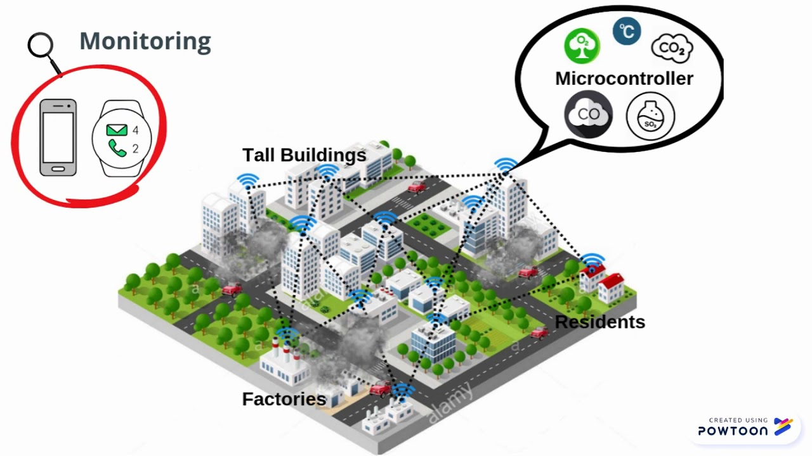In conclusion, the Air Quality Monitoring project aims to create a comprehensive, user-friendly system that contributes to improved public health by promoting awareness of air quality and its health impacts through real-time data and community engagement. This documentation provides a detailed overview of the project's components and its potential impact on public awareness and health.