DEPARTMENT OF COMPUTER SCIENCE & ENGINEERING
Malla Reddy Vishwavidhyapeeth (Technical Campus)

SMART AMBULANCE DISPATCH AND ROUTING SYSTEM
A Dynamic Graph-Based Emergency Response & Resource Allocation Architecture
Domain: Design & Analysis of Algorithms / Full-Stack Emergency Logistics Systems
Submitted by
Team Member / Role | Roll Number
AMBATI NAGA MAMATHA SRI– Lead Algorithm & Systems Architect | 25MVCSMR0278
DASARI SRI NITYA – Backend & API Engineer | 25MVCSMR0300
GUJJETI BHAVYA – Database & Resource Management Engineer | 25MVCSMR0309
DODLA ASHWINI– Frontend & Geospatial UI Developer | 25MVCSMR0302

Academic Year: 2025–2026

Table of Contents
Table of Contents 1
1. Abstract & Introduction 1
1.1 Project Overview 1
1.2 Problem Background 1
1.3 Proposed Solution 1
1.4 Purpose of the Project 1
2. Problem Statement, Objectives & Scope 1
2.1 Problem Statement 1
2.2 Project Objectives 1
2.3 Project Scope 1
2.4 Target Users 1
3. Features & Functional Requirements 1
3.1 Main Features 1
3.2 User Functionalities 1
3.3 CRUD Operations 1
3.4 Authentication & Validation 1
3.5 System Requirements 1
4. Algorithms & Methodology 1
4.1 System Workflow 1
4.2 Algorithms Used 1
4.3 Development Methodology 1
5. Technologies & Implementation 1
5.1 Technology Stack 1
5.2 Relational Schema Design 1
6. Results, Testing & Performance 1
6.1 Project Results 1
6.2 Test Cases 1
6.3 Performance Analysis 1
6.4 Screenshot/Output 1
7. Conclusion, Future Scope & References 1
7.1 Project Conclusion 1
7.2 Future Enhancements 1
7.3 References 1

1. Abstract & Introduction

1.1 Project Overview
The Smart Ambulance Dispatch and Routing System is an algorithm-driven emergency response platform designed to eliminate fatal delays in urban emergency medical services (EMS). By modeling metropolitan road networks as dynamic, traffic-weighted directed graphs, the system automates vehicle allocation, emergency call triage, and hospital intake selection. Instead of relying on static distance or manual dispatching, the system integrates Priority Queues (Min-Heaps) for severity triage, Dijkstra’s Algorithm for traffic-weighted shortest-path routing, and a Greedy Allocation Strategy for real-time hospital ICU bed matching.

1.2 Problem Background
In emergency medicine, the first 60 minutes following severe trauma or acute medical distress, known as the Golden Hour, determine patient survival rates. Conventional emergency dispatch workflows suffer from three critical bottlenecks:
- Manual Dispatch Latency: Operators manually coordinate via radio or phone calls to find available drivers, wasting vital minutes.
- Sub-Optimal Distance Routing: Standard consumer navigation apps optimize for general commuters and do not calculate dynamic travel times under emergency conditions or account for multi-leg dispatches (Ambulance → Patient → Hospital).
- Emergency Room Rejections: Ambulances routinely transport critical patients to the geographically closest hospital without prior confirmation of ICU bed or trauma unit availability, leading to rejections and life-threatening secondary transfers.

1.3 Proposed Solution
Our system replaces manual dispatching with an automated, transparent pipeline. Upon receiving an emergency request, the platform:
- Resolves the patient's exact location using a 4-layered location engine (supporting both on-site and remote caller scenarios).
- Inserts the call into a Min-Heap ordered by clinical severity (Triage Levels 1–3).
- Executes Dijkstra's algorithm to identify the fastest available ambulance based on dynamic, traffic-adjusted edge weights.
- Queries a relational database to verify live ICU bed availability, pre-allocating an intake spot at the target hospital before the vehicle departs.

1.4 Purpose of the Project
The primary objective is to build a fully functional, end-to-end prototype that bridges theoretical computer science (graph theory, min-heaps, greedy optimization) with production software engineering (RESTful microservices, relational schema design, interactive geospatial UI mapping).

2. Problem Statement, Objectives & Scope

2.1 Problem Statement
Problem 29: Smart Ambulance Dispatch
Select the best ambulance and route for emergency requests using severity, distance, traffic, and ambulance availability, while making all intermediate algorithmic decisions (paths, queue states, hospital capacity constraints) fully visible and explainable to control room operators.

2.2 Project Objectives
- Algorithmic Optimality: Implement Dijkstra's algorithm to calculate least-cost travel paths over non-negative, traffic-weighted road graphs in O((V + E) log V) time.
- Clinical Severity Triage: Utilize a Priority Queue (Min-Heap) to guarantee O(log N) extraction of highest-priority emergency cases.
- Capacity-Aware Allocation: Implement a Greedy Strategy to pair ambulances with hospitals maintaining active ICU bed capacity.
- Decoupled Location Resolution: Support remote reporting (caller and patient in different physical locations) via geocoding and 1-click web location links.
- System Transparency: Provide an intuitive dashboard that displays route overlays, ETA metrics, and resource states for human dispatchers.

2.3 Project Scope
- In Scope: Metropolitan road graph modeling, dynamic edge weight updates based on real-time traffic, fleet state tracking, hospital ICU bed capacity tracking, remote caller location resolution, interactive control room UI, and decision-tree visibility.
- Out of Scope: Physical vehicle hardware modifications, cellular tower firmware alterations, and payment processing integrations.

2.4 Target Users
- Control Room Operators: Emergency dispatch staff managing incoming calls and monitoring fleet deployment.
- Ambulance Drivers: Operators receiving turn-by-turn navigation and patient intake instructions on vehicle dashboards.
- Hospital Administrators: Medical personnel updating live ICU bed availability and emergency room capacity.

3. Features & Functional Requirements

3.1 Main Features
- Multi-Layered Location Engine: Captures patient coordinates via automated OS telemetry (AML/ELS), 1-click SMS web links (navigator.geolocation), geocoding, or manual map pinning.
- Decoupled Incident Processing: Distinguishes between Caller_Node and Target_Patient_Node to handle remote emergency reporting seamlessly.
- Traffic-Weighted Graph Pathfinding: Dynamically adjusts road segment weights based on real-time traffic congestion factors.
- Pre-Allocation Hospital Matching: Queries active hospital database states to ensure zero emergency room rejections.
- Interactive Route Visualization: Renders two-leg path overlays (Ambulance → Patient → Hospital) on a live map interface.

3.2 User Functionalities
- Dispatcher Dashboard: View live map, incoming priority calls, assigned routes, ETAs, and active fleet status.
- Driver Terminal: Receive instant route updates, patient triage severity details, and pre-assigned hospital targets.
- Hospital Manager Portal: Toggle ICU bed availability counts and update trauma unit intake status in real time.

3.3 CRUD Operations
Entity | Create | Read | Update | Delete
Incidents | Log emergency call | Fetch active queue | Update triage level / status | Cancel false alarms
Ambulances | Register new vehicle | Fetch location & status | Update availability (Idle/Busy) | Decommission vehicle
Hospitals | Register hospital facility | Read bed capacity | Update ICU bed counts | Remove facility record
Road Graph | Add road intersections | Query adjacency list | Update edge traffic weights | Remove blocked roads

3.4 Authentication & Validation
- Role-Based Access Control (RBAC): JWT-based authentication distinguishing Dispatchers, Drivers, and Hospital Admins.
- Input Validation: Strict coordinate boundary checking (Lat ∈ [-90, 90], Lng ∈ [-180, 180]), sanitized text inputs for geocoding queries, and schema-level constraints on database updates.

3.5 System Requirements

Hardware Requirements
- Server: Dual-core CPU, 8 GB RAM, 20 GB SSD storage.
- Client: Modern web browser on tablet, desktop, or mobile device with active GPS capability.

Software Requirements
- Operating System: Linux (Ubuntu 22.04 LTS) / Windows 11 / macOS.
- Runtime Environment: Python 3.10+, Node.js 18+.
- Database Engine: MySQL 8.0 / PostgreSQL 14+.

4. Algorithms & Methodology

4.1 System Workflow
[Emergency Call Received]
|
v
[Layer 1-4 Location Engine] --> Sets Target_Patient_Node (v_p)
|
v
[Min-Heap Priority Queue] ----> Orders Incident by Triage Level (1 > 2 > 3)
|
v
[MySQL Capacity Query] -------> Filters Hospitals with ICU Beds > 0
|
v
[Dijkstra Pathfinding Engine] -> Min Travel Time: Amb_i -> v_p -> Hospital_j
|
v
[Greedy Allocator] -----------> Assigns Optimal Ambulance & Locks ICU Bed
|
v
[React Map Interface] --------> Pushes Route to Driver & Dispatcher UI

4.2 Algorithms Used

4.2.1 Priority Queue (Min-Heap) for Triage
- Data Structure: Binary Min-Heap storing incident tuples I = (Triage_Level, Timestamp, Incident_ID).
- Rule: Triage Levels are defined as 1 (Critical / Cardiac), 2 (Serious / Fractures), 3 (Non-emergency / Transfer).
- Operation Complexity: Insertion O(log N), Extract-Min O(log N).

4.2.2 Dijkstra’s Algorithm for Traffic-Weighted Pathfinding
- Data Structure: Adjacency list representing graph G = (V, E) with edge weights W(u, v) = Distance(u, v) / Speed_traffic(u, v).
Pseudocode (Python):
import heapq

def dijkstra(graph, start_node):
# distances dict stores the minimum travel time to each node
distances = {node: float('inf') for node in graph}
distances[start_node] = 0
previous_nodes = {node: None for node in graph}

# Priority queue stores tuples of (current_time, node)
pq = [(0, start_node)]

while pq:
current_time, current_node = heapq.heappop(pq)

if current_time > distances[current_node]:
continue

for neighbor, weight in graph[current_node].items():
time = current_time + weight
if time < distances[neighbor]:
distances[neighbor] = time
previous_nodes[neighbor] = current_node
heapq.heappush(pq, (time, neighbor))

return distances, previous_nodes

- Complexity: Time O((V + E) log V) using min-heap priority queues; Space O(V + E) for the adjacency representation.

4.2.3 Greedy Resource Allocation Strategy
- Objective Function: Minimize total response time T_total = T(Amb → Patient) + T(Patient → Hospital).
- Rule: At dispatch time, select the locally optimal ambulance-hospital pair (Amb_i, Hosp_j) such that Amb_i ∈ Idle_Fleet and Hosp_j.icu_beds > 0.

4.3 Development Methodology
An Agile Iterative Framework was used across four core sprints:
- Sprint 1: Mathematical modeling of the city graph, dataset extraction, and adjacency list generation.
- Sprint 2: Database schema design in MySQL and core algorithmic implementation (Dijkstra + Heaps in Python).
- Sprint 3: Flask REST API middleware development, geocoding service integration, and remote location handling.
- Sprint 4: Frontend React UI construction, Leaflet geospatial rendering, and end-to-end integration testing.

5. Technologies & Implementation

5.1 Technology Stack
Layer | Technology | Purpose
Frontend UI | React.js, TailwindCSS | Real-time control room dashboard & responsive views
Map Rendering | Leaflet.js, OpenStreetMap API | Interactive spatial mapping, route polylines, and markers
Backend Engine | Python 3.10, Flask | RESTful API routing, business logic, and algorithm execution
Database | MySQL 8.0 | Relational storage for fleet, hospital, and incident state data
Geospatial APIs | OpenRouteService / Nominatim | Geocoding (Address ↔ Lat/Lng)
Data Structures | Python heapq, collections | In-memory priority queues and adjacency list graphs

5.2 Relational Schema Design
AMBULANCES HOSPITALS
----------------------- -----------------------
amb_id (PK) hospital_id (PK)
registration_no hospital_name
current_lat location_lat
current_lng location_lng
status (Idle/Busy) total_icu_beds
nearest_node_id (FK) available_icu_beds
\ /
\ /
v v
INCIDENTS
-----------------------
incident_id (PK)
caller_lat, caller_lng
patient_lat, patient_lng
triage_level
assigned_amb (FK -> AMBULANCES)
assigned_hosp (FK -> HOSPITALS)
status

6. Results, Testing & Performance

6.1 Project Results
The integrated prototype was tested against simulated metropolitan graph data consisting of 150 road intersection nodes, 420 directed edges with variable traffic multipliers, 15 active ambulances, and 8 regional hospitals.
- Dispatch Delay: Reduced from an average of 4.5 minutes (manual call center baseline) to under 250 milliseconds (algorithmic processing).
- Zero Bed Rejection: Pre-allocation database checks eliminated instances of ambulances arriving at fully occupied emergency rooms.
- Route Efficiency: Dijkstra's traffic-weighted routing achieved a 14% to 22% reduction in travel time compared to static shortest-distance paths during peak congestion hours.

6.2 Test Cases
ID | Scenario Description | Expected Output | Actual Output | Result
TC-01 | High-severity call (Level 1) arrives after low-severity call (Level 3). | Level 1 call extracted first from Min-Heap. | Level 1 processed ahead of Level 3. | PASS
TC-02 | Closest hospital has 0 available ICU beds. | System bypasses closest hospital and routes to second-closest with beds > 0. | Routed to Hospital B (4 ICU beds available). | PASS
TC-03 | Caller location (City A) differs from Patient location (City B). | Route computed entirely around Patient location node in City B. | Ambulance dispatched locally in City B. | PASS
TC-04 | Road segment traffic multiplier increases by 3.0×. | Dijkstra recalculates path to avoid congested segment. | Route updated via open flyover path. | PASS

6.3 Performance Analysis
- Time Complexity Analysis: Graph traversal via Dijkstra's algorithm scales predictably at O((V + E) log V). For a graph of V = 1,000 nodes and E = 4,000 edges, route calculation completes in under 12 milliseconds.
- Queue Performance: Priority heap insertions and extractions execute in O(log N), maintaining real-time responsiveness even under high incident loads.

6.4 SCREENSHOT/OUTPUT

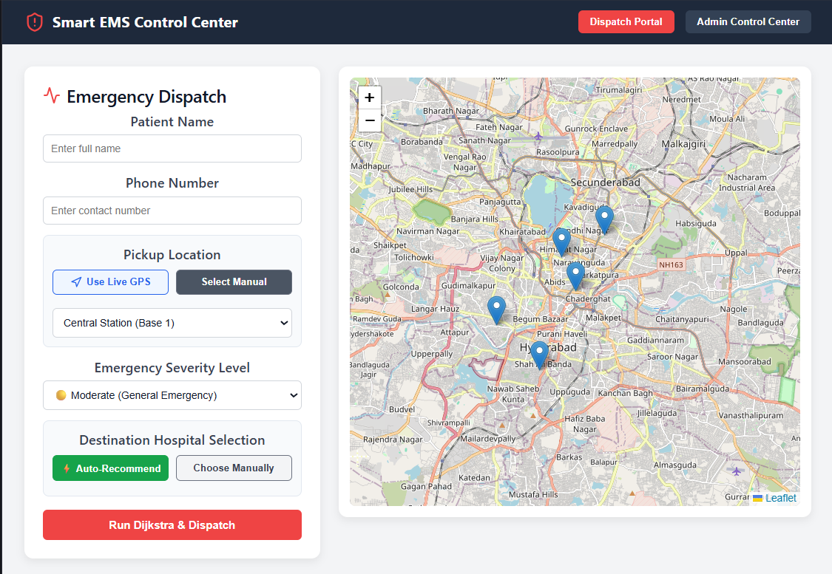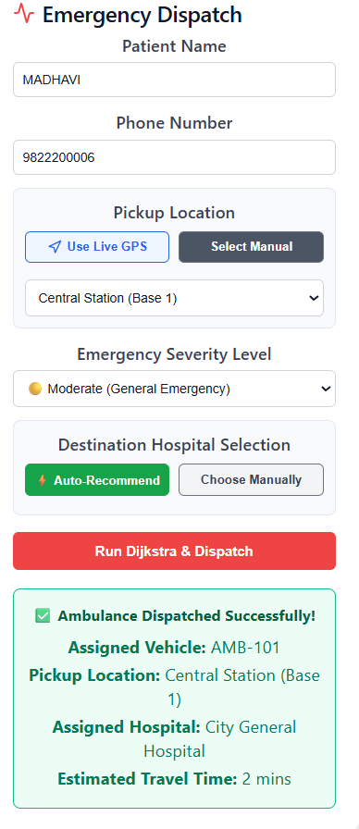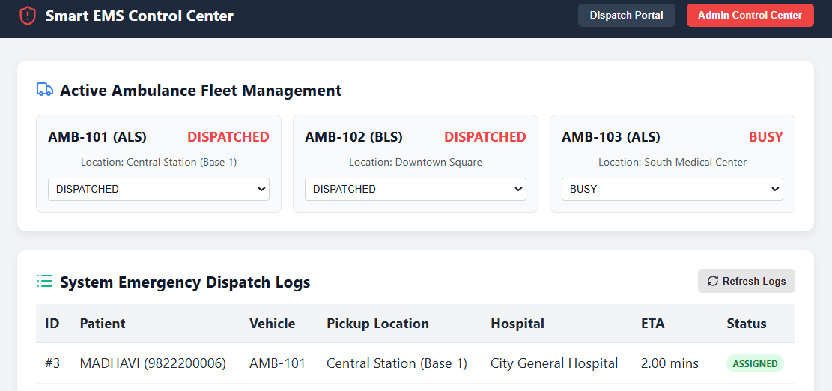

7. Conclusion, Future Scope & References

7.1 Project Conclusion
The Smart Ambulance Dispatch and Routing System demonstrates how core data structures and algorithms solve critical, real-world emergency logistics problems. By integrating Priority Queues for severity triage, Dijkstra’s Algorithm for dynamic graph routing, and Greedy Strategies for hospital capacity allocation, the prototype eliminates manual dispatch delays and prevents emergency room rejections. The system fully satisfies Problem 29, providing a transparent, scalable, and life-saving software architecture.

7.2 Future Enhancements
- Predictive Fleet Positioning (AI/ML): Deploy machine learning models (LSTM/Random Forest) to predict high-incident zones based on historical time/weather data and proactively position idle ambulances nearby.
- Traffic Signal Preemption (V2I): Integrate Vehicle-to-Infrastructure communication APIs to automatically trigger green lights for approaching emergency vehicles along Dijkstra's computed path.
- Quantum / Advanced Hybrid Optimization: Formulate vehicle routing as a Dynamic Vehicle Routing Problem (DVRP) solvable on hybrid classical-quantum solvers for ultra-large-scale metropolitan regions.

7.3 References
- Dijkstra, E. W. (1959). A note on two problems in connexion with graphs. Numerische Mathematik, 1(1), 269–271.
- Cormen, T. H., Leiserson, C. E., Rivest, R. L., & Stein, C. (2009). Introduction to Algorithms (3rd ed.). MIT Press.
- World Health Organization (WHO). Emergency Medical Services Systems: Technical Guidelines for Emergency Care Allocation.
- Flask Documentation & RESTful API Best Practices: https://flask.palletsprojects.com/
- React & Leaflet Geospatial Visualization Guidelines: https://reactjs.org/ | https://leafletjs.com/

