PHSX 536 Final Project Proposal: Voltage Controlled Filter
Grant Saggars

Voltage controlled filters are a classic component in audio engineering, and were originally created in the late 20th century. They provide ways to shape a simple waveform, such as a square or triangle wave, into anything from a classic rock guitar sound to a kick drum. I aim to implement an op-amp based design, popularized in Moog synthesizers during the late 20th century. This design deviates from the classic ladder filter by incorporating a diode ladder to maintain a more uniform voltage-dependent control.

Circuit Schematic in Falstad
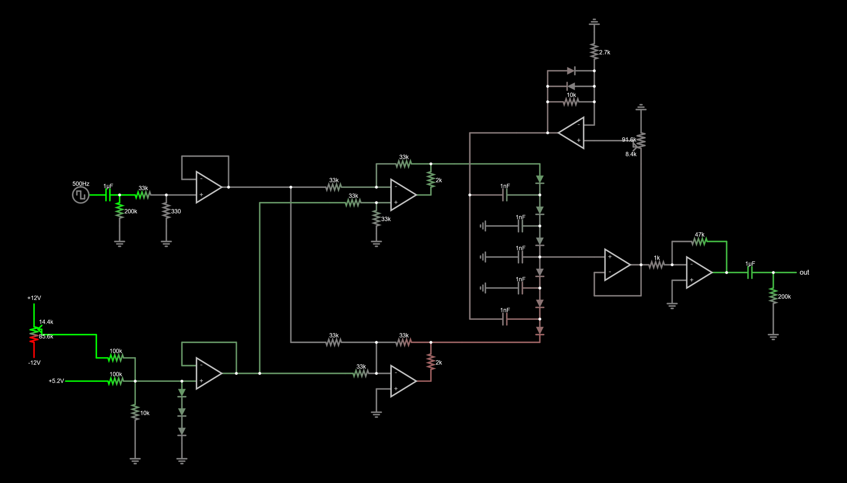

Parts List
Semiconductors
- 11x 1N4148 diode
Capacitors
- 2x 1uF film capacitor (or 2x 0.5uF)
- 5x 1nF film capacitor (or 2x 0.5uF)
ICs
- 7x TL074
Resistors
- 2x 200k resistor
- 2x 100k resistor
- 1x 47k resistor
- 8x 33k resistor
- 2x 10k resistor
- 1x 2k7 resistor
- 2x 2k resistor
- 1x 1k resistor
- 1x 330 resistor
Potentiometers
- 2x 100k linear mono potentiometer
Misc
- 3x audio jack socket

