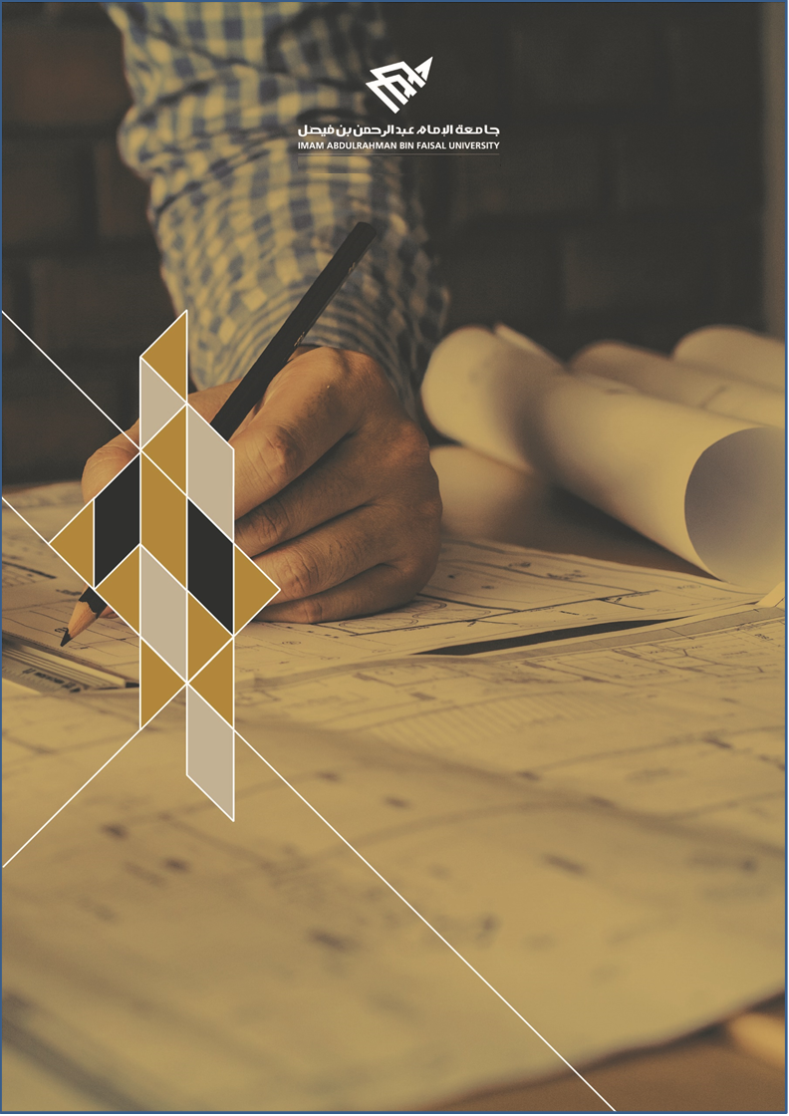

**ARTI407 – Image Processing**

**STUDENT PROCEDURAL MANUAL Lab 1**

**2019 - 2020**

**College of Computer Science and Information Technology**

**كلية علوم الحاسب وتقنية المعلومات**

**DEPARTMENT OF COMPUTER SCIENCE**

|  |  |  |
| --- | --- | --- |
| **Session Topic/Title** | **Session No.** | **Session Duration (Minutes)** |
| Basics of programming with Python | 1 | 100 |

|  |  |
| --- | --- |
| 1. **Session Outcomes** |  |

**Outcome#1:** Explain how digital images are represented and manipulated in a computer.

|  |  |
| --- | --- |
| 1. **Tool(s)/Software** | *.* |

* Python 3
* Anaconda
* IDE for Python: Jupyter, Spyder.

|  |  |
| --- | --- |
| 1. **procedural steps (Tasks)** |  |

**Step#1:Install Anaconda:**

Download and install latest version of Anaconda from<https://www.anaconda.com/>

The current version of Anaconda is 3. After installation and running Anaconda, you will get similar environment, where Jupyter and Spyder are already installed, which are the target tools for this course.

**Step#2: Start Jupyter or Spyder for Python.**

You can start Jupyter or Spyder either from the Anaconda GUI (which is most time-consuming task. You can also start Jupyter or Spyder directly from the start menu (without starting Anaconda).

**Step#3: Install Libraries / Packages in Python:**

Most of the time you will need libraries/Packages in Python during your work. The easiest way to install them is by using **pip** option.

**Note: You can also google colab in the lab if none of the machine is working**

**Step#4: Install Image Processing Libraries:**

You need to install the following image libraries.

1. PIL/Pillow
2. OpenCV
3. SimpleCV
4. Scikit-image

**Task#1:**

Apply each library to read and display an image.

Rubrics for Marking

|  |  |  |  |
| --- | --- | --- | --- |
| Installing | Tasks (read/display) | Write about Error if there’s | Marks (5 points) |
| PIL |  |  | 1 |
| OpenCV |  |  | 2 |
| SimpleCV |  | Error: Student need to write about error | 1 |
| Scikit-image |  |  | 1 |

|  |  |
| --- | --- |
| 1. **Assessment** |  |

The student will be asked to read and display various image format and display on the screen.

|  |  |
| --- | --- |
| 1. **Resources** |  |

NumPy cheat sheet

Python Basics cheat sheet

|  |  |
| --- | --- |
| **Submission** |  |

The students need to prepare the report in a PDF format and submit via Blackboard with the following details.

* Assignment #:
* Student_ID:
* Student_Name:
* Class Name:

Task code / clear screen shot of the code.

Output: Screen shot

**Appendix:**