**VIRTUAL FINANCE AGENT**

“A Financial Analytics tool’

***SRS Report(Part-2)***

S. M. Mamdudur Rahman(151014067)

Md. Fazlay Rabbi(151014047)

Farzana Anwer(151014048)

Mir Md. Maksudul Alam(151014065)

***Instructor:***  Mr. Rakib Hossain

Lecturer, DEPT of CSE, ULAB

*Submitted in partial fulfillment of the requirements of a Software Engineering course project

27th December, 2018

**

# Table of Contents

**CHAPTER TITLE PAGE**

**4.0 SCENARIO-BASED MODELING……………………………….**1

4.1 Introduction**……………………....………………………….**1

4.2 Use Case Diagrams and Scenario**……..………….…………**1

4.3 Conclusion **………………………………………………….**2

.

**5.0 DATA MODEL OF VIRTUAL FINANCIAL ANALYST ……..**4

5.1 Data Modeling Concept**…………………………………......4**

5.2 Data Relationship Diagram**………………………………….4**

5.3 Entity Relationship Diagram**………………………………...4**

5.4 Conclusion**…………………………………………………...4**

**6.0 CLASS-BASED MODEL…………………………….……………**4

6.1 Class Based Modeling Concept **…………………….……….**4

6.2 Class Diagram of the project**……………………….………..**5

6.2 Conclusion **……………………………………….………….5**

**7.0 DATA FLOW MODEL……….…………………………………...5**

7.1 Introduction**………………………………………………….5**

7.2 Data Flow Diagram (DFD)**…………………………………..5**

**8.0 CONCLUSION …………………………………………….………5**

8.1 Introduction**………………………………………………….6**

8.2 Future plans**………………………………………………….7**

8.3 Conclusion**…………….…………………..…………………7**

**9.0 Appendix and References………………………………….………5**

9.1 Questionnaires**……………………………………………….6**

9.2 References**……..…………………………………………….7**

**Chapter 4 Scenario-based Modeling**

**4.1 Introduction**

Scenario based modeling comprises of three parts:

* Use case diagram
* Activity diagram
* Swimlane diagram

A use case diagram is a graphic depiction of the interactions among the elements of a system. A use case is a methodology used in system analysis to identify, clarify, and organize system requirements and it contains some components.

* The actors, usually individuals involved with the system defined according to their roles.
* The use cases, which the specific roles are played by the actors within and around the system.
* The relationships among the actors and the use cases.

In ‘Virtual financial Analyst’ the use case diagram represents the whole process and activities of managing user and administrator operations. The actors are to be identified from the scenario.

These actors are of two types.

* Primary actor
* Secondary actor

**Primary actor:** The actors those both produce and consume information of a system.

**Secondary actor:** The actors those either produce or consume information of a system.

The identified actors of project are:

* System Admin (SA)
* Financial Analyst/User
* Management bodies of the consumer company

**4.2 Use Case Diagrams and Scenario**

In this section use case diagram and scenario are described elaborately. Each use case diagram contains its name, level number, primary and secondary actors.

Use Case Scenario

|  |  |  |  |
| --- | --- | --- | --- |
| Level 0 | Level 1 | Level 2 | Actor |
| Virtual financial analyst | **Profile Management** | 1. **User info collection** 2. **Modification** | **User** |
| “ | **Market Info** | 1. **Stock Market** 2. **Money Market** 3. **Economic Indicators** | **User, Admin** |
| “ | **Companies Info** | 1. **Annual Reports** | **User, Admin** |
| “ | **Analysis Tools** | **1. Prediction Tool**  **2. Market Map** | **User, Admin** |

**Table 4(a) Use Case Scenario**

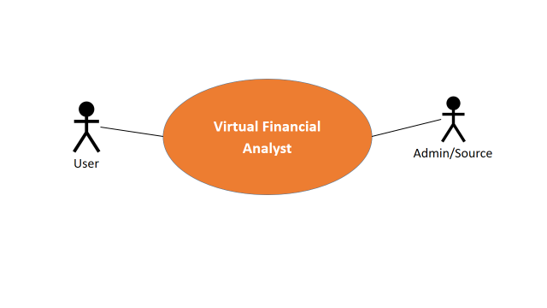

**Fig: Use case (a): Virtual financial analyst (Level 0)**

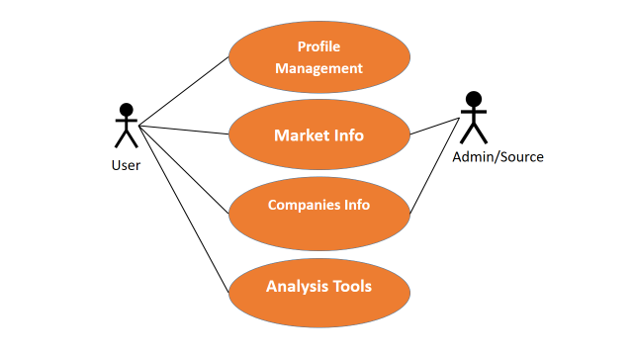

**Fig: Use case (b): Virtual financial analyst (Level 1)**

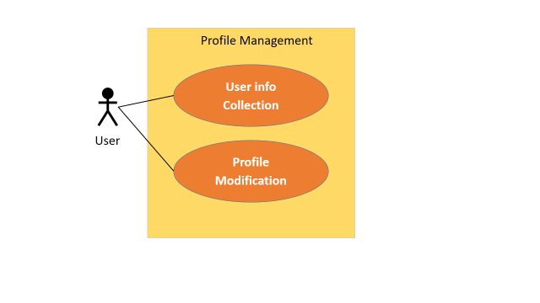

**Fig: Use case (c): Profile Management (Level 1.1.1)**

1. Use Case Description: Profile Management

|  |  |
| --- | --- |
| Use Case Id | Level 1.1.1 |
| Use Case Name | Profile Management |
| Primary Actor | User |
| Secondary Actor | None |
| Goal in Context | To make a user profile |
| Scenario | 1. Click the profile button 2. Edit the profile 3. Click SAVE button |
| Priority | Essential, must be implemented. |

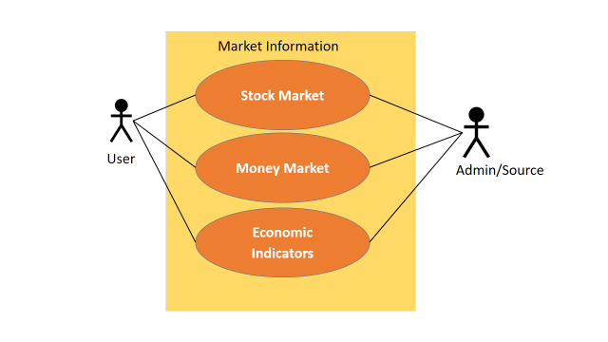

**Fig: Use case (d): Market Information (Level 1.1.2)**

1. Use Case Description:  **Market Information**

|  |  |
| --- | --- |
| Use Case Id | Level 1.1.2 |
| Use Case Name | Market Information |
| Primary Actor | User, Admin |
| Secondary Actor | None |
| Goal in Context | To grow Market Awareness |
| Scenario | 1. Click Market Information 2. See All the Indexes |
| Priority | Essential, must be implemented to gather Knowledge |

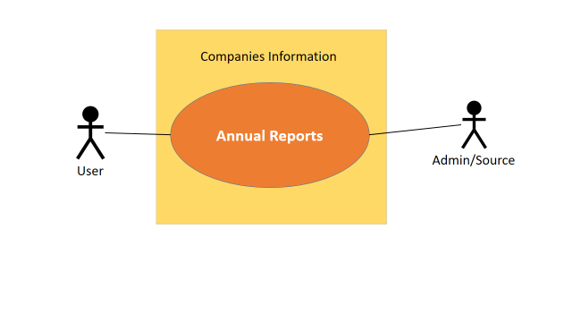

**Fig: Use case (e): Companies Information (Level 1.3)**

1. Use Case Description:  **Companies Information**

|  |  |
| --- | --- |
| Use Case Id | Level 1.1.3 |
| Use Case Name | Companies Information |
| Primary Actor | User |
| Secondary Actor | Admin |
| Goal in Context | To gather knowledge about companies |
| Scenario | 1. Click Companies Information 2. See All the Indexes and reports |
| Priority | Essential, must be implemented to gather Knowledge |

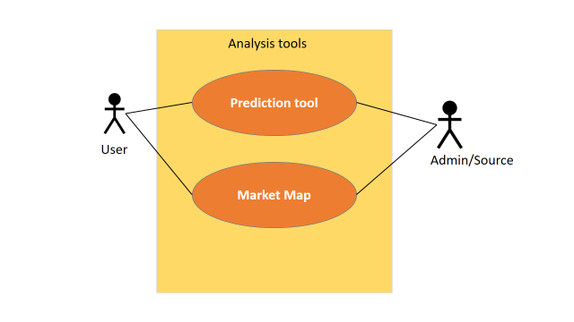

**Fig: Use case (f): Companies Information (Level 1.4)**

1. Use Case Description:  **Analysis Tools**

|  |  |
| --- | --- |
| Use Case Id | Level 1.1.4 |
| Use Case Name | Analysis tools |
| Primary Actor | User |
| Secondary Actor | Admin |
| Goal in Context | To apply prediction on investment |
| Scenario | 1. Click Analysis tools 2. Apply Prediction tools |
| Priority | Essential, must be implemented to make optimal decision |

**4.3 Conclusion**

Eventually, in this section we have used case diagram and scenario are described elaborately. Each use case diagram contains its name, level number, primary and secondary actors.

**Chapter 6 Class-based model**

**6.1 Class Based Modeling Concept**

Class-based modeling represents the objects that the system will manipulate, the operations that will be applied to the objects, relationships between the objects and the collaborations that occur between the classes that are defined. The elements of a class-based model include classes and objects, attributes, operations, class-responsibility-collaborator (CRC) models, class diagrams.

**6.2 Class Diagram for Virtual Financial Analyst**

Although customers only need to press a few buttons to Operate the system, there are many layers of modules that provide value for customers. The various functions of the system are illustrated by this easy-to-read diagram—every class has its title, and the attributes are listed beneath.

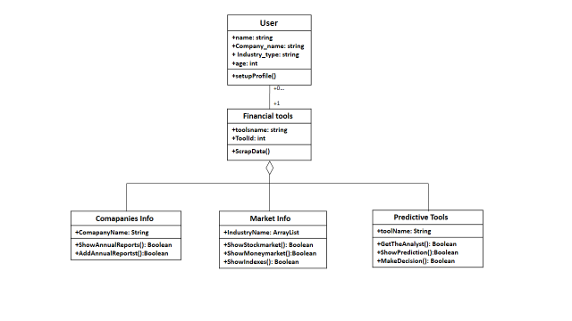

**Fig 6(a): Class Diagram**

**6.3 Conclusion**

We have identified all potential classes, drawn class. Next chapter is about dataflow model.