Here's how you can use the predict_sentiment function to predict the sentiment of the given sample_review

This code will output "Negative review" because the sentiment of the sample review "The food is really bad." is negative.

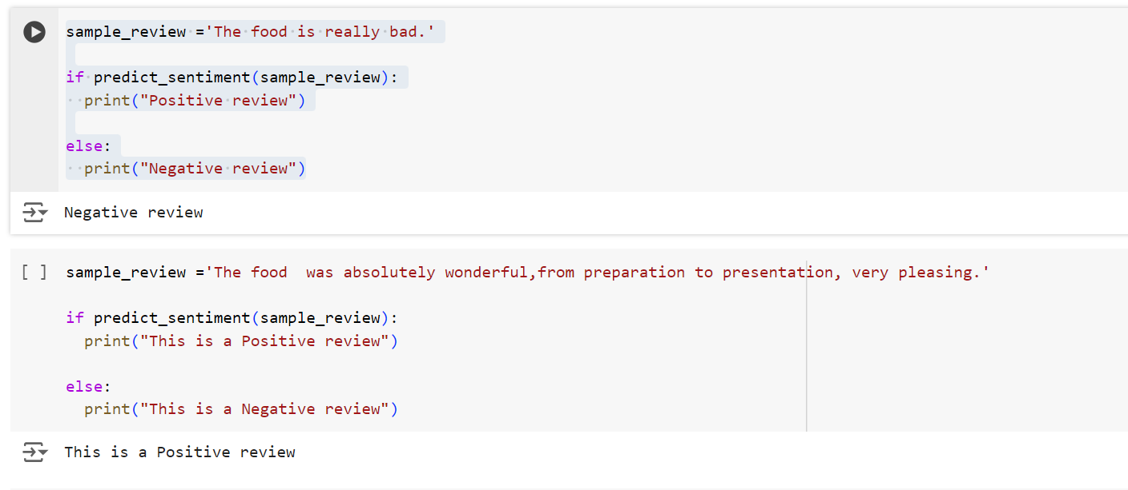

However, since the predict_sentiment function returns an array of predictions, you should check whether the first element of this array is 1 or not

Here's the adjusted code to handle the sentiment prediction for the sample review 'food averag'

This code will output "Negative review" because the sentiment of the sample review 'food averag' is likely to be negative.

