RollNo:
23WH1A0526
Date:

Title:1) Set up the Node.js environment for the CelebrationHub backend and display a basic server response
Page No:


AIM: Set up the Node.js environment for the CelebrationHub backend and display a basic server response
Description: This experiment demonstrates the basic setup of a Node.js environment using the CelebrationHub backend application. The Express server is initialized and a simple root route is created to verify successful configuration. When the server runs, it returns a basic text response confirming that the backend environment is installed, connected, and ready for further development.

Source Code:

require("dotenv").config();
const express = require("express");
const cors = require("cors");
const connectDB = require("./utils/db");
const userRoutes = require("./routes/userRoutes");
const celebrationRoutes = require("./routes/celebrationRoutes");
const authRoutes = require("./routes/authRoutes");
const app = express();
// Connect Database
connectDB();
app.use(cors());
app.use(express.json());
// Routes
app.use("/api/users", userRoutes);
app.use("/api/celebrations", celebrationRoutes);
app.use("/api/auth", authRoutes);
app.get("/", (req, res) => {
res.send("CelebrationHub Backend Running");
});
const PORT = process.env.PORT || 5000;
app.listen(PORT, () => {
console.log(`Server running on port ${PORT}`);
});

RollNo: Title:
23WH1A0526
Date:

Page No:


OUTPUT:
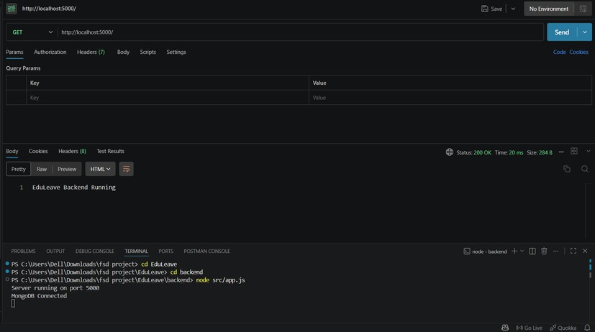

RollNo:
23WH1A0526
Date:

Title:
- Develop a Node.js based user login system for the CelebrationHub application.
Page No:


AIM: Develop a Node.js based user login system for the CelebrationHub application.
Description: This experiment implements a user login system using Node.js, Express, and MongoDB. It validates user credentials, checks encrypted passwords with bcrypt, and generates a JWT token after successful login. The CelebrationHub project uses this module for secure authentication of users and admins. It shows how backend login logic can be used to control access to protected application features.

Source Code:
File: backend/src/routes/authRoutes.js const express = require("express"); const {
register, registerAdmin, login, resetPassword, me
} = require("../controllers/authController");
const { protect } = require("../middleware/authMiddleware"); const router = express.Router();
router.post("/register", register); router.post("/register-admin", registerAdmin); router.post("/login", login);
router.post("/reset-password", resetPassword); router.get("/me", protect, me); module.exports = router;
File: backend/src/controllers/authController.js const bcrypt = require("bcryptjs");
const jwt = require("jsonwebtoken"); const User = require("../models/User"); const buildToken = (user) =>
jwt.sign(
{ id: user._id, role: user.role }, process.env.JWT_SECRET || "secretkey",
{ expiresIn: "1d" }
);
const sanitizeUser = (user) => {
const { password, ...userData } = user._doc; return userData;
};

RollNo: Title:
23WH1A0532
Date:

Page No:


exports.login = async (req, res) => { try {
const { email, password } = req.body;

if (!email || !password) {
return res.status(400).json({ message: "Email and password are required" });
}
const normalizedEmail = email.trim().toLowerCase();
const user = await User.findOne({ email: normalizedEmail });

if (!user) {
return res.status(400).json({ message: "User not found" });
}
const isMatch = await bcrypt.compare(password, user.password); if (!isMatch) {
return res.status(400).json({ message: "Invalid password" });
}

res.json({
token: buildToken(user), user: sanitizeUser(user)
});
} catch (err) {
res.status(500).json({ message: err.message });
}
};
File: `backend/src/models/user.js`

const mongoose = require("mongoose"); const userSchema = new mongoose.Schema(
{
name: { type: String,
required: true, trim: true
},
email: { type: String,
required: true,

RollNo: Title:
23WH1A0532
Date:

Page No:


unique: true, lowercase: true, trim: true
},
role: {
type: String,
enum: ["student", "faculty", "admin"], required: true
},
department: { type: String, trim: true, default: ""
},
password: { type: String,
required: true, minlength: 6
}
},
{ timestamps: true }
);
module.exports = mongoose.model("User", userSchema);

OUTPUT:
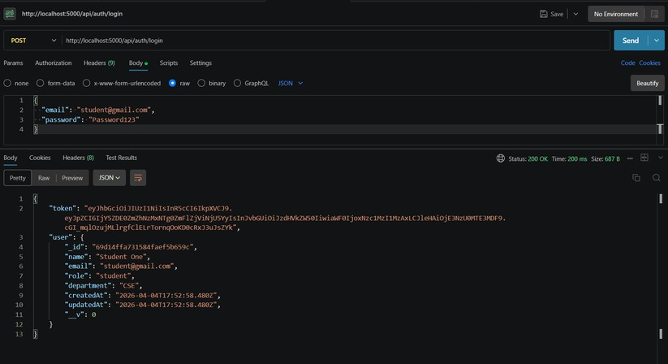

RollNo:
23WH1A0532
Date:

Title:
- Write a Node.js program to insert and remove EduLeave project data using backend scripts.
Page No:


AIM: Write a Node.js program to insert and remove EduLeave project data using backend scripts.

Description:
This experiment focuses on performing data operations similar to read, write, and delete actions in Node.js. In EduLeave, these actions are handled through MongoDB scripts rather than traditional file system operations. The seed and reset scripts insert sample records and remove existing records from the database. It demonstrates programmatic data management for application setup and testing.

Source Code:
File: `backend/src/seed.js` require("dotenv").config();
const bcrypt = require("bcryptjs"); const connectDB = require("./utils/db"); const User = require("./models/User"); connectDB();
const seed = async () => { await User.deleteMany();
const password = await bcrypt.hash("Password123", 10); await User.create([
{
name: "Student One",
email: "student@gmail.com", role: "student",
department: "CSE", password},{
name: "Faculty One",
email: "faculty@gmail.com", role: "faculty",
department: "CSE", password},{
name: "Admin One",
email: "admin@gmail.com", role: "admin",
department: "Administration", password}]);
console.log("Seed data inserted");
console.log("Default password for all seeded users: Password123"); process.exit();};
seed();

RollNo: Title:
23WH1A0532
Date:

Page No:


File: `backend/src/resetData.js` require("dotenv").config();
const connectDB = require("./utils/db"); const User = require("./models/User"); const Leave = require("./models/Leave"); connectDB();
const resetData = async () => { await Leave.deleteMany(); await User.deleteMany();
console.log("All users and leave requests have been removed."); process.exit();
};
resetData();

OUTPUT:
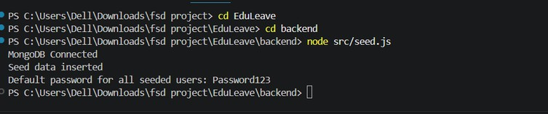

RollNo:
23WH1A0532
Date:

Title:
- Implement HTTP request and response handling for the EduLeave leave application API.
Page No:


AIM: Implement HTTP request and response handling for the EduLeave leave application API. Description: This experiment shows how Node.js handles HTTP requests and responses through backend routes. In EduLeave, leave applications are submitted through API endpoints created with Express. The server receives request data, validates it, processes it, and returns a JSON response. It highlights the request-response cycle used in modern web application backends.

Source Code:
File: `backend/src/routes/leaveRoutes.js` const express = require("express");
const { applyLeave, getMyLeaves, getAllLeaves,
updateLeaveStatus
} = require("../controllers/leaveController");
const { protect, authorize } = require("../middleware/authMiddleware"); const router = express.Router();
router.post("/", protect, authorize("student", "faculty"), applyLeave); router.get("/mine", protect, authorize("student", "faculty"), getMyLeaves); router.get("/", protect, authorize("admin"), getAllLeaves); router.patch("/:id/status", protect, authorize("admin"), updateLeaveStatus); module.exports = router;
File: `backend/src/controllers/leaveController.js` const Leave = require("../models/Leave");
const User = require("../models/User");
const calculateTotalDays = (fromDate, toDate) => { const start = new Date(fromDate);
const end = new Date(toDate);
const diff = end.setHours(0, 0, 0, 0) - start.setHours(0, 0, 0, 0);
return Math.floor(diff / (1000 * 60 * 60 * 24)) + 1;
};
exports.applyLeave = async (req, res) => { try {
const { leaveType, fromDate, toDate, reason } = req.body; if (!leaveType || !fromDate || !toDate || !reason) {
return res.status(400).json({ message: "All leave fields are required" });} const start = new Date(fromDate);
const end = new Date(toDate); const today = new Date(); today.setHours(0, 0, 0, 0);
if (Number.isNaN(start.getTime()) || Number.isNaN(end.getTime())) { return res.status(400).json({ message: "Invalid leave dates" });}

RollNo: Title:
23WH1A0532
Date:

Page No:


if (start < today) {
return res.status(400).json({ message: "Leave start date cannot be in the past" });} if (end < start) {
return res.status(400).json({ message: "To date cannot be before from date" }); } if (reason.trim().length < 10) {
return res.status(400).json({ message: "Reason must be at least 10 characters long" }); } const hasOverlap = await Leave.findOne({
requestedBy: req.user._id,
status: { $in: ["Pending", "Approved"] },
$or: [
{
fromDate: { $lte: end }, toDate: { $gte: start }
}
]
});
if (hasOverlap) {
return res.status(400).json({
message: "You already have a pending or approved leave in this date range"
});
}
const leave = await Leave.create({ requestedBy: req.user._id,
leaveType,
fromDate: start, toDate: end,
totalDays: calculateTotalDays(start, end), reason: reason.trim()
});
const populatedLeave = await Leave.findById(leave._id)
.populate("requestedBy", "name email role department")
.populate("reviewedBy", "name email role");

RollNo: Title:
23WH1A0532
Date:

Page No:


OUTPUT:
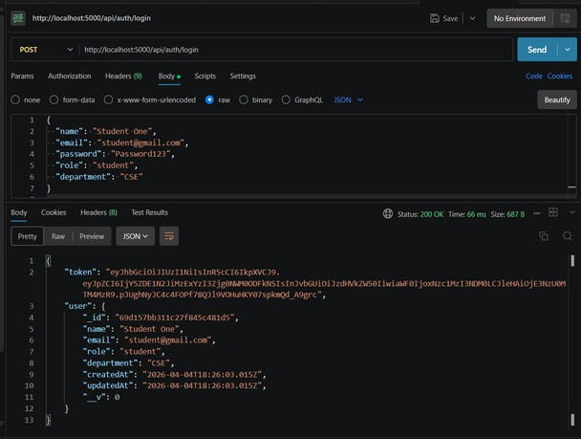

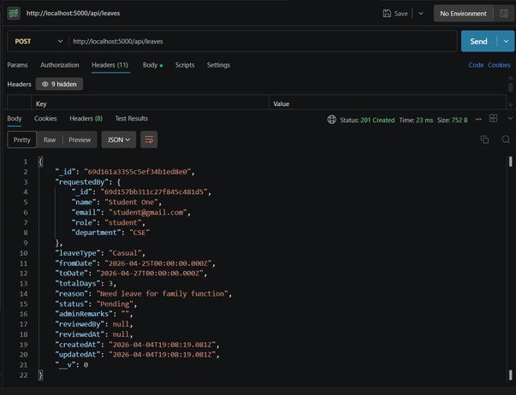

RollNo:
23WH1A0532
Date:

Title: 5)Connect the EduLeave project to MongoDB and define the required database collections.
Page No:


AIM: Connect the EduLeave project to MongoDB and define the required database collections. Description:This experiment demonstrates the use of MongoDB databases and collections in the EduLeave project. The application connects to MongoDB and defines schemas for users and leave records using Mongoose. These schemas represent structured collections that store authentication and leave information. It explains how database connection and collection design support the project’s data layer.

Source Code:
File: `backend/src/utils/db.js`

const mongoose = require("mongoose"); const connectDB = async () => {
try {
await mongoose.connect(process.env.MONGO_URI); console.log("MongoDB Connected");
} catch (error) {
console.error("DB Connection Failed:", error.message); process.exit(1);}};
module.exports = connectDB;
File: `backend/src/models/user.js`
const mongoose = require("mongoose"); const userSchema = new mongoose.Schema(
{
name: { type: String,
required: true, trim: true}, email: {
type: String, required: true, unique: true, lowercase: true, trim: true }, role: {
type: String,
enum: ["student", "faculty", "admin"], required: true
},
department: { type: String, trim: true,

RollNo: Title:
23WH1A0532
Date:

Page No:


default: ""
},
password: { type: String, required: true, minlength: 6}},
{ timestamps: true }
);
module.exports = mongoose.model("User", userSchema);
File: `backend/src/models/Leave.js` const mongoose = require("mongoose");
const leaveSchema = new mongoose.Schema({ requestedBy: {
type: mongoose.Schema.Types.ObjectId, ref: "User",
required: true}, leaveType: { type: String,
enum: ["Sick", "Casual", "Personal", "Emergency", "On Duty"], required: true },
fromDate: { type: Date, required: true }, toDate: {
type: Date, required: true}, totalDays: { type: Number, required: true, min: 1}, reason: {
type: String, required: true, minlength: 10, trim: true}, status: {
type: String,
enum: ["Pending", "Approved", "Rejected"], default: "Pending"},
adminRemarks: { type: String, trim: true,

RollNo: Title:
23WH1A0532
Date:

Page No:


default: ""},
reviewedBy: {
type: mongoose.Schema.Types.ObjectId, ref: "User",
default: null
},
reviewedAt: { type: Date,
default: null
}
},
{ timestamps: true }
);
module.exports = mongoose.model("Leave", leaveSchema);

OUTPUT:
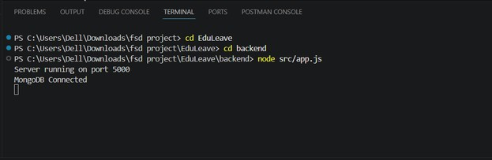

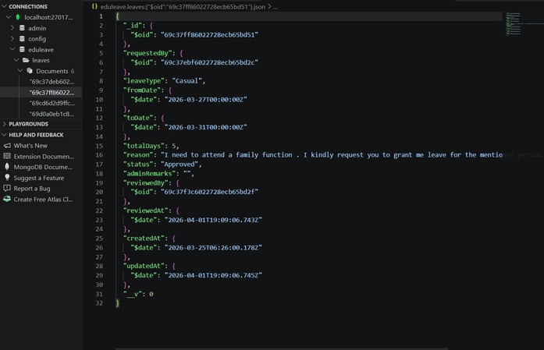

RollNo: Title:
23WH1A0532
Date:

Page No:



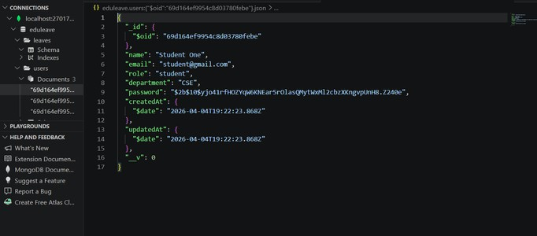

RollNo:
23WH1A0532
Date:

Title: 6) Implement CRUD operations for EduLeave users and leave requests using MongoDB.
Page No:


AIM: Implement CRUD operations for EduLeave users and leave requests using MongoDB.

Description:
This experiment implements CRUD operations using MongoDB in the EduLeave system. Users can be registered, leave requests can be created, records can be viewed, and leave status can be updated. Administrative actions and reset scripts also support deletion or clearing of stored data. It clearly demonstrates the complete lifecycle of data management in a real project.

Source Code:
File: `backend/src/controllers/authController.js`

const createUser = async ({ name, email, password, role, department }) => { const normalizedEmail = email.trim().toLowerCase();
const existingUser = await User.findOne({ email: normalizedEmail }); if (existingUser) {
return { error: { status: 409, message: "User already exists" } };
}
const hashedPassword = await bcrypt.hash(password, 10); const user = await User.create({
name: name.trim(), email: normalizedEmail,
password: hashedPassword, role,
department: department?.trim() || ""
});
return { user };
};
exports.register = async (req, res) => { try {
const { name, email, password, department } = req.body; const role = req.body.role || "student";
if (!name || !email || !password) {
return res.status(400).json({ message: "Name, email, and password are required" });
}
if (!["student", "faculty"].includes(role)) {
return res.status(400).json({ message: "Role must be student or faculty" });
}
const result = await createUser({ name, email, password, role, department }); if (result.error) {
return res.status(result.error.status).json({ message: result.error.message });
}

RollNo: Title:
23WH1A0532
Date:

Page No:


res.status(201).json({
message: "Registration successful", user: sanitizeUser(result.user)
});
} catch (err) {
res.status(400).json({ message: err.message });
}
};
File: `backend/src/controllers/leaveController.js` exports.getMyLeaves = async (req, res) => {
try {
const leaves = await Leave.find({ requestedBy: req.user._id })
.populate("reviewedBy", "name email role")
.sort({ createdAt: -1 }); res.json(leaves);
} catch (error) {
res.status(500).json({ message: error.message });
}
};
exports.getAllLeaves = async (req, res) => { try {
const query = {};
if (req.query.status && req.query.status !== "All") { query.status = req.query.status;
}
if (req.query.role && req.query.role !== "All") {
const matchedUsers = await User.find({ role: req.query.role }).select("_id"); query.requestedBy = { $in: matchedUsers.map((user) => user._id) };
}
const leaves = await Leave.find(query)
.populate("requestedBy", "name email role department")
.populate("reviewedBy", "name email role")
.sort({ createdAt: -1 }); res.json(leaves);
} catch (error) {
res.status(500).json({ message: error.message });
}};
exports.updateLeaveStatus = async (req, res) => { try {
const { status, adminRemarks } = req.body;

RollNo: Title:
23WH1A0532
Date:

Page No:


if (!["Approved", "Rejected"].includes(status)) {
return res.status(400).json({ message: "Status must be Approved or Rejected" });
}
if (status === "Rejected" && !adminRemarks?.trim()) {
return res.status(400).json({ message: "Remarks are required when rejecting leave" });
}
const leave = await Leave.findById(req.params.id);

if (!leave) {
return res.status(404).json({ message: "Leave request not found" });
}

leave.status = status;
leave.adminRemarks = adminRemarks?.trim() || ""; leave.reviewedBy = req.user._id;
leave.reviewedAt = new Date(); await leave.save();
const populatedLeave = await Leave.findById(leave._id)
.populate("requestedBy", "name email role department")
.populate("reviewedBy", "name email role"); res.json(populatedLeave);
} catch (error) {
res.status(400).json({ message: error.message });
}
};
File: `backend/src/routes/userRoutes.js` const express = require("express"); const User = require("../models/User");
const { protect, authorize } = require("../middleware/authMiddleware"); const router = express.Router();
router.get("/", protect, authorize("admin"), async (req, res) => { try {
const users = await User.find().select("-password").sort({ createdAt: -1 }); res.json(users);
} catch (error) {
res.status(500).json({ message: error.message });
}
});

RollNo: Title:
23WH1A0532
Date:

Page No:


module.exports = router;
File: `backend/src/resetData.js` require("dotenv").config();
const connectDB = require("./utils/db"); const User = require("./models/User"); const Leave = require("./models/Leave"); connectDB();

const resetData = async () => { await Leave.deleteMany(); await User.deleteMany();
console.log("All users and leave requests have been removed."); process.exit();
};
resetData();

OUTPUT:
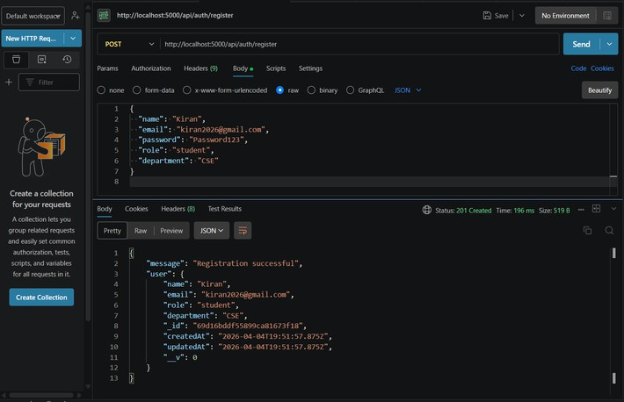

RollNo: Title:
23WH1A0532
Date:

Page No:



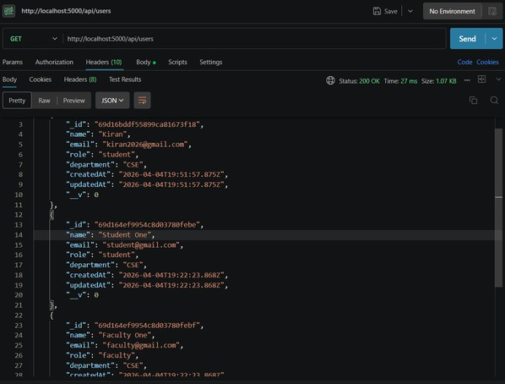

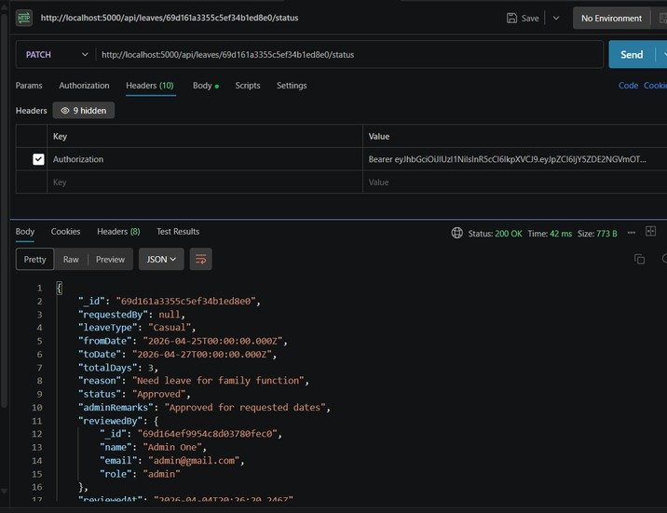

RollNo:
23WH1A0532
Date:

Title:
- Perform count and sorting operations on EduLeave leave records using MongoDB queries
Page No:


AIM: Perform count and sorting operations on EduLeave leave records using MongoDB queries

Description:
This experiment explores MongoDB operations such as count and sort on application data. In EduLeave, leave records are sorted by creation date and counted to generate dashboard summaries. These operations help organize records and present useful statistics to the user. Although limit and skip are not fully implemented, the project still shows practical query handling.

Source Code:
File: `backend/src/controllers/leaveController.js`

exports.getMyLeaves = async (req, res) => { try {
const leaves = await Leave.find({ requestedBy: req.user._id })
.populate("reviewedBy", "name email role")
.sort({ createdAt: -1 });

res.json(leaves);
} catch (error) {
res.status(500).json({ message: error.message });
}
};
exports.getAllLeaves = async (req, res) => { try {
const query = {};
if (req.query.status && req.query.status !== "All") { query.status = req.query.status;
}
if (req.query.role && req.query.role !== "All") {
const matchedUsers = await User.find({ role: req.query.role }).select("_id"); query.requestedBy = { $in: matchedUsers.map((user) => user._id) };
}
const leaves = await Leave.find(query)
.populate("requestedBy", "name email role department")
.populate("reviewedBy", "name email role")
.sort({ createdAt: -1 }); res.json(leaves);
} catch (error) {
res.status(500).json({ message: error.message });
}
};

RollNo: Title:
23WH1A0532
Date:

Page No:


OUTPUT:

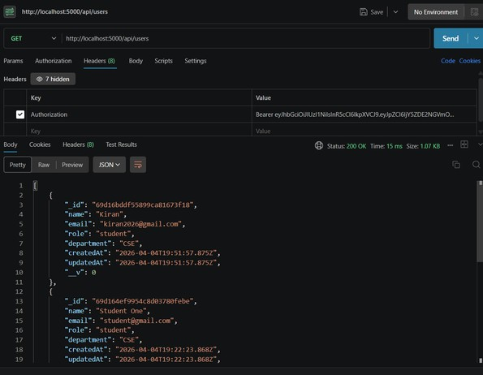
users count=4
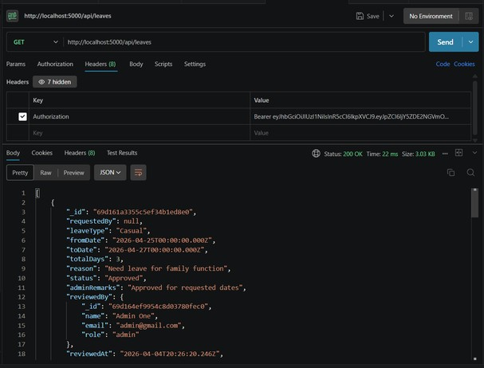

Leave records are sorted in descending order of created time. Latest leave appears first.

RollNo:
23WH1A0532
Date:

Title:
- Develop a styled EduLeave signup form and handle user input events Page No:
in the frontend.


AIM: Develop a styled EduLeave signup form and handle user input events in the frontend. Description: This experiment demonstrates a styled form with event handling in the frontend. EduLeave uses a React signup form where CSS is applied for layout and appearance.
User interactions such as typing and submitting are managed through `onChange` and
`onSubmit` events. It shows how frontend forms respond dynamically to user input in a web application.

Source Code:
File: `eduleave-frontend/src/pages/Signup.js`

import React, { useState } from "react";
import { Link, useNavigate } from "react-router-dom"; import API from "../services/api";
import "../App.css"; function Signup() {
const [formData, setFormData] = useState({ name: "",
email: "",
role: "student", department: "", password: "",
confirmPassword: ""
});
const [loading, setLoading] = useState(false); const [message, setMessage] = useState(""); const [error, setError] = useState("");
const navigate = useNavigate(); const handleChange = (e) => {
const { name, value } = e.target; setFormData((current) => ({
...current,
[name]: value
}));
};
const handleSignup = async (e) => { e.preventDefault();
setMessage("");
setError("");
const { name, email, role, department, password, confirmPassword } = formData; if (!name || !email || !password || !role || !department) {

RollNo: Title:
23WH1A0532
Date:

Page No:


setError("Please fill in all required fields."); return;
}
if (password.length < 6) {
setError("Password must be at least 6 characters long."); return;
}
if (password !== confirmPassword) { setError("Passwords do not match."); return;
}
try {
setLoading(true);
await API.post("/auth/register", { name,
email, role,
department, password
});

setMessage("Account created successfully. You can log in now."); setTimeout(() => navigate("/"), 700);
} catch (err) {
setError(err.response?.data?.message || "Signup failed. Please try again.");
} finally {
setLoading(false);
}
};
File: `eduleave-frontend/src/App.css`
:root {
--bg: linear-gradient(135deg, #f6efe3 0%, #e3eef7 100%);
--panel: rgba(255, 255, 255, 0.92);
--panel-strong: #ffffff;
--text: #18324a;
--muted: #61768d;
--accent: #0f7b6c;
--accent-dark: #0a5f54;
--accent-soft: #e2f3f0;
--border: #d4deea;
--danger: #be3d3d;
--danger-soft: #fff1f1;

RollNo: Title:
23WH1A0532
Date:

Page No:


--success: #1d7d47;
--success-soft: #effaf2;
--pending: #b27400;
--pending-soft: #fff6db;
} {
box-sizing: border-box;
}
body { margin: 0;
font-family: "Segoe UI", Tahoma, Geneva, Verdana, sans-serif; color: var(--text);
background: var(--bg);
}
a {
color: var(--accent); text-decoration: none;
}
button, input, select,
textarea {
font: inherit;
}
input, select,
textarea {
width: 100%;
border: 1px solid var(--border); border-radius: 14px;
padding: 14px 16px;
background: var(--panel-strong);
}
input:focus, select:focus, textarea:focus {
outline: 2px solid rgba(15, 123, 108, 0.16); border-color: var(--accent);
}
button,
.button-link {
display: inline-flex; align-items: center;

RollNo: Title:
23WH1A0532
Date:

Page No:


justify-content: center; min-height: 48px;
padding: 12px 18px; border: none; border-radius: 14px;
background: var(--accent); color: #fff;
cursor: pointer; font-weight: 700;
transition: background 0.2s ease, transform 0.2s ease;
}
button:hover,
.button-link:hover {
background: var(--accent-dark); transform: translateY(-1px);}
button:disabled { cursor: not-allowed; opacity: 0.7;
transform: none;}

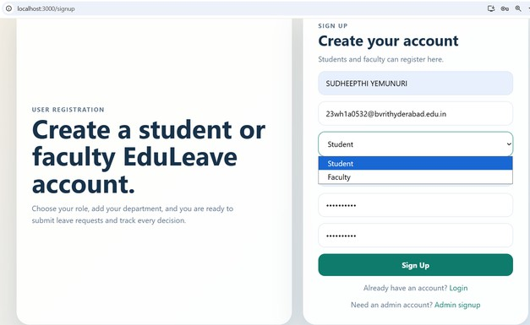
OUTPUT:

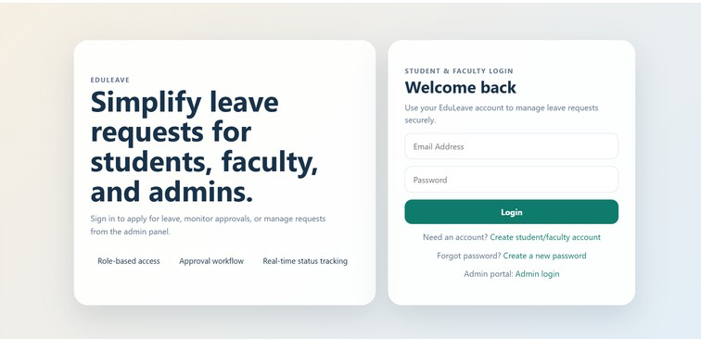

RollNo:
23WH1A0532
Date:

Title:
- Develop and validate the EduLeave user registration form for students and faculty.
Page No:


AIM:Develop and validate the EduLeave user registration form for students and faculty.
Description: This experiment focuses on form validation in a registration system.
The EduLeave signup and admin signup pages check required fields, password rules, and input matching. The backend also validates data to prevent invalid or duplicate registration requests. It demonstrates both client-side and server-side validation for reliable data entry.

Source Code:
File: `eduleave-frontend/src/pages/Signup.js`

import React, { useState } from "react";
import { Link, useNavigate } from "react-router-dom"; import API from "../services/api";
import "../App.css"; function Signup() {
const [formData, setFormData] = useState({ name: "",
email: "",
role: "student", department: "", password: "", confirmPassword: ""
});
const [loading, setLoading] = useState(false); const [message, setMessage] = useState(""); const [error, setError] = useState("");
const navigate = useNavigate(); const handleChange = (e) => { const { name, value } = e.target; setFormData((current) => ({
...current, [name]: value
}));
};
const handleSignup = async (e) => { e.preventDefault(); setMessage("");
setError("");
const { name, email, role, department, password, confirmPassword } = formData; if (!name || !email || !password || !role || !department) {
setError("Please fill in all required fields."); return;
}

RollNo: Title:
23WH1A0532
Date:

Page No:


if (password.length < 6) {
setError("Password must be at least 6 characters long."); return;}
if (password !== confirmPassword) { setError("Passwords do not match."); return;
}
try {
setLoading(true);
await API.post("/auth/register", { name,
email, role,
department, password});
setMessage("Account created successfully. You can log in now."); setTimeout(() => navigate("/"), 700);
} catch (err) {
setError(err.response?.data?.message || "Signup failed. Please try again.");
} finally { setLoading(false);}}; return (
<div className="auth-page">
<div className="auth-shell">
<div className="hero-panel">
<p className="auth-eyebrow">User Registration</p>
<h1>Create a student or faculty EduLeave account.</h1>
<p>
Choose your role, add your department, and you are ready to submit leave requests and track every decision.
</p>
</div>
<form className="auth-card" onSubmit={handleSignup}>
<div className="auth-copy">
<p className="auth-eyebrow">Sign Up</p>
<h2>Create your account</h2>
<p>Students and faculty can register here.</p>
</div>
<input
name="name"
placeholder="Full Name"

RollNo: Title:
23WH1A0532
Date:

Page No:


value={formData.name}
onChange={handleChange}/>
<input
name="email" type="email"
placeholder="Email Address" value={formData.email}
onChange={handleChange}
/>
<select name="role" value={formData.role} onChange={handleChange}>
<option value="student">Student</option>
<option value="faculty">Faculty</option>
</select>
<input
name="department"
placeholder="Department" value={formData.department} onChange={handleChange}/>
<input name="password" type="password"
placeholder="Password" value={formData.password}
onChange={handleChange} />
<input
name="confirmPassword" type="password"
placeholder="Confirm Password" value={formData.confirmPassword} onChange={handleChange} />
{error ? <p className="form-message error">{error}</p> : null}
{message ? <p className="form-message success">{message}</p> : null}
<button type="submit" disabled={loading}>
{loading ? "Creating account..." : "Sign Up"}
</button>
<p className="auth-switch">
Already have an account? <Link to="/">Login</Link>
</p>
<p className="auth-switch">
Need an admin account? <Link to="/admin/signup">Admin signup</Link>
</p>

RollNo: Title:
23WH1A0532
Date:

Page No:


</form>
</div>
</div>
);
}
export default Signup;
File: `eduleave-frontend/src/pages/AdminSignup.js` import React, { useState } from "react";
import { Link, useNavigate } from "react-router-dom"; import API from "../services/api";
import "../App.css";
function AdminSignup() {
const [formData, setFormData] = useState({ name: "",
email: "",
department: "Administration", password: "",
confirmPassword: "", adminSecret: ""
});
const [loading, setLoading] = useState(false); const [message, setMessage] = useState(""); const [error, setError] = useState("");
const navigate = useNavigate();

const handleChange = (e) => { const { name, value } = e.target; setFormData((current) => ({
...current,
[name]: value
}));
};
const handleSignup = async (e) => { e.preventDefault();
setError("");
setMessage("");
const { name, email, department, password, confirmPassword, adminSecret } = formData; if (!name || !email || !department || !password || !confirmPassword || !adminSecret) { setError("Please fill in all required fields.");
return;
}

RollNo: Title:
23WH1A0532
Date:

Page No:


if (password.length < 6) {
setError("Password must be at least 6 characters long."); return;
}
if (password !== confirmPassword) { setError("Passwords do not match."); return;
}
try { setLoading(true);
await API.post("/auth/register-admin", { name,
email, department, password, adminSecret
});
setMessage("Admin account created successfully. You can log in now."); setTimeout(() => navigate("/admin/login"), 700);
} catch (err) {
setError(err.response?.data?.message || "Admin signup failed. Please try again.");
} finally { setLoading(false);
}
};
File: `backend/src/controllers/authController.js` const bcrypt = require("bcryptjs");
const jwt = require("jsonwebtoken"); const User = require("../models/User"); const buildToken = (user) =>
jwt.sign(
{ id: user._id, role: user.role }, process.env.JWT_SECRET || "secretkey",
{ expiresIn: "1d" }
);
const sanitizeUser = (user) => {
const { password, ...userData } = user._doc; return userData;
};
const createUser = async ({ name, email, password, role, department }) => { const normalizedEmail = email.trim().toLowerCase();

RollNo: Title:
23WH1A0532
Date:

Page No:


const existingUser = await User.findOne({ email: normalizedEmail }); if (existingUser) {
return { error: { status: 409, message: "User already exists" } };
}
const hashedPassword = await bcrypt.hash(password, 10); const user = await User.create({
name: name.trim(), email: normalizedEmail,
password: hashedPassword, role,
department: department?.trim() || ""
});
return { user };
};
exports.register = async (req, res) => { try {
const { name, email, password, department } = req.body; const role = req.body.role || "student";
if (!name || !email || !password) {
return res.status(400).json({ message: "Name, email, and password are required" });
}

if (!["student", "faculty"].includes(role)) {
return res.status(400).json({ message: "Role must be student or faculty" });
}
const result = await createUser({ name, email, password, role, department }); if (result.error) {
return res.status(result.error.status).json({ message: result.error.message });
}

res.status(201).json({
message: "Registration successful", user: sanitizeUser(result.user)
});
} catch (err) {
res.status(400).json({ message: err.message });
}
};

RollNo: Title:
23WH1A0532
Date:

Page No:


exports.registerAdmin = async (req, res) => { try {
const { name, email, password, department, adminSecret } = req.body;

if (!name || !email || !password || !adminSecret) { return res.status(400).json({
message: "Name, email, password, and admin secret are required"
});
}
if (adminSecret !== (process.env.ADMIN_SECRET || "EDULEAVE_ADMIN_2026")) { return res.status(403).json({ message: "Invalid admin secret" });
}
const result = await createUser({ name,
email, password, role: "admin", department
});
if (result.error) {
return res.status(result.error.status).json({ message: result.error.message });
}
res.status(201).json({
message: "Admin account created successfully", user: sanitizeUser(result.user)
});
} catch (err) {
res.status(400).json({ message: err.message });
}
};
exports.login = async (req, res) => {try { const { email, password } = req.body; if (!email || !password) {
return res.status(400).json({ message: "Email and password are required" });
}
const normalizedEmail = email.trim().toLowerCase();
const user = await User.findOne({ email: normalizedEmail }); if (!user) {
return res.status(400).json({ message: "User not found" });
}
const isMatch = await bcrypt.compare(password, user.password);

RollNo: Title:
23WH1A0532
Date:

Page No:


if (!isMatch) {
return res.status(400).json({ message: "Invalid password" });
}
res.json({
token: buildToken(user), user: sanitizeUser(user)
});
} catch (err) {
res.status(500).json({ message: err.message });
}
};
exports.resetPassword = async (req, res) => { try {
const { email, role, newPassword } = req.body; if (!email || !role || !newPassword) {
return res.status(400).json({
message: "Email, role, and new password are required"
});
}
if (!["student", "faculty", "admin"].includes(role)) {
return res.status(400).json({ message: "Invalid role selected" });
}
if (newPassword.length < 6) { return res.status(400).json({
message: "New password must be at least 6 characters long"
});
}
const normalizedEmail = email.trim().toLowerCase();
const user = await User.findOne({ email: normalizedEmail, role }); if (!user) {
return res.status(404).json({ message: "User not found for this role" });
}
user.password = await bcrypt.hash(newPassword, 10); await user.save();
res.json({ message: "Password reset successful. Please login with your new password." });
} catch (err) {
res.status(400).json({ message: err.message });
}
};
exports.me = async (req, res) => { res.json(req.user);
};

RollNo: Title:
23WH1A0532
Date:

Page No:


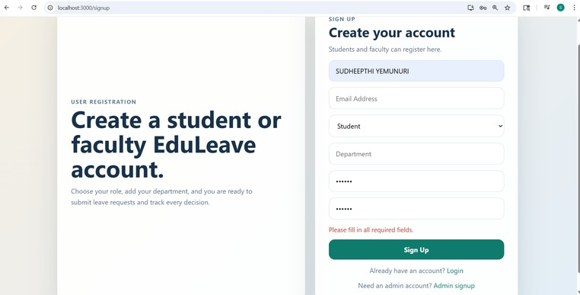
OUTPUT:

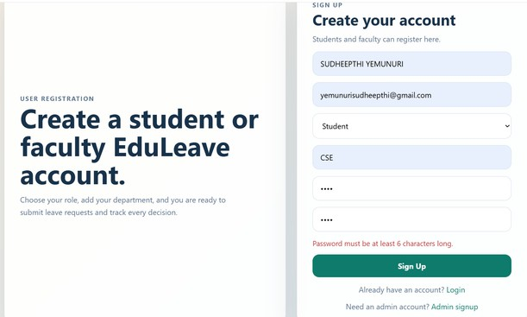

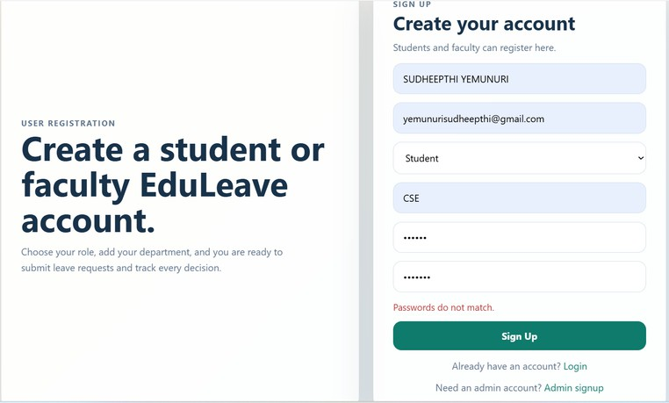

RollNo:
23WH1A0532
Date:

Title:
- Fetch and display EduLeave JSON data from the backend using frontend service calls.
Page No:


AIM: F.etch and display EduLeave JSON data from the backend using frontend service calls.

Description:
This experiment shows how a frontend application fetches JSON data from a server.
In EduLeave, React components use Axios services to request dashboard and leave history data from backend APIs. The received JSON response is processed and displayed in the user interface. It explains how frontend and backend communicate to build a data-driven application.

Source Code:
File: `eduleave-frontend/src/services/api.js`

import axios from "axios"; const API = axios.create({
baseURL: "http://localhost:5000/api"
});
API.interceptors.request.use((config) => { const token = localStorage.getItem("token"); if (token) {
config.headers.Authorization = `Bearer ${token}`;
}
return config;
});
export default API;

File: `eduleave-frontend/src/pages/Dashboard.js` import React, { useEffect, useState } from "react"; import { Link, useNavigate } from "react-router-dom"; import API from "../services/api";
import { clearSession, getStoredUser } from "../services/auth"; import "../App.css";

function Dashboard() {
const navigate = useNavigate();
const [user, setUser] = useState(null); const [stats, setStats] = useState({ total: 0,
pending: 0,
approved: 0,
rejected: 0,
users: 0
});

RollNo: Title:
23WH1A0532
Date:

Page No:


useEffect(() => {
const storedUser = getStoredUser(); if (!storedUser) {
navigate("/"); return;
}
setUser(storedUser);

}, [navigate]); useEffect(() => { if (!user) {
return;
}
const loadStats = async () => { try {
if (user.role === "admin") {
const [leavesRes, usersRes] = await Promise.all([ API.get("/leaves"),
API.get("/users")
]);
const leaves = leavesRes.data; setStats({
total: leaves.length,
pending: leaves.filter((leave) => leave.status === "Pending").length, approved: leaves.filter((leave) => leave.status === "Approved").length, rejected: leaves.filter((leave) => leave.status === "Rejected").length, users: usersRes.data.length
});
return;
}
const leavesRes = await API.get("/leaves/mine"); const leaves = leavesRes.data;
setStats({
total: leaves.length,
pending: leaves.filter((leave) => leave.status === "Pending").length, approved: leaves.filter((leave) => leave.status === "Approved").length, rejected: leaves.filter((leave) => leave.status === "Rejected").length, users: 0
});
} catch (error) {
if (error.response?.status === 401) {

RollNo: Title:
23WH1A0532
Date:

Page No:


clearSession(); navigate("/"); } }
};
loadStats();
}, [navigate, user]);
const handleLogout = () => {

clearSession(); navigate("/");
};
if (!user) { return null;
}
return (
<div className="dashboard-page">
<section className="dashboard-header">
<div>
<p className="auth-eyebrow">Dashboard</p>
<h1>Welcome, {user.name}</h1>
<p className="dashboard-subtitle">
{user.role === "admin"
? "Manage every leave request from one approval workspace."
: "Apply for leave, review request history, and track approvals in one place."}
</p>
</div>
<div className="top-actions">
{user.role === "admin" ? (
<Link className="button-link" to="/admin/leaves"> Manage Requests
</Link>
) : (
<>
<Link className="button-link" to="/apply"> Apply Leave
</Link>
<Link className="button-link secondary-button-link" to="/my-leaves"> View History
</Link>
</>
)}
<button className="secondary-button" onClick={handleLogout}>

RollNo: Title:
23WH1A0532
Date:

Page No:


Logout
</button>
</div>
</section>
<section className="summary-grid">
<div className="summary-card">
<span>Total</span>
<strong>{stats.total}</strong>
</div>
<div className="summary-card">
<span>Pending</span>
<strong>{stats.pending}</strong>
</div>
<div className="summary-card">
<span>Approved</span>
<strong>{stats.approved}</strong>
</div>
<div className="summary-card">
<span>Rejected</span>
<strong>{stats.rejected}</strong>
</div>
{user.role === "admin" ? (
<div className="summary-card">
<span>Users</span>
<strong>{stats.users}</strong>
</div>
) : null}
</section>
<section className="panel-grid">
<div className="panel-card">
<h3>Your profile</h3>
<p><strong>Email:</strong> {user.email}</p>
<p><strong>Role:</strong> {user.role}</p>
<p><strong>Department:</strong> {user.department || "Not provided"}</p>
</div>
<div className="panel-card">
<h3>{user.role === "admin" ? "Admin actions" : "Next steps"}</h3>
{user.role === "admin" ? (
<>
<p>Review pending requests, approve them, or reject with remarks.</p>
<Link className="inline-link" to="/admin/leaves">Open approval queue</Link>

RollNo: Title:
23WH1A0532
Date:

Page No:


</>
) : (
<>
<p>Submit a new request or check how your previous applications were handled.</p>
<Link className="inline-link" to="/apply">Apply for leave</Link>
<Link className="inline-link" to="/my-leaves">See leave history</Link>
</>
)}
</div>
</section>
</div>
);
}
export default Dashboard;
File: `eduleave-frontend/src/pages/LeaveHistory.js` import React, { useEffect, useState } from "react"; import { Link, useNavigate } from "react-router-dom"; import API from "../services/api";
import { getStoredUser } from "../services/auth"; import "../App.css";
function LeaveHistory() {
const [leaves, setLeaves] = useState([]); const [loading, setLoading] = useState(true); const [error, setError] = useState("");
const navigate = useNavigate(); useEffect(() => {
const user = getStoredUser();
if (!user || user.role === "admin") { navigate("/");
return;
}
const loadLeaves = async () => { try {
const res = await API.get("/leaves/mine"); setLeaves(res.data);
} catch (err) {
setError(err.response?.data?.message || "Could not load leave history.");
} finally { setLoading(false);
}
};
loadLeaves();

RollNo: Title:
23WH1A0532
Date:

Page No:


}, [navigate]); return (
<div className="dashboard-page">
<section className="dashboard-header">
<div>
<p className="auth-eyebrow">My Leaves</p>
<h1>Leave history</h1>
<p className="dashboard-subtitle">
Review every request, its duration, and the final admin decision.
</p>
</div>
<div className="top-actions">
<Link className="button-link secondary-button-link" to="/dashboard"> Dashboard
</Link>
<Link className="button-link" to="/apply"> Apply Leave
</Link>
</div>
</section>

{loading ? <div className="panel-card">Loading leave history...</div> : null}
{error ? <div className="panel-card error-box">{error}</div> : null}

{!loading && !error ? (
<div className="list-grid">
{leaves.length === 0 ? (
<div className="panel-card">No leave requests found yet.</div>
) : (
leaves.map((leave) => (
<div className="panel-card" key={leave._id}>
<div className="card-header">
<h3>{leave.leaveType} Leave</h3>
<span className={`status-badge status-${leave.status.toLowerCase()}`}>
{leave.status}
</span>
</div>
<p><strong>Dates:</strong> {leave.fromDate.slice(0, 10)} to {leave.toDate.slice(0, 10)}
</p>
<p><strong>Total days:</strong> {leave.totalDays}</p>
<p><strong>Reason:</strong> {leave.reason}</p>
<p><strong>Admin remarks:</strong> {leave.adminRemarks || "No remarks yet"}</p>

RollNo: Title:
23WH1A0532
Date:

Page No:


<p>
<strong>Reviewed by:</strong> {leave.reviewedBy?.name || "Awaiting action"}
</p>
</div>
))
)}
</div>
) : null}
</div>
);
}
export default LeaveHistory;

OUTPUT:
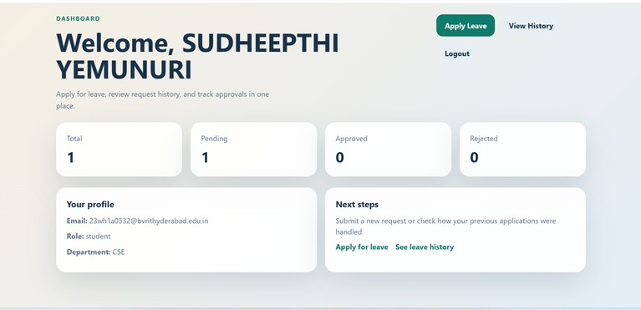
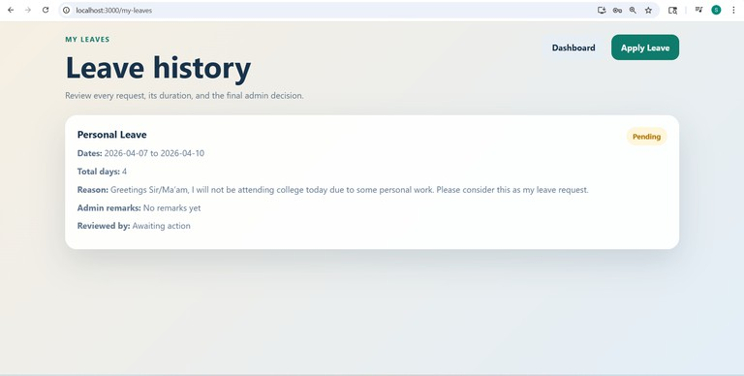

RollNo:
23WH1A0532
Date:

Title:11) Develop the EduLeave web application to manage student and user information using Express and React.
Page No:


AIM: Develop the EduLeave web application to manage student and user information using Express and React.
Description: This experiment develops a web application for managing student-related information using Express and a frontend framework. EduLeave supports registration, login, dashboard access, and user data retrieval through connected backend and frontend modules. The Express server handles routes and APIs, while React provides the interactive user interface. It demonstrates a complete full-stack application structure for academic record management.

Source Code:
. File: backend/src/app.js const app = express(); connectDB(); app.use(cors()); app.use(express.json());
app.use("/api/users", userRoutes); app.use("/api/leaves", leaveRoutes); app.use("/api/auth", authRoutes); app.get("/", (req, res) => { res.send("EduLeave Backend Running");
});

File: backend/src/routes/authRoutes.js const router = express.Router(); router.post("/register", register);
router.post("/register-admin", registerAdmin); router.post("/login", login);
router.post("/reset-password", resetPassword); router.get("/me", protect, me); module.exports = router;

File: backend/src/routes/userRoutes.js const router = express.Router();
router.get("/", protect, authorize("admin"), async (req, res) => { try {
const users = await User.find().select("-password").sort({ createdAt: -1 }); res.json(users);
} catch (error) {
res.status(500).json({ message: error.message });
}
});
module.exports = router;

RollNo: Title:
23WH1A0532
Date:

Page No:


File: eduleave-frontend/src/pages/Signup.js const handleSignup = async (e) => {
e.preventDefault(); setMessage("");
setError("");
const { name, email, role, department, password, confirmPassword } = formData; if (!name || !email || !password || !role || !department) {
setError("Please fill in all required fields."); return;
}
if (password !== confirmPassword) { setError("Passwords do not match."); return;
}
await API.post("/auth/register", { name,
email, role,
department, password
});
setMessage("Account created successfully. You can log in now.");
};
frontend/src/pages/Dashboard.js const loadStats = async () => {
try {
const leavesRes = await API.get("/leaves/mine"); const leaves = leavesRes.data;
setStats({
total: leaves.length,
pending: leaves.filter((leave) => leave.status === "Pending").length, approved: leaves.filter((leave) => leave.status === "Approved").length, rejected: leaves.filter((leave) => leave.status === "Rejected").length, users: 0
});
} catch (error) {
if (error.response?.status === 401) { clearSession();
navigate("/");
}
}
};

RollNo: Title:
23WH1A0532
Date:

Page No:


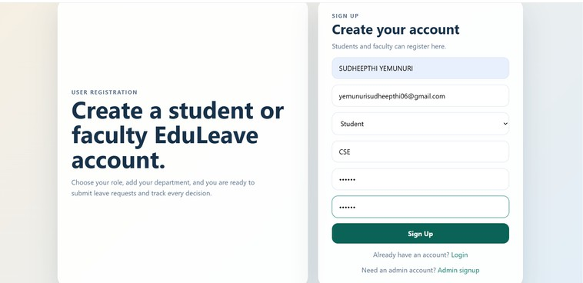
OUTPUT:

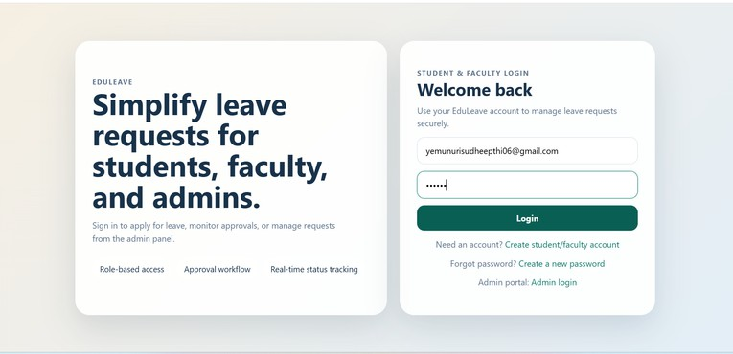

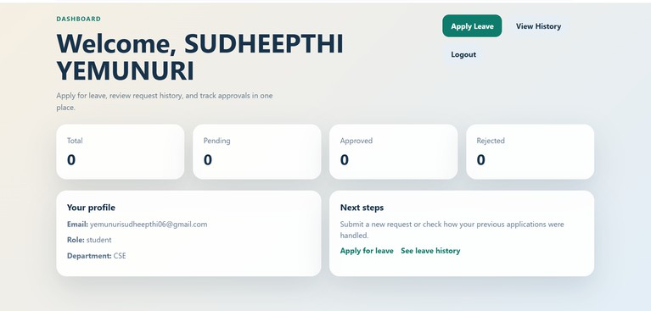

RollNo:
23WH1A0532
Date:

Title:
- Implement an approval decision workflow in React for reviewing EduLeave leave requests.
Page No:


AIM: Implement an approval decision workflow in React for reviewing EduLeave leave requests.

Description:
This experiment presents a React-based decision workflow similar to a voting application.
In EduLeave, admins review leave requests and choose to approve or reject them from the management page.Each decision updates the status of the leave request in the database and interface. It shows how action-based state changes can be implemented in a React application.

Source Code:
File: eduleave-frontend/src/pages/ManageLeaves.js

const handleDecision = async (leaveId, status) => { setError("");
setMessage(""); try {
await API.patch(`/leaves/${leaveId}/status`, { status,
adminRemarks: remarks[leaveId] || ""
});
setMessage(`Leave ${status.toLowerCase()} successfully.`); fetchLeaves(statusFilter, roleFilter);
} catch (err) {
setError(err.response?.data?.message || "Could not update leave status.");
}
};
<textarea rows="3"
placeholder="Write admin remarks" value={remarks[leave._id] || ""} onChange={(e) => setRemarks((current) => ({
...current,
[leave._id]: e.target.value
}))
}
/>
<div className="action-row">
<button onClick={() => handleDecision(leave._id, "Approved")}> Approve
</button>

RollNo: Title:
23WH1A0532
Date:

Page No:


<button className="secondary-button"
onClick={() => handleDecision(leave._id, "Rejected")}
>
Reject
</button>
</div>

File: backend/src/controllers/leaveController.js exports.updateLeaveStatus = async (req, res) => { try {
const { status, adminRemarks } = req.body;
if (!["Approved", "Rejected"].includes(status)) {
return res.status(400).json({ message: "Status must be Approved or Rejected" });
}
if (status === "Rejected" && !adminRemarks?.trim()) {
return res.status(400).json({ message: "Remarks are required when rejecting leave" });
}
const leave = await Leave.findById(req.params.id); if (!leave) {
return res.status(404).json({ message: "Leave request not found" });
}
leave.status = status;
leave.adminRemarks = adminRemarks?.trim() || ""; leave.reviewedBy = req.user._id;
leave.reviewedAt = new Date(); await leave.save();
const populatedLeave = await Leave.findById(leave._id)
.populate("requestedBy", "name email role department")
.populate("reviewedBy", "name email role");

res.json(populatedLeave);
} catch (error) {
res.status(400).json({ message: error.message });
}
};

RollNo: Title:
23WH1A0532
Date:

Page No:



OUTPUT:
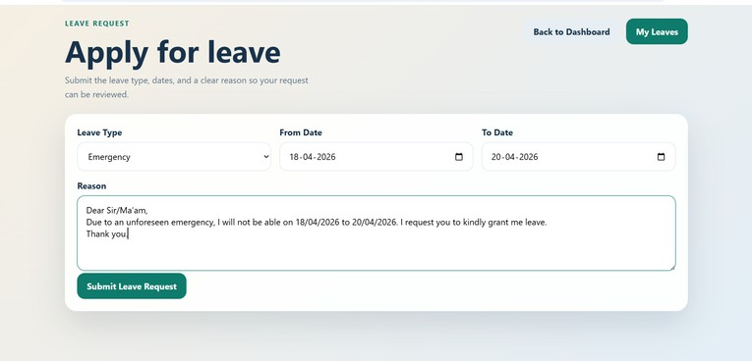

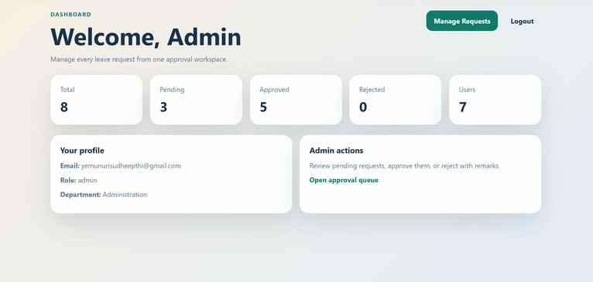

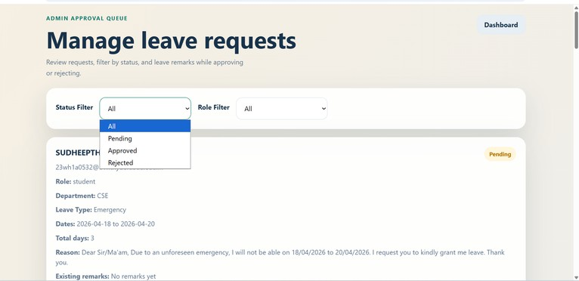

RollNo: Title:
23WH1A0532
Date:

Page No:



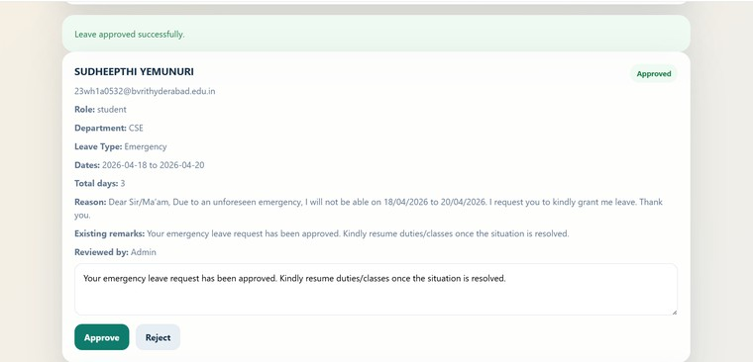

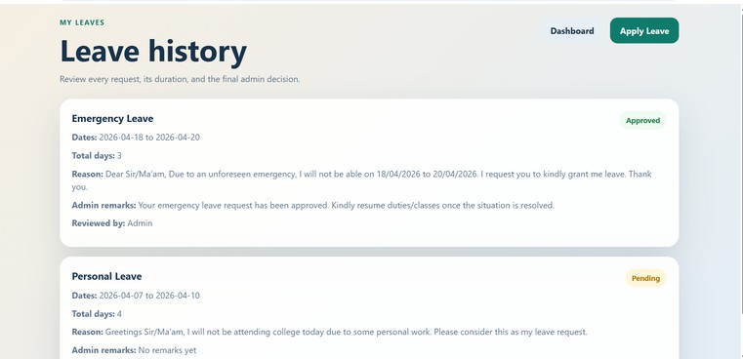

RollNo:
23WH1A0532
Date:

Title:
- Develop the EduLeave leave management system using React and Node.js.
Page No:


AIM: Develop the EduLeave leave management system using React and Node.js.

Description:
This experiment develops a leave management system using React, which directly matches the EduLeave project. Users can apply for different leave types, view leave history, and track approval status from the dashboard. The backend calculates leave duration and stores each request in MongoDB. It represents the core functionality and main objective of the entire project.

Source Code:
File: backend/src/models/Leave.js

const leaveSchema = new mongoose.Schema(
{
requestedBy: {
type: mongoose.Schema.Types.ObjectId, ref: "User",
required: true }, leaveType: { type: String,
enum: ["Sick", "Casual", "Emergency", "Duty", "Other"], required: true
},
fromDate: { type: Date, required: true
},
toDate: { type: Date,
required: true
},
totalDays: { type: Number, required: true
},
reason: { type: String,
required: true
},
status: { type: String,
enum: ["Pending", "Approved", "Rejected"],

RollNo: Title:
23WH1A0532
Date:

Page No:


default: "Pending"
}
},
{ timestamps: true }
);
File: backend/src/controllers/leaveController.js exports.applyLeave = async (req, res) => {
try {
const { leaveType, fromDate, toDate, reason } = req.body; if (!leaveType || !fromDate || !toDate || !reason) {
return res.status(400).json({ message: "All leave fields are required" });
}
const start = new Date(fromDate); const end = new Date(toDate);
if (end < start) {
return res.status(400).json({ message: "To date cannot be before from date" });
}
const leave = await Leave.create({ requestedBy: req.user._id, leaveType,
fromDate: start, toDate: end,
totalDays: calculateTotalDays(start, end), reason: reason.trim()
});
res.status(201).json(leave);
} catch (error) {
res.status(400).json({ message: error.message });
}
};
File: eduleave-frontend/src/pages/ApplyLeave.js const handleSubmit = async (e) => { e.preventDefault();
setError("");
setMessage(""); try {
await API.post("/leaves", { leaveType: formData.leaveType, fromDate: formData.fromDate, toDate: formData.toDate, reason: formData.reason
});

RollNo: Title:
23WH1A0532
Date:

Page No:


setMessage("Leave applied successfully."); setFormData({
leaveType: "Sick", fromDate: "",
toDate: "",
reason: ""
});
} catch (err) {
setError(err.response?.data?.message || "Failed to apply for leave.");
}
};

File: eduleave-frontend/src/pages/LeaveHistory.js useEffect(() => {
const loadLeaves = async () => { try {
const res = await API.get("/leaves/mine"); setLeaves(res.data);
} catch (err) {
setError(err.response?.data?.message || "Could not load leave history.");
} finally { setLoading(false);
}
};

loadLeaves();
}, [navigate]);
leaves.map((leave) => (
<div className="panel-card" key={leave._id}>
<div className="card-header">
<h3>{leave.leaveType} Leave</h3>
<span className={`status-badge status-${leave.status.toLowerCase()}`}>
{leave.status}
</span>
</div>
<p><strong>Dates:</strong> {leave.fromDate.slice(0, 10)} to {leave.toDate.slice(0, 10)}</p>
<p><strong>Total days:</strong> {leave.totalDays}</p>
<p><strong>Reason:</strong> {leave.reason}</p>
</div>
))

RollNo: Title:
23WH1A0532
Date:

Page No:


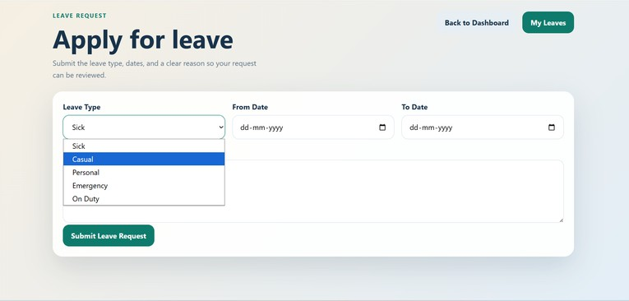
OUTPUT:

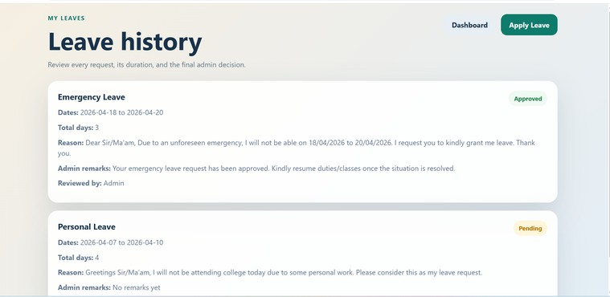

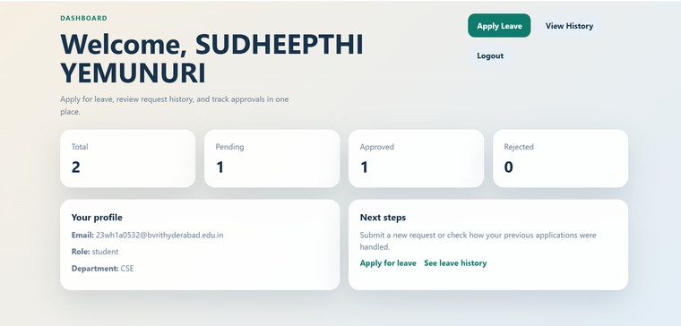

RollNo:
23WH1A0532
Date:

Title:
- Build the EduLeave React application using reusable components and routing between pages.
Page No:


AIM: Build the EduLeave React application using reusable components and routing between pages. Description: This experiment demonstrates the use of React components and routing across multiple web pages. EduLeave includes separate pages for login, signup, dashboard, leave application, history, and admin management. React Router is used to navigate between pages,
and protected routes restrict access to authorized users. It explains how component-based design and routing improve the structure of a multi-page frontend application.

Source Code:
File: eduleave-frontend/src/App.js import React from "react";
import { BrowserRouter, Route, Routes } from "react-router-dom"; import ProtectedRoute from "./components/ProtectedRoute";
import AdminLogin from "./pages/AdminLogin";
import AdminSignup from "./pages/AdminSignup"; import ApplyLeave from "./pages/ApplyLeave";
import Dashboard from "./pages/Dashboard";
import LeaveHistory from "./pages/LeaveHistory"; import Login from "./pages/Login";
import ManageLeaves from "./pages/ManageLeaves"; import ResetPassword from "./pages/ResetPassword"; import Signup from "./pages/Signup";
function App() { return (
<BrowserRouter>
<Routes>
<Route path="/" element={<Login />} />
<Route path="/signup" element={<Signup />} />
<Route path="/reset-password" element={<ResetPassword />} />
<Route path="/admin/login" element={<AdminLogin />} />
<Route path="/admin/signup" element={<AdminSignup />} />
<Route element={<ProtectedRoute allowedRoles={["student", "faculty", "admin"]} />}>
<Route path="/dashboard" element={<Dashboard />} />
</Route>
<Route element={<ProtectedRoute allowedRoles={["student", "faculty"]} />}>
<Route path="/apply" element={<ApplyLeave />} />
<Route path="/my-leaves" element={<LeaveHistory />} />
</Route>
<Route element={<ProtectedRoute allowedRoles={["admin"]} />}>
<Route path="/admin/leaves" element={<ManageLeaves />} />
</Route>
</Routes>
</BrowserRouter>

RollNo: Title:
23WH1A0532
Date:

Page No:


);
}
export default App;
File: eduleave-frontend/src/components/ProtectedRoute.js import React from "react";
import { Navigate, Outlet } from "react-router-dom"; import { getStoredUser } from "../services/auth";
function ProtectedRoute({ allowedRoles }) { const user = getStoredUser();
if (!user) {
return <Navigate to="/" replace />;
}
if (allowedRoles && !allowedRoles.includes(user.role)) { return <Navigate to="/dashboard" replace />;
}
return <Outlet />;
}
export default ProtectedRoute;
File: eduleave-frontend/src/pages/Login.js return (
<div className="auth-page">
<div className="auth-shell">
<div className="hero-panel">
<p className="auth-eyebrow">EduLeave</p>
<h1>Simplify leave requests for students, faculty, and admins.</h1>
</div>
<form className="auth-card" onSubmit={handleLogin}>
<input
type="email"
placeholder="Email Address" value={email}
onChange={(e) => setEmail(e.target.value)}
/>
<input type="password"
placeholder="Password" value={password}
onChange={(e) => setPassword(e.target.value)}
/>
{error ? <p className="form-message error">{error}</p> : null}
<button type="submit" disabled={loading}>
{loading ? "Signing in..." : "Login"}



RollNo:  Title: | 23WH1A0532 | Date:  Page No:
</button>
</form>
</div>
</div>
);
}
OUTPUT:




RollNo: Title:
23WH1A0532
Date:

Page No:







