Hierarchical GLM of prediction error
17 September 2026. All numbers and figures are produced by one script from the forecast table; the figures are in analysis/results/figures/signal_glm/.

Data
Sixteen target models, the eight of 2025-II and the eight of 2026-I, each forecast in four domains (science, math, coding, cyber) by six protocols. The protocols are the saturated-item prediction, which is the baseline and forecasts every target as the mean capability of the reference models; Length, kept as a diagnostic only; Deterministic features; Embedding; Absolute scoring; and Pairwise judge. The two judge protocols use whichever judge did best on the reference models for that task. That gives 384 rows. Each row is one squared forecast error, (true capability − forecast)². A handful of forecasts hit the true value exactly, and those errors are set to 1e-6 because a Gamma distribution cannot produce zero.
All targets are open-weights models and every transcript is full length. Closed-frontier targets and truncated transcripts are separate experiments and are not in this data. There is no frontier / non-frontier flag.
The paper reports a prediction score, 100 × (1 − error / baseline error): 0 means the protocol did no better than the baseline, 100 means a perfect forecast, and negative means worse than the baseline. Figure one of the paper pools each model's error over its four domains, computes one score per model, and tests the sixteen scores against zero with a one-sample t-test. This table is that test. Mean score is the average of the sixteen scores; p is the t-test; the median error ratio is the middle model's error divided by its baseline error; the last column is the plain mean squared error.
Protocol | Mean score | p (N = 16) | Median error ratio | Mean squared error (baseline 1.37)
Pairwise judge | 49 | 0.006 | 0.31 | 0.33
Embedding | 23 | < 0.001 | 0.75 | 1.04
Absolute scoring | 10 | 0.124 | 0.81 | 1.14
Deterministic features | 10 | 0.625 | 0.74 | 0.84
Table 1. Pairwise judge roughly halves the baseline error on average (score 49, p = 0.006) and Embedding reliably takes a quarter off it (score 23, p < 0.001). Absolute scoring and Deterministic features average about 10 but are not distinguishable from zero. Length is far below zero on average because two models have enormous errors under it; its median ratio of 0.94 shows the typical model is unaffected.

Model
The GLM fits all 384 errors at once. Each squared error is modelled as a draw from a Gamma distribution with mean μ; the Gamma's shape, which sets how noisy the errors are around their mean, is a separate number for each protocol. The log of μ for one row is a sum of five parts:
log μ = intercept + protocol effect + domain effect + protocol-in-domain effect + model-in-domain intercept (+ judge intercept)
The intercept is the baseline's log error averaged over domains. The protocol effect is the shift for that row's protocol; it is fixed at zero for the baseline, so exp(protocol effect) is the protocol's error as a ratio to the baseline's, and 100 × (1 − that ratio) is the prediction score. The domain effect is the shift for that row's domain, applying to every protocol; the four domain effects are constrained to sum to zero, so the intercept is the mean over domains and each domain effect is a departure from it, as you suggested. The protocol-in-domain effect is the extra shift for that protocol in that domain, the interaction; it is a random effect with one spread estimated per protocol, and a spread near zero means the protocol works the same everywhere. The model called m2 has this term; m1 does not.
The model-in-domain intercept is the term that accounts for the variance of the target model. Every protocol forecasts the same model in the same domain, and a model that is hard to forecast raises all six of its error rows together. Giving each of the 64 model-and-domain combinations its own random intercept carries that shared part, so the protocol effects are estimated from how the protocols differ within a model and domain, which is the same logic as pairing. I tried an intercept per model first; models vary far more between domains than between each other, so the per-model-per-domain version is the one used. Its estimated standard deviation is about 1.0 on the log scale, a factor of 2.7 in error, which is larger than any protocol's effect. There is no period term, since each target belongs to one period.
The judge intercept is fixed at zero in the reported fit, which uses one judge per task and so has nothing to vary. In a fit with all judges it is free, comes out with a standard deviation of 0.39, and gives the same picture. Priors are wide: Normal(0, 2) on the intercept, Normal(0, 1) on the protocol and domain effects, HalfNormal(0.5) on the protocol-in-domain and judge spreads, HalfNormal(1) on the model-in-domain spread, Exponential(1) on the shapes. The fit is by NUTS through hibayes, four chains with 1000 warmup and 2000 kept draws each, target_accept 0.95. As a cross-check, the same Gamma regression fitted by maximum likelihood with a fixed intercept for every model and domain gives the same estimates.

Results
This table converts the GLM's protocol effects to prediction scores, 100 × (1 − exp(effect)), so it reads the same way as the t-test table: above 0 beats the baseline. Each entry is the posterior median with the 95% interval in brackets. The pooled column is the protocol effect on its own, which is what the model predicts for a domain it has not seen; the next column is the average of the four domains it has seen. The last column is the estimated spread of the protocol's effect across domains, on the log scale.
Protocol | Science | Math | Coding | Cyber | Pooled (new domain) | Mean of 4 domains | Spread across domains
Pairwise judge | 15 (-92, 57) | 17 (-89, 57) | 80 (39, 92) | 72 (28, 88) | 51 (-13, 77) | 42 (2, 63) | 0.71 (0.20, 1.31)
Embedding | 28 (3, 47) | 33 (13, 52) | 29 (7, 47) | 21 (-14, 39) | 28 (1, 47) | 27 (11, 40) | 0.15 (0.01, 0.59)
Absolute scoring | 31 (2, 57) | 23 (-7, 46) | 17 (-22, 40) | 17 (-24, 40) | 22 (-13, 46) | 21 (0, 38) | 0.18 (0.01, 0.70)
Deterministic features | -2 (-84, 38) | 3 (-64, 39) | 1 (-96, 43) | 3 (-67, 40) | 2 (-66, 37) | 0 (−59, 32) | 0.17 (0.01, 0.68)
Table 2. Pairwise judge scores about 80 in coding and 72 in cyber with intervals well clear of zero, and about 15 in science and math with intervals that include zero; its spread across domains, 0.71, is the largest of any protocol. Embedding scores 21 to 33 in every domain with a spread of 0.15: a small gain that is the same everywhere. Absolute scoring is similar in size but three of its four intervals include zero. Deterministic features is at zero. Note that a Gamma GLM estimates the mean error, which a few very large errors dominate; Deterministic features scores 2 here although its median error ratio in the first table is 0.74. For it the mean and the median disagree, and I would not attach a p-value.
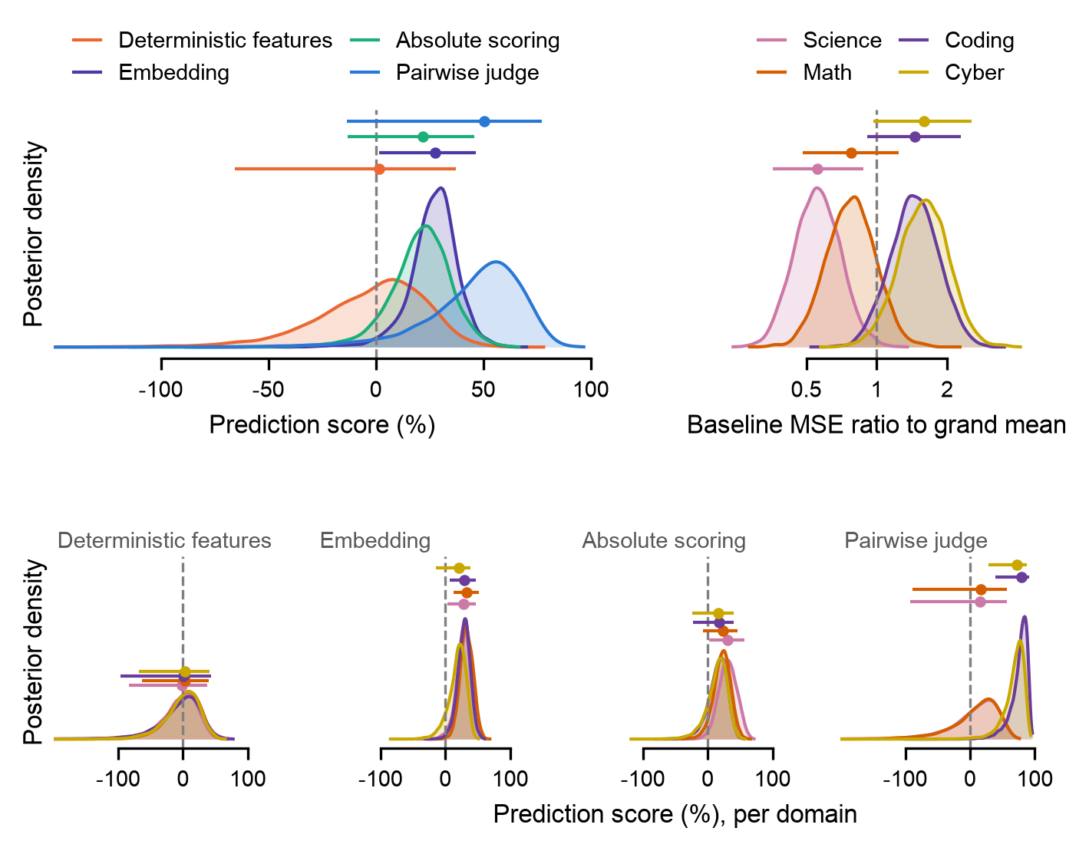
Figure 1. The same estimates as full posterior distributions. Each curve is the posterior density of one parameter, with unit area on the plotted axis, so a taller, narrower curve is a more precisely estimated parameter; the horizontal bar above it marks the median and 95% interval. Top left: each protocol's pooled effect on the prediction-score scale, above zero meaning better than the baseline. Top right: the domain effects, shown as the baseline's error in each domain relative to the average domain (a ratio, not a score); science is the easiest domain to forecast and cyber the hardest. Bottom row: each protocol's effect in each domain, one panel per protocol and one colour per domain. Where the four coloured curves in a panel lie on top of each other, the protocol works the same in every domain; where they separate, its effect depends on the domain. Pairwise judge is the only panel where they separate: coding and cyber sit around 80 and science and math around 15 with tails through zero. Embedding's four curves coincide around 28. Absolute scoring's coincide around 22 with tails reaching zero. Deterministic features is centred on zero.
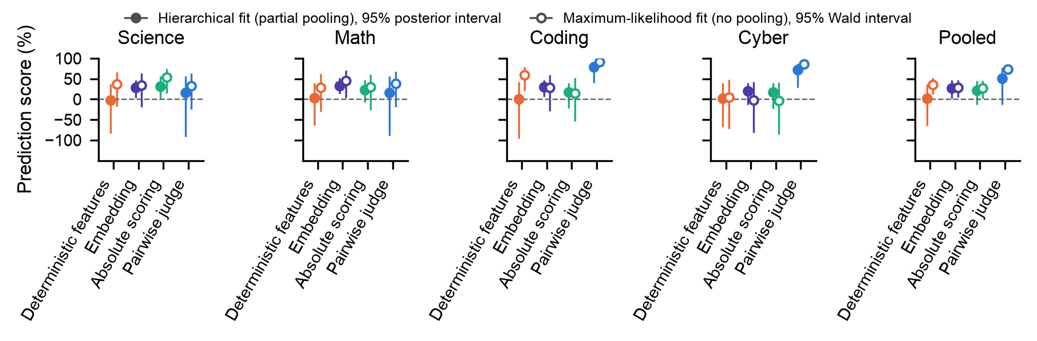
Figure 2. The same estimates once more, on the prediction-score scale (100 × (1 − error ratio to the baseline); above 0 is better), with the classical cross-check added. One panel per domain plus a pooled panel; one marker per protocol. Filled markers, as the legend says, are the hierarchical fit's median and 95% interval; open markers are the same regression fitted by maximum likelihood with a fixed intercept per model and domain and no pooling, with its 95% Wald interval. The two agree everywhere, so partial pooling has not moved any estimate. The intervals are longer downward than upward because the score is bounded at 100 above and unbounded below: a ratio of 0.5 is a score of 50 but a ratio of 2 is a score of −100. Pairwise judge's pooled interval is the wide one because the pooled effect is a prediction for a new domain and inherits the spread across domains. The same figure on the error-ratio scale, where a halving and a doubling are the same distance from the line, is ratios.png.
Whether Pairwise judge is better than another protocol is a question about the difference between two effects, and the two intervals overlapping or not does not answer it, because the effects are correlated through the shared model-in-domain intercepts. The contrasts below are computed draw by draw: for each posterior draw, Pairwise judge's error divided by the other protocol's. The table gives the median ratio, the 95% interval, and P, the fraction of draws in which the ratio is below 1, which is the posterior probability that Pairwise judge is the better of the two.
Other protocol | Science | Math | Coding | Cyber | Pooled
Embedding | 1.18 (0.58, 2.68); P = 0.33 | 1.26 (0.63, 2.92); P = 0.26 | 0.29 (0.12, 0.90); P = 0.98 | 0.34 (0.15, 0.92); P = 0.98 | 0.69 (0.30, 1.63); P = 0.82
Absolute scoring | 1.25 (0.60, 3.00); P = 0.29 | 1.09 (0.53, 2.57); P = 0.41 | 0.24 (0.10, 0.76); P = 0.99 | 0.33 (0.14, 0.88); P = 0.99 | 0.63 (0.28, 1.54); P = 0.86
Deterministic features | 0.83 (0.37, 1.98); P = 0.67 | 0.86 (0.38, 2.19); P = 0.63 | 0.21 (0.07, 0.68); P = 1.00 | 0.28 (0.11, 0.79); P = 0.99 | 0.50 (0.21, 1.24); P = 0.94
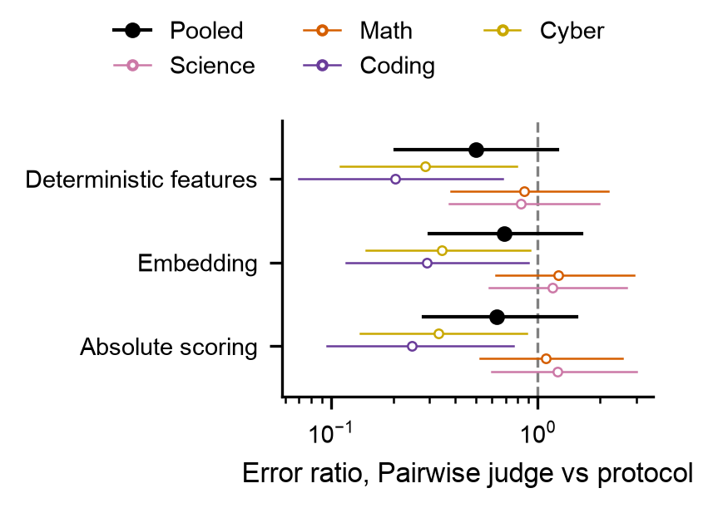
Figure 3. The contrasts as a figure: one row per other protocol, the ratio of Pairwise judge's error to that protocol's on a log axis, coloured markers per domain and black for pooled, bars for the 95% interval, dashed line at 1. In coding and cyber every contrast is well below 1, with 98 to 100% of the posterior on that side: Pairwise judge has a fifth to a third of the error of any other protocol there. In science and math every contrast straddles 1, so the protocols cannot be told apart. Pooled, 82 to 94% of the posterior favours Pairwise judge.
Whether the protocol-in-domain term is needed at all is a model comparison. m1 leaves it out, so every protocol has the same effect in every domain; m2 keeps it. The comparison is by leave-one-out cross-validation: for each of the 384 observations, how probable does the model find that observation when fitted without it, summed over all observations as a log score (elpd). Higher is better, and only the difference between the two models means anything. The difference has a standard error because it is a sum of 384 per-observation differences. The stacking weight is the proportion in which the two models' predictions would be blended to predict best, and p_loo is the number of parameters the model is effectively using.
Model | elpd | SE | Difference | SE of difference | p_loo | Stacking weight
m2 protocol x domain | -203.4 | 33.2 | 0.0 | 0.0 | 72.3 | 0.86
m1 protocol + domain | -207.6 | 33.3 | 4.2 | 3.4 | 65.0 | 0.14
Table 3. m2 is ahead by 4.2 with a standard error of 3.4, a little over one standard error, and takes 0.86 of the stacking weight. That is weak evidence that protocols behave differently across domains, and the posteriors above show that the difference comes from Pairwise judge alone. On the eight 2026-I targets by themselves the difference is 15.4 with a standard error of 4.2, which is clear. Both comparisons carry a warning from the Pareto-k diagnostic, explained under the next figure.

Fit and convergence
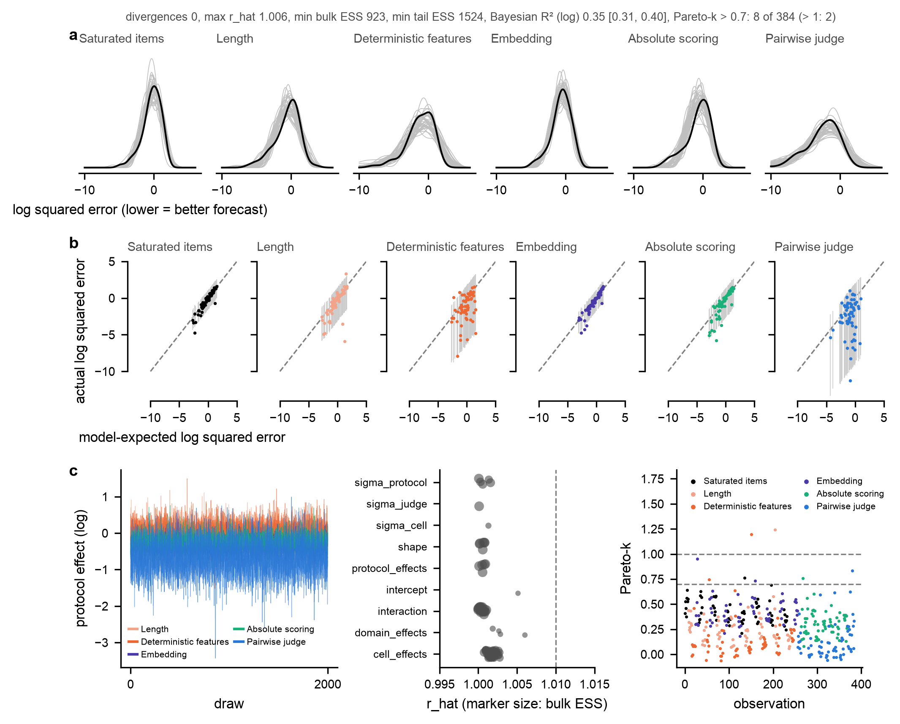
Figure 4. Three checks on the reported model, m2. Row a is the posterior predictive check. For each protocol, the black curve is the distribution of the 64 observed log squared errors (lower is better on this axis), and each grey curve is the same distribution in one of forty datasets simulated from the fitted model. If the model could not produce data like ours, the black curve would fall outside the grey bundle. It is inside for all six protocols, including the long lower tail of Pairwise judge where its near-perfect forecasts sit, so the Gamma model with one shape per protocol reproduces the data.
Figure 4, continued. Row b plots each observation individually. Both axes are log squared error, so unlike the prediction score, lower is better: a point at −10 is a near-perfect forecast and a point at +2 is a bad miss. Horizontal position is the error the model expects for that row, the posterior median of log μ; vertical position is the log error actually observed; the grey bar through each point is the model's 95% predictive interval for it; the dashed line is where expected equals observed. Points along the line mean the expectations are right on average, and if the model's uncertainty is calibrated about 95% of points should fall inside their bars. They follow the line and 94 to 97% are inside, per protocol, so the intervals the model reports can be believed. Pairwise judge forms a vertical stripe: the model expects roughly the same error for every one of its rows while the observed errors run from near zero to large. That is a property of the protocol, whose forecasts are excellent for most models and poor for a few, and the model-in-domain intercepts, shared with the other protocols, cannot say which. Its wide bars and its small Gamma shape (0.40) are the model absorbing that. Its pooled score of about 50 should be read as an average of very good and occasionally bad.
Figure 4, continued. Row c is the sampler diagnostics. Left: each protocol effect's draws against step number, the four chains drawn on top of each other. When the sampler has converged, each trace is a flat fuzzy band and the four chains coincide; a drift, or one chain at a different level, would mean it had not. These are flat and coincide. Middle: r_hat for every parameter, grouped by family, with the marker size showing the effective sample size; r_hat compares the variance between chains with the variance within them and is 1.00 when the chains agree, and the dashed line at 1.01 is the accepted limit. Everything is below it, the largest being 1.006, and every effective sample size is above 900 (of 8000 draws). Right: Pareto-k for each of the 384 observations, coloured by protocol, with dashed lines at 0.7 and 1. Leave-one-out is computed by reweighting the existing draws rather than refitting 384 times, and Pareto-k says whether that reweighting was reliable for a given observation; above 0.7 it was not, above 1 it failed. Eight observations are above 0.7 and two above 1. They are the forecasts that hit the true value exactly and were floored at 1e-6, which are extremely influential by construction. The leave-one-out totals therefore carry a warning. The m1-to-m2 difference is less affected, since the same rows are flagged under both, but the proper check is a refit without those rows, which I have not done yet.
Quantity | m2 (reported) | m1 (no protocol-in-domain term)
Divergences | 0.0000 | 0.0000
Largest r_hat | 1.006 | 1.004
Smallest effective sample size, bulk / tail | 923 / 1524 | 1224 / 2450
Observations with Pareto-k > 0.7 (> 1) | 8 (2.0000) of 384 | 6 (2.0000) of 384
Bayesian R² on the log scale | 0.35 (0.31, 0.40) | 0.32 (0.28, 0.36)
95% predictive coverage, per protocol | 0.97, 0.95, 0.94, 0.95, 0.97, 0.97
Table 4. The same diagnostics as numbers, for both models. Divergences are sampler steps that failed numerically and would indicate an unexplored region of the posterior; there are none. R² is the share of the variance in log error that the model's expected values account for; 0.35 is modest, but most of the remainder is the row-to-row noise a Gamma expects, and the model's purpose is the protocol effects rather than predicting individual errors.

Your points
The variance of the target model is in, as the model-in-domain intercept. Domains are sum-to-zero coded. The m1 against m2 comparison by LOO is done and gives a weak preference for m2. The contrasts against Pairwise judge are done. The posterior predictive plot and the fit and convergence numbers are above.
Frontier against non-frontier targets: there is no such flag in the data. The only frontier notion anywhere in the project is the top three targets per task by true capability. If that is an acceptable definition I will add it as m3; otherwise I would like your view on what should count as frontier. Open against closed, and truncated against full: confirmed, neither is in this data.
One question. The pooled protocol effect is the model's prediction for a new domain, so its interval includes the spread across domains: Pairwise judge 51 with an interval from −13 to 77. The mean of the four fitted domains is tighter, 42 from 2 to 63. Which should the pooled panel of the figure show?

