Supplementary methods and results: the signal GLM
Hierarchical Gamma GLM of prediction error over protocols and domains. State as of 17 September 2026. Every number is regenerated by scripts/analyses/signal_glm.py from analysis/results/forecasts.csv.

1. Summary
- Question. Do transcripts from saturated benchmark items carry capability signal beyond accuracy, and which protocols recover it, in which domains?
- Main test (figure one). One-sample t-test of per-model prediction scores against 0, N = 16 target models. Pairwise judge: mean score 49, p = 0.006. Embedding: 23, p < 0.001. Absolute scoring and Deterministic features: about 10, not significant.
- Hierarchical GLM. Pairwise judge's gain is concentrated in the agentic domains: coding 80 (39, 92), cyber 72 (28, 88); science and math about 15 with intervals crossing 0. Embedding is a small, uniform gain (21 to 33 in every domain). Domain dependence is supported weakly by leave-one-out model comparison (m2 ahead by 4.2 elpd, SE 3.4).
- Fit. 0 divergences, r_hat ≤ 1.006, bulk ESS ≥ 923, 8 of 384 rows with Pareto-k > 0.7, Bayesian R² on the log scale 0.35, 95% predictive coverage 0.94 to 0.97 per protocol.

2. Data
- 16 target models: the 8 targets of 2025-II and the 8 of 2026-I, the two semesters every domain has. Each is forecast in all four domains (science, math, coding, cyber): 64 (target model, domain) cells.
- 6 protocols, one variant each: the saturated-item prediction (baseline; the references' mean θ*), Length (3 length features, diagnostic only), Deterministic features (length + 9 lexical rates + log tool-call count), Embedding, Absolute scoring, Pairwise judge. Judge protocols use the best judge on references per task. 384 rows in total.
- All targets are open-weights and every transcript is full length. Closed-frontier targets and truncated transcripts are separate challenges and are not in this data. There is no frontier / non-frontier flag in the data.
- Outcome per row: the squared forecast error (θ* − θ̂)². Exact hits are floored at 1e-6 so the Gamma likelihood is defined.

3. Prediction score and the figure-one test
Per target model i and protocol P:
score(P, i) = 100 · (1 − error(P, i) / baseline error(i)), error = (θ* − θ̂)²
0 is indistinguishable from the baseline, 100 is a perfect prediction, and negative values are worse than the baseline (the score is unbounded below, so a single badly missed model can pull a mean far down). Figure one averages each model's squared error over its four domains before taking the score, giving one score per model per protocol, and tests the 16 scores against 0 with a one-sample t-test. The 95% t-interval of the mean drawn in the figure is the same test in interval form.
Protocol | Mean score | p (t-test, N = 16) | Median error ratio | Pooled MSE (baseline 1.37)
Pairwise judge | 49 | 0.006 | 0.31 | 0.33
Embedding | 23 | < 0.001 | 0.75 | 1.04
Absolute scoring | 10 | 0.124 | 0.81 | 1.14
Deterministic features | 10 | 0.625 | 0.74 | 0.84
Length (diagnostic only) | -228 | 0.334 | 0.94 | 1.66

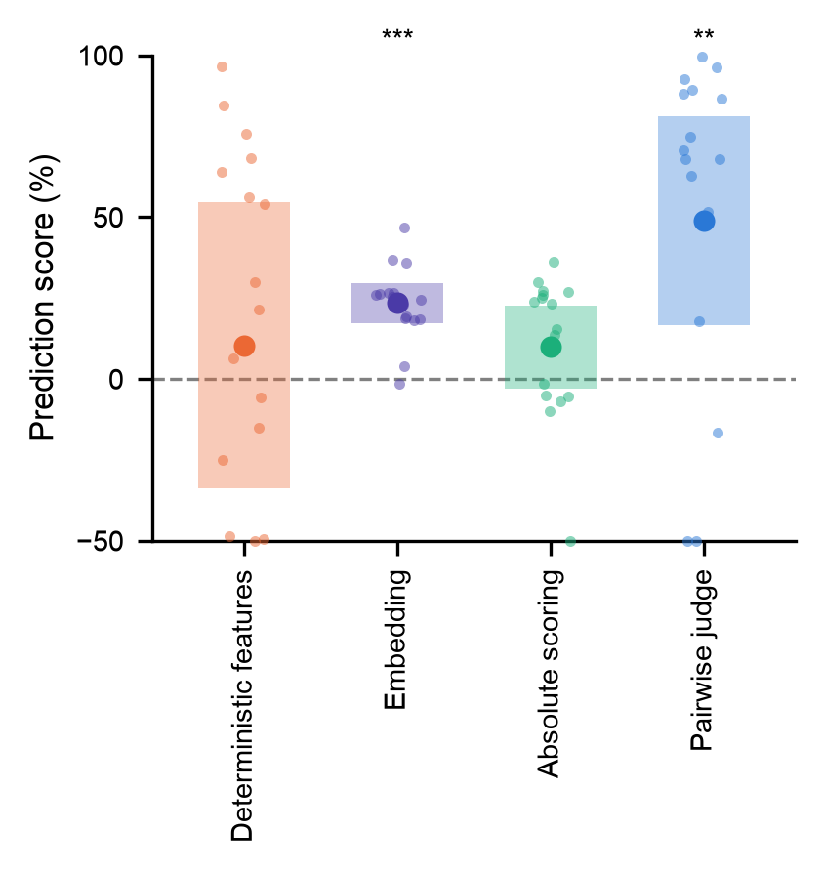
Figure one (paper: fig2_signal_box). Mean prediction score (filled circle), 95% t-interval (box), one point per target model; points below −50 are drawn at the axis edge. **: p < 0.01, ***: p < 0.001.
Note on the test. Until 17 September the test was a Wilcoxon signed-rank test on the same 16 differences (Pairwise judge p = 0.0008, Absolute scoring p = 0.044). The t-test on scores is the paper's test; it is sensitive to the unbounded lower tail, which is why Absolute scoring (p = 0.12) has no star under it. Holm correction over the four paper protocols keeps Embedding and Pairwise judge.
Robustness. 2026-I alone (N = 8): Pairwise judge 51, p = 0.004; Embedding 24, p = < 0.001; Absolute scoring 7, p = 0.242. No self-judging (each target judged by the best judge from another developer family): Pairwise judge 47, p = 0.006; Absolute scoring 12, p = 0.095.

4. The hierarchical GLM
The figure-one test pools domains and asks only whether a protocol beats the baseline. The GLM keeps every (model, domain) squared error as its own observation and estimates, jointly, how much each protocol changes the error, whether that differs by domain, and how far the answer depends on which model or judge produced it. It is fitted with hibayes (numpyro, NUTS) as model m2, and again without the protocol-by-domain term as model m1 for comparison.
error ~ Gamma(shape[protocol], shape[protocol] / μ)
log μ = intercept + protocol[p] + domain[d] + (protocol | domain)[p, d] + (1 | model × domain)[c] + (1 | judge within protocol)[j]

4.1 What the words mean
Fixed effect. A quantity estimated on its own, one number per level, with nothing tying the levels together. The protocol effects are fixed: we want each protocol's own value and there are only five, so there is nothing to borrow strength from. "Main effect" is the same idea applied to a single factor on its own, before any interaction: the protocol main effect is a protocol's average change in error over all domains.
Random effect. A set of levels treated as draws from a common distribution whose spread is estimated from the data. Writing (1 | model × domain) says: each of the 64 (model, domain) cells has its own intercept, but the 64 intercepts are assumed to scatter around zero with some standard deviation σ_cell that the model learns. Levels with little data are pulled toward the group mean ("partial pooling", "shrinkage"); levels with lots of data keep their own value. We use random effects for the things we do not care about individually but must account for: which model, which judge.
Interaction, (protocol | domain). An extra term per (protocol, domain) pair that lets a protocol's effect differ by domain. Written as a random slope, each protocol's four domain deviations are draws from a distribution with its own spread σ_protocol[p]. A spread near 0 means the protocol works the same everywhere; a large spread means it is domain dependent. This spread is the "how domain-dependent is this protocol" number.
Reference level and sum-to-zero coding. A factor with k levels can only carry k − 1 free numbers. For protocol, the baseline's coefficient is pinned to 0 (the reference level), so every other coefficient is "relative to the saturated-item prediction", which is exactly what we want to read. For domain, the four effects are constrained to sum to zero instead, so the intercept is the grand mean over domains and each domain effect is a departure from that mean, rather than science being the reference.
Gamma family, log link. Squared errors are positive and right-skewed over orders of magnitude. The Gamma family assumes the noise grows with the mean, so one huge error does not dominate as it would under a normal model. The log link means effects add on the log scale and multiply the mean: exp(protocol[p]) is the ratio of that protocol's expected error to the baseline's, and 100 · (1 − ratio) puts it on the prediction-score scale. One Gamma shape per protocol lets a protocol with small consistent gains (Embedding) and one with erratic large gains (Pairwise judge) have different noise.

4.2 The terms in this model
Term | Type | What it does | Why it is there
intercept | fixed | Baseline's log error at the grand mean over domains | Anchor
protocol[p] | fixed, reference = baseline | Protocol's log error ratio to the baseline, pooled over domains | The estimand: exp() is the error ratio, 100·(1−ratio) the score
domain[d] | fixed, sum-to-zero | How the baseline's error differs by domain | Baseline error differs several-fold between domains
(protocol | domain)[p, d] | random slope, one spread per protocol | Protocol's departure from its pooled effect in domain d | "Is the gain domain dependent?"; dropped in m1
(1 | model × domain)[c] | random intercept, 64 levels, SD ≈ 1.0 | How hard this target is to forecast in this domain, shared by every protocol's row for that cell | Pairing. Every protocol forecasts the same target in the same domain; without it, the models' very different error levels swamp the protocol effect (the first version of this model, without it, found nothing). Covers the mentor's "variance of target model"; semester is absorbed because each target sits in one semester
(1 | judge within protocol)[j] | random intercept, SD 0.39 | Which judge produced the forecast | Pinned to 0 in the best-judge table (one judge per task); free in the all-judges fit
shape[p] | one per protocol | Gamma noise level per protocol | 0.40 (Pairwise judge) to 3.8 (baseline)

Priors and sampling. Intercept Normal(0, 2); protocol and domain effects Normal(0, 1) on the log scale (ratio between 0.14 and 7 with 95% prior probability); σ_protocol and σ_judge HalfNormal(0.5); σ_cell HalfNormal(1); shapes Exponential(1). Random effects are non-centred. 4 chains × 2000 draws after 1000 warmup, target_accept 0.95, seed 0. A prior predictive check confirms the priors cover the data's range.
Flat cross-check. A statsmodels Gamma GLM (log link) with protocol × domain and a fixed intercept per cell, fitted by Newton (IRLS overflows on the 64 cell dummies). Its Wald intervals are the open markers in the ratio figure; they agree with the hierarchical fit and are wider where pooling helps.

5. Results

5.1 Prediction score by protocol and domain
Posterior median and 95% credible interval of 100 · (1 − error ratio to baseline). Above 0 beats the baseline. The pooled column is exp(protocol[p]), the effect expected in a new domain, whose interval includes the across-domain spread. "Mean of domains" is the mean of the four fitted domains' ratios, which is what the text refers to and is tighter.
Protocol | Science | Math | Coding | Cyber | Pooled (new domain) | Mean of 4 domains | σ across domains
Pairwise judge | 15 (-92, 57) | 17 (-89, 57) | 80 (39, 92) | 72 (28, 88) | 51 (-13, 77) | 42 (2, 63) | 0.71 (0.20, 1.31)
Embedding | 28 (3, 47) | 33 (13, 52) | 29 (7, 47) | 21 (-14, 39) | 28 (1, 47) | 27 (11, 40) | 0.15 (0.01, 0.59)
Absolute scoring | 31 (2, 57) | 23 (-7, 46) | 17 (-22, 40) | 17 (-24, 40) | 22 (-13, 46) | 21 (0, 38) | 0.18 (0.01, 0.70)
Deterministic features | -2 (-84, 38) | 3 (-64, 39) | 1 (-96, 43) | 3 (-67, 40) | 2 (-66, 37) | 0 (−59, 32) | 0.17 (0.01, 0.68)
Length (diagnostic only) | 14 (-30, 47) | 13 (-31, 46) | -10 (-75, 24) | -24 (-129, 19) | -1 (-58, 36) | −4 (−41, 21) | 0.30 (0.02, 0.82)

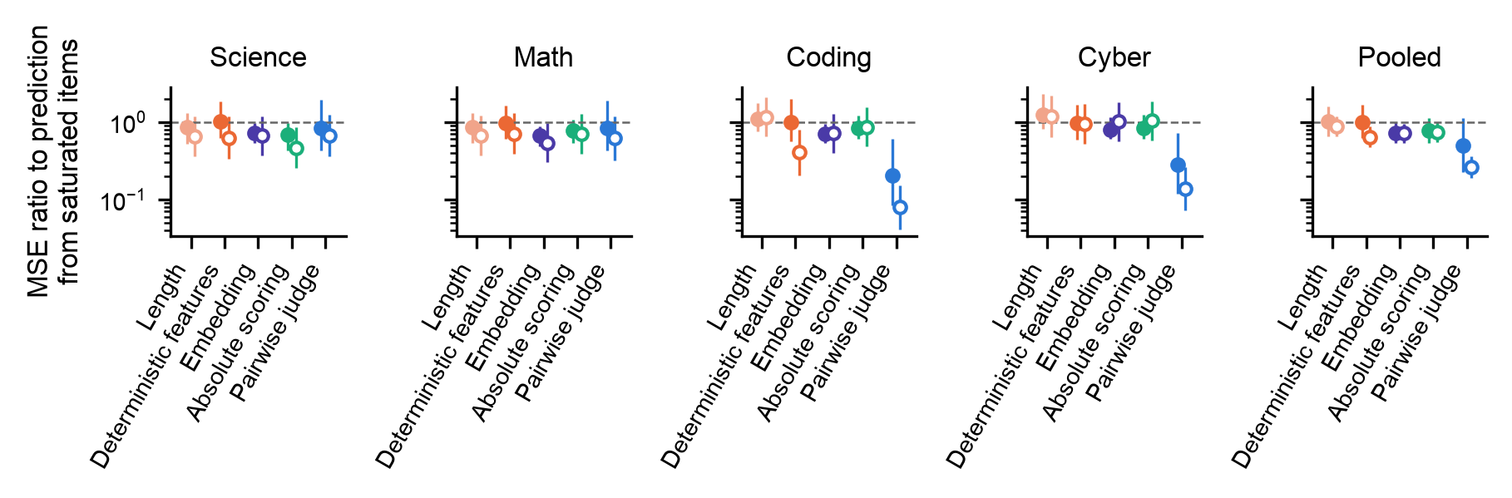
Error ratio to the saturated-item prediction (log axis), one panel per domain plus pooled. Filled: hierarchical posterior median and 95% interval; open: flat GLM Wald interval. Below 1 beats the baseline.
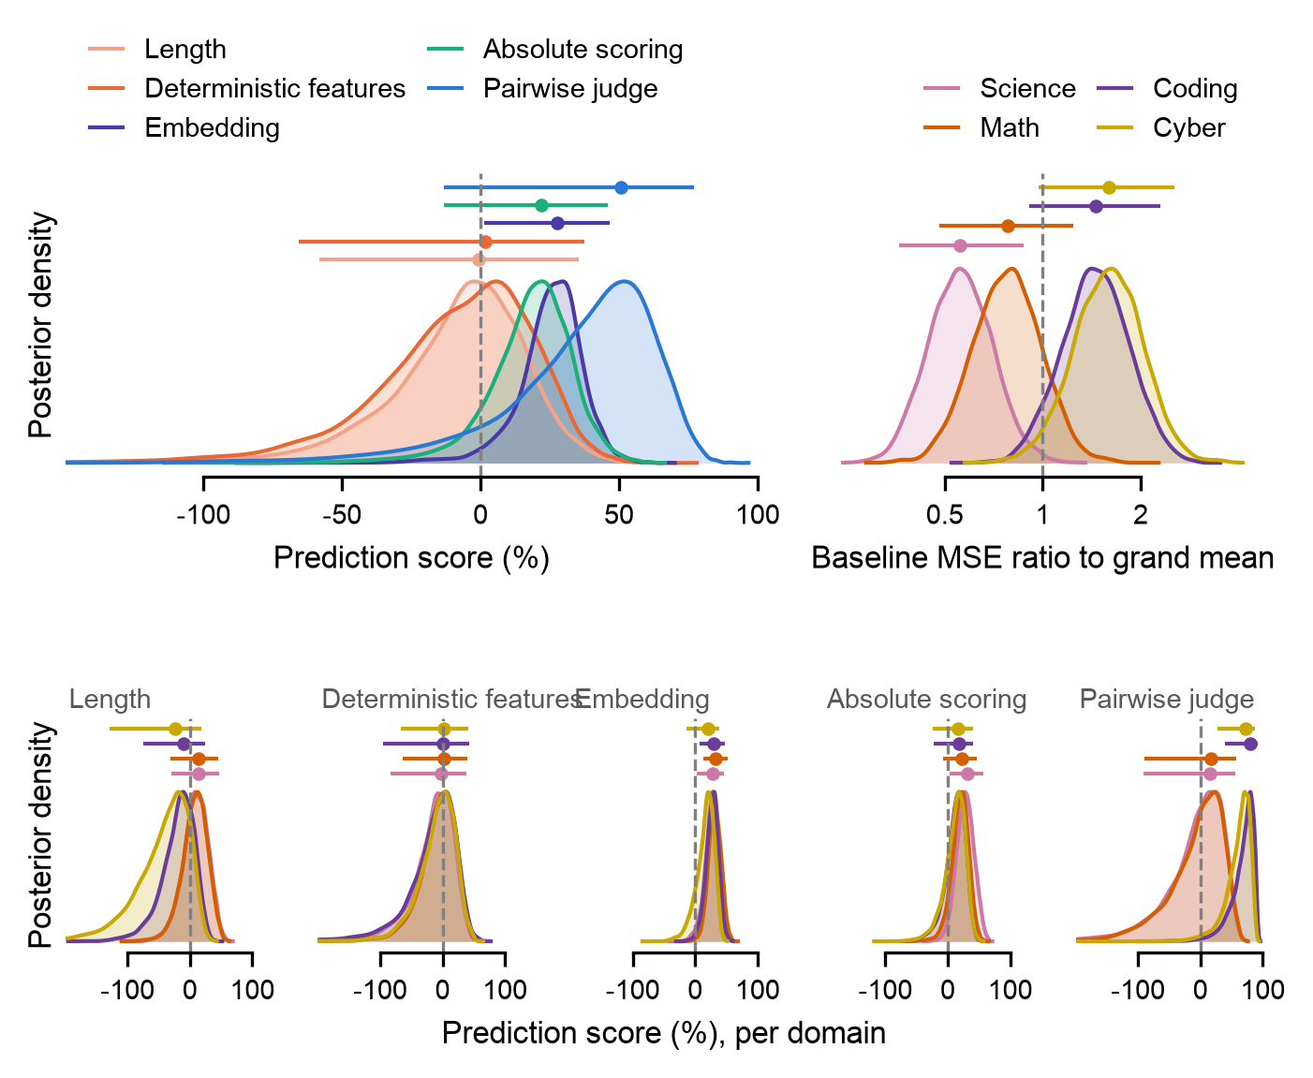
Posterior densities on the prediction-score scale (100 · (1 − error ratio); above 0 beats the baseline): the pooled protocol effects (top left), the baseline's error by domain relative to the grand mean (top right, a ratio), and each protocol's effect per domain (bottom). Bars: median and 95% interval. The same figure on the error-ratio scale is posteriors.png.
Reading. Pairwise judge is far better than the baseline in coding and cyber and indistinguishable from it in science and math; its spread across domains (σ = 0.71) is the largest of any protocol. Embedding is a small gain of similar size in every domain (σ = 0.15). Absolute scoring is a similar small gain whose intervals cross 0 in three domains. Deterministic features and Length sit at the baseline under this model.
Estimand caveat. A Gamma GLM with a log link still estimates the arithmetic mean within a group; Gamma only changes the noise assumption. With cell intercepts the protocol effect is close to the mean of per-cell error ratios, which a few blow-ups dominate for the heavy-tailed protocols. Deterministic features scores 2 here but its median error ratio is 0.74 (a rank test would give it 26); Length scores −1 against a median ratio of 0.94. For these two the conclusion depends on mean versus rank, so the paper should not put a p-value on either.

5.2 Contrasts: Pairwise judge against each other protocol
Posterior of the error ratio Pairwise judge / other protocol, per domain and pooled, with the posterior probability that it is below 1 (Pairwise judge better). Contrasts are read directly from the joint posterior, so they are tighter than comparing two marginal intervals.
Other protocol | Science | Math | Coding | Cyber | Pooled
Embedding | 1.18 (0.58, 2.68); P<1 = 0.33 | 1.26 (0.63, 2.92); P<1 = 0.26 | 0.29 (0.12, 0.90); P<1 = 0.98 | 0.34 (0.15, 0.92); P<1 = 0.98 | 0.69 (0.30, 1.63); P<1 = 0.82
Absolute scoring | 1.25 (0.60, 3.00); P<1 = 0.29 | 1.09 (0.53, 2.57); P<1 = 0.41 | 0.24 (0.10, 0.76); P<1 = 0.99 | 0.33 (0.14, 0.88); P<1 = 0.99 | 0.63 (0.28, 1.54); P<1 = 0.86
Deterministic features | 0.83 (0.37, 1.98); P<1 = 0.67 | 0.86 (0.38, 2.19); P<1 = 0.63 | 0.21 (0.07, 0.68); P<1 = 1.00 | 0.28 (0.11, 0.79); P<1 = 0.99 | 0.50 (0.21, 1.24); P<1 = 0.94
Length (diagnostic only) | 1.00 (0.45, 2.46); P<1 = 0.50 | 0.98 (0.45, 2.37); P<1 = 0.52 | 0.18 (0.07, 0.57); P<1 = 1.00 | 0.22 (0.09, 0.58); P<1 = 1.00 | 0.49 (0.20, 1.25); P<1 = 0.94

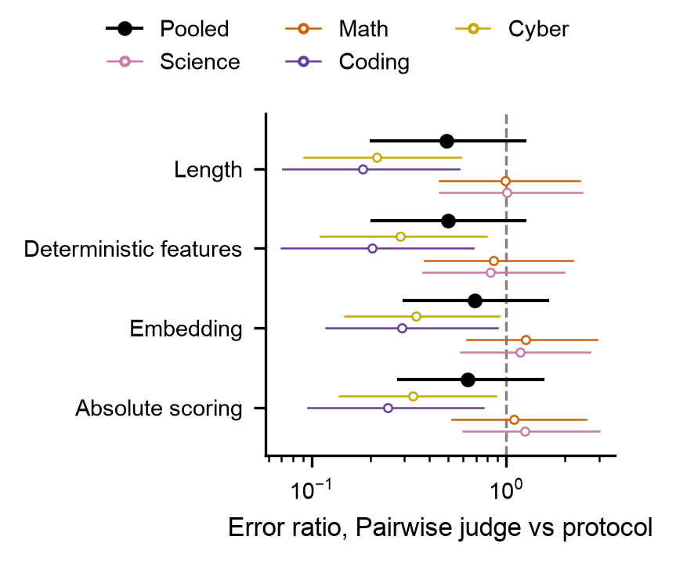
Contrast figure: ratio of Pairwise judge's error to each other protocol's, per domain (coloured) and pooled (black).
In coding and cyber, Pairwise judge has 98 to 100% posterior mass below every other protocol, at a fifth to a third of their error. In science and math the contrasts straddle 1. Pooled, 82 to 94% of the mass favours Pairwise judge.

5.3 Is the domain dependence real? Leave-one-out model comparison
m1 drops the (protocol | domain) term, so every protocol's effect is the same in every domain; m2 keeps it. Leave-one-out cross-validation (PSIS-LOO) estimates each model's expected log predictive density (elpd) for a new observation: higher is better, and the difference's standard error says how sure the ranking is. Stacking weights are the mix of the two models that would predict best.
Model | elpd_loo | SE | Δ elpd | SE of Δ | p_loo | weight
m2 protocol x domain | -203.4 | 33.2 | 0.0 | 0.0 | 72.3 | 0.86
m1 protocol + domain | -207.6 | 33.3 | 4.2 | 3.4 | 65.0 | 0.14

m2 is ahead by 4.2 with a standard error of 3.4: weak evidence that protocols' gains differ by domain on the 16 targets, driven by Pairwise judge. On 2026-I alone the same comparison is 15.4 (SE 4.2). Both LOO runs carry arviz's warning for the rows with bad Pareto-k (below).

6. Fit and convergence
Quantity | m2 (protocol × domain) | m1 (additive) | What it means
Divergences | 0.0000 | 0.0000 | Sampler transitions that broke; any nonzero count means a region of the posterior was not explored
max r_hat | 1.0060 | 1.0044 | Agreement between chains; ≤ 1.01 means they converged to the same distribution (pinned reference levels have no r_hat and are excluded)
min bulk ESS | 923 | 1224 | Effective independent draws for the centre of each posterior; ≥ 400 is comfortable
min tail ESS | 1524 | 2450 | The same for the 5% and 95% quantiles
Pareto-k > 0.7 / > 1 | 6.0000 / 2.0000 of 384 | 4.0000 / 2.0000 of 384 | Rows whose leave-one-out estimate is unreliable; these are the near-zero (floored) errors, which are influential by construction
Bayesian R² (log scale) | 0.35 (0.31, 0.40) | 0.32 (0.28, 0.36) | Share of the variance of log error explained by the linear predictor, var(log μ) / (var(log μ) + residual)

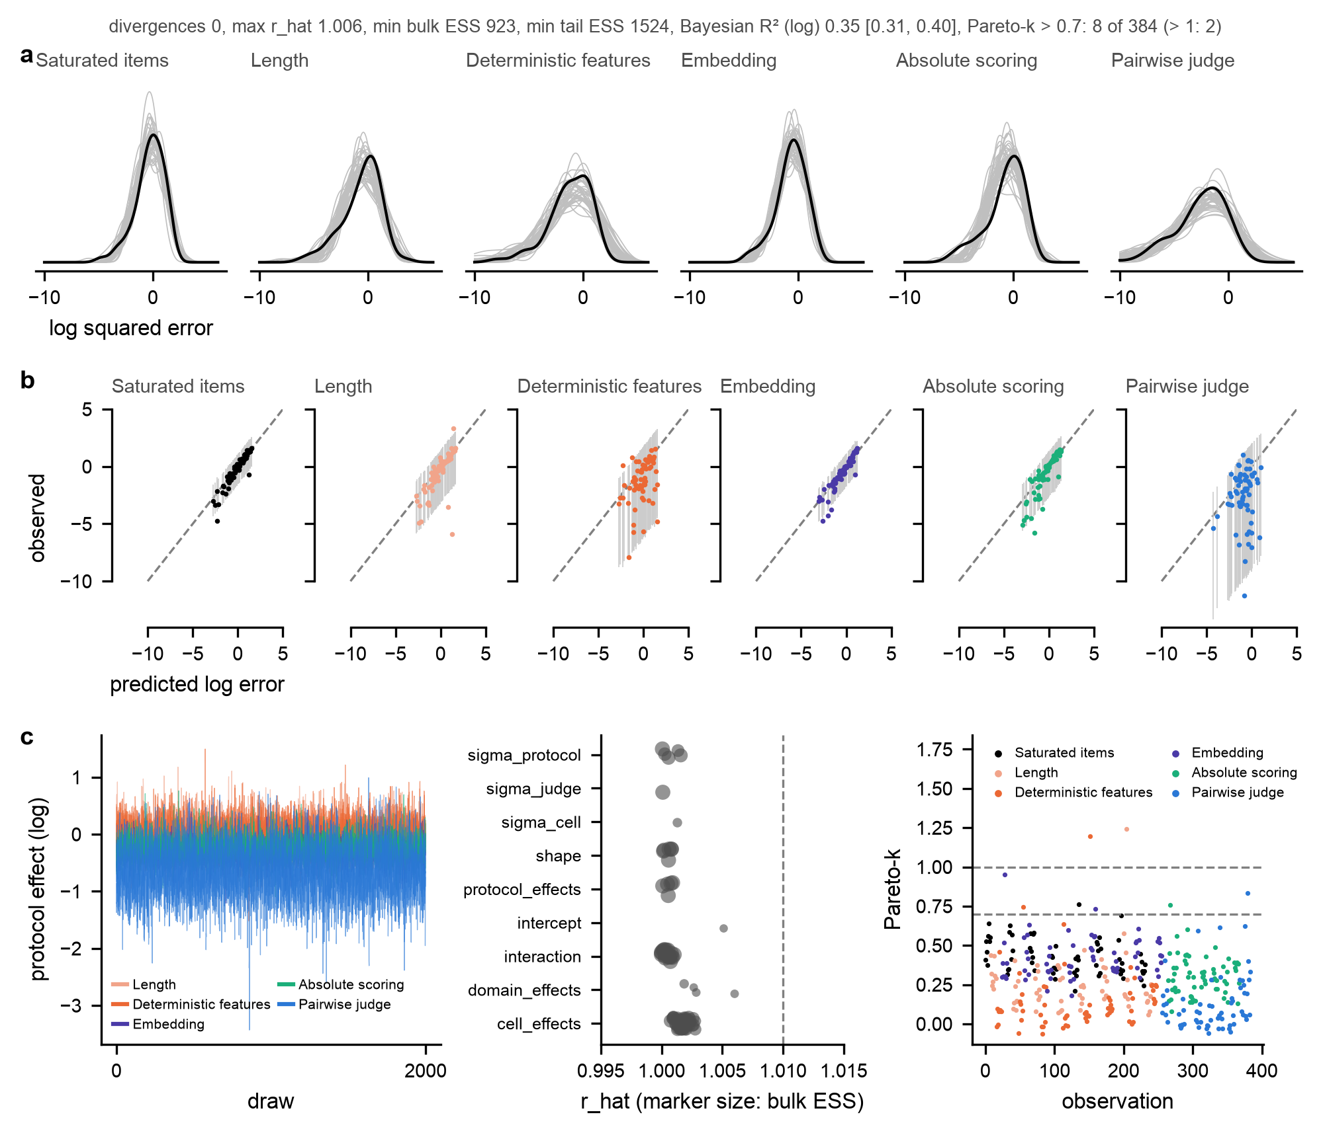
Fit and convergence, m2 (fit_quality.png). (a) Posterior predictive check: observed density of log squared error per protocol (black) against 40 replicated datasets (grey). (b) Observed against predicted log error per row with the 95% predictive interval (grey bars) and the identity (dashed). (c) Sampler and LOO diagnostics: traces of the five protocol effects, four chains overlaid; r_hat per parameter family with bulk ESS as marker size, dashed line at 1.01; Pareto-k per observation by protocol, dashed lines at 0.7 and 1. Title line: the scalar summary. The three rows are also written separately as predictive.png, fit.png and convergence.png.
Protocol | n | 95% predictive coverage | R² of log error within protocol
Saturated-item prediction (baseline) | 64 | 0.97 | 0.88
Length (diagnostic only) | 64 | 0.95 | 0.52
Deterministic features | 64 | 0.94 | 0.16
Embedding | 64 | 0.95 | 0.84
Absolute scoring | 64 | 0.97 | 0.76
Pairwise judge | 64 | 0.97 | 0.01

Coverage is at the nominal 95% for every protocol. The within-protocol R² is low for Pairwise judge (0.01) because its errors are almost all near zero with a few large misses, which the cell intercepts, fitted to all protocols jointly, do not track; that is the erratic-gain pattern its small Gamma shape (0.40) is there to absorb.

7. Other fits
All judges, with the judge random effect (signal_glm_all_judges_wide.csv). Every judge's forecasts enter and the judge intercept is free (SD 0.39 on the log scale). Fitted on 17 September at 02:03, before the tool-call count was added to Deterministic features and forecasts were refit, so the Deterministic-features row is stale and the others move slightly through the joint fit. Rerun with JUDGES = "all" before quoting. Scores as they stand:
Protocol | Science | Math | Coding | Cyber | Pooled
Pairwise judge | -9 (-98, 40) | -10 (-105, 43) | 62 (21, 80) | 59 (14, 79) | 32 (-39, 65)
Embedding | 28 (2, 47) | 33 (9, 53) | 29 (4, 48) | 20 (-18, 40) | 27 (-3, 47)
Absolute scoring | 39 (5, 62) | 25 (-14, 52) | 9 (-42, 41) | 16 (-30, 45) | 22 (-29, 53)
Deterministic features | 4 (-66, 40) | 7 (-59, 42) | 7 (-70, 45) | 8 (-53, 44) | 6 (-53, 40)
Length (diagnostic only) | 18 (-29, 52) | 17 (-29, 50) | -12 (-80, 25) | -40 (-163, 14) | -1 (-69, 39)

2026-I only (signal_glm_2026-I_wide.csv, 8 targets, 192 rows). Same picture with wider intervals; Absolute scoring gains in science and math:
Protocol | Science | Math | Coding | Cyber | Pooled
Pairwise judge | -37 (-274, 37) | -69 (-349, 22) | 84 (37, 94) | 84 (38, 94) | 41 (-60, 78)
Embedding | 27 (-6, 48) | 26 (-6, 47) | 43 (16, 64) | 16 (-31, 41) | 28 (-12, 52)
Absolute scoring | 49 (3, 73) | 47 (6, 72) | 9 (-71, 44) | 11 (-63, 47) | 29 (-29, 60)
Deterministic features | -48 (-233, 22) | -32 (-171, 25) | 18 (-75, 67) | -21 (-139, 33) | -19 (-123, 35)
Length (diagnostic only) | 30 (-18, 62) | 20 (-26, 54) | -22 (-107, 23) | 3 (-57, 39) | 9 (-48, 45)

Stronger constant guesses (computed once, not in any output file). "The new model equals the best reference" has pooled MSE 0.34, "the top-3 mean" 0.46. Embedding and Absolute scoring are significantly worse than both (p ≤ 0.009); Pairwise judge is indistinguishable from them (p = 0.94), and its pooled MSE (0.33) equals the oracle's (hard-item accuracy). Not used in the paper; recorded because they bound what "good" means.

8. Reviewer's points, status
Point | Status
Account for the variance of the target model | Done, as a random intercept per (target model, domain) cell, which is the pairing unit. A model-level intercept alone was tried and helped little: cell means vary more than model means. Period is absorbed (each target is in one semester).
Sum-to-zero coding for domain | Done; the intercept is the grand mean over domains.
LOO comparison m1 vs m2 for domain dependence | Done; m2 ahead by 4.2 elpd (SE 3.4), weights 0.87 / 0.13. Weak.
Contrasts, Pairwise judge vs each other protocol | Done, section 5.2.
Frontier vs non-frontier targets (m3, stats for Q3.1) | Not done. No such flag exists in the data; the only frontier notion in the repo is the top-3 targets per task by θ*. Needs a definition before it can be a model term.
Open/closed and truncated/full in this data? | Confirmed no: all targets open-weights, all transcripts full length.
Posterior predictive plot; R², ESS, r_hat, divergences, Pareto-k | Done, section 6.

9. Open items
- Shared calibration within a semester. The 8 targets of a semester share one fitted calibration per protocol (one ridge, one judge, one linear conversion), so the 16 scores are not independent and the t-test is somewhat anti-conservative. The per-semester replication is the current answer. The principled fix is a random effect per protocol per (domain, semester) task, partially pooled across protocols; 8 tasks per protocol, so weakly identified. Proposed, not built.
- Model families. glm 4.5/4.7/5.1/5.2, kimi k2-thinking/2.5/2.6, gpt-oss 20b/120b and three qwen3 variants are among the 16; siblings have correlated errors. Not modelled.
- Pooled panel. New-domain effect versus mean of the four domains: undecided which the pooled panel of the ratio figure should show.
- Judge and task are confounded in the best-judge table (one judge per task); the all-judges fit is the version with a judge term, and it needs rerunning.

10. Paper text check (results section draft)
- Pairwise judge: mean score 49, p = 0.006 (so "p < .01" holds), MSE 0.33 vs 1.37 for the baseline. GLM coding 80 and cyber 72 hold.
- Embedding's mean score is 23, not 10 (10 is Absolute scoring and Deterministic features). Suggested: "Embedding predictions were also better than baseline (mean prediction score 23%, p < .001)".
- Caption: "positive for embedding, absolute scoring and pairwise judging" is true of the means but Absolute scoring is not significant (p = 0.12); consider "positive and significant for embedding and pairwise judging".

11. Files
- Code: src/analysis/challenges/signal_glm.py (rows, score, tests, figures, diagnostics), scripts/analyses/signal_glm/model.py (the numpyro model), scripts/analyses/signal_glm/config.yaml (hibayes pipeline), scripts/analyses/signal_glm.py (runner; JUDGES toggle, SIGNAL_SEMESTERS env var), tests/test_signal_glm.py.
- Tables: analysis/results/signal_score_tests*.csv, signal_glm{,_2026-I,_all_judges}{,_wide,_contrasts}.csv, signal_glm*/{diagnostics,loo_compare,per_model,fit_coverage}.csv.
- Figures: analysis/results/figures/bars/figure1_score_box (paper), figure1_{mse,delta,ratio,score}; analysis/results/figures/signal_glm/{ratios,ratios_table,posteriors,posteriors_score,contrasts,fit_quality,convergence,predictive,fit}.
- Rerun: uv run python scripts/analyses/signal_glm.py (about 6 minutes on CPU). Rerun scripts/analyses/results.py first only if forecasts change.

