Notes on the signal GLM
These notes go with the supplement (2026-09-17-signal-glm-supplement.docx) and explain the model and its diagnostics from scratch, using our own numbers throughout.

The data and the question
Sixteen target models were each forecast in four domains by six protocols, so there are 384 forecasts. Since we know each model's true capability from the held-out hard items, every forecast has a squared error, and those 384 squared errors are the data. The baseline is one of the six protocols: it forecasts every model as the average of the reference models, and its errors sit in the table like anyone else's.
The question is which protocols have smaller errors than the baseline, and whether that depends on the domain. One test per domain would answer the first part four times over and the second part not at all. A single regression over all 384 errors answers both at once, and that is the GLM.

Why a Gamma regression with a log link
A regression writes the outcome as an intercept plus an effect for each factor plus noise. Ordinary least squares assumes the noise is normal, which is wrong for squared errors: they cannot be negative, most of them are small, and a handful are enormous. A generalised linear model keeps the additive structure but lets you choose the noise distribution (the family) and the scale on which the effects add (the link).
The Gamma family fits squared errors well. It lives on the positive numbers, it is skewed to the right, and its spread grows with its mean, so a large error is treated as an expectedly noisy observation rather than an outlier that drags the fit. With a log link the effects add on the log scale, which is to say they multiply on the original scale. A protocol effect of −0.7 means the protocol's error is exp(−0.7), about half, of the baseline's. Multiplicative effects are also what we want to report, because the baseline error differs several-fold between domains and "halves the error" is comparable across them where "reduces it by 0.3" is not.
log(expected error) = intercept + protocol effect + domain effect + protocol-in-domain effect + model-in-domain intercept (+ judge intercept)
Each squared error is then a draw from a Gamma distribution with that expected value, and the Gamma's shape, its noise level, is estimated separately for each protocol. For Pairwise judge forecasting kimi-k2.5 in coding, the expected error is exp(intercept + Pairwise judge's effect + coding's effect + Pairwise judge's extra effect in coding + kimi-k2.5-in-coding's difficulty).
Everything the paper reports comes from exp(protocol effect), the ratio of a protocol's error to the baseline's. Pairwise judge in coding has a ratio of 0.20, and the prediction score in the paper is 100 × (1 − 0.20) = 80.

The terms
Protocol and domain are fixed effects, meaning each level gets its own free coefficient with no assumed relationship between levels. That is the right choice when there are few levels, plenty of data per level, and the individual values are what you want to know. Five protocols with 64 rows each is that situation.
A factor with k levels can only carry k − 1 free coefficients, because raising all of them by one is indistinguishable from raising the intercept. For protocol the baseline is pinned to zero, so every other coefficient is read relative to it, which is the comparison we care about. For domain the four coefficients are instead constrained to sum to zero, so the intercept is the mean over domains and each domain coefficient is a departure from that mean. Science comes out at −0.58: its baseline error is exp(−0.58), about 0.56, of the average domain's. The earlier version used science as the reference, which made the other three domain coefficients "relative to science" and harder to read.
The interaction term lets a protocol's effect differ by domain. Without it the model has to give Pairwise judge the same effect in coding as in math, and the domain-specific story disappears. Here the interaction is fitted as a random effect: each protocol's four domain deviations are treated as draws from a distribution centred on zero whose spread is estimated separately per protocol. A protocol with an estimated spread near zero has its four domain values pulled together, because the data say it works the same everywhere; a protocol with a large spread keeps distinct values per domain. The spread itself is the answer to how domain-dependent the protocol is. Pairwise judge's is 0.71 and Embedding's 0.15.
Every protocol forecasts the same 16 models in the same 4 domains. Some of those 64 model-and-domain combinations are hard for everyone: a model whose true capability is far from the reference average will be missed by all six protocols, so all six of its error rows are large together. The model therefore has an intercept for each model in each domain, 64 of them, fitted as a random effect. It is the level of error that a given model in a given domain produces before any protocol is considered, and the protocol effects are estimated from how the protocols differ around that level. Without it, in the first version of this model, the shared difficulty went into the noise and hid the differences between protocols, and nothing was significant. This is the same logic as pairing in a t-test. The estimated standard deviation of these intercepts is about 1.0 on the log scale, so models differ from one another by a factor of around 2.7 in error at one standard deviation, which is more than any protocol changes it. Each target model belongs to one time period, so these intercepts also absorb any period effect and no period term is needed.
The judge term works the same way for which LLM judged a transcript, but in the reported fit it is switched off, because that fit uses only the best judge per task and there is nothing to vary. It is live in the all-judges fit, where its standard deviation comes out at 0.39.
Fixed and random effects are the two ways to handle a categorical factor. Fixed: one free number per level. Random: one number per level, but drawn from a common distribution whose spread is estimated, so the levels inform each other and poorly measured levels are pulled toward the group mean (this is called partial pooling, or shrinkage). Random effects are the natural choice for factors you have to account for but do not care about level by level, such as which model or which judge, and for interactions where you want a summary of how much the levels vary. A model that contains random effects is called hierarchical or multilevel, because some parameters, the per-model intercepts for instance, have parameters of their own.
Three smaller details. The Gamma shape, which sets how spread out the errors are around their mean, is estimated separately for each protocol, because Embedding's small reliable gain and Pairwise judge's large erratic one have different noise and a single shape would fit neither. The random effects are written in non-centred form, effect = spread × standard normal, which changes nothing about the model and helps the sampler when a spread is near zero. And errors of exactly zero, which occur when a forecast hits the true value, are floored at 1e-6 because a Gamma cannot produce zero; those few rows are the points at the bottom of the fit figure and the cause of the Pareto-k warnings discussed below.

Priors, posteriors and how the fit is computed
The fit is Bayesian. Each parameter starts with a prior, a distribution expressing what is plausible before the data are seen, and the data update it into a posterior. The priors here are wide (a normal with standard deviation 1 on a log ratio allows ratios from about 0.14 to 7) and with 384 rows they have little influence. A prior predictive check, which simulates data from the priors alone and confirms the simulated range covers the observed one, was run and passed.
The posterior is a distribution for every parameter, and what gets reported is its median and the interval containing 95% of it. That interval has the interpretation people usually want from an interval: given the model and the data, the parameter is in there with 95% probability. The frequentist confidence interval does not mean that, although with wide priors and this much data the two nearly coincide numerically.
With this many parameters there is no formula for the posterior, so it is explored by sampling. The sampler (NUTS, a variant of Hamiltonian Monte Carlo) takes a walk through parameter space, spending time in each region in proportion to its posterior probability, and records where it has been. Those recorded positions are the draws; their histogram is the posterior curve and their quantiles are the interval. We run four such walks, called chains, from different starting points, discard the first 1000 steps of each while the sampler tunes itself (the warmup), and keep the next 2000 from each, 8000 draws in all. Four chains is the convention across Stan, PyMC and brms. The setting target_accept = 0.95 asks for smaller, more careful steps than the default, which is slower but avoids the numerical failures that random-effect models tend to produce.

Checking that the sampler converged
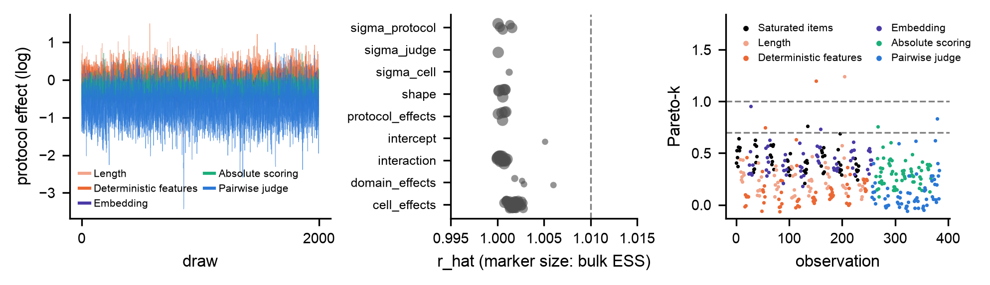
convergence.png. Left: traces of the protocol effects. Middle: r_hat for every parameter, marker size proportional to effective sample size. Right: Pareto-k for each of the 384 observations.
Sampling only gives the right answer if the chains have actually found and settled into the posterior, so the first thing to check is whether they did. The trace plot shows each chain's 2000 draws of each protocol effect against step number. When the sampler has settled, a trace looks like a flat fuzzy band, and the four chains' bands lie on top of each other. A trace that drifts means the sampler was still on its way somewhere; two chains at different levels mean the posterior has separate regions and the answer depends on the starting point. Ours are flat and superimposed.
r_hat expresses the same thing as a number: the variance between chains relative to the variance within them, which is 1.00 when the chains are indistinguishable. The accepted limit is 1.01. Our largest values are 1.006, for the intercept and the coding domain effect. Those two are slowest to mix because they trade off against the 64 per-model, per-domain intercepts (the grand mean can rise if every one of those falls), which is typical for a random-intercept model and not a concern at this level. Parameters that are pinned to zero, such as the baseline's protocol effect, have no r_hat and are left out.
Consecutive draws are correlated, so 8000 draws carry less information than 8000 independent samples would. The effective sample size, ESS, is the equivalent number of independent samples. It is reported separately for the bulk of the posterior, which governs the median, and for the tails, which govern the edges of the 95% interval. Below about 400 the interval edges become noticeably jittery. Our smallest are 923 for the bulk and 1524 for the tails.
A divergence is a step on which the sampler's numerical integration failed. They arise in sharply curved regions of the posterior, and their presence means such a region exists and has probably not been explored. Any number above zero is a warning. There were none.

Checking that the model describes the data
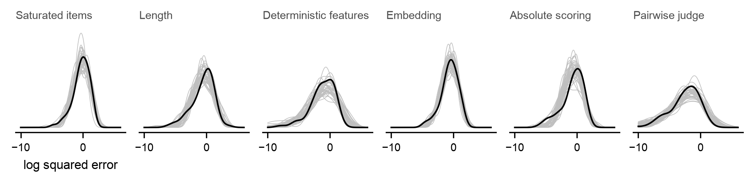
predictive.png. The observed distribution of log squared error for each protocol in black, over forty datasets simulated from the fitted model in grey.
A converged fit of a wrong model is still wrong, so the second check is whether the fitted model can generate data that look like ours. This is the posterior predictive check: simulate whole datasets from the fitted model and compare their distribution with the real one, protocol by protocol. If the real curve fell outside the simulated ones, the model would be missing something structural, whatever its coefficients say. Here the black curve is inside the grey bundle for all six protocols, including the long lower tail of Pairwise judge, which is where its near-perfect forecasts sit and which a single shared Gamma shape could not have reproduced.
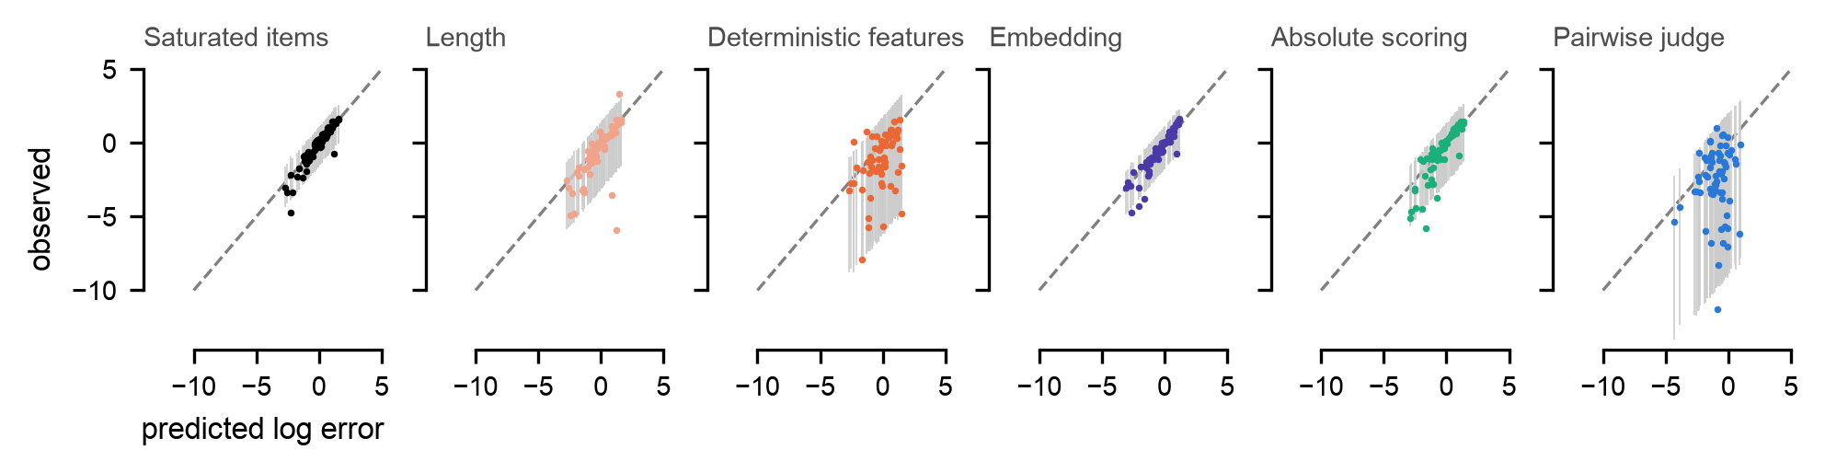
fit.png. Each dot is one observation, plotted at the model's predicted log error horizontally and the observed log error vertically, with the model's 95% predictive range as a grey bar. The dashed line is where prediction equals observation.
The observed-against-predicted plot asks the same question one observation at a time. Dots along the diagonal mean the predictions are right on average. The grey bar through each dot is the model's 95% range for that observation, and if the model's uncertainty is calibrated, about 95% of the dots should fall inside their bars. That fraction, the coverage, is between 0.94 and 0.97 for every protocol, so the intervals the model reports are neither too narrow nor too wide.
Pairwise judge looks different from the others. Its dots form a vertical stripe: the model predicts roughly the same error for every row, while the observed errors run from near zero to large. This is a property of the protocol rather than a defect in the model. Its forecasts are excellent for most models and poor for a few, and the per-model intercepts, which are shared with the other five protocols, carry no information about which models those are. The model responds with a small Gamma shape for this protocol, hence the wide bars. It also means the protocol's pooled score of about 50 is an average of very good and occasionally bad rather than a steady 50, which is why its intervals in science and math are wide.
The Bayesian R² on the log scale is 0.35, the share of the variance in log error that the linear predictor accounts for. It is a description rather than a test. The rest is mostly the noise a Gamma expects, and the per-model intercepts have already absorbed the largest source of variation, which is the models themselves.

The checks together, and what follows from them
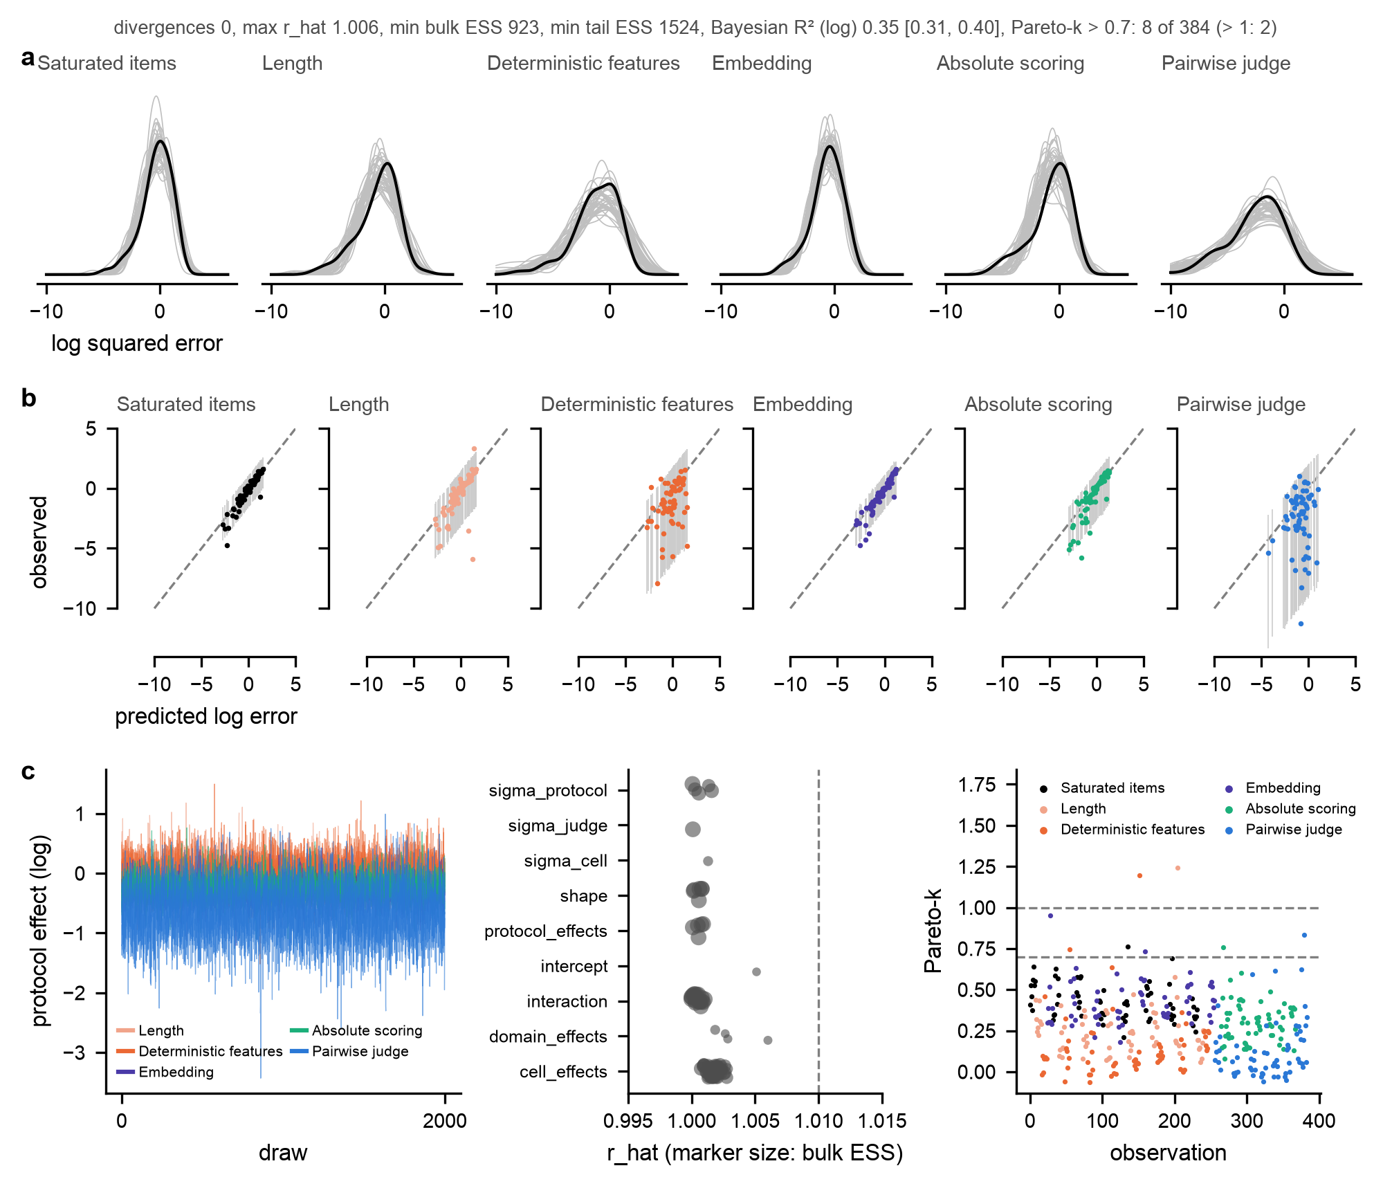
fit_quality.png. The posterior predictive check, the observed-against-predicted plot and the convergence diagnostics in one figure, with the summary numbers in the title line.
Taken together: the sampler converged, so the posterior intervals come from a genuine sample; the model reproduces each protocol's error distribution and its intervals are calibrated, so the protocol effects and their intervals can be read at face value; and Pairwise judge's effect should be read as a mean over erratic outcomes. The one caveat concerns the model comparison, which depends on eight influential observations that the leave-one-out approximation handles badly (next section). Nothing here needs fixing before the results are quoted. If a reviewer presses on the eight rows, the answer is to refit without the exact hits and show that the effects do not move, which has not yet been done.

Comparing models with leave-one-out cross-validation
Whether the protocol-by-domain term earns its place is a model comparison. m1 is the model without it, so every protocol has the same effect in every domain; m2 is the model with it. The comparison asks which predicts unseen data better.
Leave-one-out cross-validation scores each of the 384 observations as if the model had been fitted without it: how probable does the model, fitted to the other 383, find the value that actually occurred? The log of that probability, summed over all observations, is the expected log predictive density, elpd. Higher is better, and only differences between models fitted to the same data are meaningful. Since each observation contributes its own term, the difference between two models has a standard error, computed from the spread of the 384 per-observation differences.
m2 comes out 4.2 ahead of m1 with a standard error of 3.4, a little over one standard error from zero. The usual reading is that a difference under four points or under two standard errors is not decisive, so this is weak evidence that protocols behave differently across domains. On the eight 2026-I targets alone the difference is 15.4 with a standard error of 4.2, which is clear. The stacking weights, 0.87 for m2 and 0.13 for m1, say the same thing another way: they are the proportions in which you would blend the two models' predictions to predict best. p_loo, the effective number of parameters, is 72 for m2 against a nominal count of about 90, the shortfall being the shrinkage of the random effects.
Refitting the model 384 times is too slow, so the software approximates each leave-one-out fit by reweighting the draws it already has. Draws that fit the left-out observation well are down-weighted and draws that fit it badly are up-weighted, which mimics the posterior that would have been obtained without that observation. The approximation is good when removing the observation changes the posterior only slightly, so the weights stay moderate, and it breaks down when the observation is influential enough that a few draws receive enormous weight. Pareto-k measures how heavy-tailed the weights are for each observation. Below 0.5 the approximation is reliable, up to 0.7 it is acceptable, above 0.7 the leave-one-out score for that observation cannot be trusted, and above 1 it has failed outright.
Eight of our 384 observations are above 0.7 and two of those above 1. They are the forecasts that hit the true value exactly and were floored at 1e-6, and leaving one of them out changes what the model believes about that protocol's lower tail, which is precisely the influential case. The software attaches a warning to the elpd totals because of them. The m1-versus-m2 difference is less affected than the totals, since the same eight rows are flagged under both models, but the proper check is a refit without those rows (or with a larger floor) to confirm the difference and the protocol effects are stable. That has not been done.

Reading the results figures
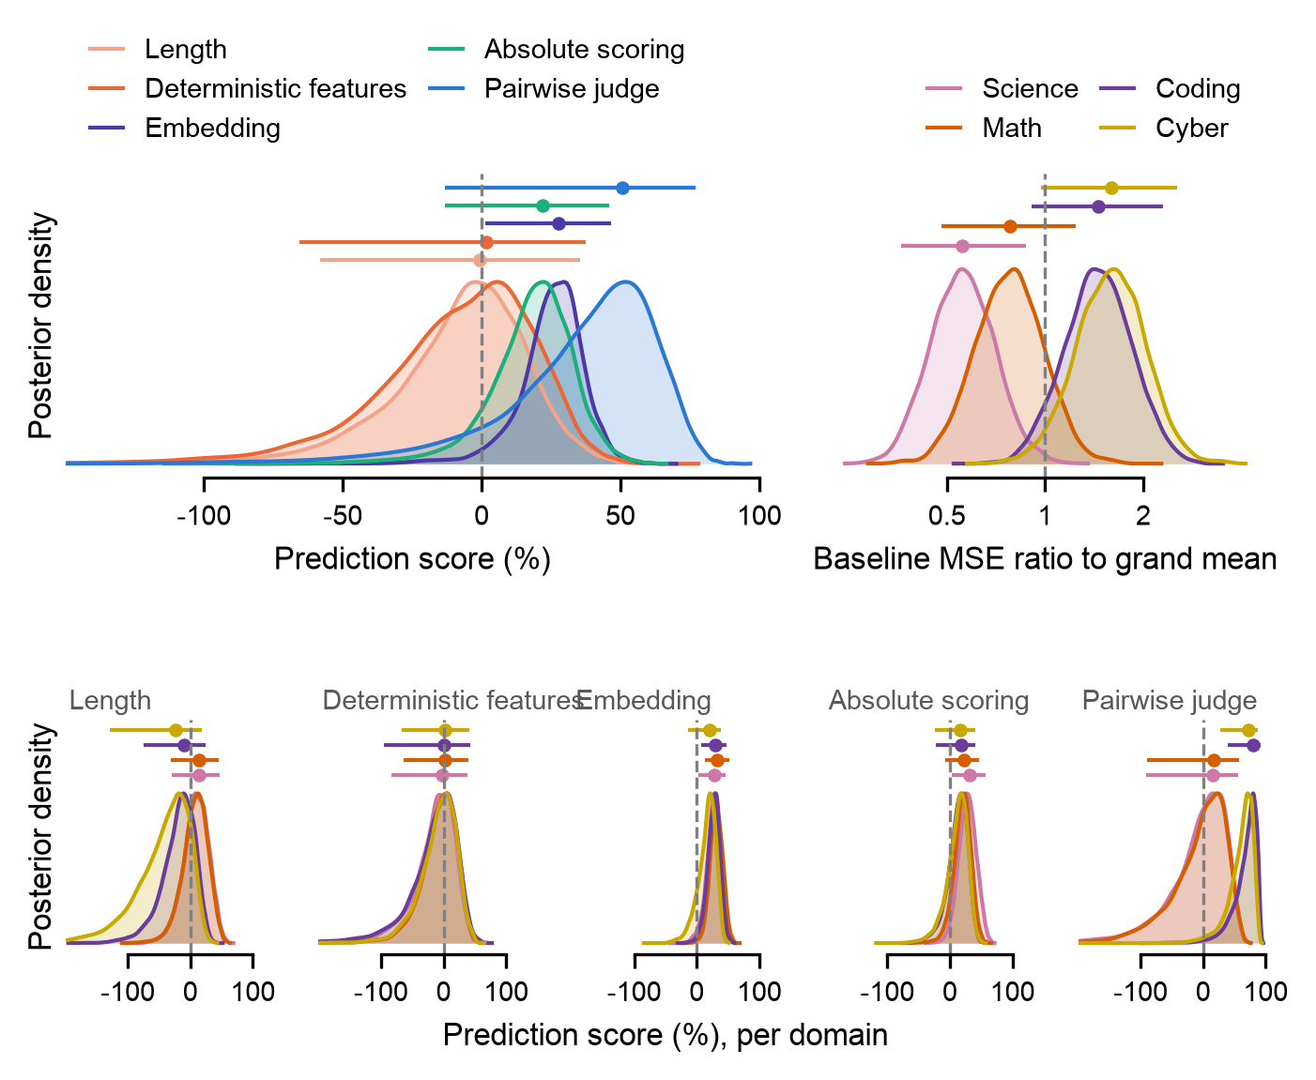
posteriors_score.png. Posterior densities on the prediction-score scale, where values above zero beat the baseline. Bars give the median and 95% interval.
Each curve is the histogram of the 8000 draws for one parameter, scaled so that every peak has the same height. The top-left panel shows the pooled protocol effects, the top-right the baseline's error in each domain relative to the average domain (a ratio rather than a score: science is the easiest domain to forecast and cyber the hardest), and the bottom row each protocol's effect in each domain. A protocol whose four domain curves lie on top of one another works the same everywhere, as Embedding does; one whose curves separate is domain dependent, as Pairwise judge is. The same figure on the error-ratio scale, with a log axis and the reference line at 1, is posteriors.png.
The pooled interval is wider than the domain intervals because the pooled effect is a prediction for a domain we have not seen, and its uncertainty therefore includes how much domains differ from each other. Pairwise judge pooled is 51 with an interval from −13 to 77, while the plain average over the four domains we did fit is 42 with an interval from 2 to 63. Which of those the pooled panel should show is still to be decided; the paper text quotes per-domain numbers, which sidesteps it.
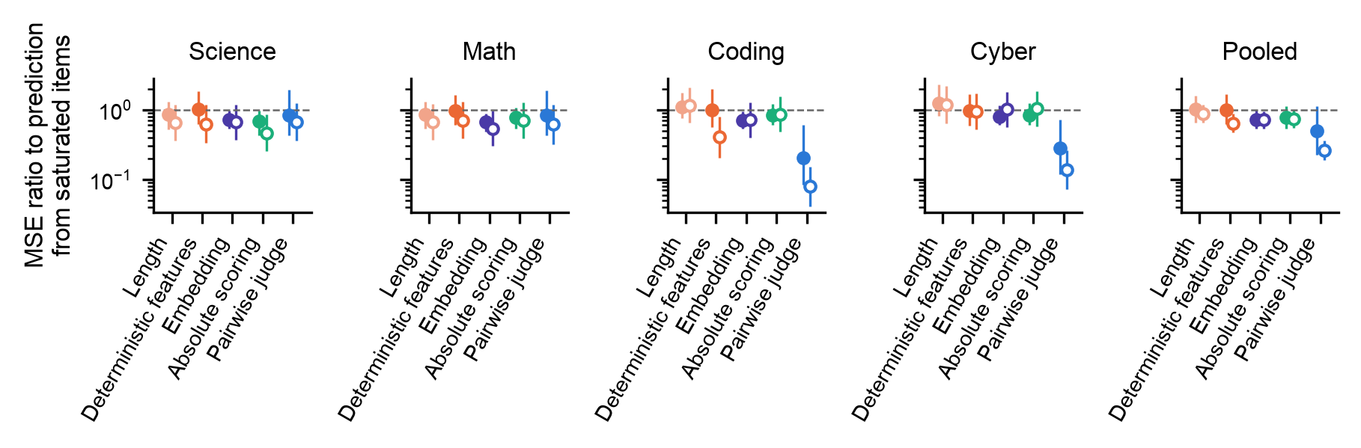
ratios.png. Error ratio to the baseline in each domain and pooled. Filled markers are the hierarchical fit, open markers the flat cross-check.
The flat cross-check is the same Gamma regression fitted by classical maximum likelihood, with a fixed intercept for every model in every domain and no pooling. Its intervals are Wald intervals, the estimate plus or minus 1.96 standard errors. Where the open and filled markers agree, pooling has not changed the answer; where the open interval is wider, pooling is doing its job. They agree here.
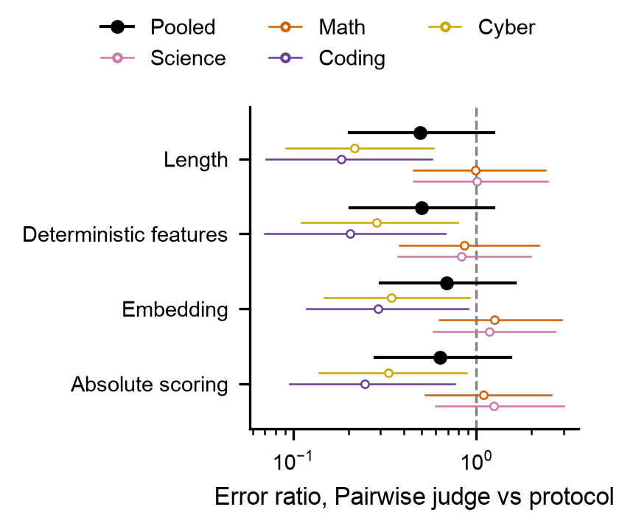
contrasts.png. Pairwise judge's error divided by each other protocol's, per domain and pooled.
To ask whether Pairwise judge is better than Embedding, the right quantity is the difference between their two effects computed draw by draw, called a contrast. Checking whether the two marginal intervals overlap is not a substitute, because the effects are correlated through the shared per-model intercepts and overlapping intervals can hide a clear difference. The fraction of draws in which the ratio is below 1 is directly the posterior probability that Pairwise judge is the better protocol: 0.99 in coding and cyber, about 0.5 in science and math.
One more point about what the model estimates. A Gamma regression with a log link estimates the arithmetic mean of the error in each group, and so does the prediction score in figure one. A mean is dominated by a few large values, and Deterministic features is a protocol that usually does a little better than the baseline and occasionally blows up. The blow-ups win the mean, and it scores 2 in the GLM, while a test on medians, which the blow-ups cannot dominate, would give it 26. Neither number is wrong; they answer different questions. For this protocol and for Length the paper should say there is no consistent gain and leave it at that.

The classical tests, for comparison
Figure one uses a one-sample t-test on the sixteen per-model prediction scores, asking whether their mean differs from zero. The 95% t-interval drawn in the box figure is the same test in interval form. The scores have no lower bound, which strains the test's normality assumption; Length has a mean score of −228. Until 17 September the test was Wilcoxon's signed-rank test, which uses only the signs and ranks of the differences and so cannot be dominated by a single blow-up. Under Wilcoxon, Absolute scoring had p = 0.044; under the t-test it has 0.12. Testing four protocols gives four chances of a false positive, and the Holm correction adjusts the thresholds so that the overall chance stays at 5%; Embedding and Pairwise judge survive it, Absolute scoring and Deterministic features do not. The Bayesian fit has no p-values. Its intervals, and the contrast probabilities, are what to report.

Glossary
Term | Meaning
GLM | A regression with a chosen noise distribution (family) and a chosen scale on which effects add (link).
Gamma family | A positive, right-skewed distribution whose spread grows with its mean; used here for squared errors.
Log link | Effects add on the log scale and therefore multiply on the original scale; exp(effect) is a ratio.
Fixed effect | One free coefficient per level, with no assumed relation between levels.
Random effect | One coefficient per level, drawn from a common distribution whose spread is estimated; levels inform each other.
Partial pooling, shrinkage | The pull of poorly measured random-effect levels toward the group mean.
Main effect, interaction | A factor's average influence; an extra term letting that influence depend on another factor.
Per-model, per-domain intercept | A random intercept for each of the 64 model-and-domain combinations; the error level shared by all six protocols there. Called cell_effects in the code.
Reference level | The level fixed at zero against which the other levels of a factor are measured.
Sum-to-zero coding | Constraining a factor's coefficients to add to zero, so the intercept is the grand mean.
Non-centred | Writing a random effect as spread × standard normal; a sampling convenience.
Prior, posterior | The distribution assumed for a parameter before the data, and the one obtained after.
95% credible interval | The range containing 95% of the posterior.
Sampler, chain, draw | The algorithm that explores the posterior; one of its runs; one recorded position.
Warmup | The discarded initial part of a chain, used for tuning.
Trace plot | Draws plotted against step number, per chain.
r_hat | Between-chain relative to within-chain variance; 1.00 is ideal and 1.01 the accepted limit.
ESS | The number of independent samples the correlated draws are equivalent to.
Divergence | A failed sampler step, indicating an unexplored region of the posterior.
Prior / posterior predictive check | Simulating data from the priors or from the fit and comparing with the observed data.
Coverage | The fraction of observations that fall inside their 95% predictive interval.
Bayesian R² | The share of outcome variance attributable to the linear predictor.
LOO, elpd | Leave-one-out cross-validation, and its summed log predictive score.
PSIS | The importance-sampling approximation that avoids refitting for each left-out observation.
Pareto-k | The reliability of that approximation for one observation; unreliable above 0.7.
p_loo | The effective number of parameters.
Stacking weight | The proportions in which compared models would best be blended.
Contrast | The difference between two parameters, computed draw by draw.
Wald interval | A classical interval, estimate ± 1.96 standard errors.

