Do saturated transcripts carry capability signal? The hierarchical GLM
17 September 2026. This document explains the analysis behind figure one of the paper and its per-domain breakdown, from the data up. The first time a statistical idea is needed it is explained in plain terms; the exact specification, settings and diagnostics an expert would want are given in the same place. Every number comes from one script (scripts/analyses/signal_glm.py) run on the forecast table, and the figures are in analysis/results/figures/signal_glm/.

1. The question and the data
Each protocol in the paper tries to forecast how capable a new model is, using only its transcripts on benchmark items that every model gets right. The forecast is a number, θ̂, on the same scale as the model's true capability θ*, which we know from held-out harder items. The forecast is good if θ̂ is close to θ*, and we measure that by the squared error (θ* − θ̂)². Squaring makes a miss of 2 count four times as much as a miss of 1, so protocols that are occasionally far off are penalised.
There are sixteen target models, the eight released in 2025-II and the eight in 2026-I, and every one of them is forecast in all four domains (science, math, coding, cyber). Six protocols make forecasts: the saturated-item prediction, Length, Deterministic features, Embedding, Absolute scoring and Pairwise judge. So there are 16 × 4 × 6 = 384 squared errors, and those are the data for everything below. The two judge protocols use whichever judge did best on the reference models in each task. A few forecasts hit θ* exactly, giving an error of zero; those are set to 1e-6, for a reason explained in section 3. All targets are open-weights models and every transcript is full length; the closed-model and truncated-transcript experiments are separate and not in this data.
The saturated-item prediction is the baseline. It has no access to anything but the reference models' capabilities, so it forecasts every new model as their average. It is one of the six protocols, with its own 64 squared errors, and every other protocol is judged by how much smaller its errors are than the baseline's. The two questions are: which protocols beat the baseline, and does the answer depend on the domain.

2. The prediction score and the paper's test
The paper reports each protocol's performance as a prediction score, 100 × (1 − error / baseline error), computed per target model. A score of 0 means the protocol did no better than guessing the average; 100 means it forecast the model exactly; a negative score means it did worse than the baseline, and there is no lower limit, since a bad enough forecast can have many times the baseline's error.
Figure one of the paper averages each model's squared error over its four domains before taking the score, so there is one score per model per protocol. Sixteen scores per protocol are then tested against zero with a one-sample t-test, which asks whether their mean could plausibly be zero given their spread. The table gives that test. The median error ratio is the middle model's error divided by its own baseline error, a summary that a couple of extreme models cannot move; the mean squared error is the plain average of the sixteen errors.
Protocol | Mean score | p (t-test, N = 16) | Median error ratio | Mean squared error (baseline 1.37)
Pairwise judge | 49 | 0.006 | 0.31 | 0.33
Embedding | 23 | < 0.001 | 0.75 | 1.04
Absolute scoring | 10 | 0.124 | 0.81 | 1.14
Deterministic features | 10 | 0.625 | 0.74 | 0.84
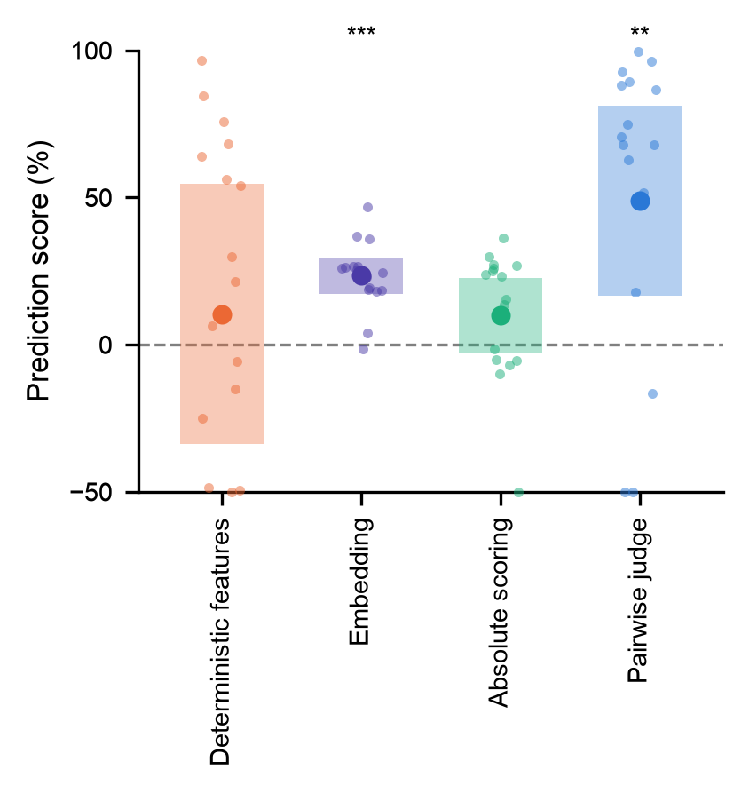
Figure 1 (figure one of the paper). For each protocol, the sixteen per-model prediction scores as small points, their mean as the large circle, and the 95% confidence interval of the mean as the shaded box; points below −50 are drawn at the axis edge. Stars mark the t-test (two for p < 0.01, three for p < 0.001). Pairwise judge roughly halves the baseline's error on average (score 49, p = 0.006), though one model is far below the axis; Embedding takes about a quarter off it for nearly every model (score 23, p < 0.001) and is the most consistent protocol. Absolute scoring and Deterministic features average about 10 with intervals that include zero. Length is left out of the figure as a diagnostic; its mean score is −228 because two models have enormous errors under it, while its median ratio of 0.94 shows the typical model is unaffected.
Until 17 September the test was Wilcoxon's signed-rank test, which uses only the signs and ranks of the sixteen differences and so cannot be dominated by one extreme model. Under it Absolute scoring had p = 0.044; under the t-test, which the unbounded lower tail of the scores strains, it has 0.12. The t-test is the paper's test because its confidence interval is what the figure draws. Correcting for testing four protocols (Holm's method), Embedding and Pairwise judge remain significant and the other two do not.

3. Why a regression, and why this kind
The t-test answers the first question, protocol by protocol, after averaging over domains. To answer both questions at once, and to use all 384 errors rather than sixteen averages, we fit one regression to the whole table. A regression writes each outcome as a starting value plus an adjustment for each factor that describes it, plus random noise, and estimates the adjustments. Here the outcome is a squared error and the factors are the protocol, the domain, and which model was being forecast.
Ordinary regression assumes the noise is normally distributed, and squared errors are nothing like that: they cannot be negative, most are small, and a few are enormous. A generalised linear model, GLM, keeps the additive structure but lets you choose the noise distribution, called the family, and the scale on which the adjustments add, called the link. We use the Gamma family, which is defined on positive numbers, is skewed to the right, and has a spread that grows with its mean, so an occasional huge error is an expected event rather than an outlier that pulls the whole fit. We use the log link, so the adjustments add on the log scale, which is the same as multiplying on the original scale. A protocol adjustment of −0.7 means the protocol's error is exp(−0.7), about half, of the baseline's. That is also the form the paper needs: the baseline error differs several-fold between domains, and "halves the error" is comparable across domains where "reduces it by 0.3" is not. The exact-zero errors are floored at 1e-6 because a Gamma distribution cannot produce zero.
For the record: error ~ Gamma(shape[protocol], shape[protocol] / μ), so the mean of each row is μ and the shape, which controls the noise around the mean, is estimated separately for each protocol. That last choice matters. Embedding gives a small gain almost every time; Pairwise judge gives a large gain most times and a large miss now and then. A single shared shape would fit neither.

4. What is in the model
The log of the expected error for one row is a sum of five parts, six when several judges are in the data:
log μ = intercept + protocol effect + domain effect + protocol-in-domain effect + model-in-domain intercept (+ judge intercept)
The intercept is the baseline's log error averaged over domains. The protocol effect is the adjustment for the row's protocol. Each factor with k levels can only carry k − 1 free adjustments, because moving all of them up by one is indistinguishable from moving the intercept, so one has to be fixed; for protocol the baseline's is fixed at zero, which is why exp(protocol effect) is the error ratio to the baseline and 100 × (1 − exp(protocol effect)) is the prediction score. Protocol is a fixed effect: each of the five free adjustments is estimated on its own with no assumed relationship between them, which is right when there are few levels, plenty of data per level, and the individual values are what you want.
The domain effect is the adjustment for the row's domain, applying to every protocol alike. Instead of fixing one domain at zero, the four domain effects are constrained to add up to zero, so the intercept is the mean over domains and each domain effect is a departure from that mean. Science comes out at −0.58: its baseline error is exp(−0.58), about 0.56, of the average domain's. An earlier version used science as the reference level, which made the other three domain effects "relative to science" and harder to read.
The protocol-in-domain effect is the extra adjustment for that particular protocol in that particular domain, the interaction. Without it the model would have to give Pairwise judge the same effect in coding as in math. It is fitted as a random effect: each protocol's four domain adjustments are treated as draws from a distribution centred on zero whose spread is estimated separately for that protocol. A random effect differs from a fixed one in that the levels are assumed to come from a common distribution, so they inform each other; a level with little evidence is pulled toward the group mean, which is called partial pooling or shrinkage, and the estimated spread is itself a result. Here the spread answers how domain-dependent each protocol is. A protocol with a spread near zero has its four domain values pulled together because the data say it works the same everywhere; a large spread lets each domain keep its own value. Pairwise judge's spread is 0.71 and Embedding's 0.15. The model with this term is called m2 and the one without it m1; section 6 compares them.
The model-in-domain intercept accounts for the target models themselves. Every protocol forecasts the same sixteen models in the same four domains, and some of those 64 combinations are hard for everyone: a model whose true capability is far from the reference average will be missed by all six protocols, so all six of its error rows are large together. Without a term for that, the shared difficulty goes into the noise and buries the differences between protocols, which is what happened in the first version of this model, where nothing was significant. So each of the 64 model-and-domain combinations has its own intercept, fitted as a random effect, and the protocol effects are estimated from how the protocols differ around it, the same logic as pairing in a t-test. A per-model intercept without the domain was tried first and helped little, because models vary far more between domains than between each other. The estimated standard deviation of these intercepts is about 1.0 on the log scale, a factor of 2.7 in error, which is larger than any protocol's effect: which model you are forecasting matters more than which protocol you use. Each target belongs to one release period, so these intercepts also absorb any period effect and no period term is needed.
The judge intercept is fixed at zero in the reported fit, which uses one judge per task and so has nothing to vary. In a separate fit that includes every judge it is a random effect with a standard deviation of 0.39, and that fit gives the same picture. A model with random effects is called hierarchical, because some parameters, the model-in-domain intercepts for instance, have parameters of their own.
Priors are the distributions assumed for each parameter before the data are seen; the data then update them. Ours are wide and matter little with 384 rows: Normal(0, 2) on the intercept, Normal(0, 1) on the protocol and domain effects (a ratio between 0.14 and 7 with 95% prior probability), HalfNormal(0.5) on the protocol-in-domain and judge spreads, HalfNormal(1) on the model-in-domain spread, Exponential(1) on the Gamma shapes. The random effects are written in non-centred form, effect = spread × standard normal, which changes nothing about the model and helps the sampler when a spread is near zero. A prior predictive check, simulating data from the priors alone and confirming the range covers the observed errors, passed.

5. How the fit is computed
The fit is Bayesian: the result for each parameter is a posterior distribution, the prior updated by the data, rather than a single estimate. What gets reported is its median and the interval containing 95% of it, which has the interpretation people usually want from an interval: given the model and the data, the parameter is in there with 95% probability. With priors this wide and this much data, that interval nearly coincides with the classical confidence interval numerically.
With this many parameters there is no formula for the posterior, so it is explored by a sampler. The sampler (NUTS, a Hamiltonian Monte Carlo method, run through hibayes on numpyro) walks through parameter space, spending time in each region in proportion to its posterior probability, and records where it has been. The recorded positions are the draws; their histogram is the posterior curve and their quantiles give the interval. We run four independent walks, called chains, from different starting points so that we can check they agree; four is the convention. Each chain takes 1000 warmup steps, during which the sampler tunes itself and which are discarded, then 2000 kept steps, 8000 draws in all. The setting target_accept = 0.95 asks for smaller, more careful steps than the default 0.8, which is slower but avoids the numerical failures that random-effect models tend to produce. The seed is 0, so a rerun reproduces the draws. As a cross-check, the same Gamma regression was fitted by classical maximum likelihood with a fixed intercept for every model and domain (statsmodels, Newton's method, Wald intervals); it agrees with the Bayesian fit and appears alongside it in the ratio figure.

6. Results
The table converts the GLM's protocol effects to prediction scores, 100 × (1 − exp(effect)), so it reads like the t-test table: above zero beats the baseline. Each entry is the posterior median with the 95% interval in brackets. The pooled column is the protocol effect on its own, which is the model's prediction for a domain it has not seen and whose interval therefore includes the spread across domains; the next column is the mean over the four domains it has seen, which is tighter. The last column is the estimated spread of the protocol's effect across domains, on the log scale.
Protocol | Science | Math | Coding | Cyber | Pooled (new domain) | Mean of 4 domains | Spread across domains
Pairwise judge | 15 (-92, 57) | 17 (-89, 57) | 80 (39, 92) | 72 (28, 88) | 51 (-13, 77) | 42 (2, 63) | 0.71 (0.20, 1.31)
Embedding | 28 (3, 47) | 33 (13, 52) | 29 (7, 47) | 21 (-14, 39) | 28 (1, 47) | 27 (11, 40) | 0.15 (0.01, 0.59)
Absolute scoring | 31 (2, 57) | 23 (-7, 46) | 17 (-22, 40) | 17 (-24, 40) | 22 (-13, 46) | 21 (0, 38) | 0.18 (0.01, 0.70)
Deterministic features | -2 (-84, 38) | 3 (-64, 39) | 1 (-96, 43) | 3 (-67, 40) | 2 (-66, 37) | 0 (−59, 32) | 0.17 (0.01, 0.68)
Table 1. Pairwise judge scores about 80 in coding and 72 in cyber with intervals well clear of zero, and about 15 in science and math with intervals that include zero; its spread across domains, 0.71, is the largest of any protocol. Embedding scores 21 to 33 in every domain with a spread of 0.15, a small gain that is the same everywhere. Absolute scoring is similar in size but three of its four intervals include zero. Deterministic features is at zero. A Gamma GLM estimates the mean error, which a few very large errors dominate, and that is why Deterministic features scores 2 here although its median error ratio in section 2 is 0.74: it usually does a little better than the baseline and occasionally blows up, and the blow-ups win the mean. For it the mean and the median disagree, and no p-value should be attached.
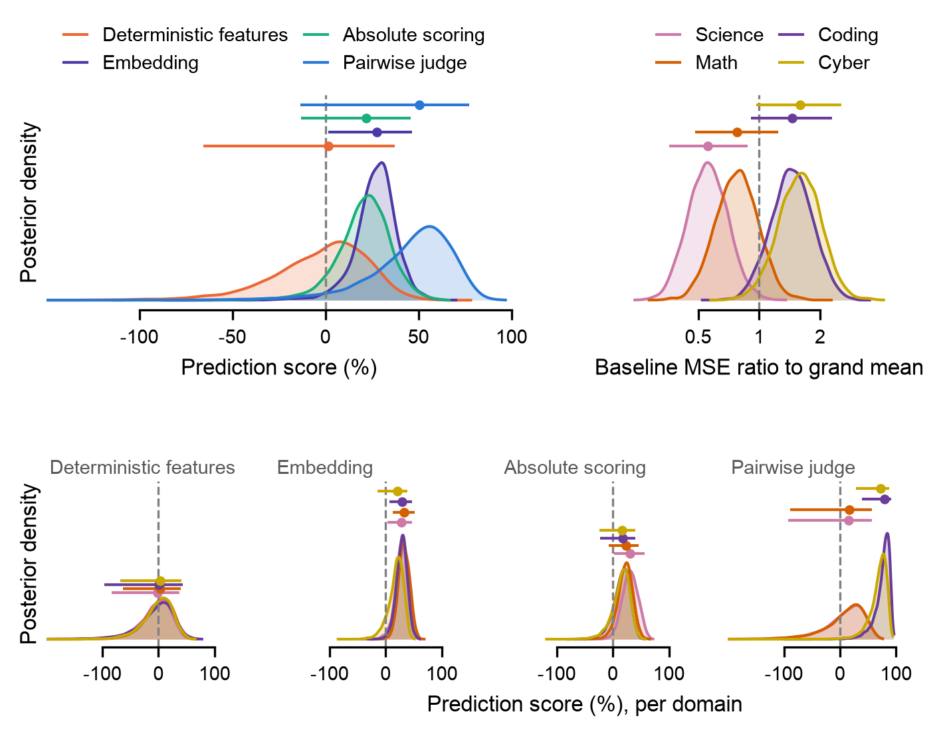
Figure 2. The same estimates as full posterior distributions. Each curve is the posterior density of one parameter, with unit area on the plotted axis, so a taller, narrower curve is a more precisely estimated parameter; the horizontal bar above it marks the median and 95% interval. Top left: each protocol's pooled effect on the prediction-score scale, above zero meaning better than the baseline. Top right: the domain effects, shown as the baseline's error in each domain relative to the average domain, a ratio rather than a score; science is the easiest domain to forecast and cyber the hardest. Bottom row: each protocol's effect in each domain, one panel per protocol and one colour per domain. Where the four coloured curves in a panel lie on top of each other the protocol works the same in every domain; where they separate its effect depends on the domain. Pairwise judge is the only panel where they separate, with coding and cyber around 80 and science and math around 15 with tails through zero. Embedding's four curves coincide around 28, Absolute scoring's around 22 with tails reaching zero, and Deterministic features is centred on zero. The version of this figure on the error-ratio scale is posteriors.png.
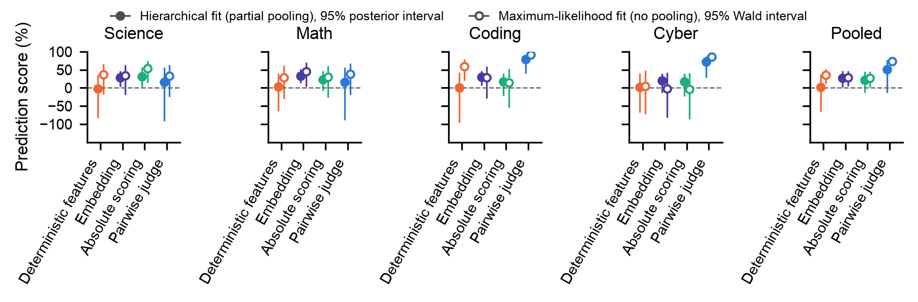
Figure 3. The same estimates once more, on the prediction-score scale (100 × (1 − error ratio to the baseline); above 0 is better), with the classical cross-check added. One panel per domain plus a pooled panel; one marker per protocol. Filled markers, as the legend says, are the hierarchical fit's median and 95% interval; open markers are the same regression fitted by maximum likelihood with a fixed intercept per model and domain and no pooling, with its 95% Wald interval. The two agree everywhere, so partial pooling has not moved any estimate. The intervals are longer downward than upward because the score is bounded at 100 above and unbounded below: a ratio of 0.5 is a score of 50 but a ratio of 2 is a score of −100. Pairwise judge's pooled interval is the wide one because the pooled effect is a prediction for a new domain and inherits the spread across domains. The same figure on the error-ratio scale, where a halving and a doubling are the same distance from the line, is ratios.png.

Pairwise judge against each other protocol
Knowing that Pairwise judge beats the baseline and that Embedding beats the baseline does not say whether Pairwise judge beats Embedding. That is a question about the difference between two effects, and whether their two intervals overlap does not answer it, because the effects are positively correlated: both are measured against the same baseline rows and the same model-in-domain intercepts, so when a posterior draw has one of them high the other tends to be high too, and their difference varies less than either does alone. The contrasts below are computed draw by draw, Pairwise judge's error divided by the other protocol's in each of the 8000 draws. The table gives the result as an error reduction, 100 × (1 − ratio), with the 95% interval, and P, the fraction of draws in which Pairwise judge has the smaller error, which is the posterior probability that it is the better of the two.
Other protocol | Science | Math | Coding | Cyber | Pooled
Embedding | -18 (-168, 42); P = 0.33 | -26 (-192, 37); P = 0.26 | 71 (10, 88); P = 0.98 | 66 (8, 85); P = 0.98 | 31 (-63, 70); P = 0.82
Absolute scoring | -25 (-200, 40); P = 0.29 | -9 (-157, 47); P = 0.41 | 76 (24, 90); P = 0.99 | 67 (12, 86); P = 0.99 | 37 (-54, 72); P = 0.86
Deterministic features | 17 (-98, 63); P = 0.67 | 14 (-119, 62); P = 0.63 | 79 (32, 93); P = 1.00 | 72 (21, 89); P = 0.99 | 50 (-24, 79); P = 0.94
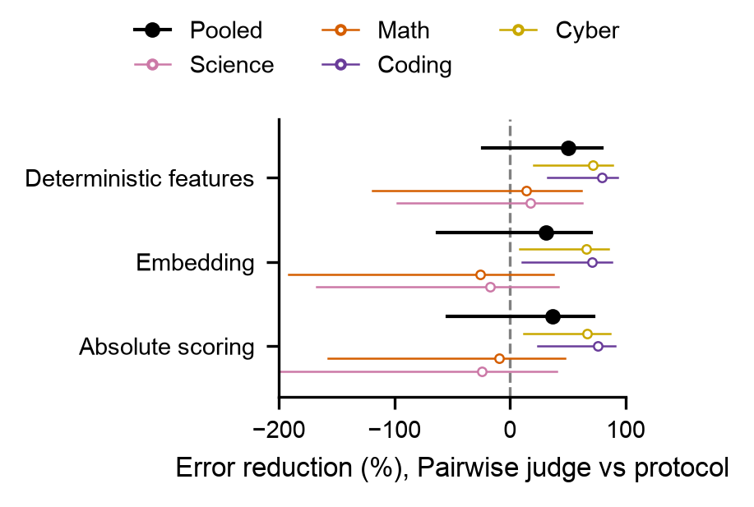
Figure 4. The contrasts as a figure: one row per other protocol, the error reduction of Pairwise judge relative to that protocol, coloured markers per domain and black for pooled, bars for the 95% interval, dashed line at zero. Positive means Pairwise judge has less error; negative means more, and the scale is unbounded below, so a ratio of 2 reads as −100 and a ratio of 3 as −200, which is why the lower tails look long. In coding and cyber every marker is between 65 and 85 with intervals clear of zero and 98 to 100% of the posterior on the positive side: Pairwise judge has a fifth to a third of the error of any other protocol there. In science and math every interval straddles zero, so the protocols cannot be told apart. Pooled, the medians are 30 to 50 with 82 to 94% of the posterior favouring Pairwise judge. The same figure on the error-ratio scale with a log axis is contrasts.png.

Is the domain dependence real? Comparing m1 and m2
Whether the protocol-in-domain term is needed is a model comparison between m1, which leaves it out so that every protocol has the same effect in every domain, and m2, which keeps it. The comparison is by leave-one-out cross-validation: for each of the 384 observations, how probable does the model find that observation when fitted without it? The log of that probability summed over all observations is the expected log predictive density, elpd. Higher is better, only the difference between two models fitted to the same data means anything, and since the difference is a sum of 384 per-observation differences it has a standard error. The stacking weight is the proportion in which the two models' predictions would be blended to predict best, and p_loo is the number of parameters the model is effectively using, which is below the raw count because the random effects are partially pooled.
Model | elpd | SE | Difference | SE of difference | p_loo | Stacking weight
m2 protocol x domain | -203.4 | 33.2 | 0.0 | 0.0 | 72.3 | 0.86
m1 protocol + domain | -207.6 | 33.3 | 4.2 | 3.4 | 65.0 | 0.14
Table 2. m2 is ahead by 4.2 with a standard error of 3.4, a little over one standard error, and takes 0.86 of the stacking weight. The usual reading is that a difference under about four points, or under two standard errors, is not decisive, so this is weak evidence that protocols behave differently across domains; the posteriors above show that whatever difference there is comes from Pairwise judge alone. On the eight 2026-I targets by themselves the difference is 15.4 with a standard error of 4.2, which is clear. Both comparisons carry a warning from the Pareto-k diagnostic, explained in the next section.

7. Checking the fit
Two things can go wrong with a fit like this: the sampler may not have found the posterior, and the model, even perfectly sampled, may not describe the data. The figure below checks both, and the table after it gives the numbers for m1 as well.
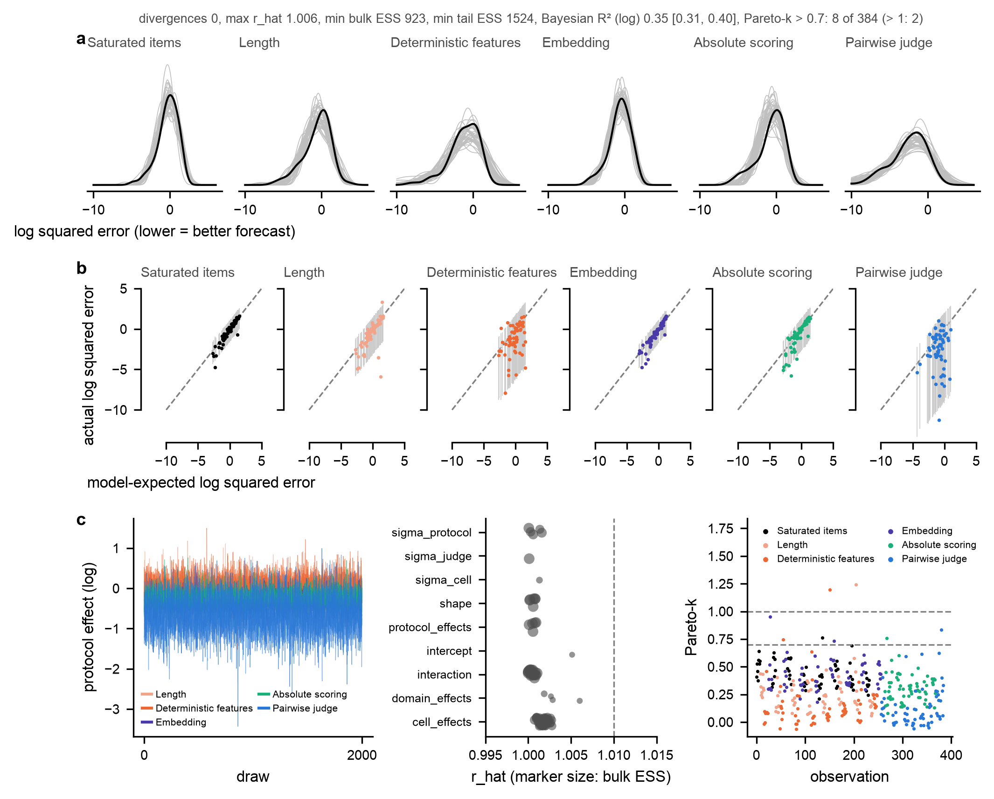
Figure 5. Row a is the posterior predictive check, which asks whether the fitted model can produce data that look like ours. For each protocol, the black curve is the distribution of the 64 observed log squared errors (lower is better on this axis), and each grey curve is the same distribution in one of forty datasets simulated from the fitted model. If the model were wrong in some structural way, the wrong family or a missing term, the black curve would fall outside the grey bundle whatever the coefficients said. It is inside for all six protocols, including the long lower tail of Pairwise judge where its near-perfect forecasts sit, so the Gamma model with one shape per protocol reproduces the data.
Figure 5, continued. Row b plots each observation individually. Both axes are log squared error, so unlike the prediction score, lower is better: a point at −10 is a near-perfect forecast and a point at +2 is a bad miss. Horizontal position is the error the model expects for that row, the posterior median of log μ; vertical position is the log error actually observed; the grey bar through each point is the model's 95% predictive interval for it; the dashed line is where expected equals observed. Points along the line mean the expectations are right on average, and if the model's uncertainty is calibrated, about 95% of points should fall inside their bars. They follow the line, and 94 to 97% are inside for every protocol, so the intervals the model reports can be believed. Pairwise judge forms a vertical stripe: the model expects roughly the same error for every one of its rows while the observed errors run from near zero to large. That is a property of the protocol, whose forecasts are excellent for most models and poor for a few, and the model-in-domain intercepts, shared with the other protocols, cannot say which. Its wide bars and its small Gamma shape (0.40) are the model absorbing that, and its pooled score of about 50 should be read as an average of very good and occasionally bad.
Figure 5, continued. Row c is the sampler diagnostics. Left: each protocol effect's draws against step number, the four chains drawn on top of each other. When the sampler has converged, each trace is a flat fuzzy band and the four chains coincide; a drift, or one chain at a different level, would mean it had not, and these are flat and coincide. Middle: r_hat for every parameter, grouped by family, with marker size showing the effective sample size. r_hat compares the variance between chains with the variance within them and is 1.00 when the chains agree; the dashed line at 1.01 is the accepted limit. Everything is below it, the largest being 1.006 for the intercept and the coding domain effect, which mix slowest because they trade off against the 64 model-in-domain intercepts. The effective sample size is the number of independent samples the correlated draws are worth; every parameter has more than 900 of the 8000, well above the 400 usually asked for. Right: Pareto-k for each of the 384 observations, coloured by protocol, with dashed lines at 0.7 and 1. Leave-one-out is computed by reweighting the existing draws rather than refitting 384 times, and Pareto-k says whether that reweighting was reliable for a given observation: above 0.7 it was not, above 1 it failed. Eight observations are above 0.7 and two above 1. They are the forecasts that hit the true value exactly and were floored at 1e-6, extremely influential by construction, and the leave-one-out totals carry a warning because of them. The m1-to-m2 difference is less affected, since the same rows are flagged under both, but the proper check is a refit without those rows, which has not been done.
Quantity | m2 (reported) | m1 (no protocol-in-domain term)
Divergences | 0.0000 | 0.0000
Largest r_hat | 1.006 | 1.004
Smallest effective sample size, bulk / tail | 923 / 1524 | 1224 / 2450
Observations with Pareto-k > 0.7 (> 1) | 8 (2.0000) of 384 | 6 (2.0000) of 384
Bayesian R² on the log scale | 0.35 (0.31, 0.40) | 0.32 (0.28, 0.36)
95% predictive coverage, per protocol | 0.97, 0.95, 0.94, 0.95, 0.97, 0.97
Table 3. The same diagnostics as numbers. Divergences are sampler steps that failed numerically; they arise in sharply curved regions of the posterior and mean such a region has probably not been explored, so any count above zero is a warning. There are none. R² is the share of the variance in log error that the model's expected values account for. 0.35 is modest, but most of the remainder is the row-to-row noise a Gamma expects, the model-in-domain intercepts have already absorbed the largest source of variation, and the model's purpose is the protocol effects rather than predicting individual errors.

8. What to conclude, and what is still open
Transcripts from saturated items do carry capability signal. Pairwise judging recovers most of it, and almost entirely in the agentic domains: prediction scores of about 80 in coding and 72 in cyber, and no measurable gain in science or math. Embedding recovers a small amount in every domain alike. Absolute scoring and deterministic features do not reliably beat the baseline. The fit behind those statements converged and describes the data, so the intervals can be quoted as they stand.
Three caveats. First, the GLM and the prediction score both estimate mean error, which a few large errors dominate; for the heavy-tailed protocols, Deterministic features and Length, the mean and the median disagree, so the paper should say there is no consistent gain and not attach a p-value. Second, the eight targets within a semester share one fitted calibration per protocol (one ridge, one judge, one conversion), so the sixteen scores in the t-test are not fully independent and the test is somewhat anti-conservative; the replication on 2026-I alone (Pairwise judge score 51, p = 0.004; Embedding 24, p = 0.001) is the current answer, and a random effect per protocol and task would be the principled one. Third, the eight floored exact hits make the leave-one-out comparison imprecise; a refit without them has not been done.
Two decisions are open. The pooled panel of the ratio figure can show the protocol effect on its own, which is the prediction for a new domain (Pairwise judge 51, −13 to 77), or the mean over the four fitted domains (42, 2 to 63); the paper text quotes per-domain numbers, which sidesteps it. And a frontier versus non-frontier term has been asked for, but no such flag exists in the data; the only frontier notion in the project is the top three targets per task by true capability, and a definition is needed before it can be a model term.

Glossary
Term | Meaning
Squared error | (true capability − forecast)²; the outcome of every row.
Prediction score | 100 × (1 − error / baseline error). 0 is the baseline, 100 is perfect, negative is worse than the baseline.
Error ratio | A protocol's error divided by the baseline's (or another protocol's). Below 1 is better.
GLM | A regression with a chosen noise distribution (family) and a chosen scale on which effects add (link).
Gamma family, log link | Positive right-skewed noise whose spread grows with the mean; effects that multiply the mean.
Fixed effect | One free coefficient per level of a factor, with no assumed relation between levels.
Random effect | One coefficient per level, drawn from a common distribution whose spread is estimated, so levels inform each other.
Partial pooling, shrinkage | The pull of poorly measured random-effect levels toward the group mean.
Interaction | An extra term letting one factor's effect depend on another; here, protocol-in-domain.
Model-in-domain intercept | A random intercept for each of the 64 model-and-domain combinations, shared by all six protocols' rows for it.
Reference level | The level of a factor fixed at zero, against which the others are measured; here, the baseline.
Sum-to-zero coding | Constraining a factor's coefficients to add to zero, so the intercept is the grand mean; used for domain.
Hierarchical model | A model with random effects: some parameters have parameters of their own.
Prior, posterior | The distribution assumed for a parameter before the data, and the one obtained after.
95% interval | The range containing 95% of the posterior.
Sampler, chain, draw | The algorithm that explores the posterior; one of its runs; one recorded position.
Warmup | The discarded initial part of a chain, used for tuning.
r_hat | Between-chain relative to within-chain variance; 1.00 is ideal and 1.01 the accepted limit.
Effective sample size | The number of independent samples the correlated draws are worth.
Divergence | A failed sampler step, indicating an unexplored region of the posterior.
Posterior predictive check | Simulating data from the fit and comparing with the observed data.
Coverage | The fraction of observations inside their 95% predictive interval.
Bayesian R² | The share of outcome variance attributable to the model's expected values.
Leave-one-out, elpd | Scoring each observation as if the model had not seen it; the summed log score.
Pareto-k | The reliability of the leave-one-out approximation for one observation; unreliable above 0.7.
p_loo | The effective number of parameters.
Stacking weight | The proportions in which compared models would best be blended.
Contrast | The difference between two parameters, computed draw by draw.
Wald interval | A classical interval, estimate ± 1.96 standard errors; used by the cross-check.

