1. Employee Role
- Functionality:
  - Log in: Logs into the employee portal.
  - Raise Ticket: Submits IT-related issues or asset requests (e.g., hardware, software, network).
  - Select Issue Type: Selects the issue type (Hardware, Software, Network, Access, Other).
  - Describe Issue: Provides a description and specifies the affected asset.
  - Ticket Status Updates: Receives updates through Slack DM or email.
  - Resolution/Replacement: Receives resolution or replacement after ticket approval.
  - Ticket closing: Once the issue is solved the ticket will be closed after the employee is satisfied.

2. IT Team Role
- Functionality:
  - Add employees data: Here the employee data will be added by the IT team based on the excel report.
  - Receive Notifications: Receives ticket notifications in the #it-helpdesk Slack channel.
  - Assign Ticket: Assigns tickets to agents.
  - Review and Investigate: Reviews and investigates the ticket issue.
  - Update Ticket Status: Updates the ticket to "In Progress."
  - Resolve or Transfer: Resolves issues (e.g., software fixes) or transfers to the IT Asset Team if hardware needs to be replaced.
  - Close Ticket: Closes the ticket as "Resolved" after the issue is addressed.
  - New joiner asset request ticket: Once request is received from the HR team the IT team will transfer the ticket to the IT asset team.

3. IT Asset Team Role
- Functionality:
  - Receive Requests: Receives transferred hardware-related requests from the IT Team.
  - Check Inventory: Checks stock availability for replacement/repair.
  - Approve or Reject: Approves or rejects hardware replacement requests based on stock.
  - Raise Purchase Order: If stock is unavailable, raises a purchase order.
  - Inventory Update: After approval, updates the asset and workstation records.
  - Allocate Asset: Allocates replacement assets after approval.

4. HR Team Role
- Functionality:
  - Log in to HR Portal: Logs into the HR portal for new joiner management.
  - Raise New Joiner Request: Submits requests for new joiners, including employee details (name, ID, role, joining date).
  - Confirm Asset Setup: Ensures that IT Asset Team has set up necessary assets for the new joiner before their start date.
  - Receive Confirmation: Receives confirmation from the IT Asset Team and IT team once the setup is complete.

5. IT Admin Role
- Functionality:
  - Monitor System: Monitors tickets, assets, and users in the system.
  - Track SLA: Tracks SLA (Service Level Agreement) breaches and escalations.
  - Full Visibility: Has full visibility into tickets, assets, users, and reports.
  - Receive Alerts: Receives alerts for any escalations from #it-escalations Slack channel.

Flow Explanations:
- Employee Role: The employee logs into the portal, raises a ticket for IT or asset requests, and follows through with status updates until resolution.
- IT Team Role: The IT team handles the tickets, resolves issues, or escalates requests to the IT Asset Team for hardware replacements.
- IT Asset Team Role: This team manages hardware requests, checking stock, approving or rejecting replacement requests, and updating asset records.
- HR Team Role: The HR team processes new joiner requests, ensuring IT setup is done before the employee's first day and confirming completion.
- IT Admin Role: Admins manage the overall system by monitoring tickets, assets, and users, and configuring categories, SLAs, and permissions.
This flow ensures clear responsibility delineation for each role within the IT Helpdesk & Asset Management system.

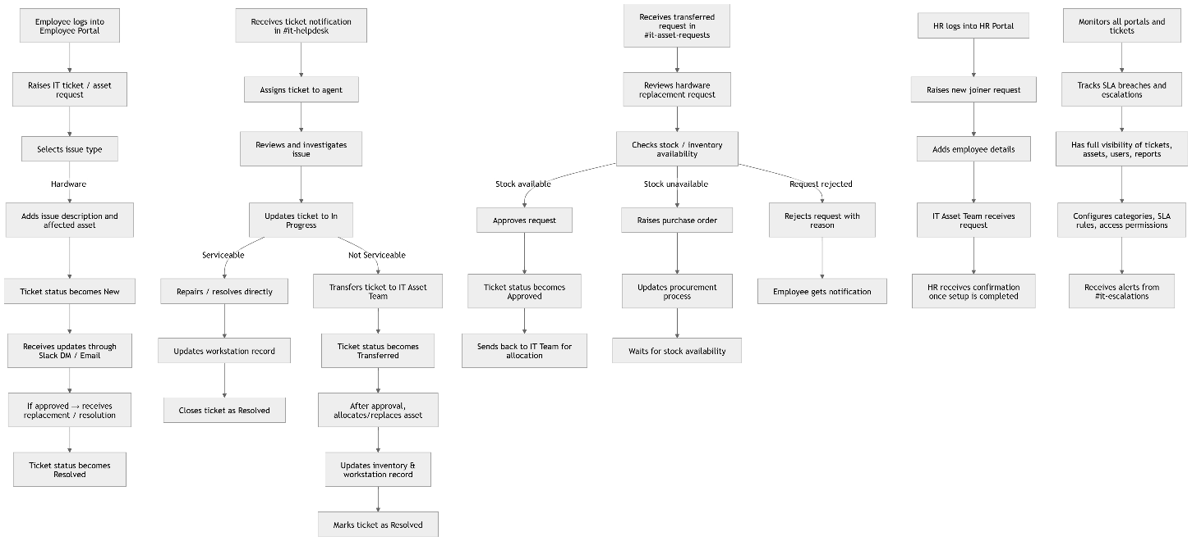

Module-Wise Timeline from May 18 to June 4

S. No | Module Name | Tasks | Timeline (May 18 - June 4) | Developer Name
1 | Employee Role | - Implement ticket system - User authentication - Raise ticket functionality - Test employee workflow | May 18 - May 22 | Sampath& Purushotham
2 | IT Team Role | - Handle ticket assignments - Update ticket status - Resolve issues (Software/Network) - Test IT team workflow | May 23 - May 26 | Sampath& Purushotham
3 | IT Asset Team Role | - Manage hardware requests - Stock check - Raise purchase orders - Allocate assets - Test IT asset handling | May 27 - May 30 | Sampath& Purushotham
4 | HR Team Role | - Process new joiner requests - Ensure asset setup - Confirm IT asset completion | May 31 - June 2 | Sampath& Purushotham
5 | IT Admin Role | - Monitor system - SLA tracking - Configuration management - Final testing of all modules | June 3 - June 4 | Sampath& Purushotham
6 | Integration & Final Testing | - Integration of all roles - Full system testing - Bug fixing - User Acceptance Testing (UAT) | May 30 - June 4 | Sampath& Purushotham
7 | Deployment | - Deployment to production server - Final testing in production - Post-deployment verification | June 4 | Sampath& Purushotham

