Task5: Establish a new directory, populate it with script files, initiate an empty repository on GitHub, convert the local directory into a Git repository, and link it to GitHub for pushing the code into the repository.Perform merge, rebase, stash commands in following github repo.

1. Establish a new directory, populate it with script files, initiate an empty repository on GitHub, convert the local directory into a Git repository, and link it to GitHub for pushing the code into the repository.  
   Commands used:  
   1.create a director: mkdir gittask

2. script file : vi scriptfile.sh

3. created an empty repository gittest in github  
 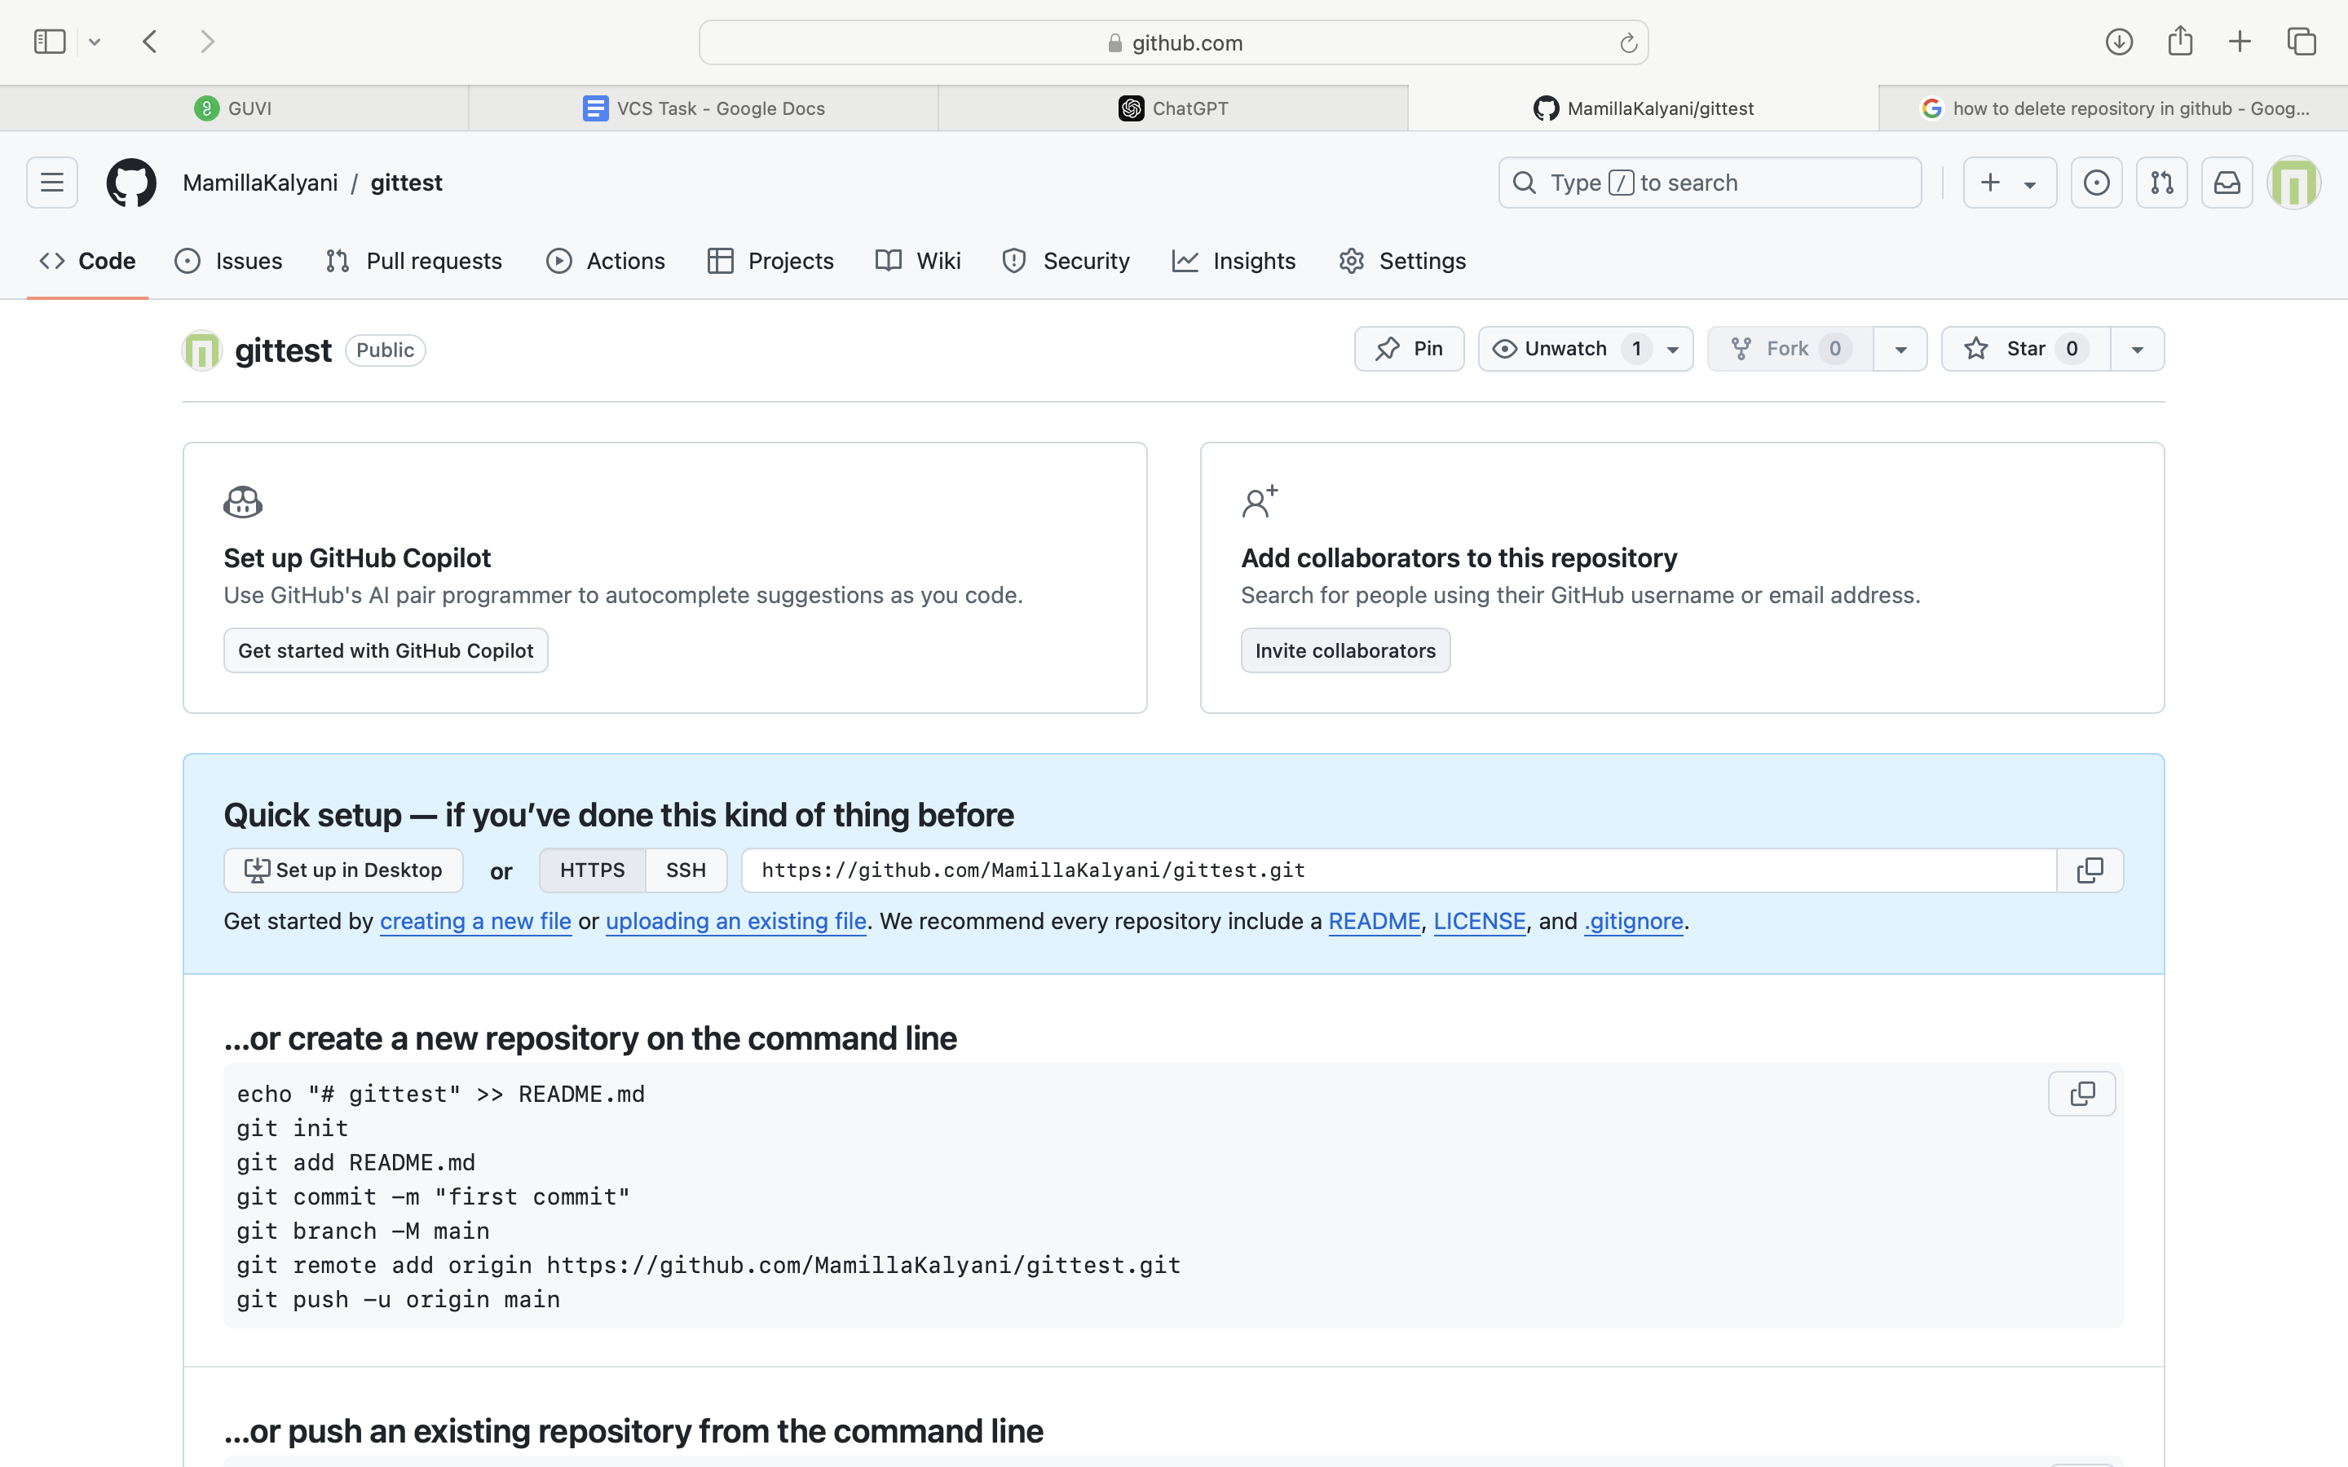

4.convert local directory into git repo: git init

git add . -> to add files to satging area

git commit –m “message” ->commitiing changes made

5. linking local repo to git repo: git remote add origin <https://github.com/MamillaKalyani/gittest.git>

6. to push code from local repo to remote repo  
 git push -u origin master

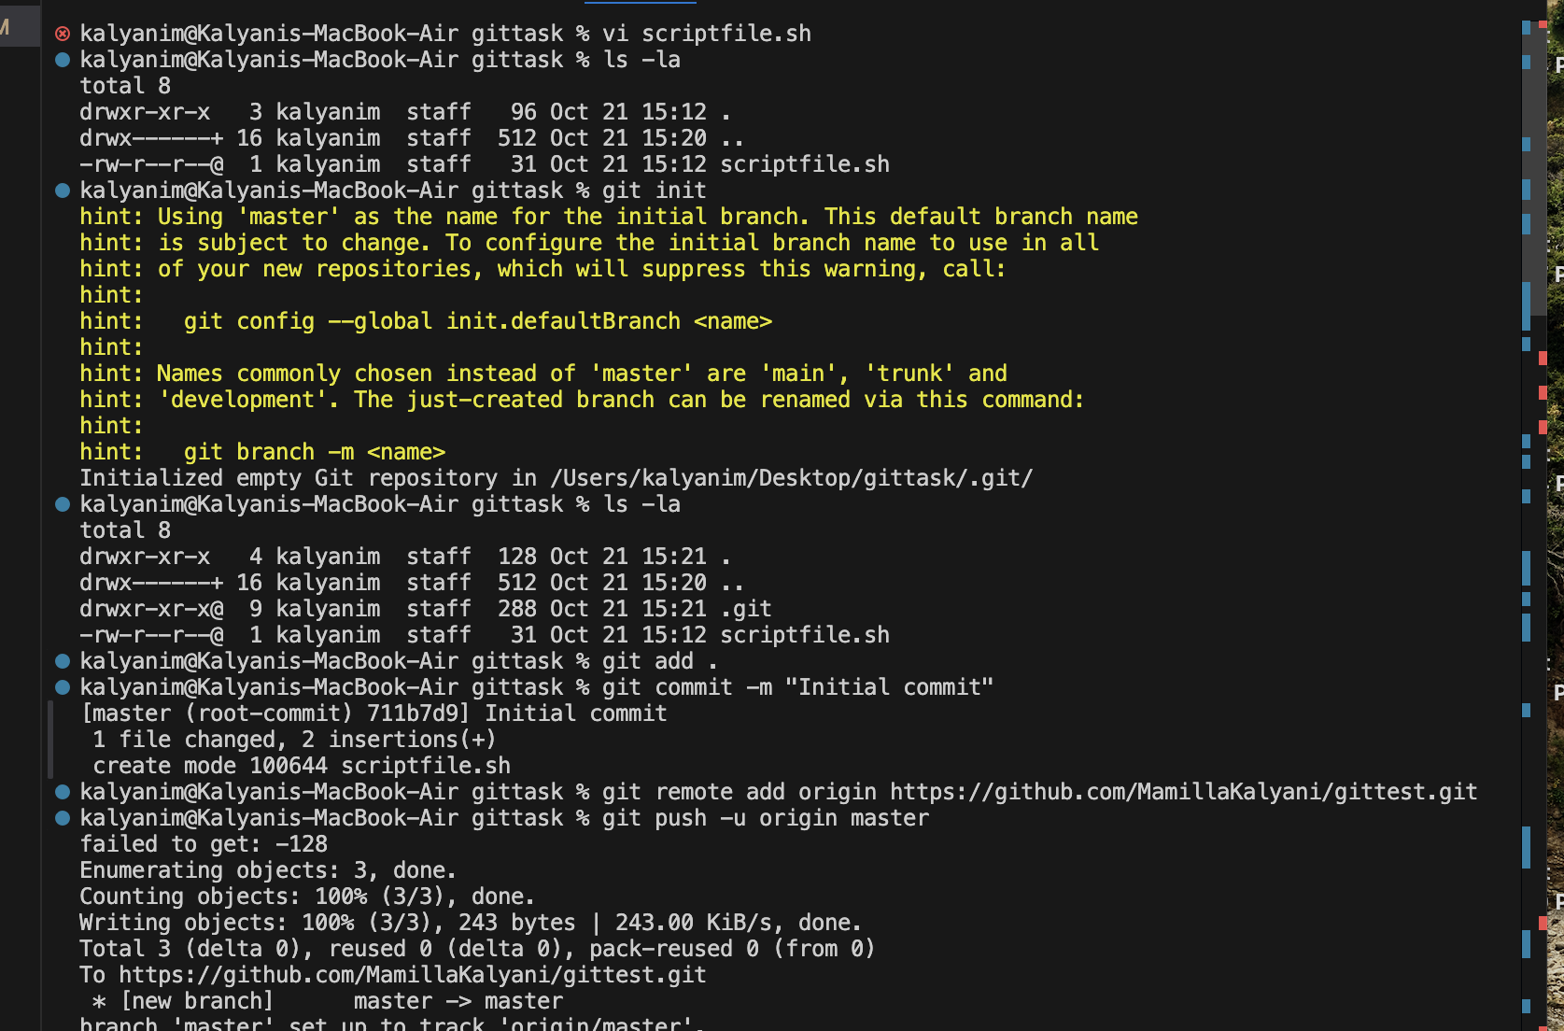

7. To perform merge, rebase and stash:

Merge:

Created a new feature branch -> git checkout -b feature-branch

Made some changes to scriptfile.sh

Navigated back to main branch -> git checkout master

Merge -> git merge feature-branch

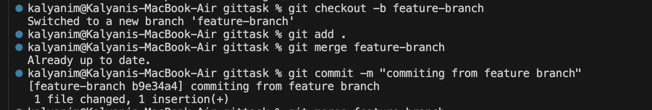

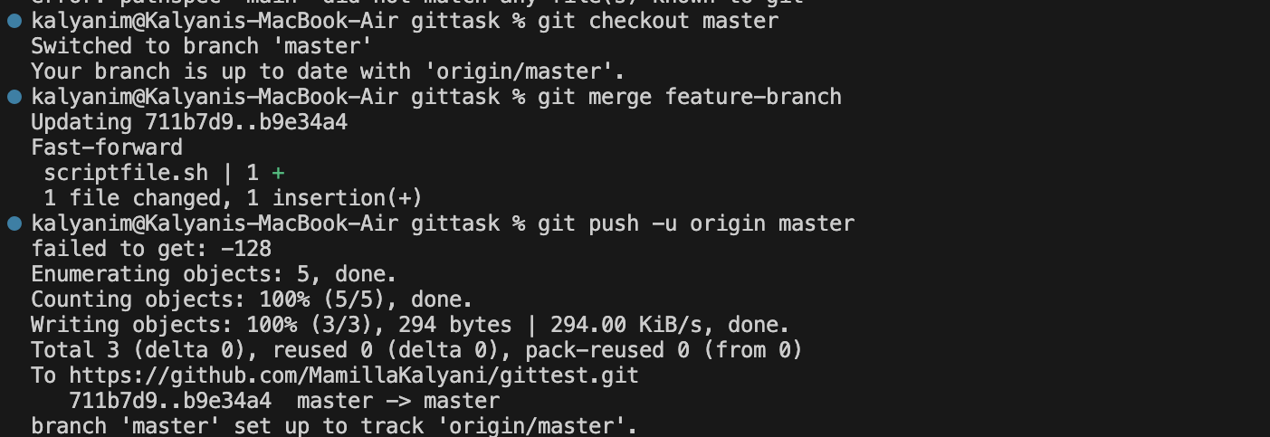  
 Rebase:  
 checkout to feature branch : git checkout feature-branch  
 Made some changes to scriptfile.sh

Navigated back to main branch -> git checkout master

Rebase: git rebase feature-branch

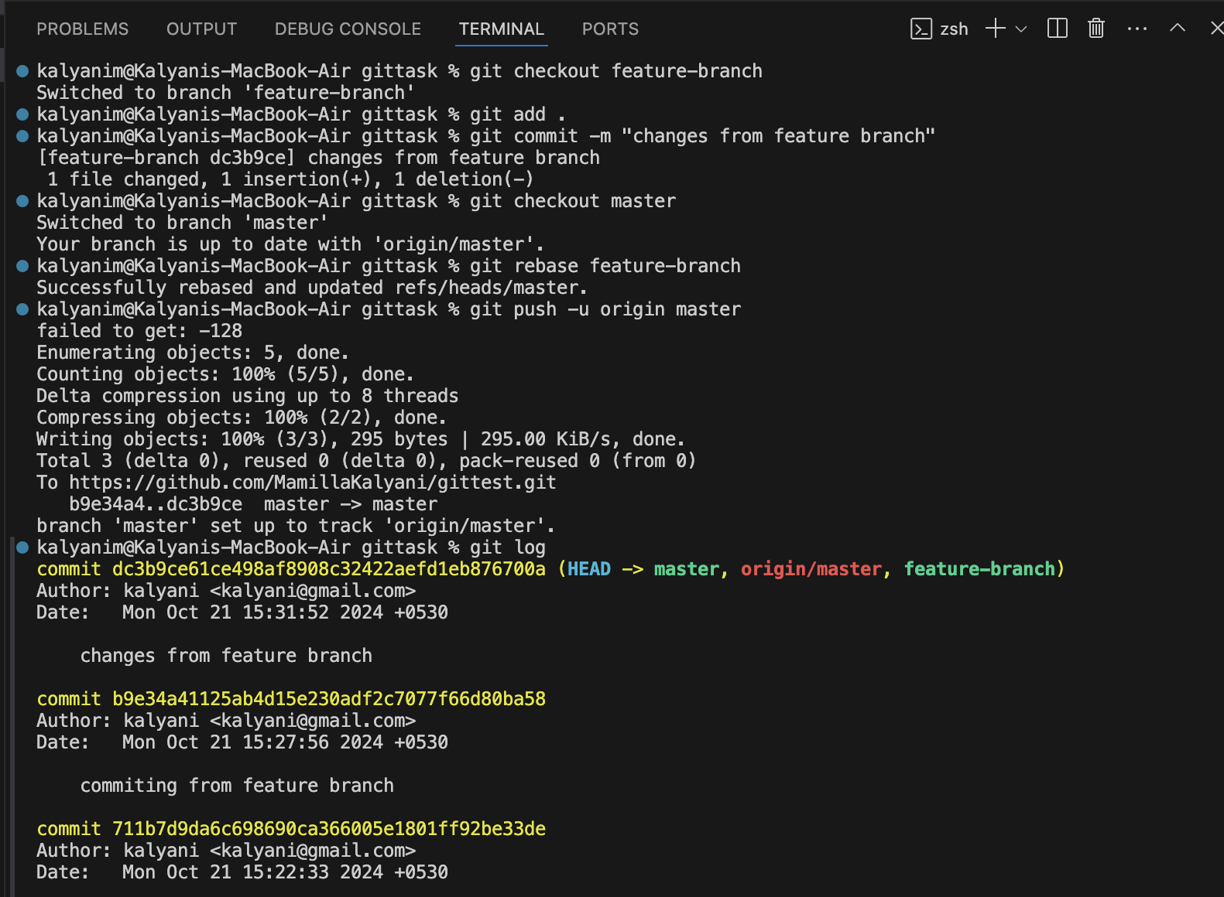

Stash:

Checkout to feature branch -> git checkout feature-branch

Made some changes, instead of adding stashed them-> git stash

To see stashed changes -> git stash pop

To apply stashed changes -> git stash apply

