Task5:

Install docker on EC2 and explore the docker commands (docker images, containers, volumes, network)

Solution:   
1. Created an amazon ec2 instance  
 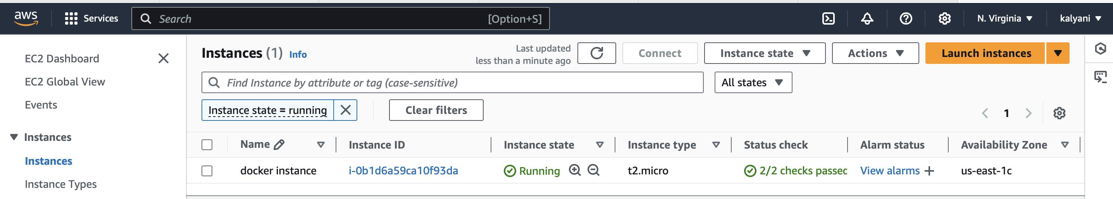

2. Connected through EC2 Instanced connected and followed below commands to install docker in EC2  
 sudo yum update –y

sudo yum install -y docker

sudo service docker start

sudo usermod -a -G docker ec2-user

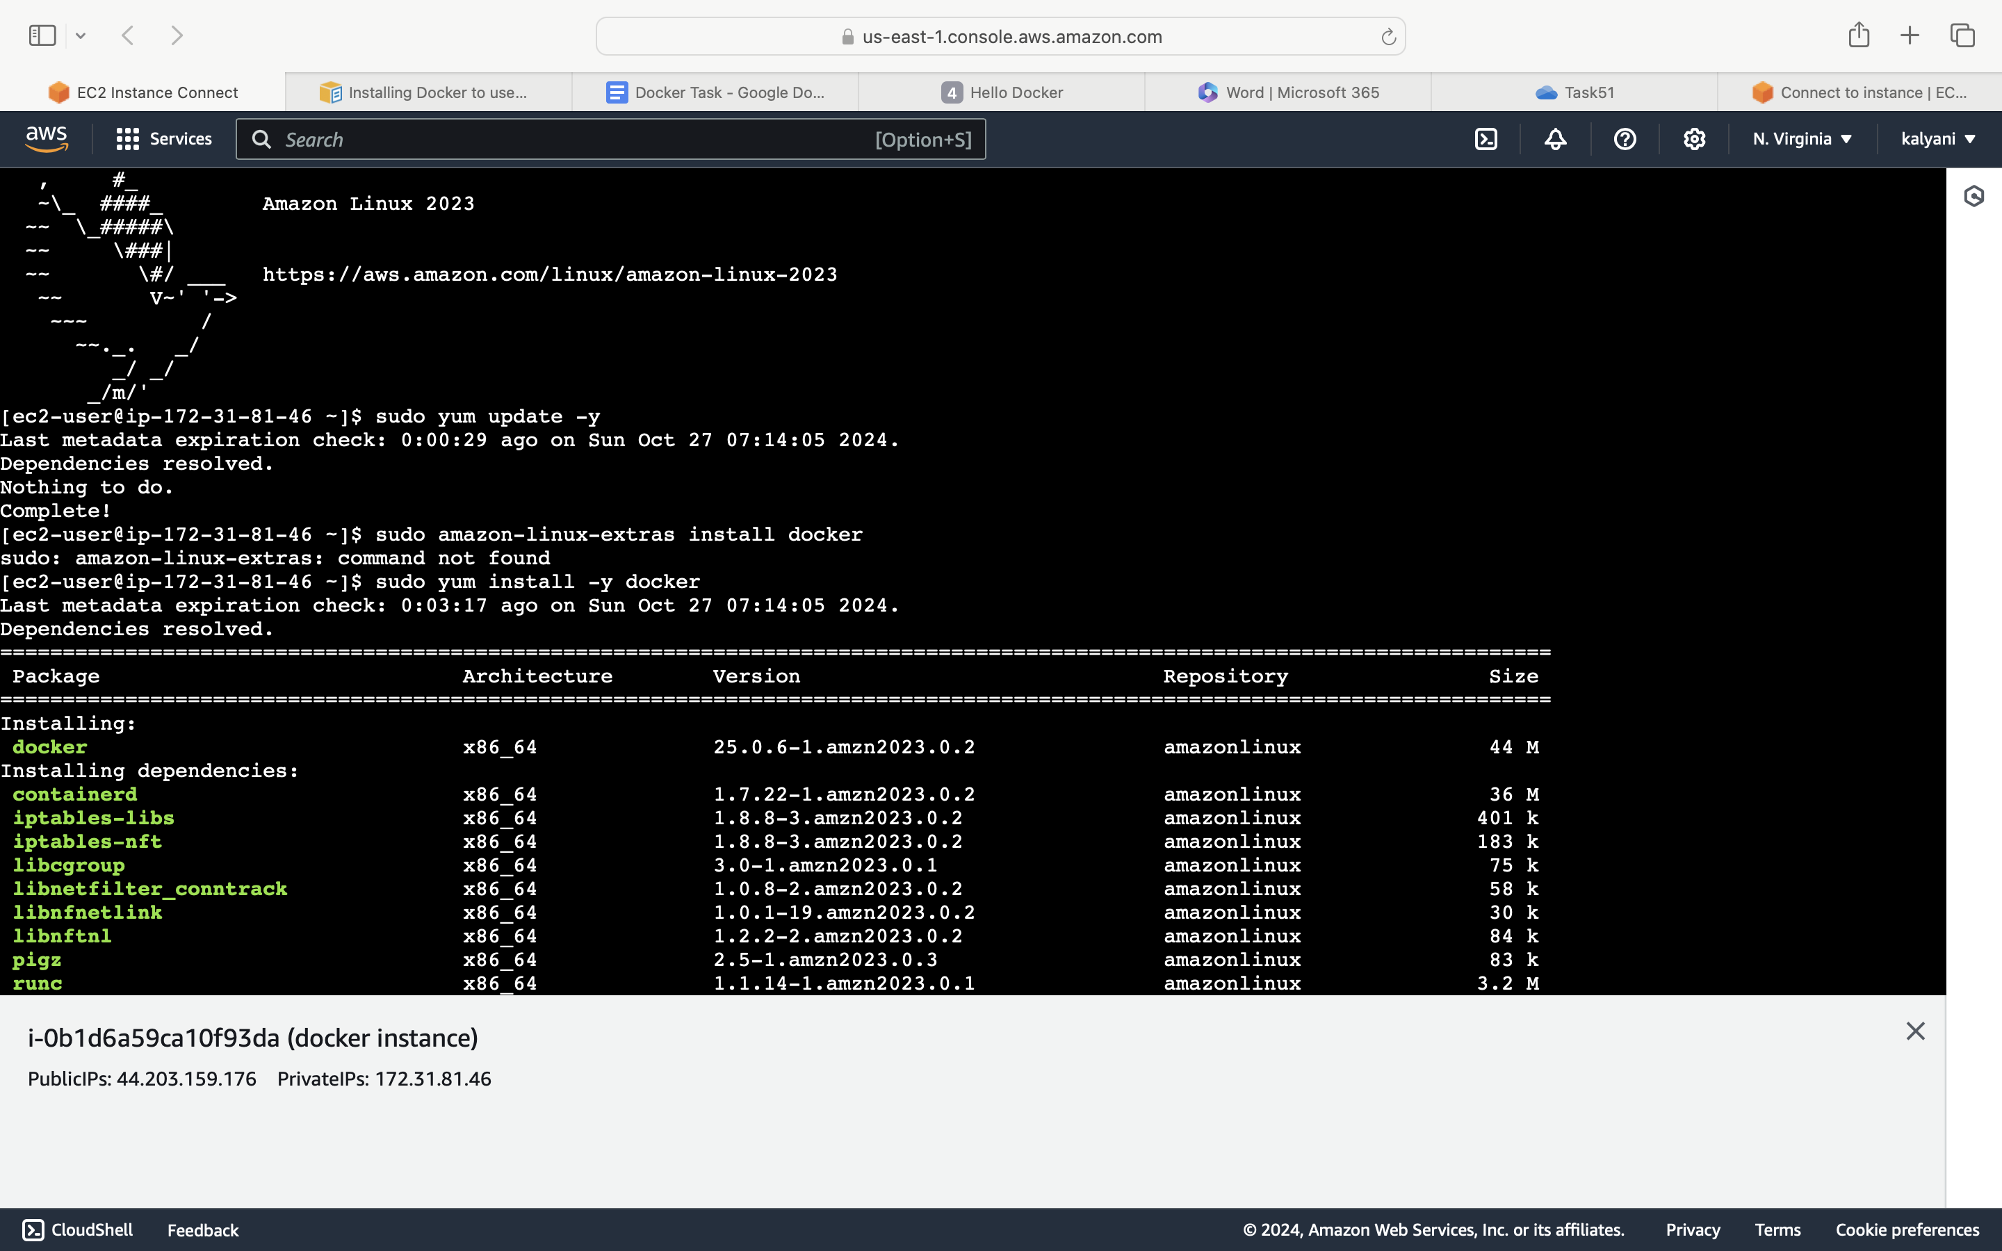 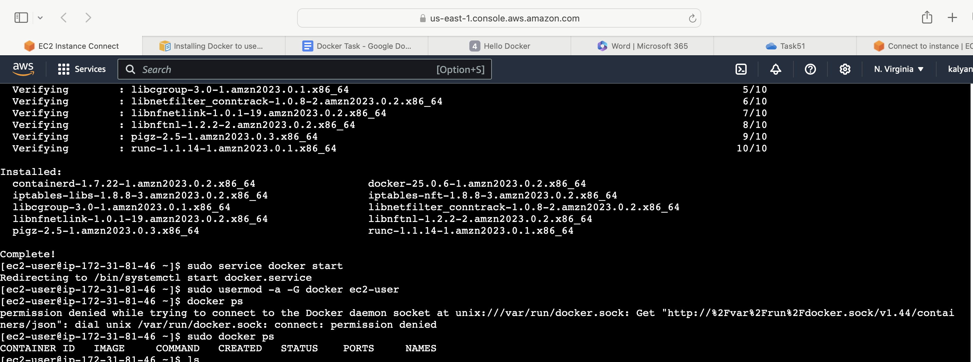

3. Tried running a website by creating index.html and docker file. Below are the commands used

docker build –t simple-nginx-sserver .

docker images  
 docker run –d –p 8080:80 simple-nginx-server

docker ps

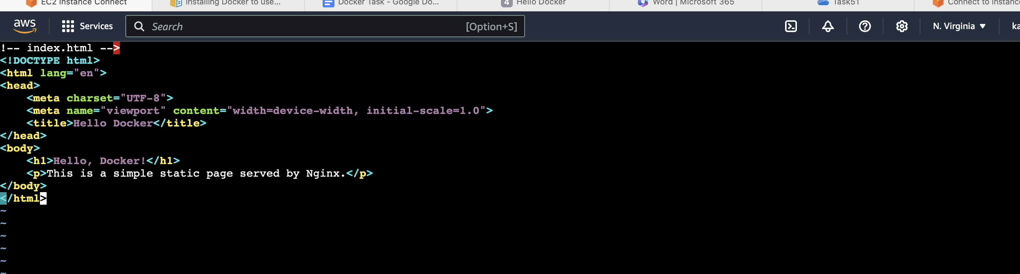

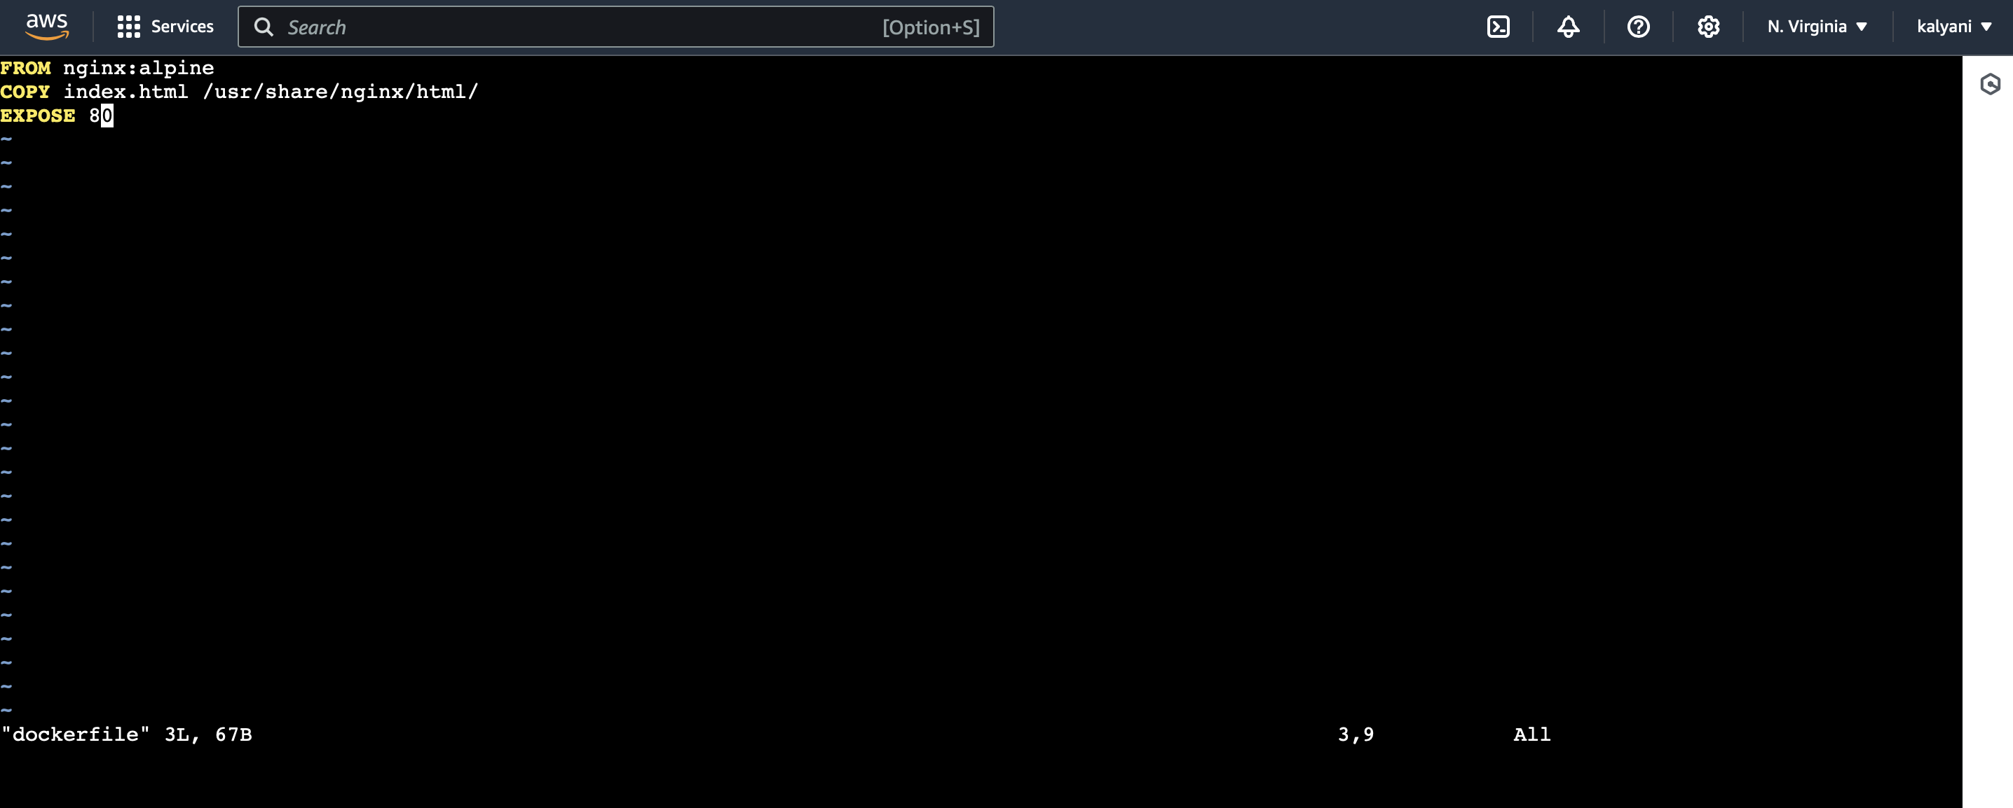

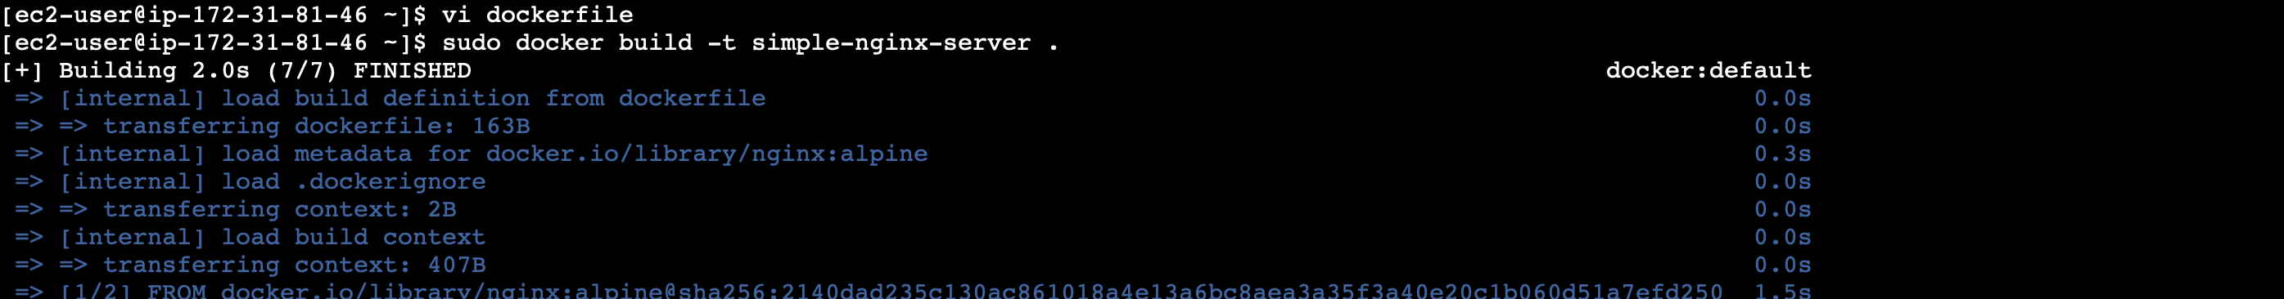

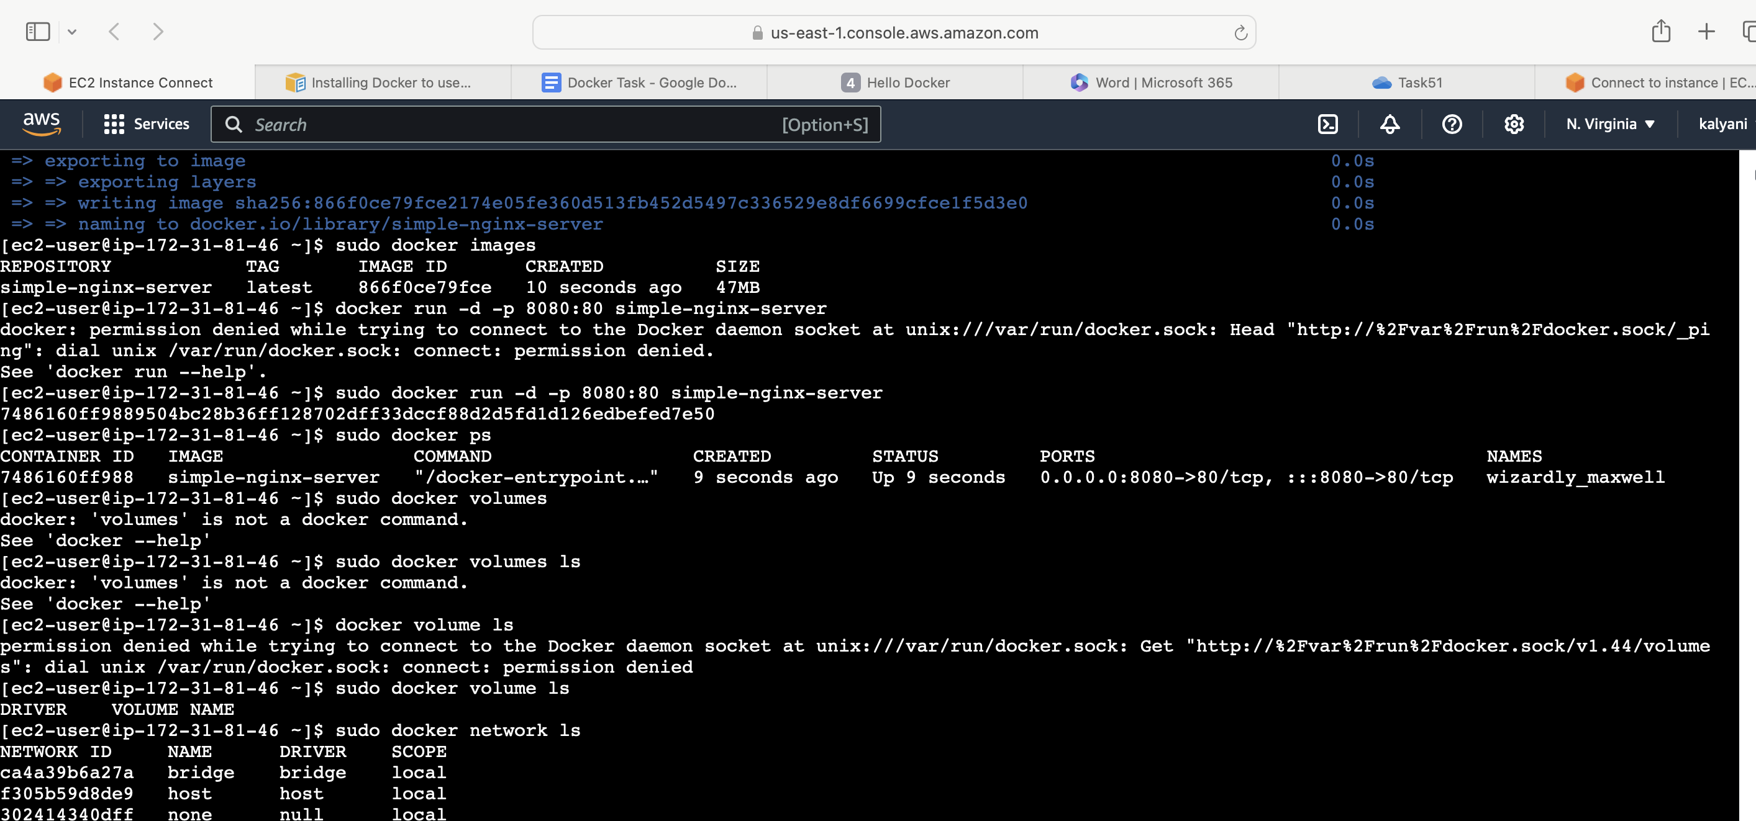

4. you can see application running on <http://44.203.159.176:8080/>

