Task8 : Launch jenkins and explore creating projects and users.

Solution:  
step 1: created an ec2 instances with the below network security group rules

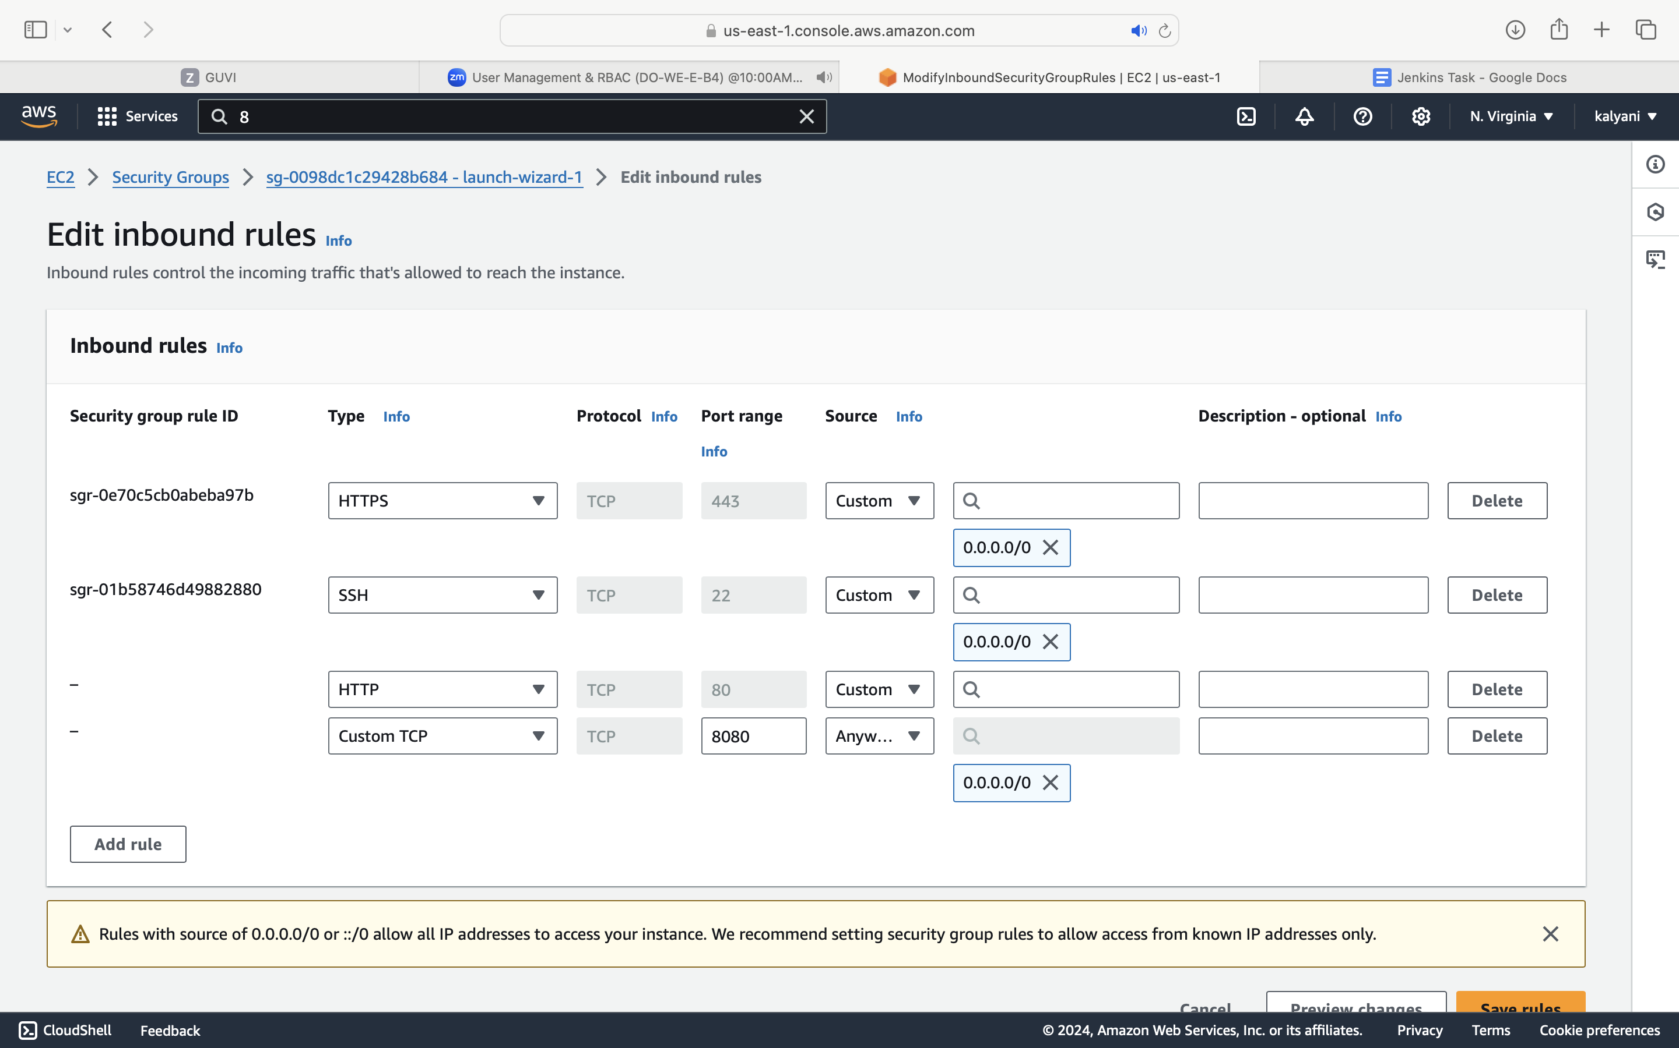

Step2: commands used to set up jenkins in aws  
sudo yum update –y

sudo wget -O /etc/yum.repos.d/jenkins.repo \  
 <https://pkg.jenkins.io/redhat-stable/jenkins.repo>sudo rpm --import <https://pkg.jenkins.io/redhat-stable/jenkins.io-2023.key>sudo yum upgrade

sudo dnf install java-17-amazon-corretto –y

sudo yum install jenkins –y

sudo systemctl enable jenkins

sudo systemctl start jenkins

TO check status of jenkins : sudo systemctl status jenkins

Step 3:  
connected to publicip:8080 to configure into jenkins  
<http://54.81.7.137:8080/>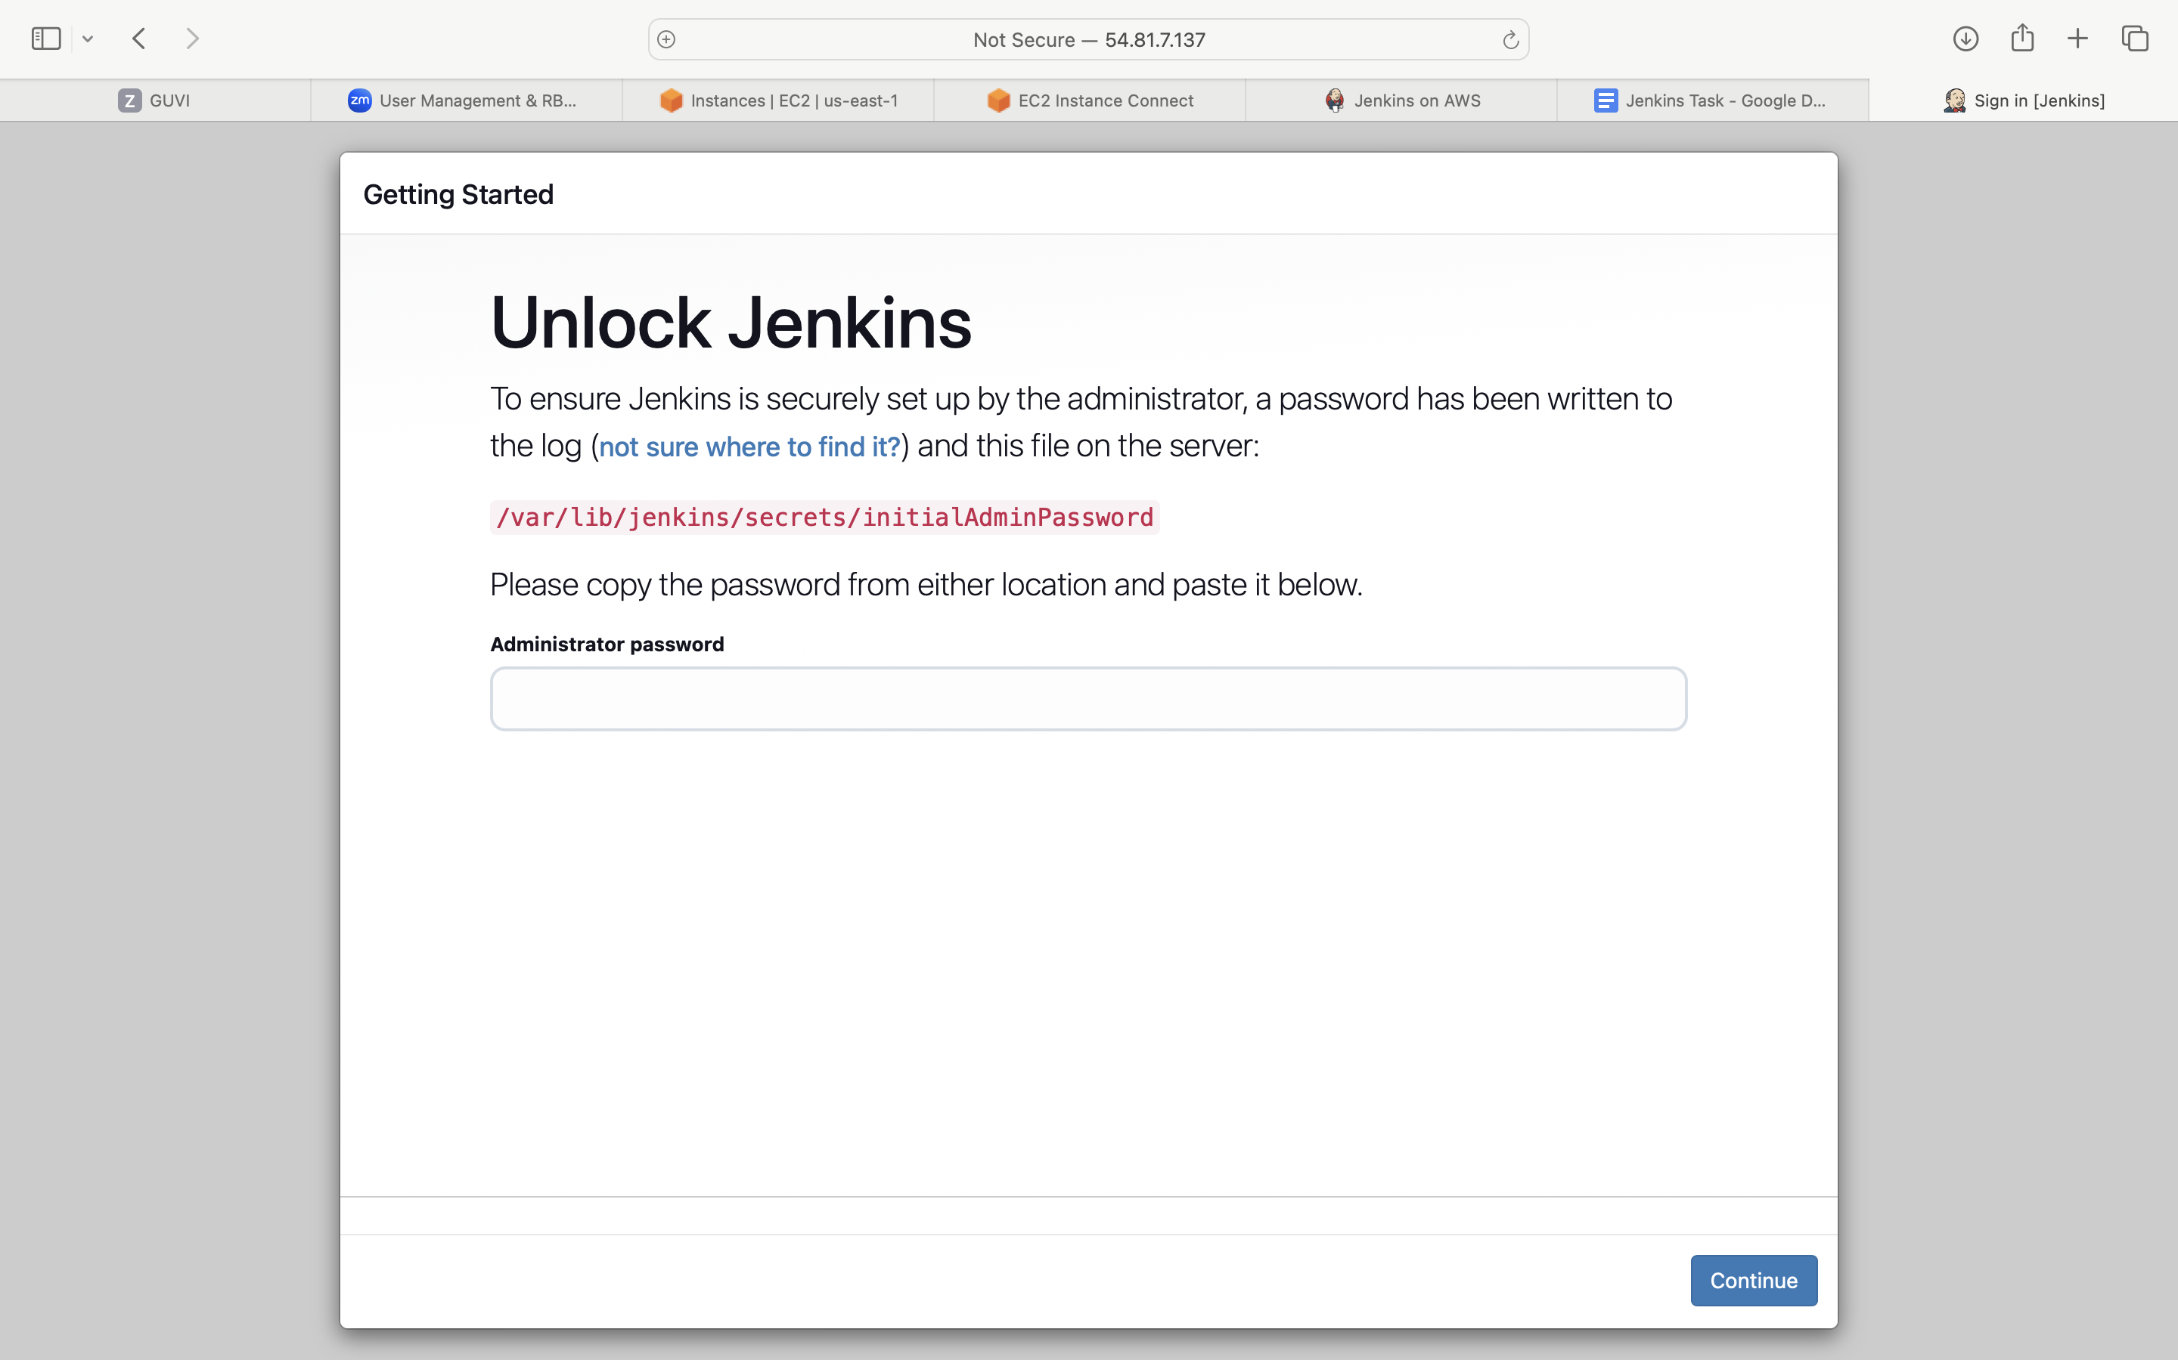

To know password   
sudo cat /var/lib/jenkins/secrets/initialAdminPassword

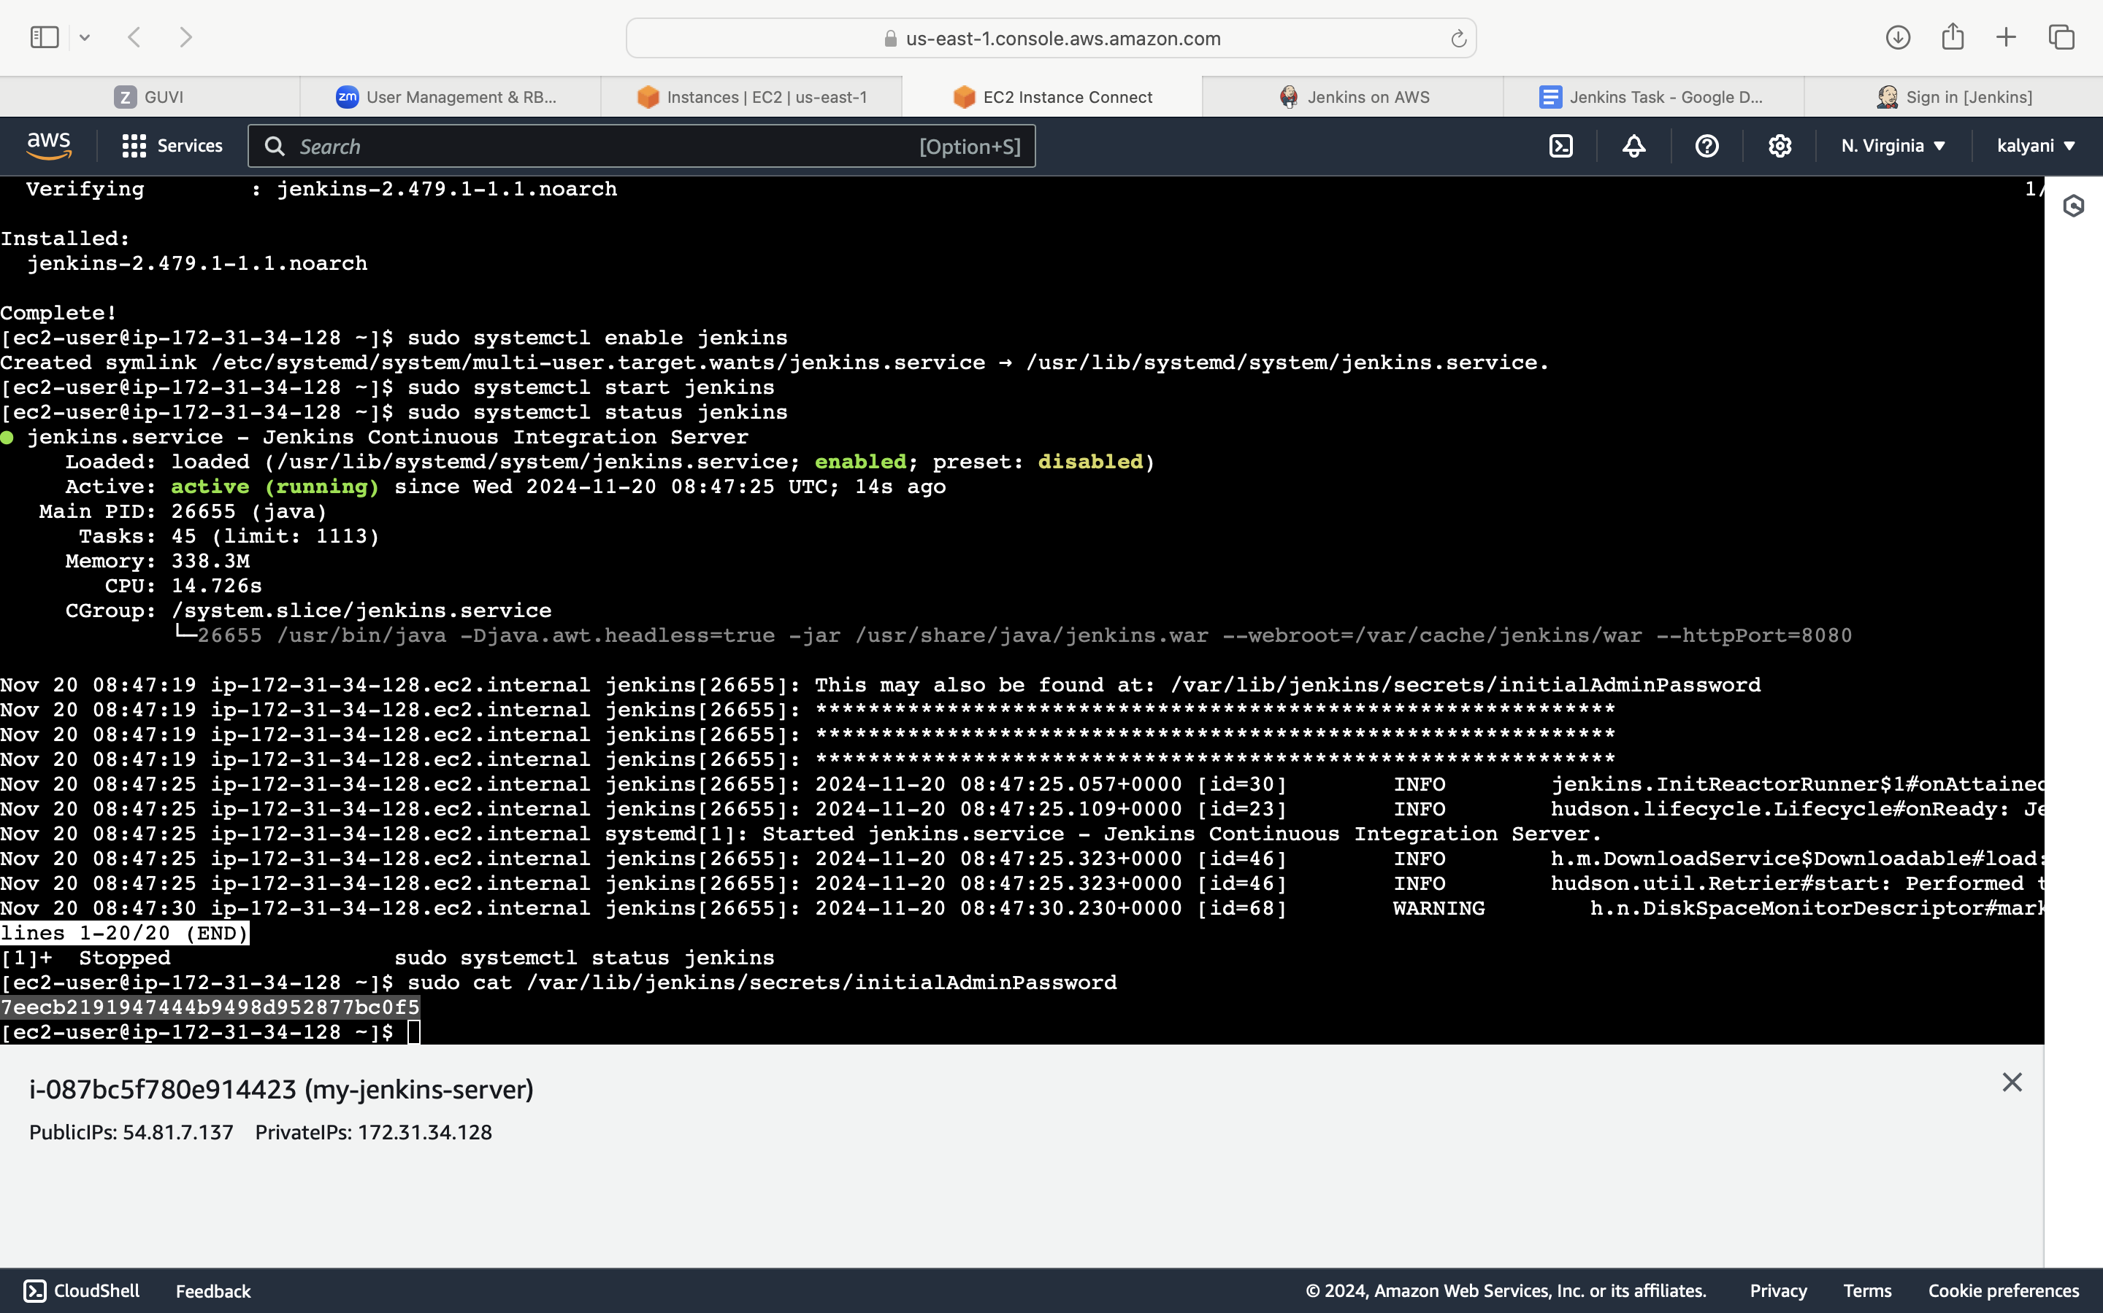

Step 4: Installation created and created first Admin user as shown below  
