Dmitrii Ponomarev

Ec22805@qmul.ac.uk

Abstract

This study provides a comprehensive analysis of global intelligence by looking at the relationships between average IQ scores and various socioeconomic factors on different continents. The average IQ of a country and the continent fluctuates significantly, as I discovered throughout the course of my study. This discrepancy can be explained by economic variables like the demand for resources from other countries and the flow of resources from a country to other countries.

The study uses a combination of statistical and visual tools to find patterns and relationships in the data. The study will highlight the gaps across continents and demonstrate how inexpensive education raises a nation's average IQ.

Global IQ analysis

Table of Contents

Table of abbreviations 1

Chapter 1 Introduction 2

Description 2

Hypothesis 2

Libraries used 2

Data Overview 2

Data limitations 2

Chapter 2 Data analysis 3

Distribution of IQ 3

Human Development Index 4

Gross National Income 5

Life expectancy 6

Chapter 3 Conclusion 7

Chapter 4 Table of figures 8

Chapter 5 References 9

# Table of abbreviations

|  |  |
| --- | --- |
| Abbreviation | Definition |
| HDI | Human development Index |
| GHI | Gross National Income |
| IQ | Intelligence Quotient |
| IQR | Interquartile Range |

# Introduction

## Description

Curios about what variables influence a person's intelligence, I scoured the web for datasets that would assist me identify patterns to answer questions about the distribution of IQ and what characteristics influence it. I combined 2 datasets containing data about Human Development Index (United Nations Development Programme, 2023) and IQ (Data Pandas, 2019) by country to create the final dataframe that I will be analysing.

The reasoning behind choosing those datasets is based on the belief that a detailed knowledge of the counties' aspects may provide insights into the complex relationships that exist between development, education, and general well-being of citizens. Through examining metrics like the life expectancy, the HDI, GNI and others I hope to find relationships and trends that contribute to a more comprehensive understanding of a country's position in the world.

## Hypothesis

I believe there is a positive correlation between 1st and 3rd world countries in their average IQ and other socio-economic factors within the dataset.

## Libraries used

To perform the analysis, I had to use multiple libraries for analysis and visualisation. Pandas to load datasets, merge them together and perform complex queries quickly without using iteration. Matplotlib was used for simple plots, whereas seaborn was used for improved visualisation, as the syntax of it is simpler, but plots are more effective Apart from matrix manipulation, which was utilised for scaling graphs in logarithmic scale, numpy was not heavily used. To make plots of the globe map, I used geopandas to load in country coordinates and outlines, which were then displayed on an interactive plot by plotly express.

## Data Overview

After removing erroneous data and null values, I was left with 157 countries that had information about their region, part of which can be seen in table 1.

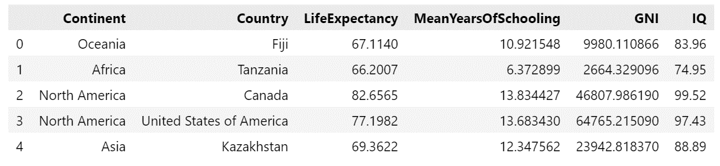

Table - Dataset example

### Data limitations

Although asking everyone on the planet for their IQ and unique living characteristics would be valuable for a thorough examination, it is both impractical and impossible. To overcome such limitations and provide a representative sample, using pre-made datasets from reliable sources such as the UNDP website (United Nations Development Programme, 2023) and others becomes a practical alternative. These datasets are selected, providing a broad comprehensive overview of many countries, allowing for a more efficient and viable examination of socioeconomic variables without the enormous work of evaluating each individual.

# Data analysis

Firstly, I wanted to see the distribution of average IQ amongst all countries visually. By colouring each country on a global IQ map, with yellow representing the most intelligent and black representing the least intelligent, which is shown on Figure 1, we are clearly able to see the differences between continents. There is a significant gap between a first-world country like the United States, where the average IQ is 97.43, and a third-world country like Ghana or Togo, where the average IQ is 58.16 and 59.83, respectively.

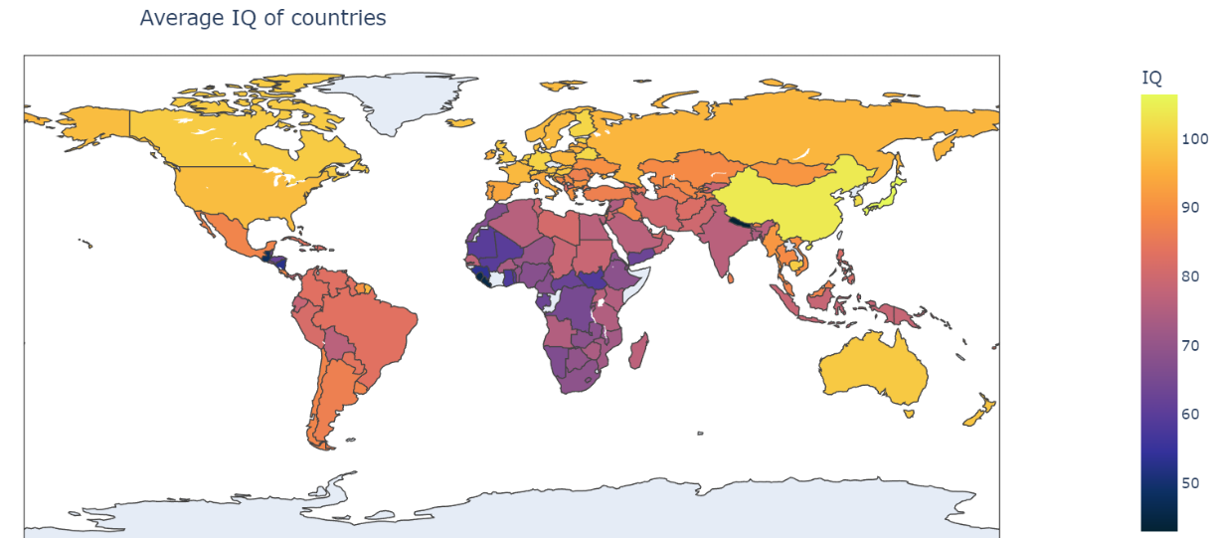

Figure - Coloured world map with countries' IQ

Given that there is a large difference in IQ between India and China (76.24 and 104.1, respectively) within Asia, we cannot conclude that a continent alone drastically affects average IQ levels.

## Distribution of IQ

The distribution of the global average IQ is seen in Figure 3, where more people have IQs between 80 and 90 points, with the global average, according to the dataset, being 82 points. Examining closely by breaking down the continents, we can find that Asia has three nations with the highest average IQs: Japan, China, and South Korea, with 106.48, 104.10, and 102.35, respectively. Out of all the continents, Europe has the highest average IQ. It's significant to notice that North America has the highest IQR, suggesting that the many socioeconomic features play a huge role affecting citizens’ IQ levels which may not be included in the dataset.

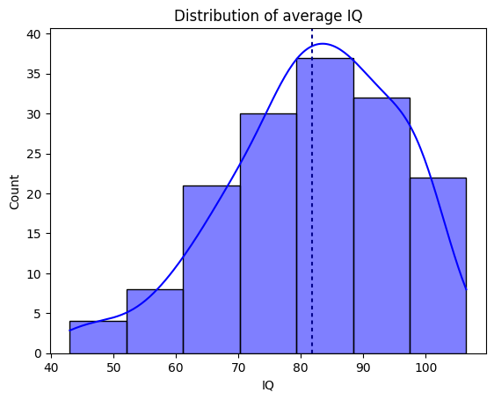

Figure - Distribution of average IQ

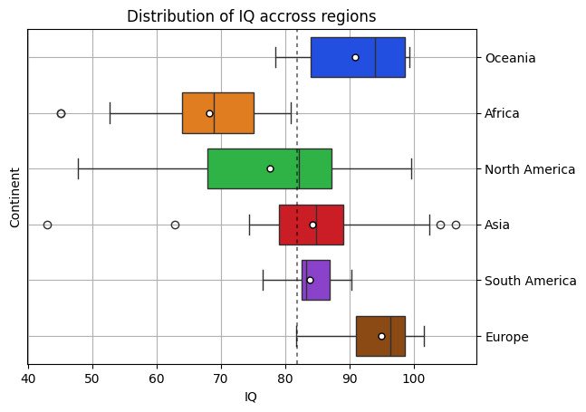

Figure - Distribution of IQ for every region

## Human Development Index

To understand how HDI affects IQ, we should look at each continent separately.

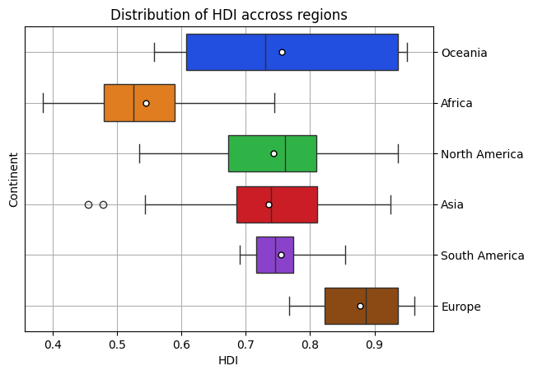

Figure - Distribution of HDI across continents

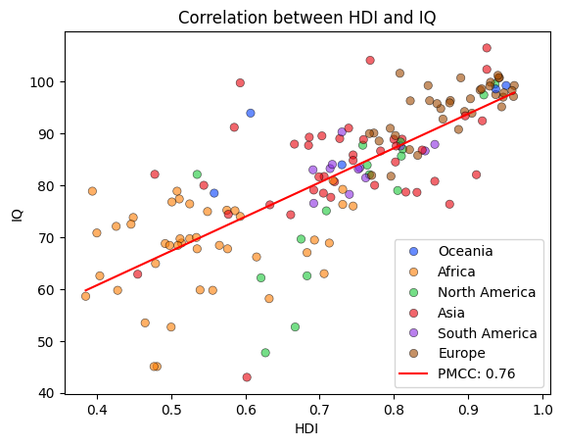

Figure - Correlation between HDI and IQ coloured by continent

Figure 4 shows that Asia has the greatest differences between average HDI. It is also the only continent to have outliers. This implies that Asia doesn’t have equal distributions of income, life expectancy, or mean years of schooling due to external circumstances that are not present in this dataset. Figure 5 support this, where countries in Asia range from 0.455 in Yamen to 0.925 in Japan. It also shows that most countries in Europe and Oceania are above the regression line, meaning that those countries have higher IQ than the model suggests. In this context, these data points reflect countries with higher average IQ scores than predicted by the linear regression model, given their degree of human development. Deviations from the regression line of this kind imply that factors other than human growth, such as well-functioning educational systems or cultural influences, are responsible for the higher IQs in these particular nations. Unfortunately, due to the lack of data we aren’t able to see what exactly causes the differences in HDI in neighbouring countries. This would be a great idea for the next project if I were to start all over again.

## Gross National Income

By exploring the relationship between GNI and HDI, we can see that there is a strong positive correlation between those factors, meaning that countries that generate more money from within and by outside trading tend to have a better development.

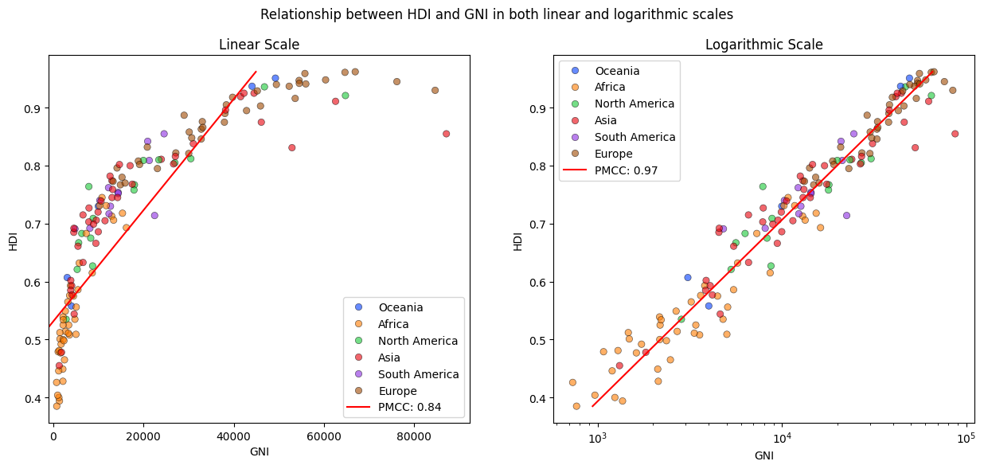

Figure - Relationship between GNI and HDI in both linear and logarithmic scales

This research reveals an important and complicated link between overall human development and economic performance, with a remarkable 0.97 correlation coefficient between GNI and HDI. Figure 6 displays a close clustering of data points to graphically represent the relationship. We can easily see that Africa has the lowest average GNI as a continent, implying that most countries there earn little revenue from people and companies, as there isn't much a country can give to its residents or tourists. This is likely to result in fewer budget for schooling, as poorer countries cannot afford to spend as much as wealthier countries on free education, hence the average IQ and length of education is lower.

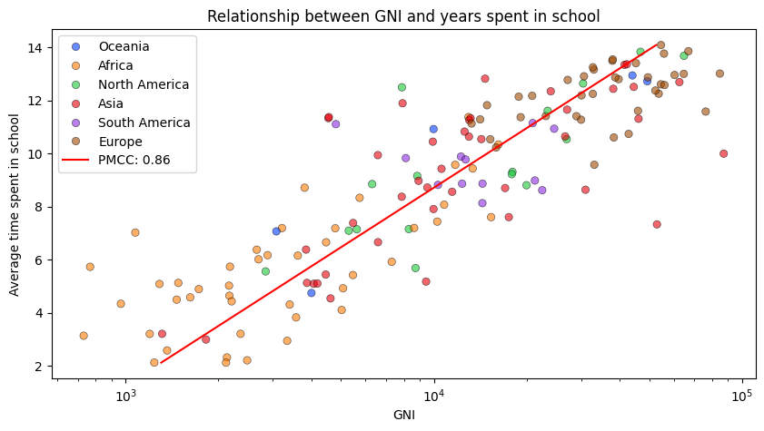

Figure - Relationship between GNI and average time spent in school

As seen from on a figure 7, the pattern repeats: Africa has the lowest GNI, which directly impacts how much time people in those countries are able to spend on education for citizens. Strong positive correlation implies that for countries to double their average time spent in school, they would need to increase their GNI by nearly ten times, as the graph is in logarithmic scale.

## Life expectancy

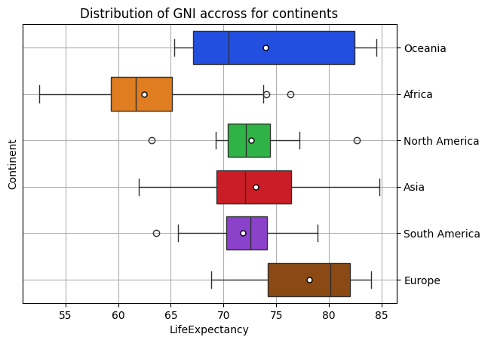

Figure - Distribution of GNI by country

Figure 8 reveals a similar trend of content distribution: Europe, Oceania, and Asia are the top three continents for dependent variables. Both Americas had the lowest IQR, implying that they are similar in terms of health care, other socioeconomic circumstances, and lifestyle patterns that are too extensive to include in the dataset.

Figure 9 clearly shows countries organised into clusters, the largest of which being Africa, where the majority of the countries fall below the expected model. It implies that such countries' life expectancy is lower than anticipated, but so is their IQ. The graph demonstrates that there are several elements that were not considered in the study and that should be improved by integrating more datasets if I were do the project all over again.

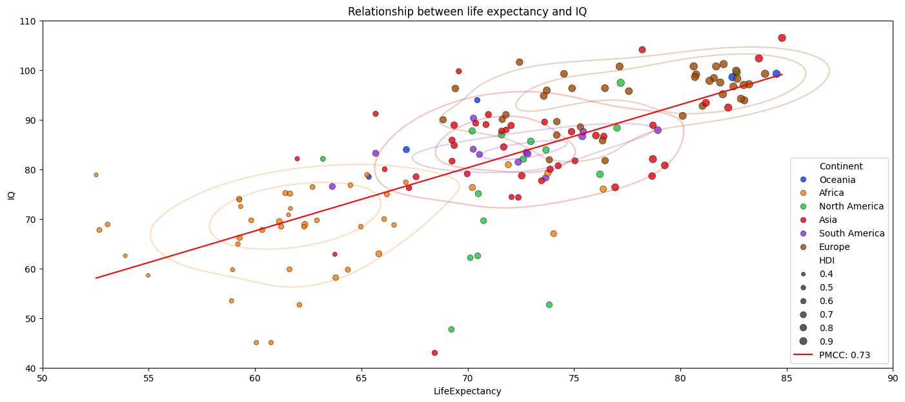

Figure - Relationship between life expectancy and IQ

Looking at clusters themselves, which are approximated with kde plot, we can notice that Asia has the most average life expectancy with a lot of outliers on both sides. Afghanistan, Pakistan and India, where it is uncommon to live in highly polluted area with poor medical help (Bhutto, 2023), are on the lower end of the scale on life expectancy, yet their IQ are around 80 points which is just below global average. This suggests that Life expectancy correlates to average IQ but doesn’t necessarily have the biggest impact or even a causation, as studies have shown that age doesn’t necessarily affect IQ (Dickinson & Hiscock, 2010).

# Conclusion

To summarise, there is a correlation between the 1st and 3rd world countries in terms of IQ and how various socio-economic factors affect them. A comprehensive analysis shows that Africa is consistently the last in the rating comparing in any analysis due to its lack of resources to trade with other countries and lack of tourism. The research shows that there is a strong correlation between economic success and overall human development, with a strong positive correlation of 0.97, which implies that countries with more money earned can spend more into human development, which leads to people being able to spend more time in school rather than going to work early in life to support their families.

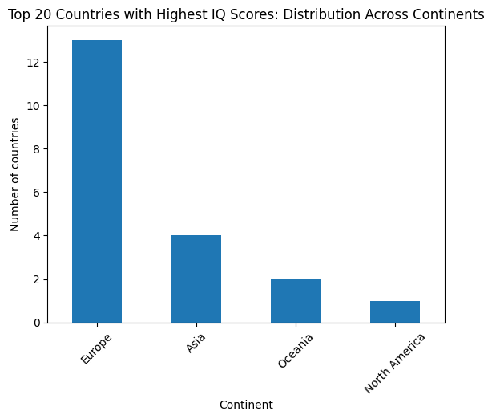

Figure - top 20 countries with highest IQ scores: distribution across continents

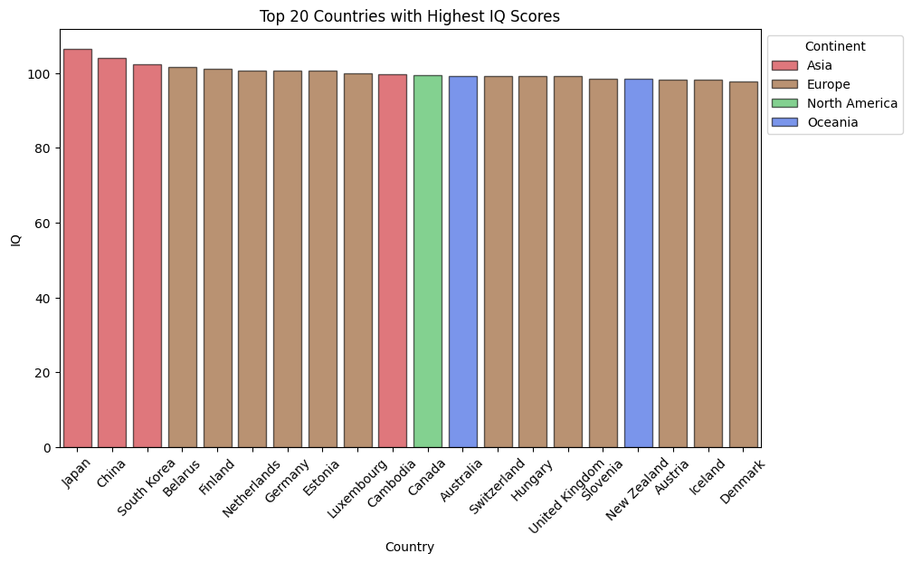

Figure - top 20 counties with the highest IQ scores

Even though Asia has three countries with the highest average IQ on the planet, Europe has more countries in the top 20 with the highest IQ scores than Asia, Oceania, and North America combined, implying that education in Europe is of higher quality than anywhere else, most likely because many countries in Europe have free or very affordable education ( Study.eu Team, 2023), allowing students in those countries to gain more knowledge and experience than in other countries.

# Table of figures

[Figure 1 - Coloured world map with countries' IQ 3](https://qmulprod-my.sharepoint.com/personal/ec22805_qmul_ac_uk/Documents/Documents/Year%202/Software%20Practices/ProfessionalSoftwareModule/FinalProject/Report/Report%20(2).docx#_Toc154360714)

[Figure 2 - Distribution of average IQ 3](https://qmulprod-my.sharepoint.com/personal/ec22805_qmul_ac_uk/Documents/Documents/Year%202/Software%20Practices/ProfessionalSoftwareModule/FinalProject/Report/Report%20(2).docx#_Toc154360715)

[Figure 3 - Distribution of IQ for every region 3](https://qmulprod-my.sharepoint.com/personal/ec22805_qmul_ac_uk/Documents/Documents/Year%202/Software%20Practices/ProfessionalSoftwareModule/FinalProject/Report/Report%20(2).docx#_Toc154360716)

[Figure 4 - Distribution of HDI across continents 4](https://qmulprod-my.sharepoint.com/personal/ec22805_qmul_ac_uk/Documents/Documents/Year%202/Software%20Practices/ProfessionalSoftwareModule/FinalProject/Report/Report%20(2).docx#_Toc154360717)

[Figure 5 - Correlation between HDI and IQ coloured by continent 4](https://qmulprod-my.sharepoint.com/personal/ec22805_qmul_ac_uk/Documents/Documents/Year%202/Software%20Practices/ProfessionalSoftwareModule/FinalProject/Report/Report%20(2).docx#_Toc154360718)

[Figure 6 - Relationship between GNI and HDI in both linear and logarithmic scales 5](https://qmulprod-my.sharepoint.com/personal/ec22805_qmul_ac_uk/Documents/Documents/Year%202/Software%20Practices/ProfessionalSoftwareModule/FinalProject/Report/Report%20(2).docx#_Toc154360719)

[Figure 7 - Relationship between GNI and average time spent in school 5](https://qmulprod-my.sharepoint.com/personal/ec22805_qmul_ac_uk/Documents/Documents/Year%202/Software%20Practices/ProfessionalSoftwareModule/FinalProject/Report/Report%20(2).docx#_Toc154360720)

[Figure 8 - Distribution of GNI by country 6](https://qmulprod-my.sharepoint.com/personal/ec22805_qmul_ac_uk/Documents/Documents/Year%202/Software%20Practices/ProfessionalSoftwareModule/FinalProject/Report/Report%20(2).docx#_Toc154360721)

[Figure 9 - Relationship between life expectancy and IQ 6](https://qmulprod-my.sharepoint.com/personal/ec22805_qmul_ac_uk/Documents/Documents/Year%202/Software%20Practices/ProfessionalSoftwareModule/FinalProject/Report/Report%20(2).docx#_Toc154360722)

[Figure 11 - top 20 countries with highest IQ scores: distribution across continents 7](https://qmulprod-my.sharepoint.com/personal/ec22805_qmul_ac_uk/Documents/Documents/Year%202/Software%20Practices/ProfessionalSoftwareModule/FinalProject/Report/Report%20(2).docx#_Toc154360723)

[Figure 10 - top 20 counties with the highest IQ scores 7](https://qmulprod-my.sharepoint.com/personal/ec22805_qmul_ac_uk/Documents/Documents/Year%202/Software%20Practices/ProfessionalSoftwareModule/FinalProject/Report/Report%20(2).docx#_Toc154360724)

[Table 1 - Dataset example 2](https://qmulprod-my.sharepoint.com/personal/ec22805_qmul_ac_uk/Documents/Documents/Year%202/Software%20Practices/ProfessionalSoftwareModule/FinalProject/Report/Report%20(2).docx#_Toc154257536)

# References

Study.eu Team, 2023. *Study in Europe for free (or low tuition fees).* [Online]   
Available at: https://www.study.eu/article/study-in-europe-for-free-or-low-tuition-fees  
[Accessed 23 December 2023].

Bhutto, A. W., 2023. *Air Quality Woes: A Joint Struggle for India and Pakistan.* [Online]   
Available at: https://thediplomat.com/2023/11/air-quality-woes-a-joint-struggle-for-india-and-pakistan/#:~:text=The%20healthcare%20systems%20in%20both,existing%20and%20emerging%20health%20issues  
[Accessed 10 December 2023].

Data Pandas, 2019. *Countries by Average IQ.* [Online]   
Available at: https://www.datapandas.org/ranking/average-iq-by-country#methodology  
[Accessed 04 December 2023].

Dickinson, M. D. & Hiscock, M., 2010. *Age-related IQ decline is reduced markedly after adjustment for the Flynn effect.* [Online]   
Available at: https://pubmed.ncbi.nlm.nih.gov/20349385/  
[Accessed 18 December 2023].

Eppig, C., 2011. *Why Is Average IQ Higher in Some Places?.* [Online]   
Available at: https://www.scientificamerican.com/article/why-is-average-iq-higher-in-some-places/\  
[Accessed 20 January 2023].

Investopedia, 2023. *What Is the Human Development Index (HDI)?.* [Online]   
Available at: https://www.investopedia.com/terms/h/human-development-index-hdi.asp  
[Accessed 15 December 2023].

Korolivska, A., 2019. *The Power of Logarithmic Scale.* [Online]   
Available at: https://dataclaritycorp.com/the-power-of-logarithmic-scale/  
[Accessed 5 December 2023].

Mlippo, 2023. *Average global IQ per country with other stats.* [Online]   
Available at: 25  
[Accessed https://www.kaggle.com/datasets/mlippo/average-global-iq-per-country-with-other-stats November 2023].

United Nations Development Programme, 2023. *Human Development Index (HDI).* [Online]   
Available at: https://hdr.undp.org/data-center/human-development-index#/indicies/HDI  
[Accessed 05 December 2023].