# Q1 - Simulation Report

## part a)

Diagram of the left topology:

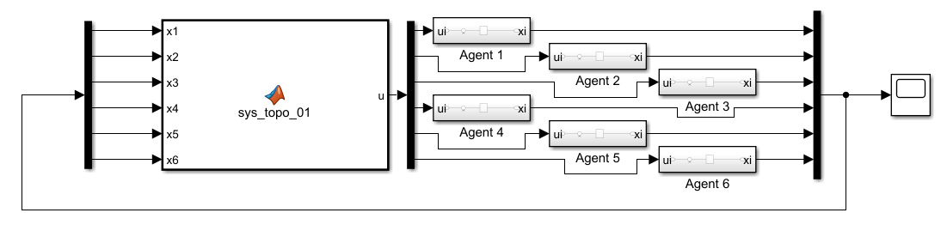

Each agent dynamics is implemented as follows:

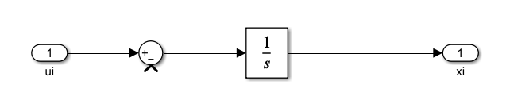

The MAS dynamics could be implemented as follows. First, laplacian matrix is formed based on the given topology. Then the control signal is generated using U = -LX.

function u = sys_topo_01(x1, x2, x3, x4, x5, x6)

L = [ 0 0 0 0 0 0;

-1 +1 0 0 0 0;

0 -1 +1 0 0 0;

0 0 -1 +1 0 0;

0 0 -1 -1 +2 0;

0 0 0 0 -1 +1;

];

states = [x1, x2, x3, x4, x5, x6]';

u = -L*states;

end

Note that the initial conditions of the agents are set as follows: 10 , 1 , 2 , 3 , 4 , 5

The consensus is reached as in the following figure.

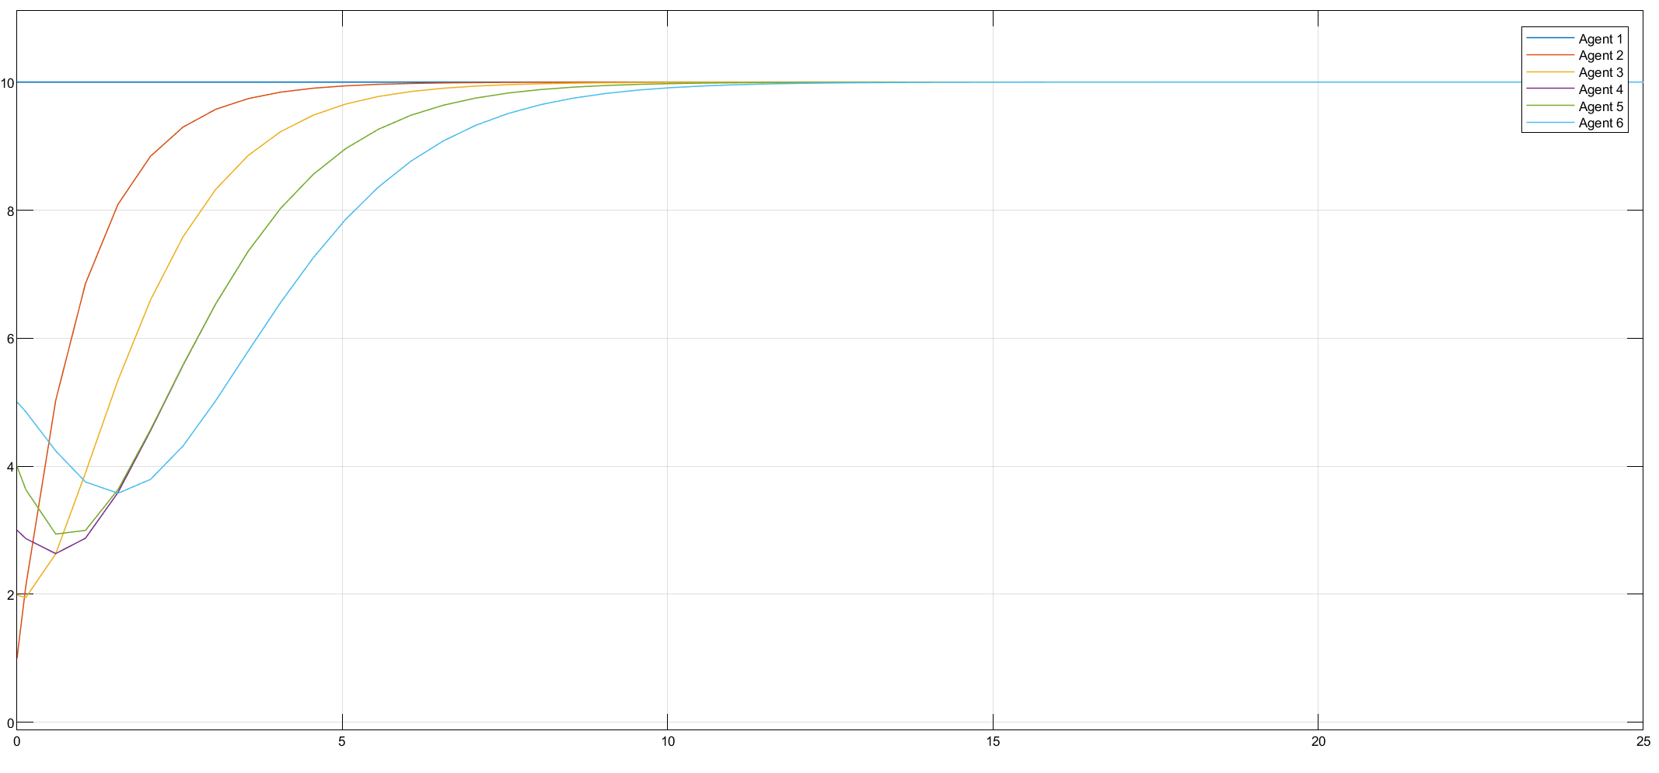

Diagram of the right topology:

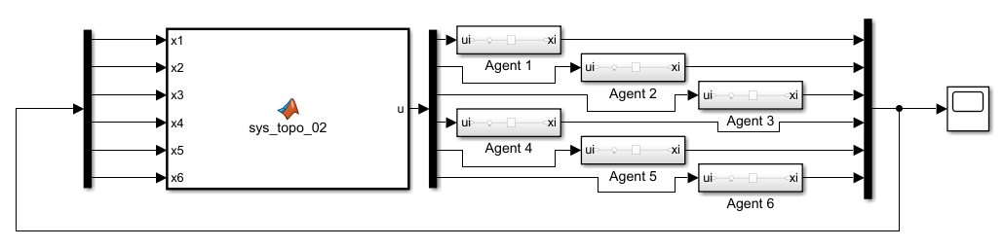

Each agent dynamics is implemented as follows:



The MAS dynamics could be implemented as follows. First, laplacian matrix is formed based on the given topology. Then the control signal is generated using U = -LX.

function u = sys_topo_02(x1, x2, x3, x4, x5, x6)

L = [+1 0 0 0 0 -1;

-1 +1 0 0 0 0;

0 -1 +1 0 0 0;

0 0 -1 +1 0 0;

0 0 0 -1 +1 0;

0 0 0 0 -1 +1;

];

states = [x1, x2, x3, x4, x5, x6]';

u = -L*states;

end

Note that the initial conditions of the agents are set as follows: 10 , 1 , 2 , 3 , 4 , 5

The consensus is reached as in the following figure.

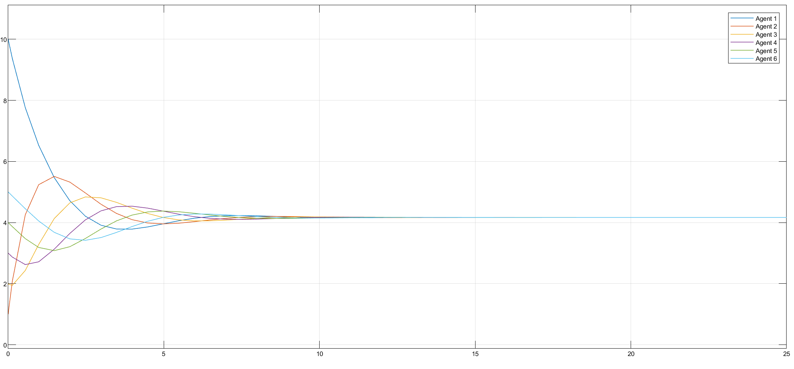

## part b)

Diagram of the left topology:

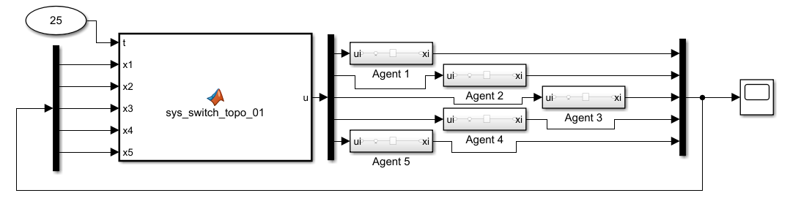

Each agent dynamics is implemented as follows:



The MAS dynamics could be implemented as follows. First, laplacian matrix is formed based on the given topology. Then the control signal is generated using U = -LX

In order to switch between topologies every 2s, we could use the clock block to access the simulation time. Therefore, passing the time into the function enables us to switch between topologies at any desired time using simple if statements.

function u = sys_switch_topo_01(t, x1, x2, x3, x4, x5)

if rem(floor(t/2),2) == 0

L = [1 0 0 0 -1;

0 0 0 0 0;

-1 -1 +2 0 0;

0 0 0 0 0;

0 0 0 0 0;

];

else

L = [1 0 0 0 -1;

0 +1 -1 0 0;

0 0 0 0 0;

0 0 -1 +1 0;

0 0 0 0 0;

];

end

states = [x1, x2, x3, x4 x5]';

u = -L*states;

end

Note that the initial conditions of the agents are set as follows: 4 , 1 , 2 , 3 , 10

The consensus is reached as in the following figure.

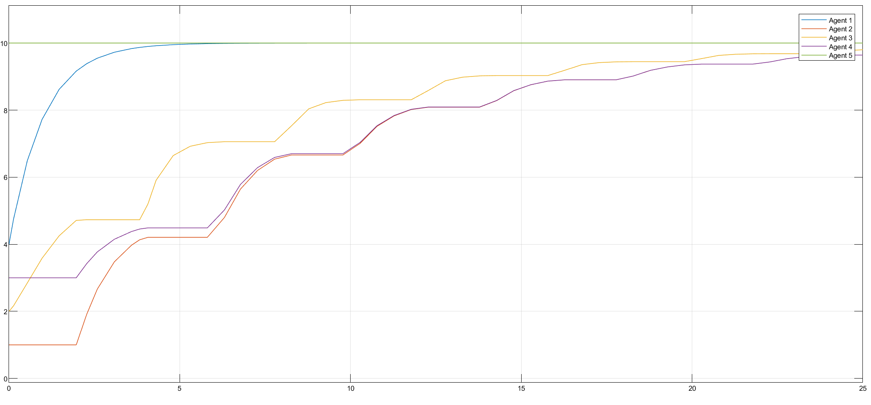

Diagram of the right topology:

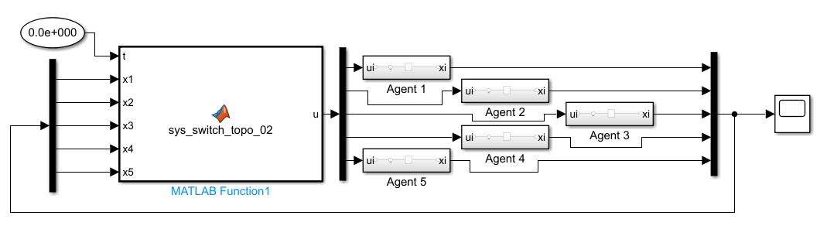

Each agent dynamics is implemented as follows:



The MAS dynamics could be implemented as follows. First, laplacian matrix is formed based on the given topology. Then the control signal is generated using U = -LX

In order to switch between topologies every 2s, we could use the clock block to access the simulation time. Therefore, passing the time into the function enables us to switch between topologies at any desired time using simple if statements.

function u = sys_switch_topo_02(t, x1, x2, x3, x4, x5)

if rem(floor(t/2),2) == 0

L = [2 0 -1 0 -1;

0 0 0 0 0;

0 0 0 0 0;

0 0 -1 +1 0;

0 0 0 0 0;

];

else

L = [2 -1 0 0 -1;

0 0 0 0 0;

0 0 0 0 0;

0 -1 0 +1 0;

0 0 0 0 0;

];

end

states = [x1, x2, x3, x4 x5]';

u = -L*states;

end

Note that the initial conditions of the agents are set as follows: 4 , 1 , 2 , 3 , 10

As there is no jointly connected tree (spanning tree) in the topology.

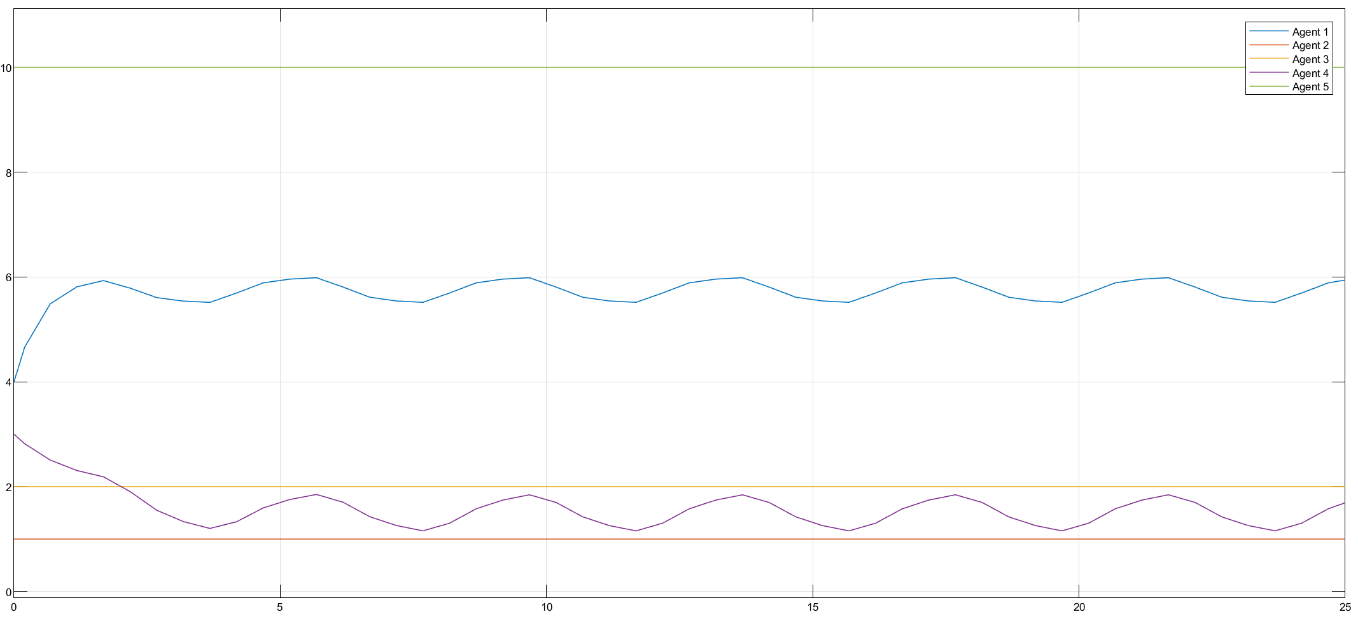

Diagram of the left topology (for dynamic input):

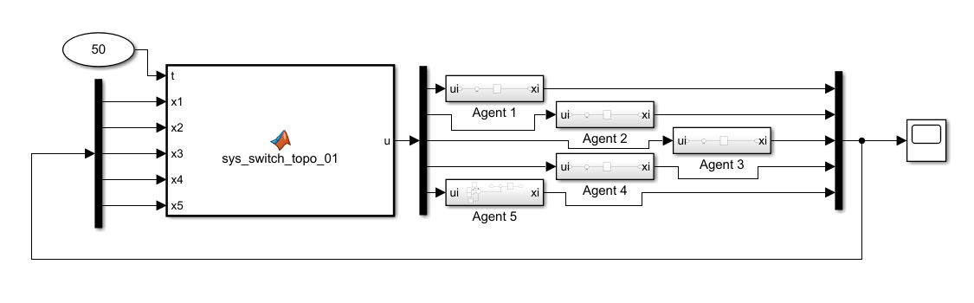

Each agent dynamics is implemented as follows:



and the leader dynamics:

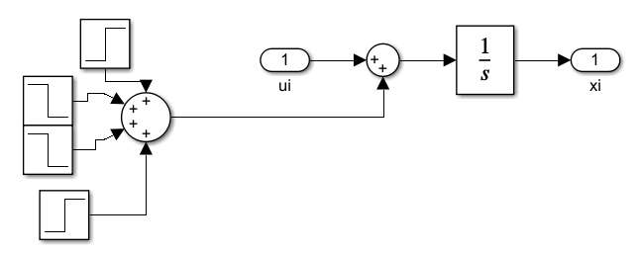

The leader is experiencing a variation in the input signal from 20 to 35 seconds. At t=20, a unit step function is applied, then at t=25, 0.5*unit_step is reduced. t=30 is when a unit step signal is reduced again anf finally, at t=35, +1/2*unit_step is addded.

The MAS dynamics could be implemented as follows. First, laplacian matrix is formed based on the given topology. Then the control signal is generated using U = -LX

In order to switch between topologies every 2s, we could use the clock block to access the simulation time. Therefore, passing the time into the function enables us to switch between topologies at any desired time using simple if statements.

function u = sys_switch_topo_02(t, x1, x2, x3, x4, x5)

if rem(floor(t/2),2) == 0

L = [2 0 -1 0 -1;

0 0 0 0 0;

0 0 0 0 0;

0 0 -1 +1 0;

0 0 0 0 0;

];

else

L = [2 -1 0 0 -1;

0 0 0 0 0;

0 0 0 0 0;

0 -1 0 +1 0;

0 0 0 0 0;

];

end

states = [x1, x2, x3, x4 x5]';

u = -L*states;

end

Note that the initial conditions of the agents are set as follows: 4 , 1 , 2 , 3 , 10

You could see that the consensus is reached and all the followers have reached to the leader.

Diagram of the right topology (for dynamic input):

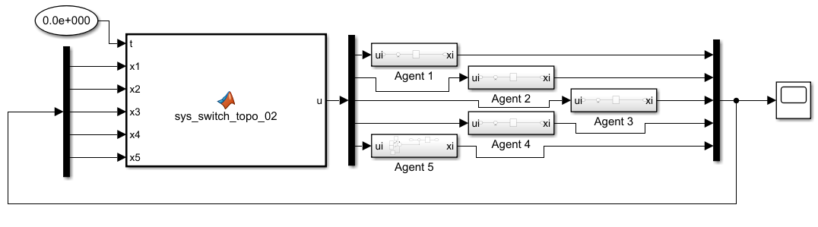

Each agent dynamics is implemented as follows:



and the leader dynamics:



The leader is experiencing a variation in the input signal from 20 to 35 seconds. At t=20, a unit step function is applied, then at t=25, 0.5*unit_step is reduced. t=30 is when a unit step signal is reduced again anf finally, at t=35, +1/2*unit_step is addded.

The MAS dynamics could be implemented as follows. First, laplacian matrix is formed based on the given topology. Then the control signal is generated using U = -LX

In order to switch between topologies every 2s, we could use the clock block to access the simulation time. Therefore, passing the time into the function enables us to switch between topologies at any desired time using simple if statements.

function u = sys_switch_topo_02(t, x1, x2, x3, x4, x5)

if rem(floor(t/2),2) == 0

L = [2 0 -1 0 -1;

0 0 0 0 0;

0 0 0 0 0;

0 0 -1 +1 0;

0 0 0 0 0;

];

else

L = [2 -1 0 0 -1;

0 0 0 0 0;

0 0 0 0 0;

0 -1 0 +1 0;

0 0 0 0 0;

];

end

states = [x1, x2, x3, x4 x5]';

u = -L*states;

end

Note that the initial conditions of the agents are set as follows: 4 , 1 , 2 , 3 , 10

Since there is no jointly connected graph, we do not expect the MAS to reach the consensus and It has not.

