# Q_02 Simulation Report

Given the following topology,

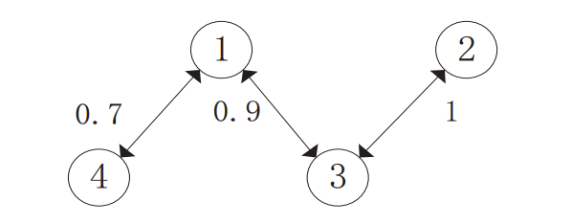

the multi-agent system would be simulated in MATLAB Simulink as in the following figure.

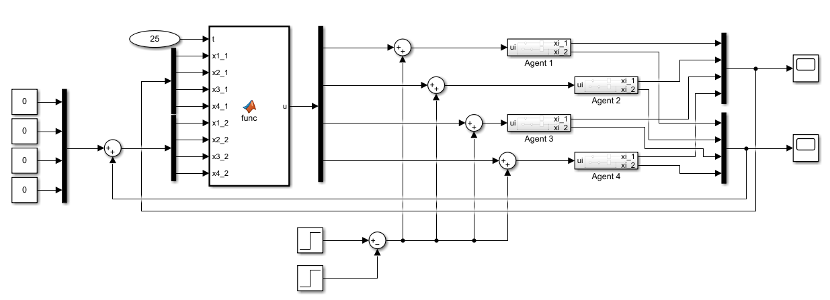

## Agent Dynamics Simulation

Each agent is designed within a subsystem block in which two integrator states are considered as given in the problem. The control signal is the only input to the agents and the outputs are agents' states.

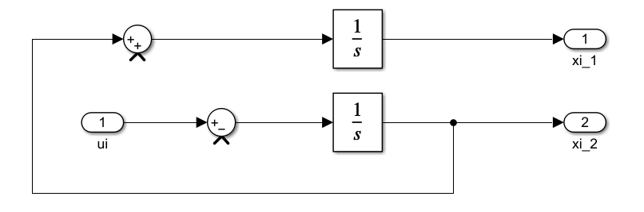

Also the following values have been set as the initial conditions of each agent states.









## Agents Input

Each agent input consists of two terms: 1- Control Signal 2- Disturbance Signal (if exists)

The disturbance is said to be a) step signal b) sinusoidal signal

The control signal is derived from the presented control protocol of the MAS.

You could find the disturbance blocks in both simulaiton files as in the following:

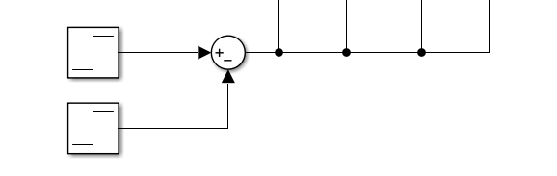

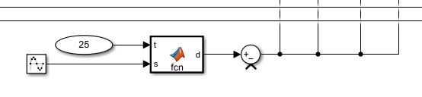

Note that both disturbance signals are applied from 5 to 8 of the runtime seconds.

The available MATLAB Function block in which the control protocol is implemented provides the agents with the control signal term.

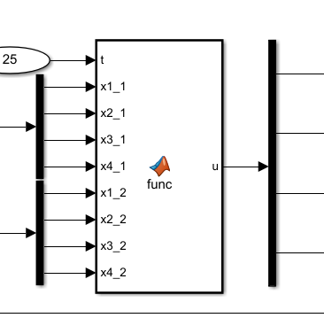

There you could find how the control protocol is implemented. Also you could find the script in the following:

function u = func(t, x1_1, x2_1, x3_1, x4_1, x1_2, x2_2, x3_2, x4_2)

states_1 = [x1_1, x2_1, x3_1, x4_1]';

states_2 = [x1_2, x2_2, x3_2, x4_2]';

L = [1.6 0 -0.9 -0.7;

0 1 -1 0;

-0.9 -1 1.9 0;

-0.7 0 0 0.7;

];

n = 4;

D = 0.4;

c1 = 2;

c2 = 2.3;

epsilons = [0.02;0.02;0.02;0.02];

eigL = round(eig(L)*10000)/10000;

lambdaMax = max(eigL);

eigs = sort(eigL);

lambdaMin = eigs(2);

S = L*(L*states_2 + c2*L*states_1 + c1*L*states_1*t);

Ebar = max(abs(c1*L*states_1 + c2*L*states_2));

lower_hi = (Ebar + epsilons + sqrt(n)*D*lambdaMax)*sqrt(n)/lambdaMin;

u = real(-lower_hi.*sign(S));

end

First, the Laplacian matrix of the given topology is formed in L and the states vectors are set up. Then some constants values (already given) are defined. Finally, the algorithm protocol is presented and the control signal is defined as the output of the function.

## Run and Simulate

Running the simulation for 25 seconds leads into the following results:

In case of the disturbance being step signal,  state of all agents would response as following:

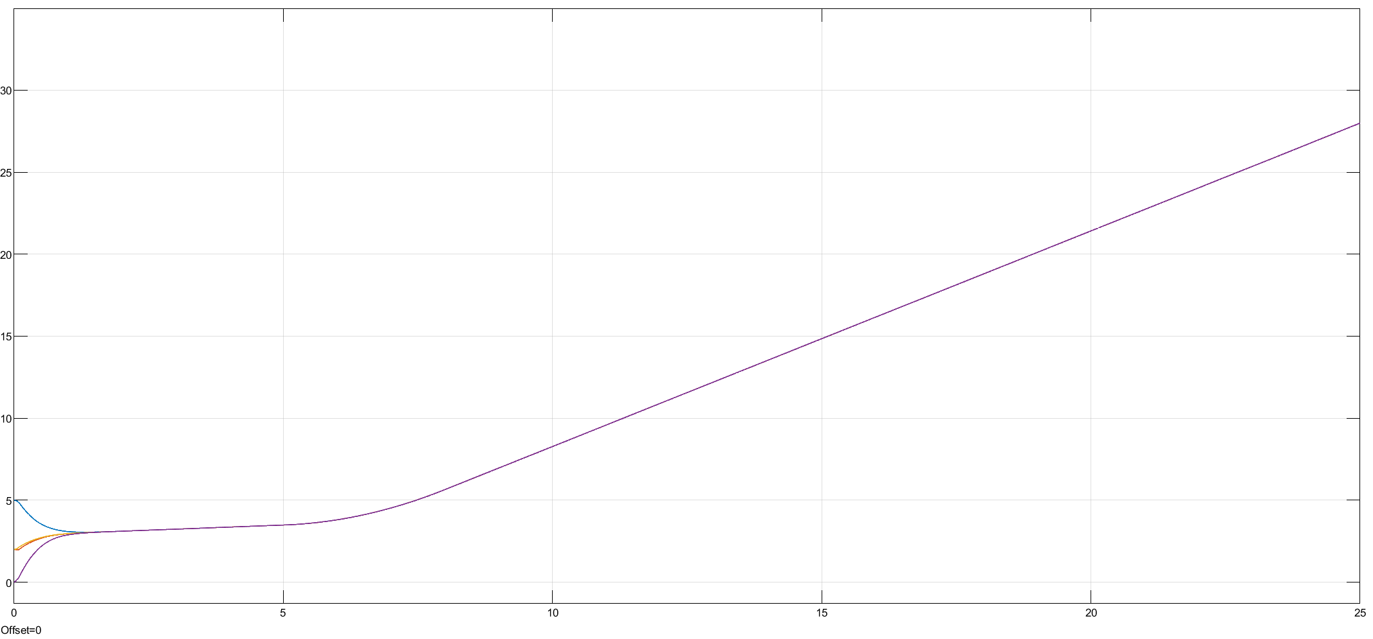

which shows that the consensus among agents is achieved well; however the states responses are diverging. Meanwhile,  state of agents behaves as in the following:

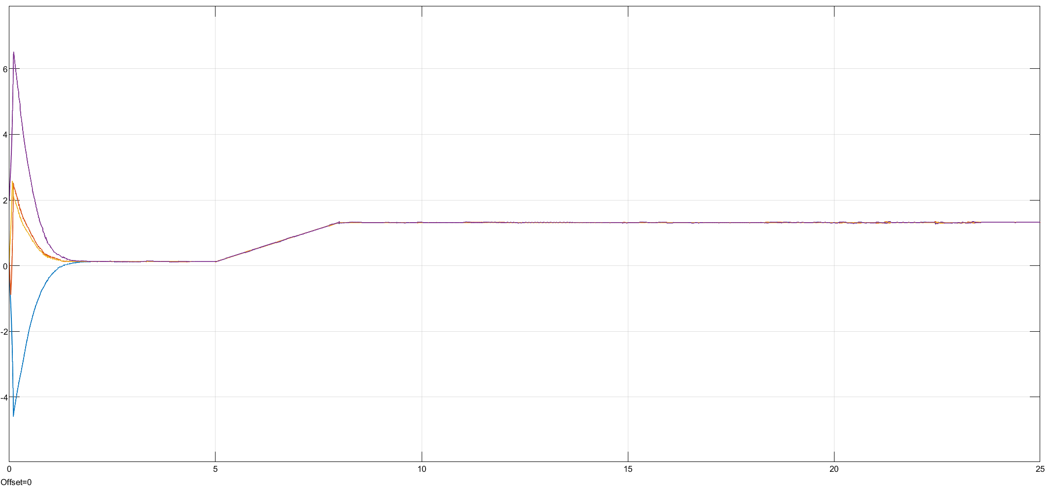

Again consensus is reached and the agents' state  are convergen to the fixed consensus values. Zooming in the disturbance time must demonstrate that the disturbance has caused some errors for at least a while. The following figure illustrates this:

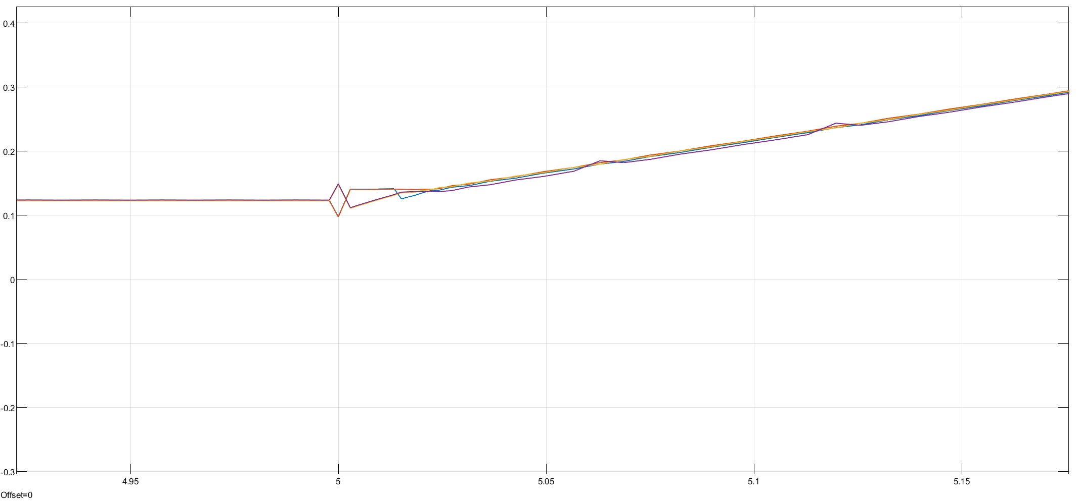

For the case that disturbance is of sinusoidal form, the and  states results are as follows respectively:

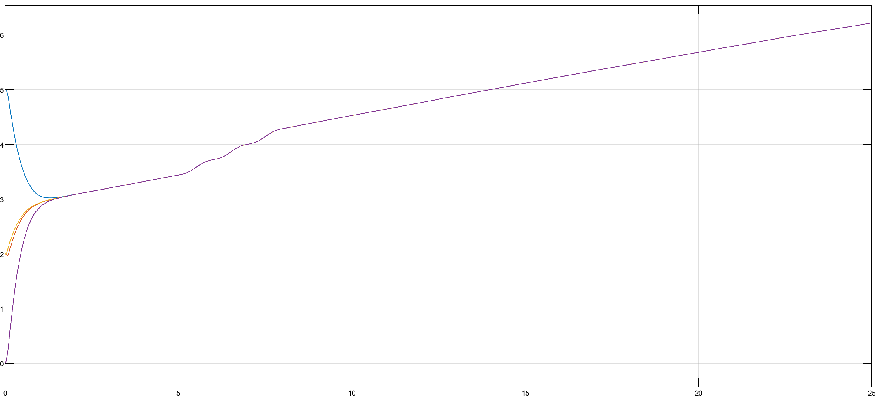

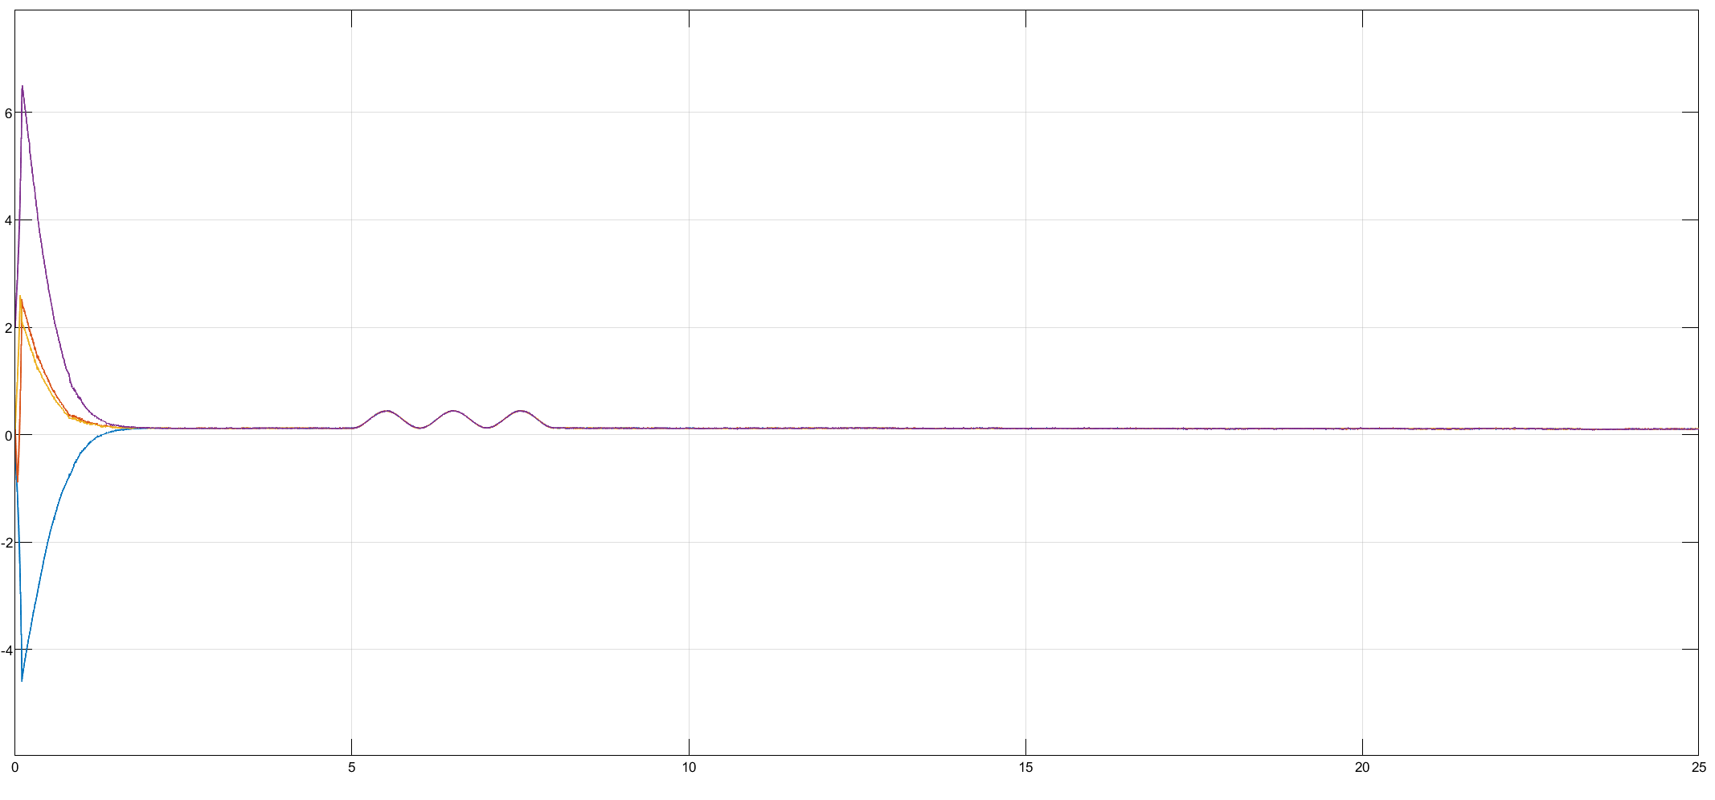

The periodic behavior of the responses, caused by the sinusoidal disturbance is obvious. Zooming in for a better view of the disturbance effect:

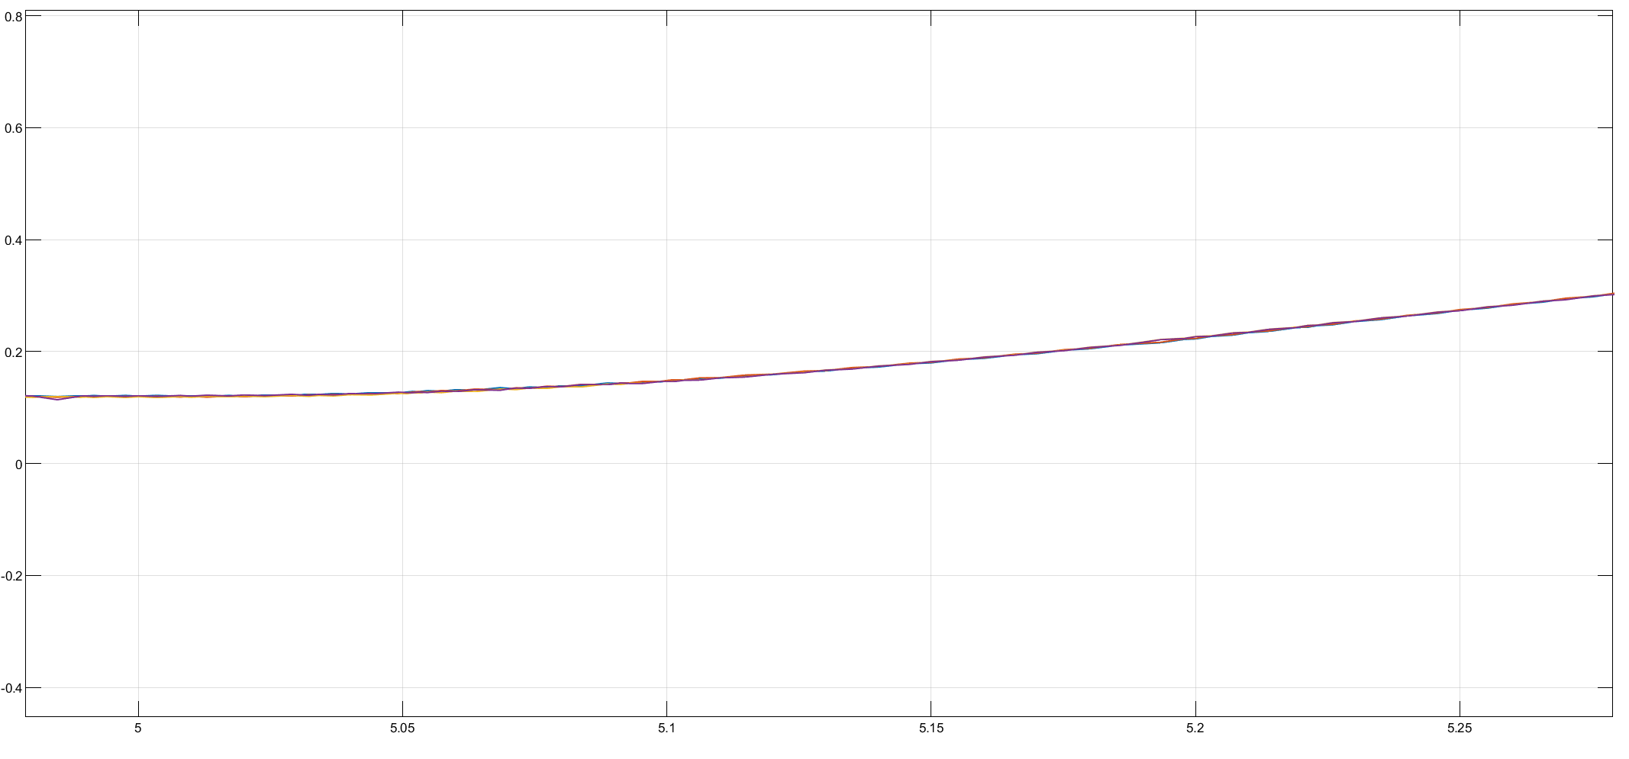

Remember that the consensus is reached among the agents even though  state is diverging in all agents.