

Define the parameter estimation error as:



The dynamics of the estimation error become:



To show that the system achieves consensus, we construct a Lyapunov function that encompasses both the consensus error $z_{i}$ and the parameter estimation error.



The derivative of V along the trajectories of the system gives us:



Now Substitute Dynamics into the derivative of V and use the fact that the graph is undirected and connected (implying $a_{ij}$ = $a_{ji}$ and the existence of a path between any two nodes) to analyze the sign of the derivative of V.

Given the system dynamics and the structure of the Lyapunov function's derivative, we should aim to show that the derivative of V is non-positive (${V }^{.}<$ 0). This condition would indicate that the system is stable and moving towards consensus (i.e., the consensus error and the parameter estimation error diminish over time).

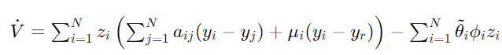

Noticing that the system is undirected and connected, we can simplify the first summation using the properties of the graph Laplacian, L, which encapsulates the adjacency matrix A=[$a_{ij}$] and the degree matrix D, such that L=D−A.

For the consensus part, focusing on the terms involved $y_{i }- y_{j}$, the quadratic form of the graph Laplacian with the consensus error vector z will appear. This term is known to be non-positive for connected graphs, contributing to the system's stability by ensuring:

