MAS Course – Assignment 02 – Containment

Problem 02

Mohammad Azimi – 402123100

A = 6×6

0 0 0 1.0000 0 0

0 0 0 0 1.0000 0

0 0 0 0 0 1.0000

0 0 -0.2003 -0.2003 0 0

0 0 0.2003 0 -0.2003 0

0 0 0 0 0 -1.6129

B = 6×2

0 0

0 0

0 0

0.9441 0.9441

0.9441 0.9441

-28.7097 28.7097

cvx_begin

variable P(6,6) symmetric

A*P + P*A' - 2*B*B' <= 0

cvx_end

Calling SDPT3 4.0: 25 variables, 4 equality constraints

------------------------------------------------------------

num. of constraints = 4

dim. of linear var = 21

dim. of free var = 4 *** convert ublk to lblk

*******************************************************************

SDPT3: Infeasible path-following algorithms

*******************************************************************

version predcorr gam expon scale_data

NT 1 0.000 1 0

it pstep dstep pinfeas dinfeas gap prim-obj dual-obj cputime

-------------------------------------------------------------------

0|0.000|0.000|1.3e+01|6.2e+01|1.4e+06| 0.000000e+00 0.000000e+00| 0:0:01| chol 1 1

1|0.702|0.928|4.0e+00|4.9e+00|1.6e+05| 0.000000e+00 -1.213948e+04| 0:0:02| chol 1 1

2|0.953|0.926|1.8e-01|5.9e-01|1.0e+04| 0.000000e+00 -4.162457e+03| 0:0:02| chol 1 1

3|0.979|0.981|3.9e-03|8.5e-02|4.2e+02| 0.000000e+00 -2.737813e+02| 0:0:02| chol 1 1

4|0.985|0.960|5.7e-05|2.6e-02|2.2e+01| 0.000000e+00 -1.245507e+01| 0:0:02| chol 1 1

5|0.978|0.885|1.6e-06|9.0e-03|3.0e+00| 0.000000e+00 -2.104276e-01| 0:0:02| chol 1 1

6|1.000|0.972|4.2e-07|2.2e-03|2.5e-01| 0.000000e+00 3.691781e-01| 0:0:02| chol 1 1

7|1.000|0.914|3.3e-08|7.5e-04|3.9e-02| 0.000000e+00 1.408172e-01| 0:0:02| chol 1 1

8|1.000|1.000|7.1e-08|1.8e-04|1.3e-02| 0.000000e+00 3.077093e-02| 0:0:02| chol 1 1

9|0.988|0.920|1.3e-09|6.5e-05|1.3e-03| 0.000000e+00 1.231694e-02| 0:0:02| chol 1 1

10|1.000|1.000|6.5e-09|6.3e-05|3.0e-04| 0.000000e+00 3.103276e-03| 0:0:02| chol 2 2

11|1.000|0.925|8.6e-11|1.6e-05|4.5e-05| 0.000000e+00 1.104349e-03| 0:0:02| chol 1 2

12|0.989|0.988|1.1e-12|2.2e-06|1.1e-06| 0.000000e+00 1.271363e-05| 0:0:02| chol 1 2

13|1.000|0.988|2.1e-13|5.3e-08|2.4e-08| 0.000000e+00 1.464649e-07| 0:0:02| chol 1 2

14|1.000|0.988|2.2e-14|1.2e-09|5.9e-10| 0.000000e+00 1.649318e-09| 0:0:02|

stop: max(relative gap, infeasibilities) < 1.49e-08

-------------------------------------------------------------------

number of iterations = 14

primal objective value = 0.00000000e+00

dual objective value = 1.64931818e-09

gap := trace(XZ) = 5.88e-10

relative gap = 5.88e-10

actual relative gap = -1.65e-09

rel. primal infeas (scaled problem) = 2.15e-14

rel. dual " " " = 1.19e-09

rel. primal infeas (unscaled problem) = 0.00e+00

rel. dual " " " = 0.00e+00

norm(X), norm(y), norm(Z) = 1.0e+03, 4.5e+01, 8.7e+01

norm(A), norm(b), norm(C) = 9.1e+00, 1.0e+03, 1.0e+00

Total CPU time (secs) = 1.95

CPU time per iteration = 0.14

termination code = 0

DIMACS: 2.2e-14 0.0e+00 1.2e-09 0.0e+00 -1.6e-09 5.9e-10

-------------------------------------------------------------------

------------------------------------------------------------

Status: Solved

Optimal value (cvx_optval): +0

P = 6×6

103 ×

0 0 -0.0050 -0.0022 -0.0015 0.0008

0 0 0.0050 -0.0015 -0.0022 -0.0008

-0.0050 0.0050 0.0069 -0.0008 0.0008 -0.0112

-0.0022 -0.0015 -0.0008 -0.0032 -0.0010 0.0012

-0.0015 -0.0022 0.0008 -0.0010 -0.0032 -0.0012

0.0008 -0.0008 -0.0112 0.0012 -0.0012 -1.0177

Since P is not Positive-Definite, we use the pole placement method to obtain the feedback gains.

rng(42)

F = place(A,B,-5*rand(1,6))

F = 2×6

-2.7894 4.3008 1.4031 -5.2719 7.5168 0.1748

-4.5983 6.1103 2.5947 -8.9450 11.1907 0.4739

Define the MAS with the given topology:

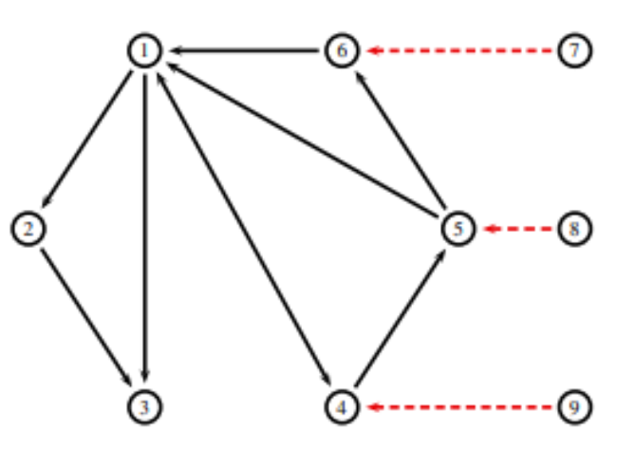

NumFollowers = 6

NumLeaders = 3

NumAgents = 9

NumStates = 6

and the Laplacian Matrices:

L_Followers = 6×6

3 0 0 -1 -1 -1

-1 1 0 0 0 0

-1 -1 2 0 0 0

-1 0 0 1 0 0

0 0 0 -1 1 0

-1 0 0 0 0 1

L_total = 9×9

3 0 0 -1 -1 -1 0 0 0

-1 1 0 0 0 0 0 0 0

-1 -1 2 0 0 0 0 0 0

-1 0 0 2 0 0 0 0 -1

0 0 0 -1 2 0 0 -1 0

-1 0 0 0 0 2 -1 0 0

0 0 0 0 0 0 0 0 0

0 0 0 0 0 0 0 0 0

0 0 0 0 0 0 0 0 0

lambda_min = 1

c_th = 1

c = 1.5000

Define the MAS and agents' dynamics and the initial conditions.

agents = repmat(struct("x_dot", [], "x", []), NumFollowers, 1);

for agent=1:NumFollowers

agents(agent).x = rand(6,1)*2

agents(agent).x_dot = zeros(6,1)

end

agents = 9×1 struct

| **Fields** | **x_dot** | **x** |
| --- | --- | --- |
| **1** | [0;0;0;0;0;0] | [0.1162;1.7324;1.2022;1.4161;0.0412;1.9398] |
| **2** | [0;0;0;0;0;0] | [1.6649;0.4247;0.3636;0.3668;0.6085;1.0495] |
| **3** | [0;0;0;0;0;0] | [0.8639;0.5825;1.2237;0.2790;0.5843;0.7327] |
| **4** | [0;0;0;0;0;0] | [0.9121;1.5704;0.3993;1.0285;1.1848;0.0929] |
| **5** | [0;0;0;0;0;0] | [1.2151;0.3410;0.1301;1.8978;1.9313;1.6168] |
| **6** | [0;0;0;0;0;0] | [0.6092;0.1953;1.3685;0.8803;0.2441;0.9904] |
| **7** | [0;0;0;0;0;0] | [1;0;1;0;1;0] |
| **8** | [0;0;0;0;0;0] | [0;1;0;1;0;1] |
| **9** | [0;0;0;0;0;0] | [1;1;1;1;1;1] |

Put together everything and form a collective structure for the MAS dynimics.

allStates = [];

allStates_dot = [];

for agent=1:NumAgents

allStates = [allStates; agents(agent).x];

allStates_dot = [allStates_dot; agents(agent).x_dot];

end

All the above results are based on:



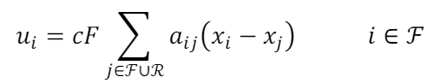 

Solving the system using the Euler's method obtains the following results:

* **state 1:** unstable and diverging



* **state 2:** unstable and diverging



* **state 3:** stable and converging within the leaders’ convex hull



* **state 4:** stable and converging but not within the leaders’ convex hull



* **state 5:** stable and converging within the leaders’ convex hull



* **state 6:** stable and converging within the leaders’ convex hull

