MAS Course – Assignment 02 – Containment

Problem 03

Mohammad Azimi – 402123100

Study and analyze the collective behavior of a MAS under the following topologies and dynamics:

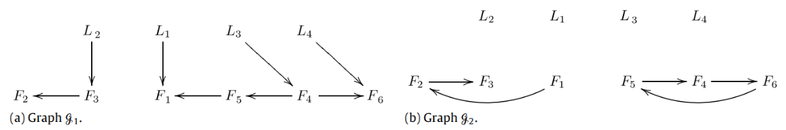

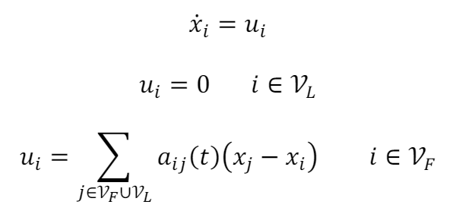

Define initial values to use in the code:

numFollowers

numFollowers = 6

numLeaders

numLeaders = 4

numAgents

numAgents = 10

Based on the given topologies, the Laplacian matrices of L1 and L2 are as follows:

L1

L1 = 10×10

2 0 0 0 -1 0 -1 0 0 0

0 1 -1 0 0 0 0 0 0 0

0 0 1 0 0 0 0 -1 0 0

0 0 0 1 0 0 0 0 -1 0

0 0 0 -1 1 0 0 0 0 0

0 0 0 -1 0 2 0 0 0 -1

0 0 0 0 0 0 0 0 0 0

0 0 0 0 0 0 0 0 0 0

0 0 0 0 0 0 0 0 0 0

0 0 0 0 0 0 0 0 0 0

L2

L2 = 10×10

0 0 0 0 0 0 0 0 0 0

0 1 -1 0 0 0 0 0 0 0

0 -1 1 0 0 0 0 0 0 0

0 0 0 1 -1 0 0 0 0 0

0 0 0 0 1 -1 0 0 0 0

0 0 0 -1 0 1 0 0 0 0

0 0 0 0 0 0 0 0 0 0

0 0 0 0 0 0 0 0 0 0

0 0 0 0 0 0 0 0 0 0

0 0 0 0 0 0 0 0 0 0

Now lets set the `seed` value to avoid different random calues for each code run:

rng(2)

The timespan that the multi-agent system is going to be simulated:

tFinal

tFinal = 80

with the time step:

timeStep

timeStep = 0.1000

and the initial conditions for both leaders and followers as in

### Case I) Leaders at [L1, L2, L3, L4] = [10;22;15;17] ||| zero i.c. for followers

x = [zeros(numFollowers,1)*5 ; 10;22;15;17]

x = 10×1

0

0

0

0

0

0

10

22

15

17

MAS responses are as follows:

Thicker lines are the leaders’ states which are constant by the way since their control signal are always zero, hence their state never changes. As expected, the follower agents have converged in to the convex hull of the four leaders i.e. all the follower lines are within the leader line boundaries.

### Case II) Leaders at [L1, L2, L3, L4] = [10;22;15;17] ||| random i.c. for followers

x

x = 10×1

10.8999

0.6482

13.7416

10.8831

10.5092

8.2584

10.0000

22.0000

15.0000

17.0000

once again, the results are as follows:



This could be observed that the convergence behavior of the MAS is the same under different initial condition values.