MAS Course – Assignment 02 – Containment

Problem 04

Mohammad Azimi – 402123100

Given the following topoly, the laplacian matrix is formed easilly:

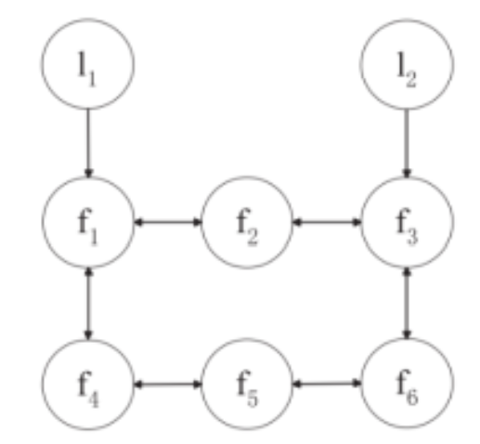

L = 8×8

3 -1 0 -1 0 0 -1 0

-1 2 -1 0 0 0 0 0

0 -1 3 0 0 -1 0 -1

-1 0 0 2 -1 0 0 0

0 0 0 -1 2 -1 0 0

0 0 -1 0 -1 2 0 0

0 0 0 0 0 0 0 0

0 0 0 0 0 0 0 0

**MAS basic information:**

* Leaders Count:

numLeaders = 2

* Followers Count:

numFollowers = 6

We take the following values for the system parameters:

* 
* 
* 
* 
* 
* 

Taking the initial conditions of position and velocity as random numbers along setting the seed value to 42 so that the random numbers won’t change under each runtime:

x = 8×1

3.7454

9.5071

7.3199

5.9866

1.5602

1.5599

0.5808

8.6618

v = 8×1

0

0

0

0

0

0

0

0

Since the system dynamics are as follows:

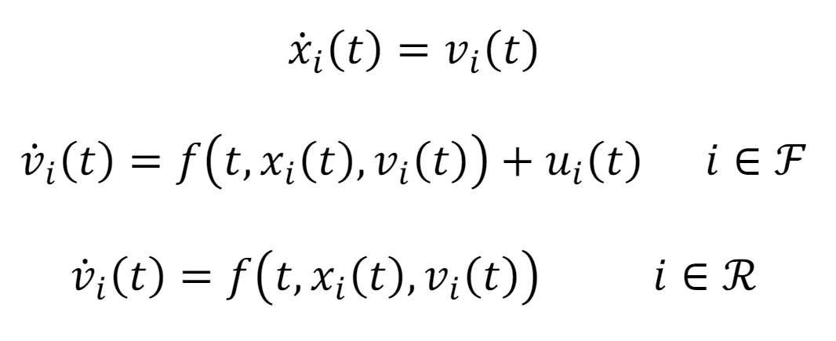

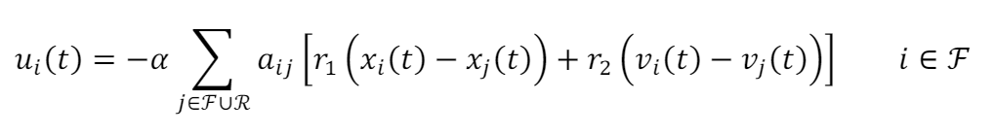



solving the system with the Euler's method will lead to the following results:

* Position



* Velocity



It is seen that both position and velocity of the followers are bounded within the leaders’ states boundaries.

$α$ acts as a feedback gain in the system. the greater the $α$, the stronger the control signal affects on the system states. Trial and error on this system shows an upper bound value for $α$ is 22.5 and the lower bound of $α$, 0.2. Also the minimum value for $α$ in order to be sure that the containment would be achieved is:

